***LAB No. 1***

***Introduction to VS Code and Google Colab for Data Analysis Using Python***

***LAB Description***

In this lab, students will learn how to work with Python programming environments using Visual Studio Code (VS Code) and Google Colab. VS Code is a lightweight and powerful source-code editor that runs on a local system and supports Python development through extensions. It allows users to write, run, and debug Python programs efficiently on their own computer.

Google Colab is a cloud-based Python notebook environment provided by Google that runs in a web browser. It does not require any local installation and provides free access to computing resources. Colab is especially useful for data analysis and visualization, as it supports interactive notebooks, built-in libraries, and easy file uploads.

Using either VS Code or Google Colab, students will create a dataset in Python, upload or load the data, and perform basic data analysis operations. The lab focuses on understanding how datasets are handled, how simple statistics are calculated, and how graphical representations help in interpreting data.

***Lab Objective***

The objectives of this lab are:

* To understand the basic functioning of VS Code and Google Colab
* To learn how to create and upload a dataset using Python
* To perform basic statistical analysis (such as mean, median, and count)
* To visualize data using simple graphs (line charts, bar charts, or histograms)
* To develop foundational skills in data analysis and visualization using Python

***How to use python in VS code?***

***1. Create environment named 'venv'***

python -m venv

***2. Activate environment***

venv\Scripts\activate

***3. Select Environment in VS CodeAfter creating the environment:***

|  |
| --- |
| 1. Open your project folder in VS Code. 2. Press Ctrl + Shift + P → search for Python: 3. Select Interpreter. 4. Choose your newly created environment (venv or myenv). |

***4. Install Machine Learning and Deep Learning Libraries***

|  |
| --- |
| * pip install –upgrade pip * pip install pandas * pip install matplotlib * pip install seaborn * pip install scikit-learn * pip install scipy * pip install numpy * pip install xgboost * pip install lightgbm * pip install catboost * pip install tensorflow * pip install keras * pip install torch |

***Task 1:***

***Save Excel file as .csv (Comma delimited)***



***Task 2:***

***Save .csv file in directory and folder where we created a python environment***

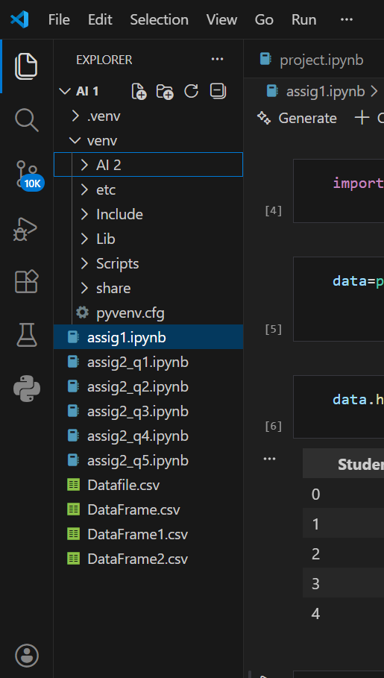

***Here we can see our file successfully***

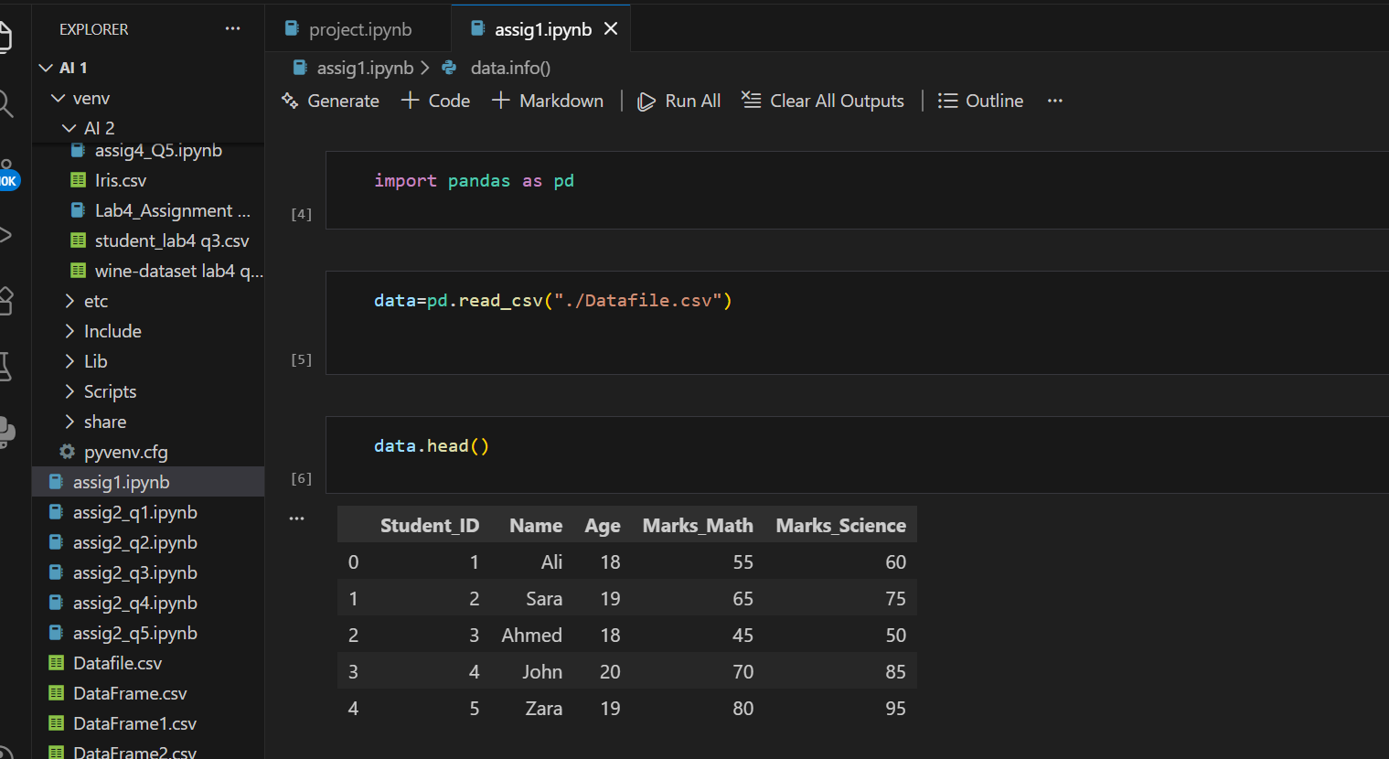

***Introduction of Google Colab***

* Colab is a free notebook environment that runs entirely in the cloud. It lets you and your team members edit documents, the way you work with Google Docs.
* Colab supports many popular machine learning libraries which can be easily loaded in your notebook.
* Another attractive feature that Google offers to the developers is the use of GPU. Colab supports GPU and it is totally free. The reasons for making it free for public could be to make its software a standard in the academics for teaching machine learning and data science.
* Colab is a free Jupyter notebook environment that runs entirely in the cloud. Most importantly, it does not require a setup and the notebooks that you create can be simultaneously edited by your team members - just the way you edit documents in Google Docs. Colab supports many popular machine learning libraries which can be easily loaded in your notebook
* *Step 1 −* Open the following URL in your browser − [https://colab.research.google.com](https://colab.research.google.com/notebooks/welcome.ipynb) Your browser would display the following screen (assuming that you are logged into your Google Drive) −

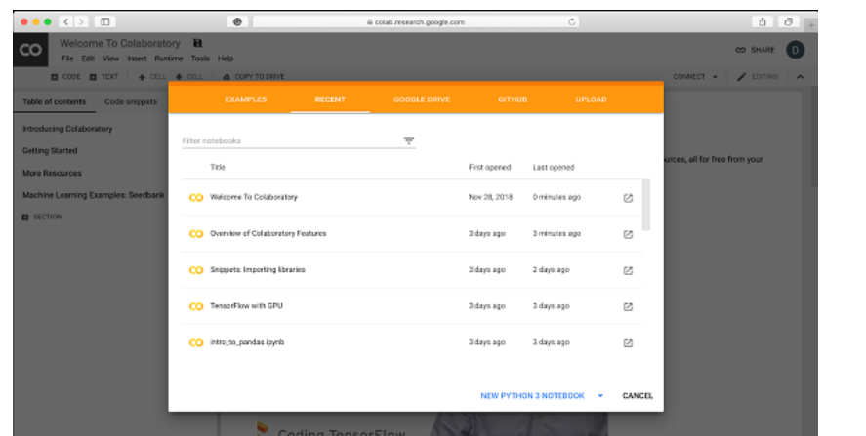

* ***Step 2*** − Click on the ***NEW PYTHON 3 NOTEBOOK*** link at the bottom of the screen. A new notebook would open up as shown in the screen below.

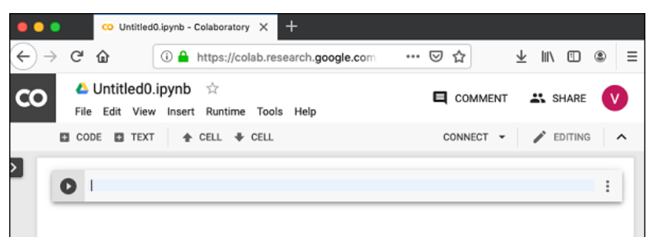

* ***Setting Notebook Name***

By default, the notebook uses the naming convention UntitledXX.ipynb. To rename the notebook, click on this name and type in the desired name in the edit box as shown here −

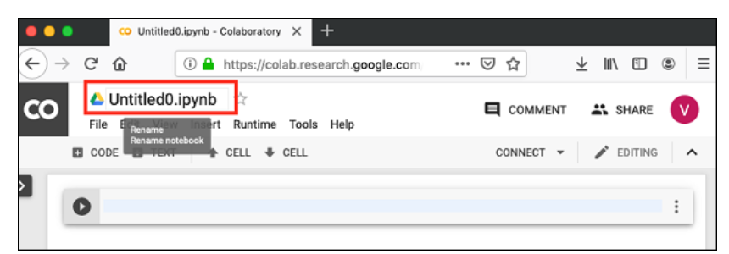

* Entering Code

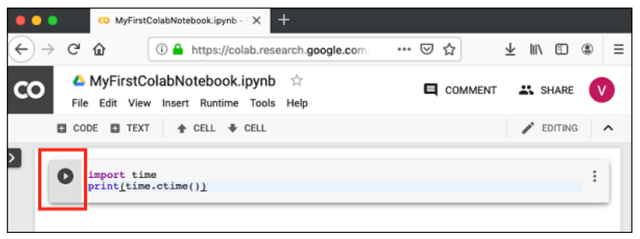

* Adding Code Cells
* To add more code to your notebook, select the following **menu** options −

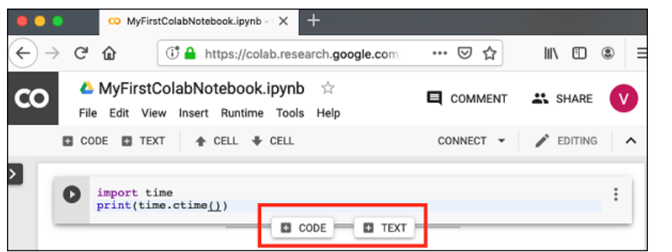

* ***Run All***

To run the entire code in your notebook without an interruption, execute the following menu options −

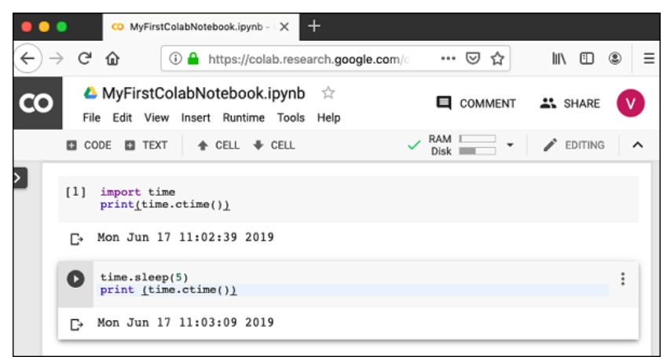

***Saving to Google Drive***

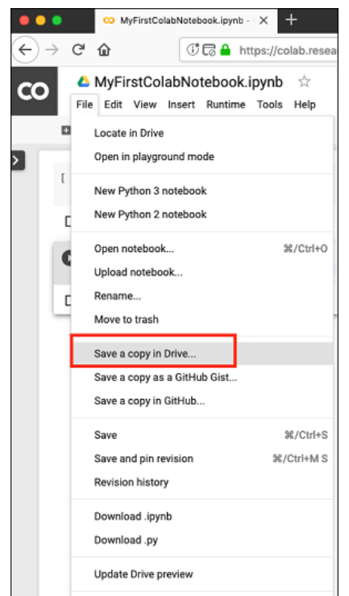

***Google Colab - Sharing Notebook***

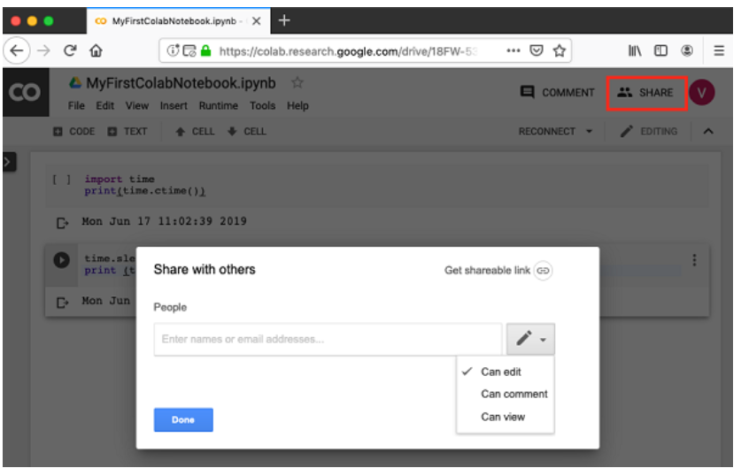

***Practice Questions:***

***Q1: Create a Dataset Manually***

* Create a dataset of at least **10 students** with the following columns:

Student-ID , Name, Age, Marks-Math, Marks-Science.

* Store the dataset in a **CSV file** named students.csv.

***Q2: Upload Dataset in Python***

* Use **Pandas** to load the dataset.

***Code:***

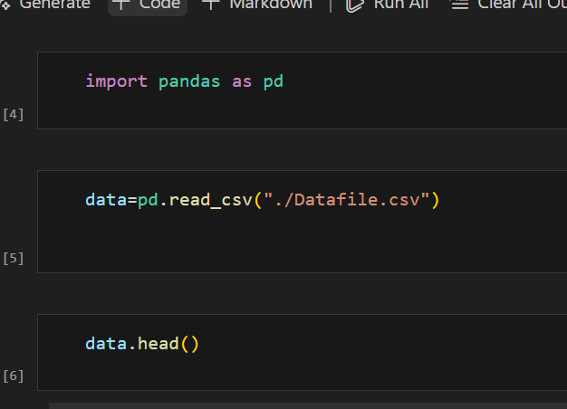

***Output:***

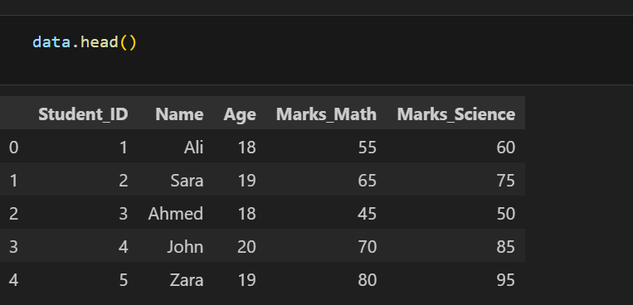

# ***Q3: Observe Dataset Information***

Run the following commands and explain the output:

1. ***data.info() → Dataset structure***

***Code:***

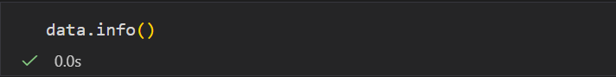

**Output:**

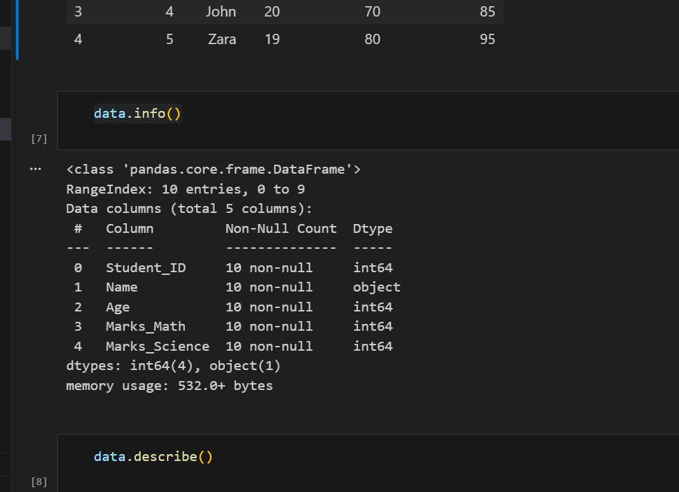

1. ***data.describe() → Summary statistics (mean, std, min, max, etc.)***

***Code:***

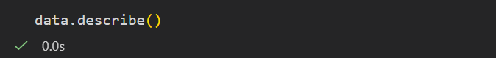

***Output:***

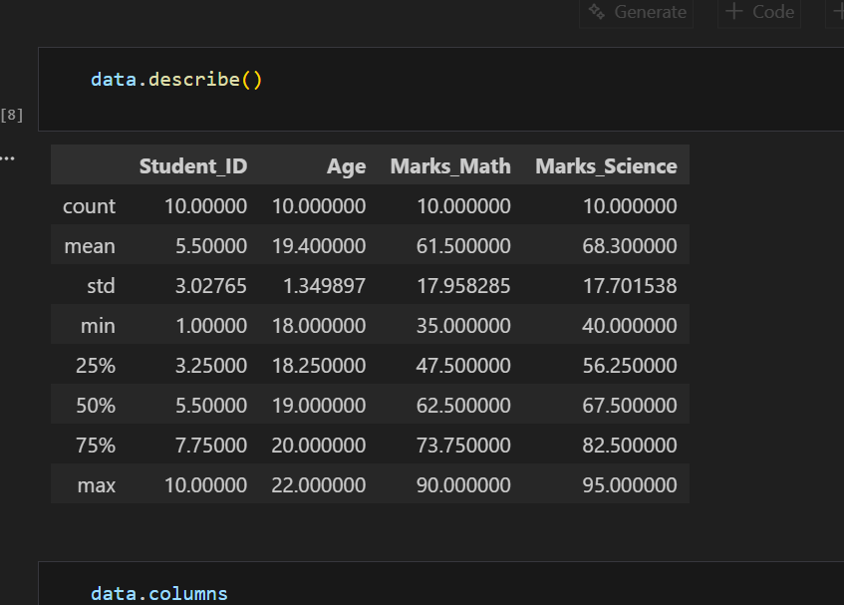

***3. data['Marks_Math'].mean() → Mean of Math marks***

***Code:***

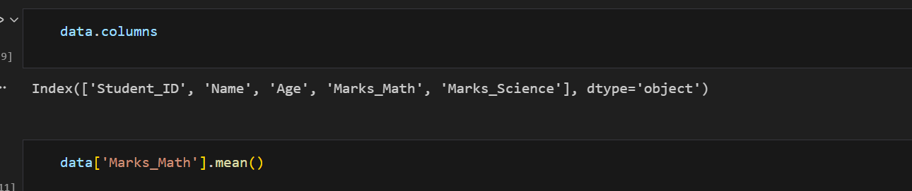

***Output:***

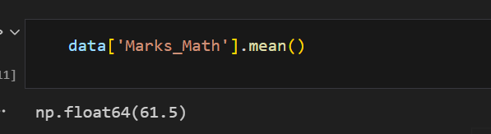

***4. data['Marks_Science'].max() → Maximum Science marks***

***Code:***

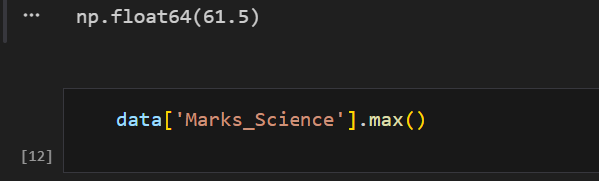

**Output:**

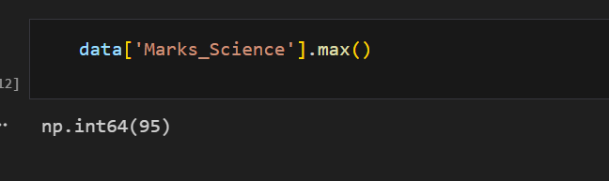

# ***Q4: Perform Some Data Analysis***

* Find how many students have Marks_Math > 50.

***Code:***

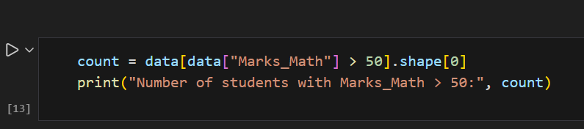

**Output:**

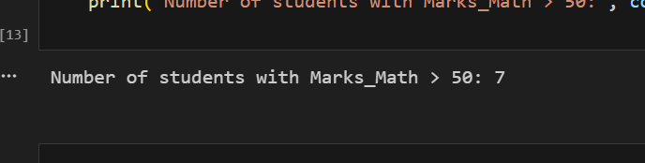

* Find the student with the **highest Science marks**.

***Code:***

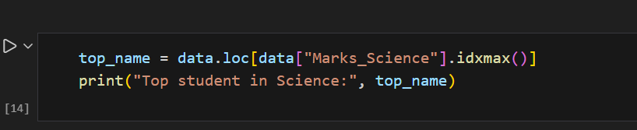

***Output:***

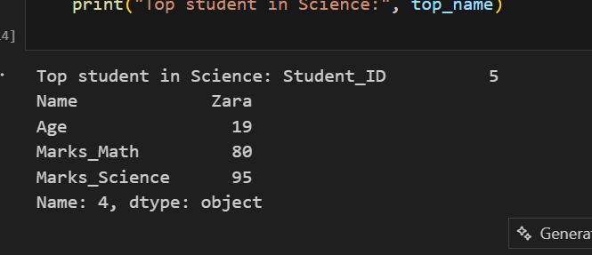

* Calculate the **correlation** between Marks_Math and Marks_Science.

***Code:***

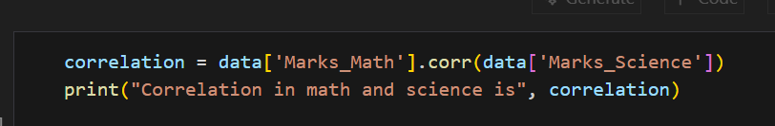

***Output:***

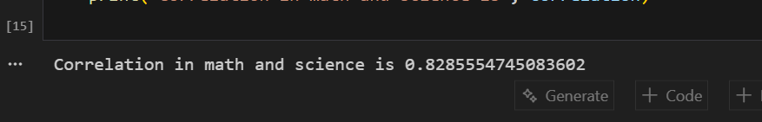

***Q5: Data Visualization***

***Use Matplotlib/Seaborn to create graphs:***

1. A bar chart of Student_ID vs Marks_Math.

# ***Code:***

***:*** 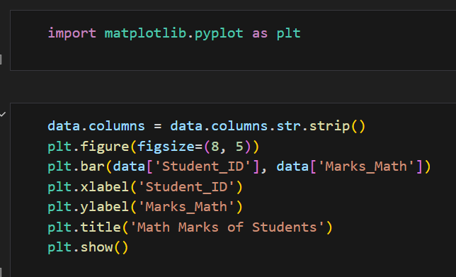

***Output:***

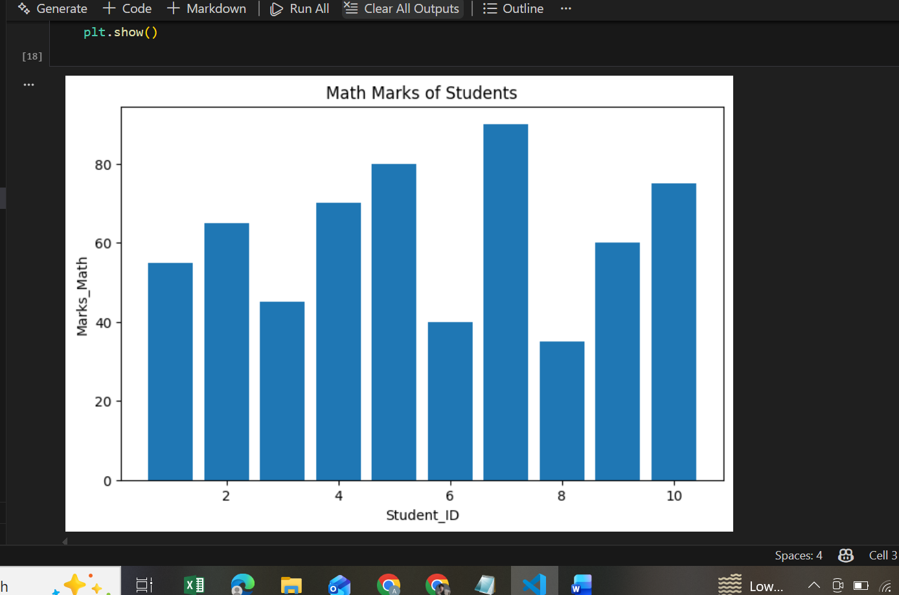

1. ***A histogram of Age.***

***Code:***

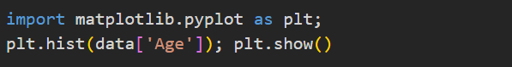

***Output:***

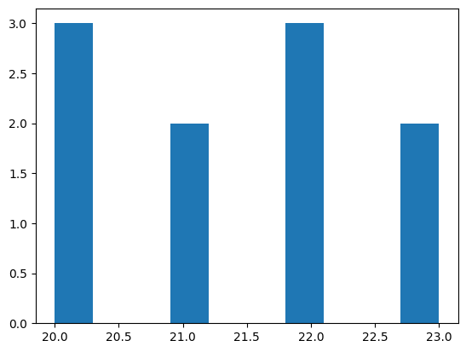

***3. A scatter plot of Marks_Math vs Marks_Science.***

***Code:***

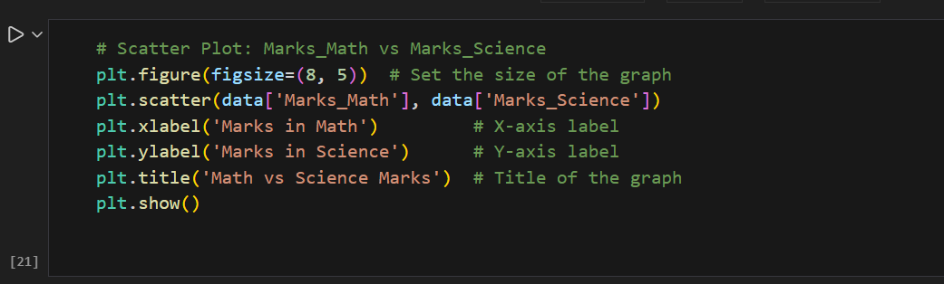

***Output:***

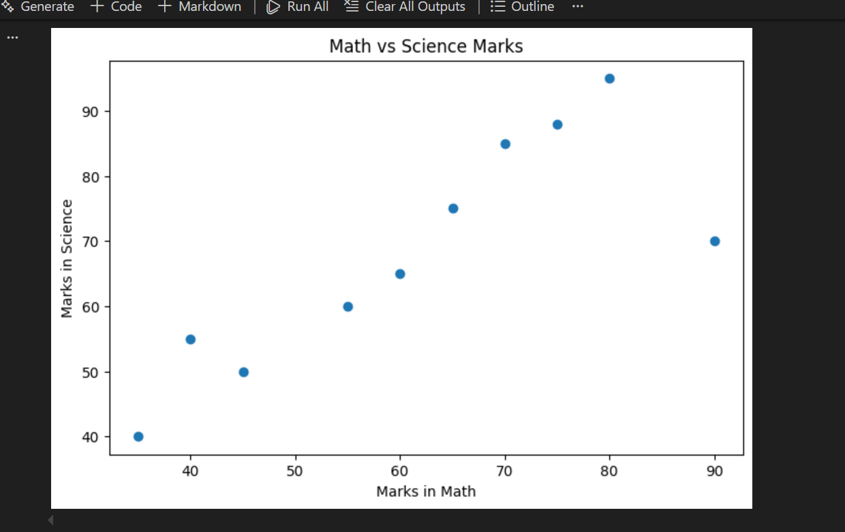

# 

***Laboratory Work Assessment Rubrics***

|  |  |  |  |  |  |  |
| --- | --- | --- | --- | --- | --- | --- |
| **Sr.**  **No.** | **Performance Indicator** | **Excellent (5)** | **Good (4)** | **Average (3)** | **Fair (2)** | **Poor (1)** |
| **1** | **Theoretical** | Student knows | Student knows most | Student knows few | Student knows | Student has poor |
|  | **knowledge** | all the related | of the related | of the related | very little about | understanding of the |
|  | **10%** | concepts about | concepts about the | concepts about the | the related | related concepts |
|  |  | the theoretical | theoretical | theoretical | concepts about the | about the theoretical |
|  |  | background of | background of the | background of the | theoretical | background of the |
|  |  | the experiment | experiment and | experiment and | background of the | experiment and |
|  |  | and rephrase | partially rephrase | partially rephrase | experiment and | unable to rephrase |
|  |  | those concepts in | those concepts in | those concepts in | poorly rephrase | those concepts in |
|  |  | written and oral | written and oral | written and oral | those concepts in | written and oral |
|  |  | assessments | assessments | assessments | written and oral | assessments |
|  |  |  |  |  | assessments |  |
| **2** | **Application** | Application runs | Application | Application | Application | Application does |
|  | **Functionality** | smoothly and | compiles with no | compiles with | compiles and | not compile or |
|  | **10%** | operation of the | warnings. Robust | few or no | runs without | compiles but |
|  |  | application runs | operation of the | warnings. | crashing. Some | crashes. |
|  |  | efficiently | application, with | Consideration | attempt at | Confusing. |
|  |  |  | good recovery. | given to unusual | detecting and | Little or no error |
|  |  |  |  | conditions with | correcting | detection or |
|  |  |  |  | reasonable | errors. | correction. |
| **3** | **Specifications** | The program | The program works | The program | The program | The program is |
|  | **10%** | works very | and meets some of | works and | produces correct | producing incorrect |
|  |  | efficiently and | the specifications. | produces the | results but does not | results. |
|  |  | meets all of the |  | correct results and | display them |  |
|  |  | required |  | displays them | correctly. |  |
|  |  | specifications. |  | correctly. It also |  |  |
|  |  |  |  | meets most of the |  |  |
|  |  |  |  | other |  |  |
|  |  |  |  | specifications. |  |  |
| **4** | **Level of** | Provide complete | Provide complete | Provide partially | Provide very few | Provide no answer to |
|  | **understanding of** | and logical | and logical answers | correct and logical | and illogical | the questions asked |
|  | **the learned skill** | answers based | based upon accurate | answers based | answers to the | by examiner. |
|  | **10%** | upon accurate | technical content to | upon minimum | questions asked by |  |
|  |  | technical content | the questions asked | technical content | examiner. |  |
|  |  | to the questions | by examiner with | to the questions |  |  |
|  |  | asked by | few errors | asked by examiner |  |  |
|  |  | examiner |  |  |  |  |
| **5** | **Readability and** | The code is | The code is fairly | Most of the code | Some parts of the | The code is poorly |
|  | **Reusability** | exceptionally | easy to read. The | could be reused in | code require | organized and very |
|  | **10%** | well organized | code could be | other programs. | change before they | difficult to read and |
|  |  | and very easy | reused as a whole |  | could be reused in | not organized for |
|  |  | to follow and | or each class could |  | other programs. | reusability. |
|  |  | reused | be reused. |  |  |  |

|  |  |  |  |  |  |  |
| --- | --- | --- | --- | --- | --- | --- |
| **6** | **AI System Design 10%** | Well-designed AI models. Code is highly maintainable | Good designed AI models and Little code duplications | Some attempt to make AI models. Code can be maintained with significant effort | Little attempt to design AI models and less understanding of code | Very poor attempt to design AI models and its code |
| **7** | **Responsiveness to**  **Questions/ Accuracy 10%** | 1. Responds well, quick and very accurate all the time. 2. Effectively uses eye contact, speaks clearly, effectively and confidently using   suitable volume | 1. Generally Responsive and accurate most of the times. 2. Maintains eye contact, speaks clearly with suitable volume and pace. | 1. Generally Responsive and accurate few times. 2. Some eye contact, speaks clearly and unclearly in different portions. | 1. Not much Responsive and accurate most of the times. 2. Uses eye contact ineffectively and fails to speak clearly and audibly | . 1. Non Responsive and inaccurate all the times.   1. No eye contact and unable to speak 2. Dresses inappropriately |
| **8** | **Efficiency 10%** | The code is extremely efficient without sacrificing readability and understanding | The code is fairly efficient without sacrificing readability and understanding | Some part of the code is efficient and other part of the code is not understandable and work properly | The code is brute force and unnecessarily long | The code is huge and appears to be patched together |
| **9** | **Delivery 10%** | The program was delivered in time during lab. | The program was delivered in Lab before the end time. | The program was delivered within the due date. | The code was delivered within a day after the due date. | The code was delivered more than 2 days overdue. |
| **10** | **Awareness of Safety Guidelines 10%** | Student has sufficient knowledge of the laboratory safety SOPs and protocol and is fully compliant to the guidelines | Student has sufficient knowledge of the laboratory safety SOPs and protocol and is Partially compliant to the guidelines | Student has little knowledge of the laboratory safety SOPs and protocol and is Partially compliant to the guidelines | Student has little knowledge of the laboratory safety SOPs and protocol and is non- compliant to the guidelines | Student has no knowledge of the laboratory safety SOPs and protocol and is non-compliant to the guidelines |

***LAB Assessment:***

|  |  |  |  |
| --- | --- | --- | --- |
| **Student Name** |  | **LAB Rubrics** | CLO3 , P5, PLO5 |
| **Total Marks** | 10 |
| **Registration No** |  | **Obtained Marks** |  |
| **Teacher Name** | Dr. Syed M Hamedoon |
| **Date** |  | **Signature** |  |

***LAB No. 2***

***Implementation of Regression Analysis using python***

Regression techniques are used to analyze relationships between variables and make predictions. Multiple Linear Regression predicts a continuous output using multiple input variables, while Logistic Regression is used for classification problems with binary outcomes. In this lab, students will apply both methods using Python to understand data modeling, prediction, and basic performance evaluation.

***Introduction***

Regression analysis is a fundamental technique in machine learning and data science used to understand the relationship between variables and to make predictions. In this lab, students will explore **Multiple Linear Regression** and **Logistic Regression** using Python.

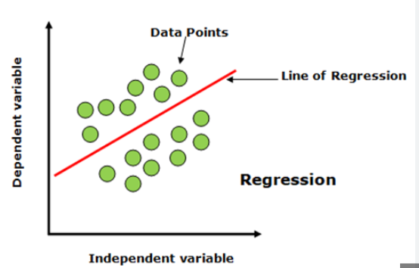

**Multiple Linear Regression** is used when a dependent (output) variable is continuous and depends on two or more independent (input) variables. It helps in modeling and analyzing how changes in multiple features affect a numerical outcome, such as predicting house prices based on area, number of rooms, and location.

**Logistic Regression** is used for classification problems where the dependent variable is categorical, usually binary (such as Yes/No, True/False, or 0/1). It estimates the probability that an input belongs to a particular class and is widely used in applications such as disease prediction, spam detection, and customer churn analysis.

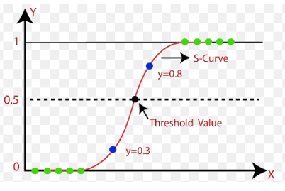

***Solved Examples***

***Example 1***

A dataset contains information about students’ **study hours** and **attendance percentage**. Predict the **final marks** using Multiple Linear Regression.

***Solution:***

|  |
| --- |
| # Import required libraries  import pandas as pd  from sklearn.linear_model import LinearRegression  # Create dataset  data = {      'Study_Hours': [2, 4, 6, 8, 10],      'Attendance': [60, 70, 80, 90, 95],      'Marks': [50, 60, 70, 85, 90]  }  df = pd.DataFrame(data)  # Independent and dependent variables  X = df[['Study_Hours', 'Attendance']]  y = df['Marks']  # Create and train model  model = LinearRegression()  model.fit(X, y)  # Prediction  prediction = model.predict([[7, 85]])  print("Predicted Marks:", prediction[0]) |

***Example 2***

***Predict the house price based on area (sq ft) and number of bedrooms using Multiple Linear Regression.***

***Solution:***

|  |
| --- |
| import pandas as pd  from sklearn.linear_model import LinearRegression  # Dataset  data = {      'Area': [800, 1000, 1200, 1500, 1800],      'Bedrooms': [1, 2, 2, 3, 3],      'Price': [50000, 65000, 75000, 90000, 110000]  }  df = pd.DataFrame(data)  X = df[['Area', 'Bedrooms']]  y = df['Price']  model = LinearRegression()  model.fit(X, y)  # Predict price  predicted_price = model.predict([[1400, 3]])  print("Predicted House Price:", predicted_price[0]) |

***Example 3***

A dataset contains **study hours** and **attendance** information. Predict whether a student will **pass (1)** or **fail (0)** using Logistic Regression.

***Solution:***

|  |
| --- |
| import pandas as pd  from sklearn.linear_model import LogisticRegression  # Dataset  data = {      'Study_Hours': [1, 2, 4, 6, 8, 10],      'Attendance': [50, 55, 65, 75, 85, 95],      'Result': [0, 0, 0, 1, 1, 1]  # 0 = Fail, 1 = Pass  }  df = pd.DataFrame(data)  X = df[['Study_Hours', 'Attendance']]  y = df['Result']  # Create and train model  model = LogisticRegression()  model.fit(X, y)  # Predict pass/fail  result = model.predict([[5, 70]])  print("Predicted Result (1=Pass, 0=Fail):", result[0]) |

***Practice Questions:***

***Q1. Multiple Linear Regression – House Price Prediction***

A dataset contains:

* Size (sqft),
* Number of Bedrooms,
* Age of House (years)

and the target variable is **House Price**.

***👉 Task:***

1. Fit a **multiple linear regression model**.
2. Predict the price of a house with: **Size = 2000 sqft**, **Bedrooms = 3**, Age = **10 years.**
3. Print coefficients and interpret them.

**Code:** 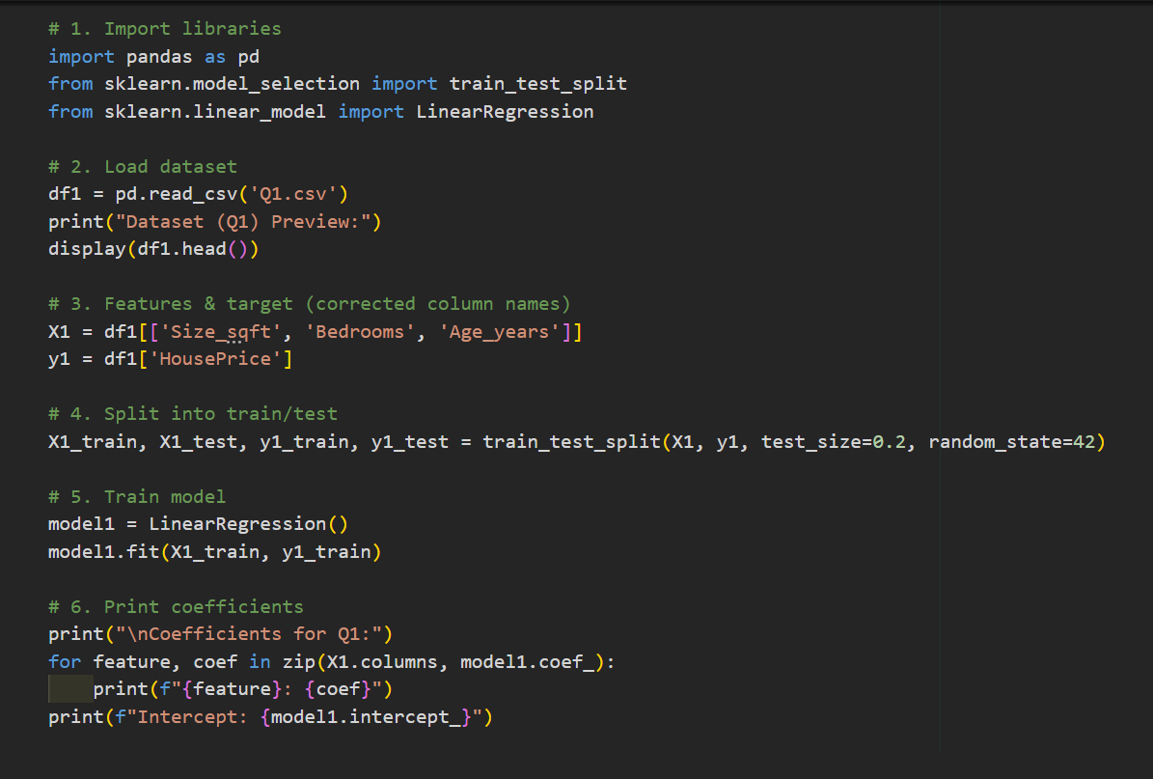

**Output:**

**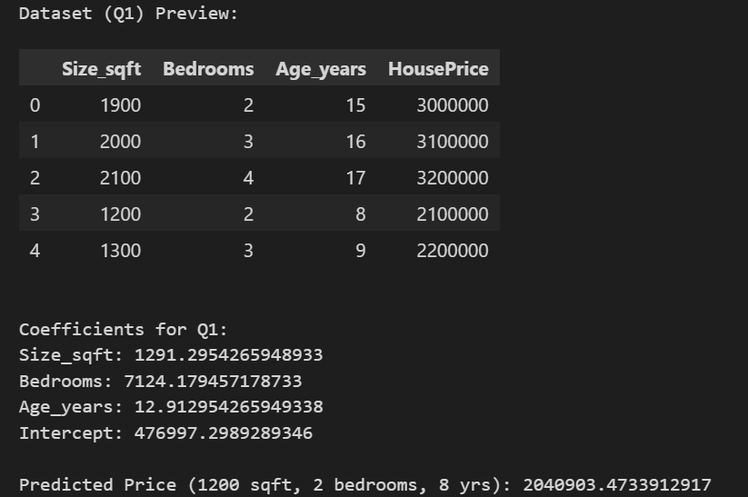*Q2. Multiple Linear Regression – Student Performance***

Dataset columns:

* Hours Study,
* Hours Sleep,
* Attendance(%),  
  Target: **Marks in Exam**

***👉 Task:***

1. Train a regression model.
2. Plot actual vs predicted marks.
3. Compute **R² score** and **Mean Squared Error (MSE)**

***Code*:** 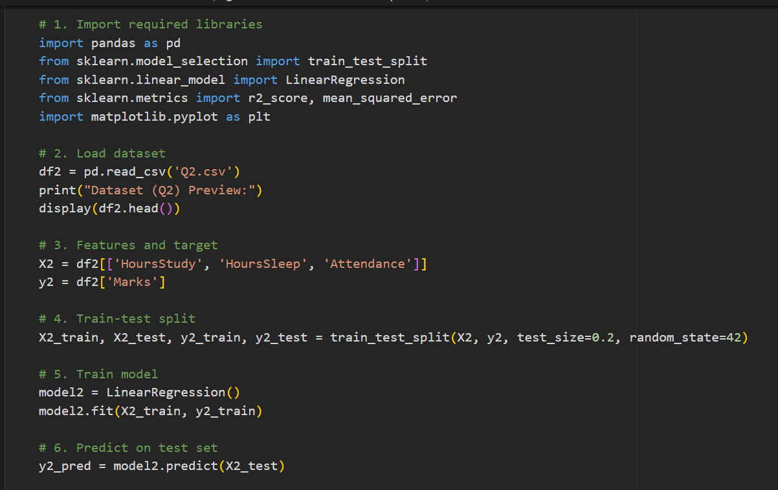

***Output:***

**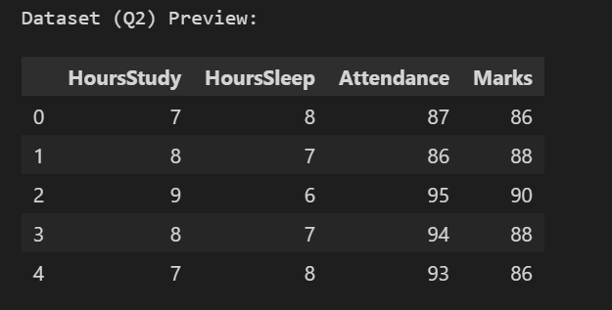*Output:***

**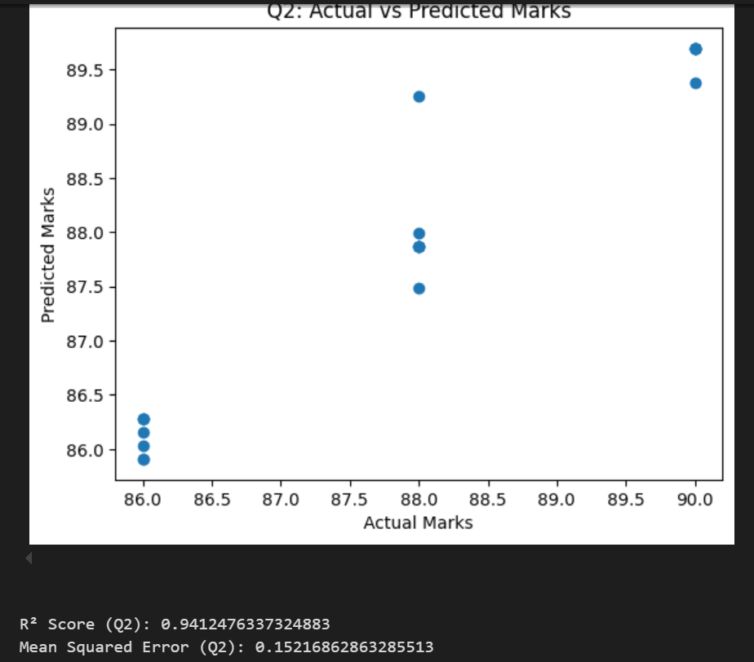*Q3. Logistic Regression – Pass/Fail Classification***

Dataset columns:

* Hours- Study
* Hours-Sleep  
  Target: Pass (1) / Fail (0)

***👉 Task:***

1. Fit a **logistic regression classifier**.
2. Predict the probability of passing if a student studies 30 hours and sleeps 6 hours.
3. Plot the **decision boundary** (pass vs fail).

***Code:***

**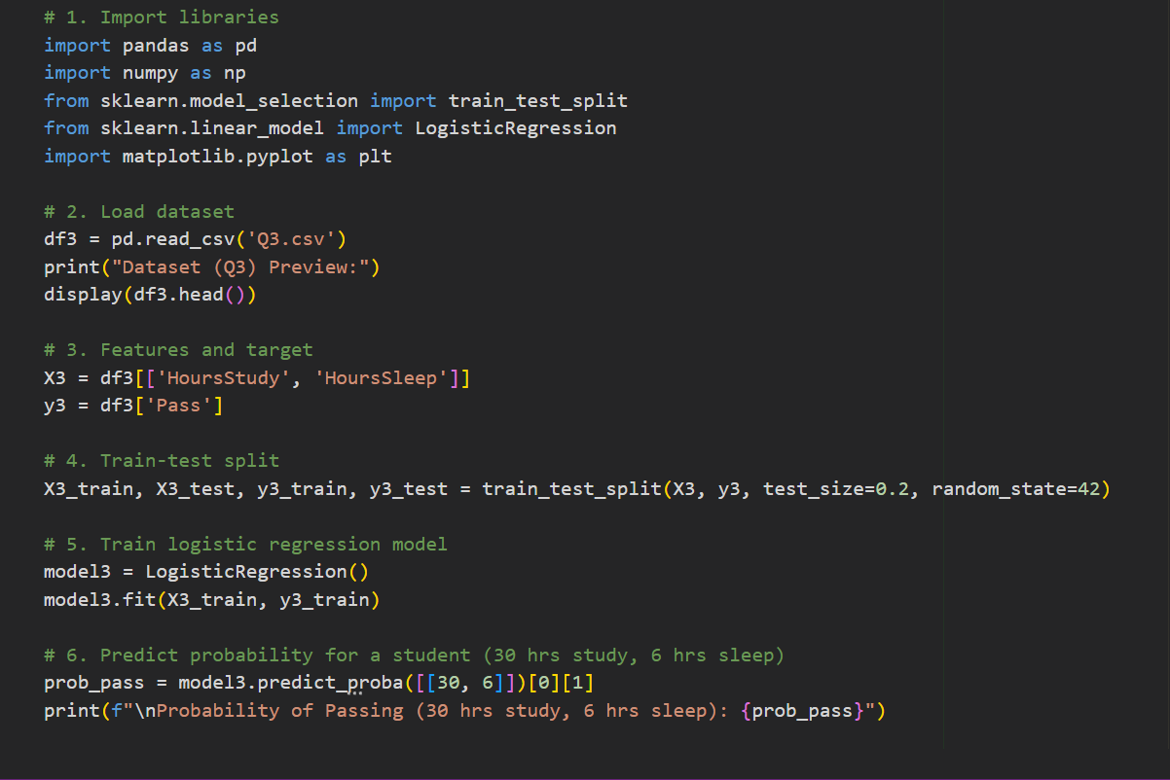*Output:***

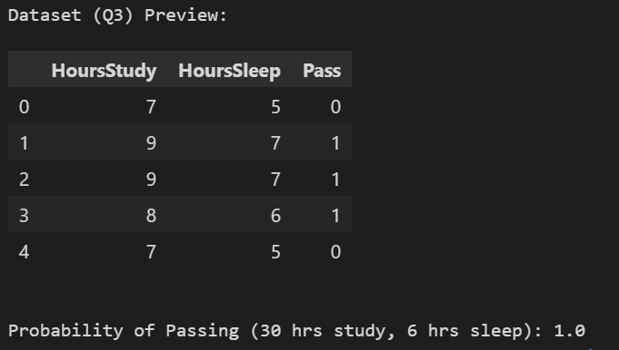

***Output:***

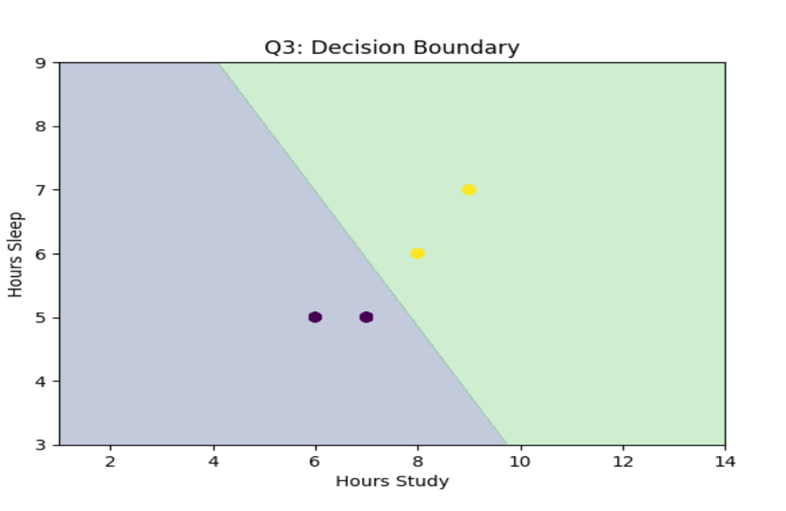

***Q4. Logistic Regression – Diabetes Prediction (Binary Classification)***

Use a small dataset with:

* BMI,
* Age,
* Glucose-Level  
  Target: **Diabetic (1) or Not (0)**

***👉 Task:***

1. Fit logistic regression.
2. Find accuracy, precision, recall.
3. Predict whether a patient (BMI=28, Age=45, Glucose=150) is diabetic.

***Code:***

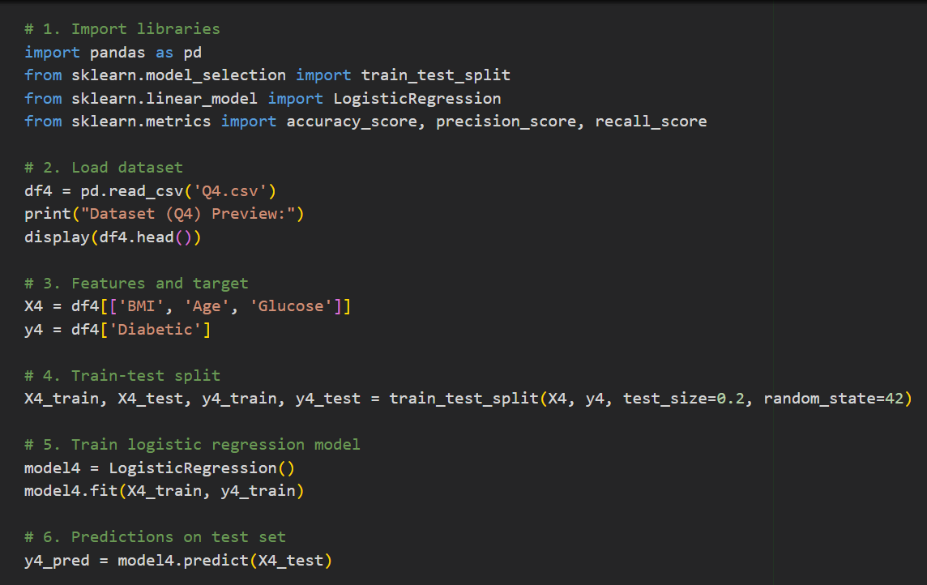

***Output:***

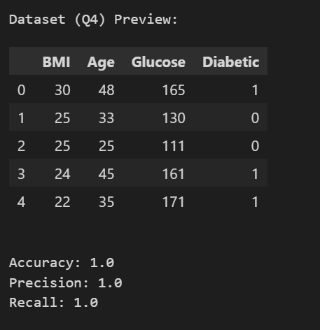

***Q5. Comparison – Linear vs Logistic Regression***

Dataset columns:

* Hours Study,
* Exam Score,
* Pass/Fail

***👉 Task:***

1. Use **Linear Regression** to predict exam scores.
2. Use **Logistic Regression** to predict pass/fail.
3. Compare results — explain why linear regression is unsuitable for classification.

***Code:***

**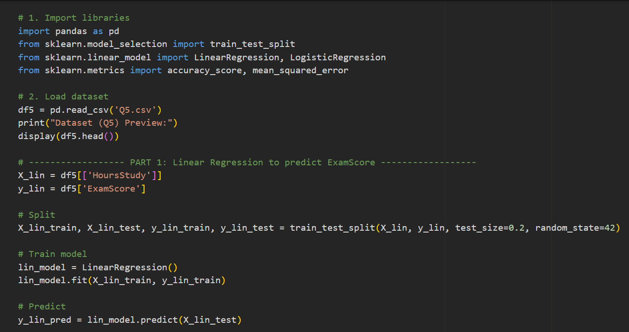*Output:***

**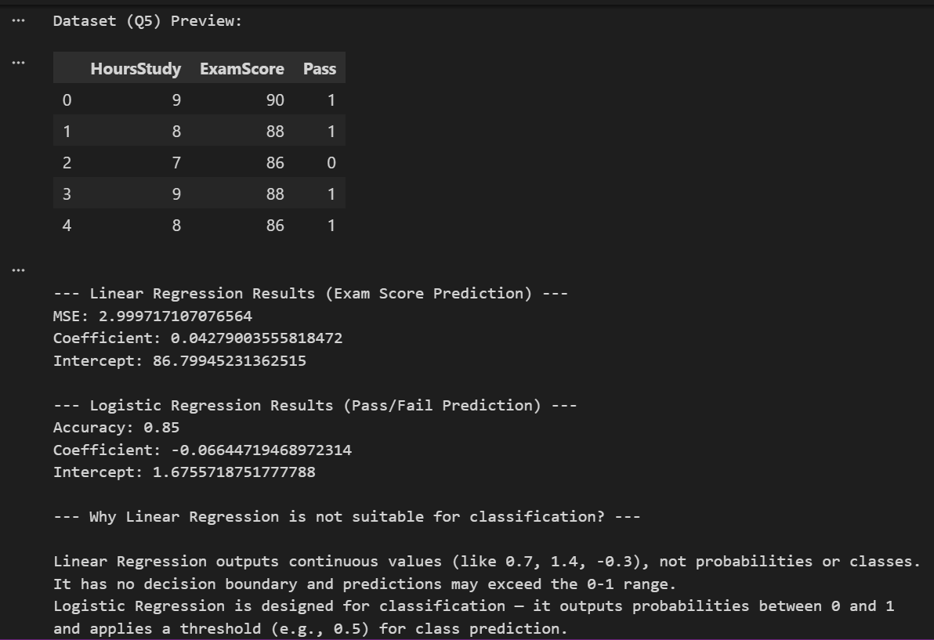*Laboratory Work Assessment Rubrics***

|  |  |  |  |  |  |  |
| --- | --- | --- | --- | --- | --- | --- |
| **Sr.**  **No.** | **Performance Indicator** | **Excellent (5)** | **Good (4)** | **Average (3)** | **Fair (2)** | **Poor (1)** |
| **1** | **Theoretical** | Student knows | Student knows most | Student knows few | Student knows | Student has poor |
|  | **knowledge** | all the related | of the related | of the related | very little about | understanding of the |
|  | **10%** | concepts about | concepts about the | concepts about the | the related | related concepts |
|  |  | the theoretical | theoretical | theoretical | concepts about the | about the theoretical |
|  |  | background of | background of the | background of the | theoretical | background of the |
|  |  | the experiment | experiment and | experiment and | background of the | experiment and |
|  |  | and rephrase | partially rephrase | partially rephrase | experiment and | unable to rephrase |
|  |  | those concepts in | those concepts in | those concepts in | poorly rephrase | those concepts in |
|  |  | written and oral | written and oral | written and oral | those concepts in | written and oral |
|  |  | assessments | assessments | assessments | written and oral | assessments |
|  |  |  |  |  | assessments |  |
| **2** | **Application** | Application runs | Application | Application | Application | Application does |
|  | **Functionality** | smoothly and | compiles with no | compiles with | compiles and | not compile or |
|  | **10%** | operation of the | warnings. Robust | few or no | runs without | compiles but |
|  |  | application runs | operation of the | warnings. | crashing. Some | crashes. |
|  |  | efficiently | application, with | Consideration | attempt at | Confusing. |
|  |  |  | good recovery. | given to unusual | detecting and | Little or no error |
|  |  |  |  | conditions with | correcting | detection or |
|  |  |  |  | reasonable | errors. | correction. |
| **3** | **Specifications** | The program | The program works | The program | The program | The program is |
|  | **10%** | works very | and meets some of | works and | produces correct | producing incorrect |
|  |  | efficiently and | the specifications. | produces the | results but does not | results. |
|  |  | meets all of the |  | correct results and | display them |  |
|  |  | required |  | displays them | correctly. |  |
|  |  | specifications. |  | correctly. It also |  |  |
|  |  |  |  | meets most of the |  |  |
|  |  |  |  | other |  |  |
|  |  |  |  | specifications. |  |  |
| **4** | **Level of** | Provide complete | Provide complete | Provide partially | Provide very few | Provide no answer to |
|  | **understanding of** | and logical | and logical answers | correct and logical | and illogical | the questions asked |
|  | **the learned skill** | answers based | based upon accurate | answers based | answers to the | by examiner. |
|  | **10%** | upon accurate | technical content to | upon minimum | questions asked by |  |
|  |  | technical content | the questions asked | technical content | examiner. |  |
|  |  | to the questions | by examiner with | to the questions |  |  |
|  |  | asked by | few errors | asked by examiner |  |  |
|  |  | examiner |  |  |  |  |
| **5** | **Readability and** | The code is | The code is fairly | Most of the code | Some parts of the | The code is poorly |
|  | **Reusability** | exceptionally | easy to read. The | could be reused in | code require | organized and very |
|  | **10%** | well organized | code could be | other programs. | change before they | difficult to read and |
|  |  | and very easy | reused as a whole |  | could be reused in | not organized for |
|  |  | to follow and | or each class could |  | other programs. | reusability. |
|  |  | reused | be reused. |  |  |  |

|  |  |  |  |  |  |  |
| --- | --- | --- | --- | --- | --- | --- |
| **6** | **AI System Design 10%** | Well-designed AI models. Code is highly maintainable | Good designed AI models and Little code duplications | Some attempt to make AI models. Code can be maintained with significant effort | Little attempt to design AI models and less understanding of code | Very poor attempt to design AI models and its code |
| **7** | **Responsiveness to**  **Questions/ Accuracy 10%** | 1. Responds well, quick and very accurate all the time. 2. Effectively uses eye contact, speaks clearly, effectively and confidently using   suitable volume | 1. Generally Responsive and accurate most of the times. 2. Maintains eye contact, speaks clearly with suitable volume and pace. | 1. Generally Responsive and accurate few times. 2. Some eye contact, speaks clearly and unclearly in different portions. | 1. Not much Responsive and accurate most of the times. 2. Uses eye contact ineffectively and fails to speak clearly and audibly | . 1. Non Responsive and inaccurate all the times.   1. No eye contact and unable to speak 2. Dresses inappropriately |
| **8** | **Efficiency 10%** | The code is extremely efficient without sacrificing readability and understanding | The code is fairly efficient without sacrificing readability and understanding | Some part of the code is efficient and other part of the code is not understandable and work properly | The code is brute force and unnecessarily long | The code is huge and appears to be patched together |
| **9** | **Delivery 10%** | The program was delivered in time during lab. | The program was delivered in Lab before the end time. | The program was delivered within the due date. | The code was delivered within a day after the due date. | The code was delivered more than 2 days overdue. |
| **10** | **Awareness of Safety Guidelines 10%** | Student has sufficient knowledge of the laboratory safety SOPs and protocol and is fully compliant to the guidelines | Student has sufficient knowledge of the laboratory safety SOPs and protocol and is Partially compliant to the guidelines | Student has little knowledge of the laboratory safety SOPs and protocol and is Partially compliant to the guidelines | Student has little knowledge of the laboratory safety SOPs and protocol and is non- compliant to the guidelines | Student has no knowledge of the laboratory safety SOPs and protocol and is non-compliant to the guidelines |

***LAB Assessment:***

|  |  |  |  |
| --- | --- | --- | --- |
| **Student Name** |  | **LAB Rubrics** | CLO3 , P5, PLO5 |
| **Total Marks** | 10 |
| **Registration No** |  | **Obtained Marks** |  |
| **Teacher Name** | Dr. Syed M Hamedoon |
| **Date** |  | **Signature** |  |

***LAB No 3***

***Decision Tree Classifier***

In this lab, students will study and implement the Decision Tree Classifier, a supervised machine learning algorithm used for classification tasks. The lab begins with a manual calculation of entropy and information gain to understand how decision trees choose splitting attributes. Students will then implement a decision tree on a small categorical dataset, followed by applying the algorithm to a real-world dataset (Iris) using Python and Scikit-learn. Through this lab, students will gain both theoretical clarity and practical experience in building, training, and visualizing decision tree models.

***Introduction & Theory***

A **Decision Tree Classifier** is a tree-structured model used to make decisions based on feature values. Each internal node represents a test on an attribute, each branch represents an outcome, and each leaf node represents a class label.

The construction of a decision tree is based on:

* **Entropy**: A measure of uncertainty or impurity in a dataset
* **Information Gain**: Reduction in entropy after splitting on an attribute

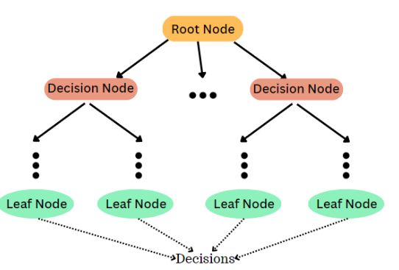

Decision trees are easy to interpret and visualize but may suffer from **overfitting**, especially on large or complex datasets.

***Solved Examples:***

***Example 1: Entropy and Information Gain***

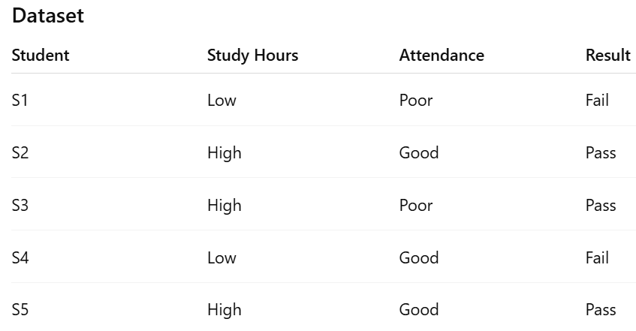

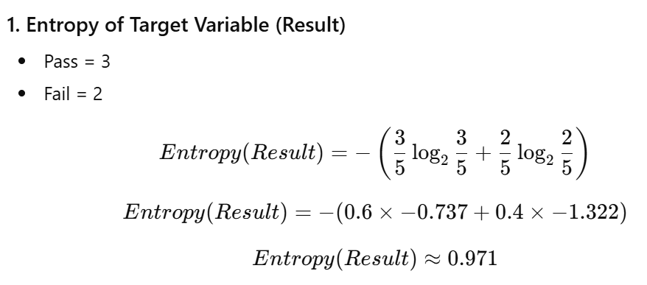

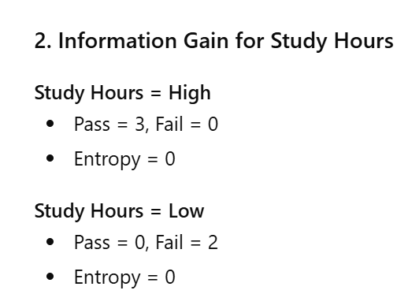

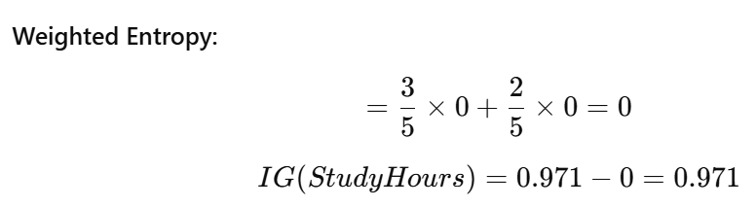

**3. Root Node Selection**

Since **Study Hours** provides the **maximum information gain**, it should be selected as the **root node**.

***Example 2: Decision Tree on Small Dataset (Python Implementation)***

***Question***

Build and visualize a decision tree using entropy.

***Solution:***

|  |
| --- |
| C:\Users\User\Desktop\Artifical Intelligence Lab Assignment no 6\Screenshot 2026-01-12 133457.png |

***Example 3: Decision Tree Classifier on Iris Dataset***

***Objective***

***Apply decision trees to a real dataset and evaluate accuracy.***

***Solution***

|  |
| --- |
| from sklearn.datasets import load_iris  from sklearn.model_selection import train_test_split  from sklearn.tree import DecisionTreeClassifier, plot_tree  from sklearn.metrics import accuracy_score  import matplotlib.pyplot as plt  # Load dataset  iris = load_iris()  X = iris.data  y = iris.target  # Train-test split  X_train, X_test, y_train, y_test = train_test_split(      X, y, test_size=0.3, random_state=42  )  # Train model  model = DecisionTreeClassifier(criterion='entropy')  model.fit(X_train, y_train)  # Predict and evaluate  y_pred = model.predict(X_test)  accuracy = accuracy_score(y_test, y_pred)  print("Accuracy:", accuracy)  # Visualize tree  plt.figure(figsize=(14,8))  plot_tree(model, feature_names=iris.feature_names,            class_names=iris.target_names, filled=True)  plt.show() |

***Practice Questions:***

***Question 1***

Entropy and Information Gain (Manual Calculation)

**Given the dataset** below about whether students pass an exam based on study time and attendance:

| **Student** | **Study Hours** | **Attendance** | **Result** |
| --- | --- | --- | --- |
| S1 | Low | Poor | Fail |
| S2 | High | Good | Pass |
| S3 | High | Poor | Pass |
| S4 | Low | Good | Fail |
| S5 | High | Good | Pass |

1. Calculate the **entropy** of the target variable (Result).
2. Compute the **information gain** for the attribute Study Hours.
3. Which attribute should be selected for the root node based on maximum information gain?

***Code:***

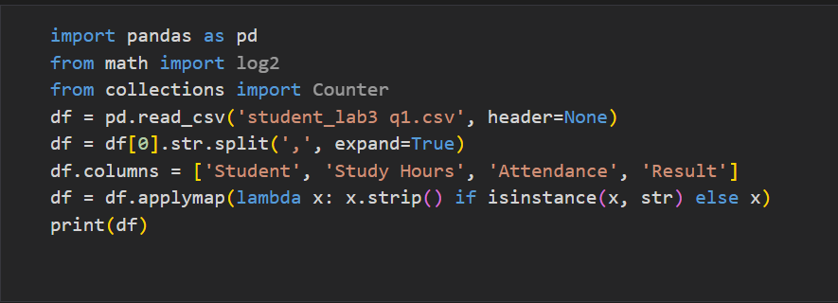

***Output:***

**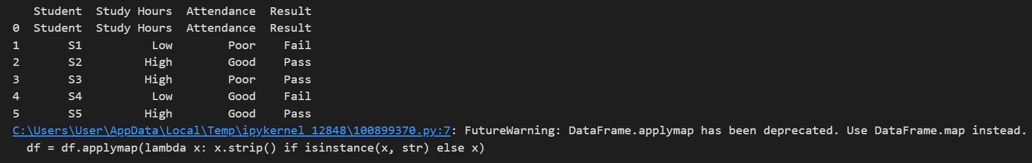*Code:***

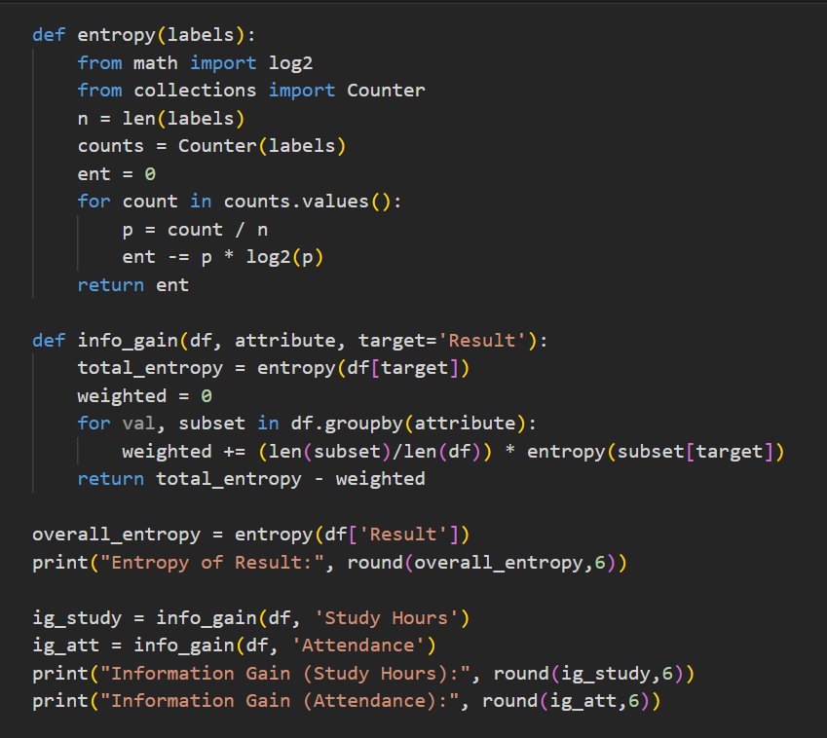

***Output:***

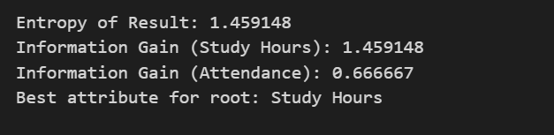

***Question No. 2***

Implement Decision Tree Classifier on a Small Dataset

Using the same dataset as above:

1. Use pandas to create a DataFrame.
2. Convert categorical values into numerical using LabelEncoder.
3. Train a **DecisionTreeClassifier** using **criterion='entropy'**.
4. Visualize the decision tree using plot_tree() from sklearn.tree.
5. Predict whether a student with Study Hours=Low and Attendance=Good will pass or fail.

***Code:***

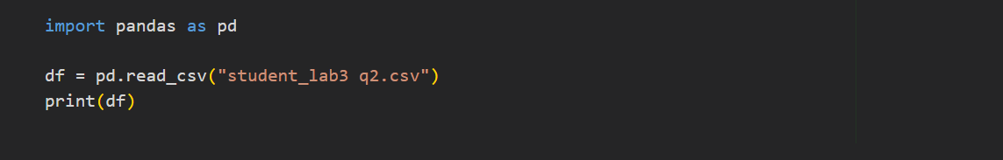

***Output:***

**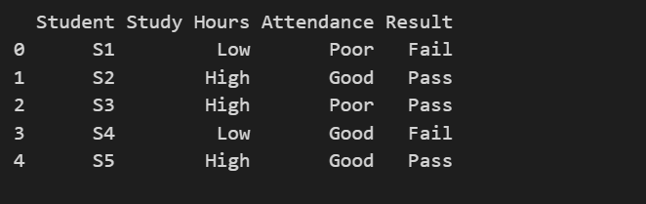*Code:***

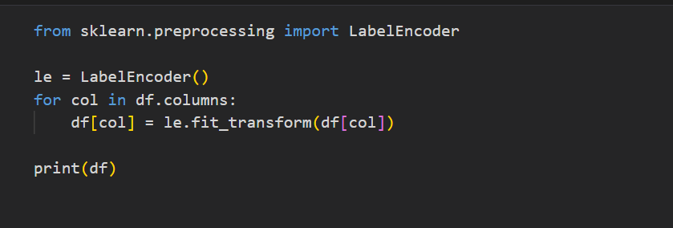

***Output:***

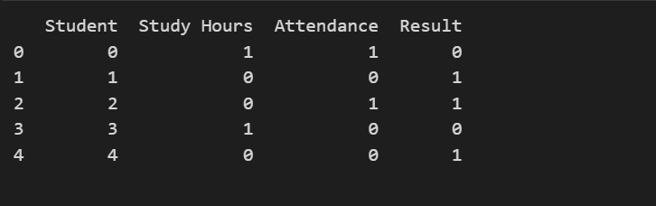

***Code:***

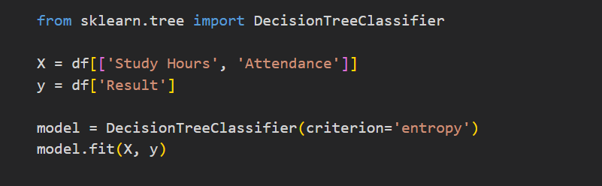

***Output:***

**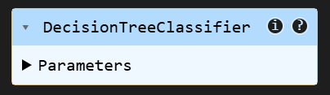*Code:***

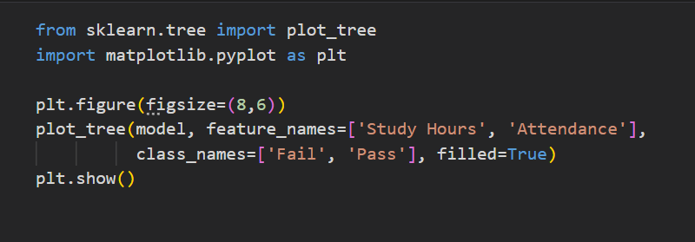

***Output:***

**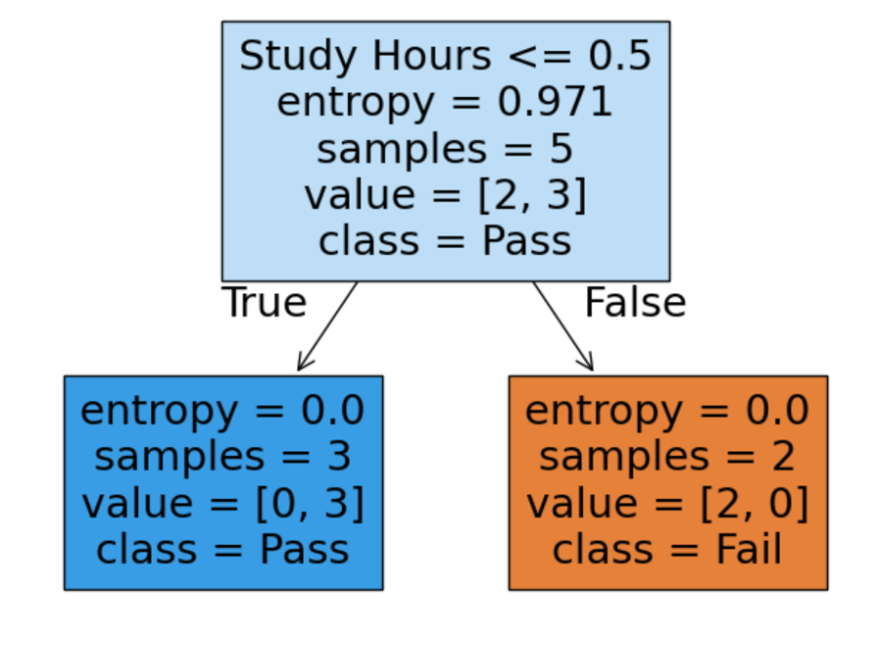*Code:***

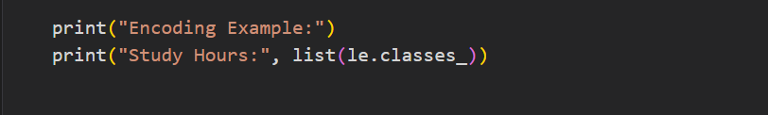

***Output:***

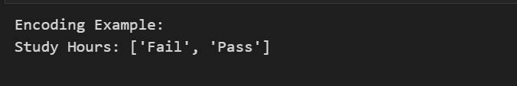

***Code:***

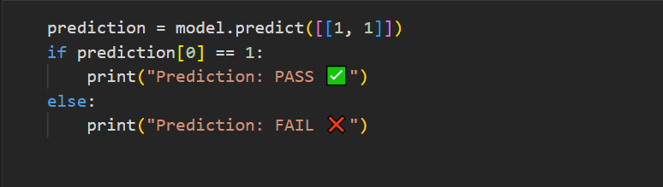

***Output:***

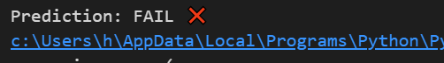

***Question 3***

***Decision Tree Classifier on Iris Dataset***

**Objective:** Apply decision trees to a real dataset.

1. Load the **Iris dataset** using sklearn.datasets.load_iris.
2. Split it into training (70%) and testing (30%) sets.
3. Train a decision tree using **criterion='entropy'**.
4. Print the accuracy on the test set.
5. Visualize the tree and explain which feature provides the most information gain at the root.

***Code:***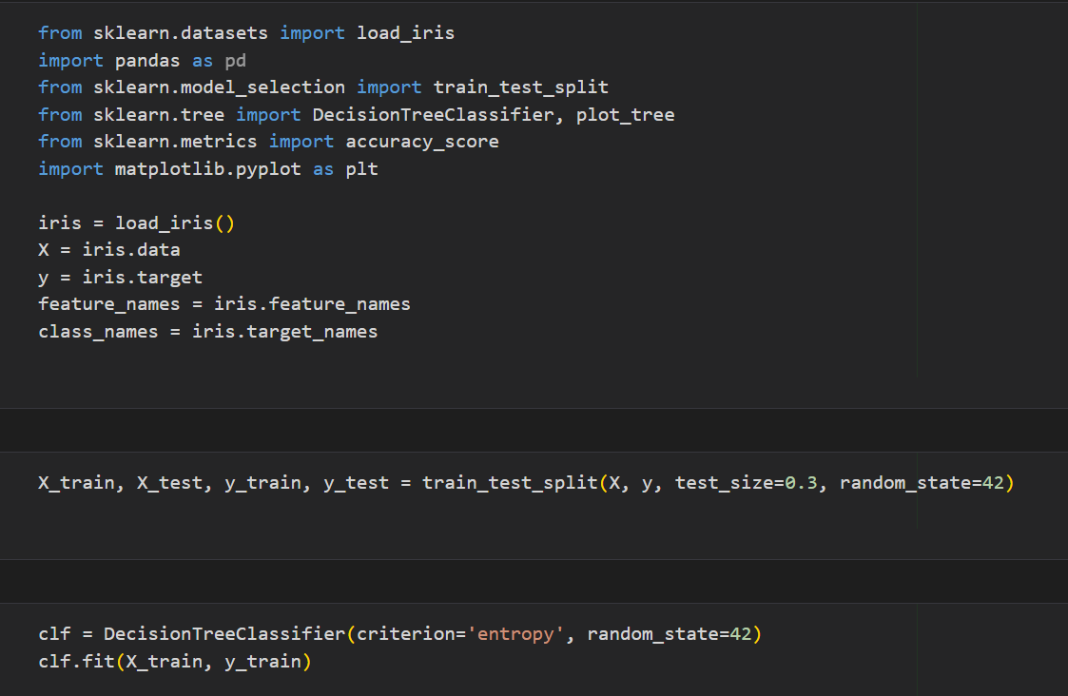

***Output:***

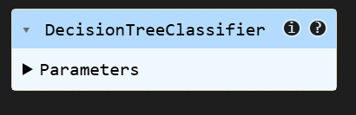

***Code:***

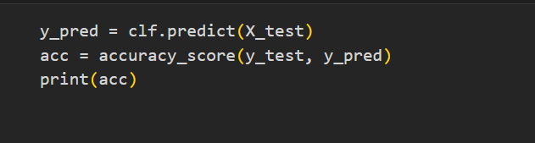

***Output:***

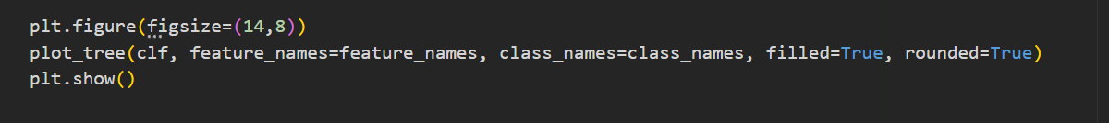

***Code:***



***Output:***

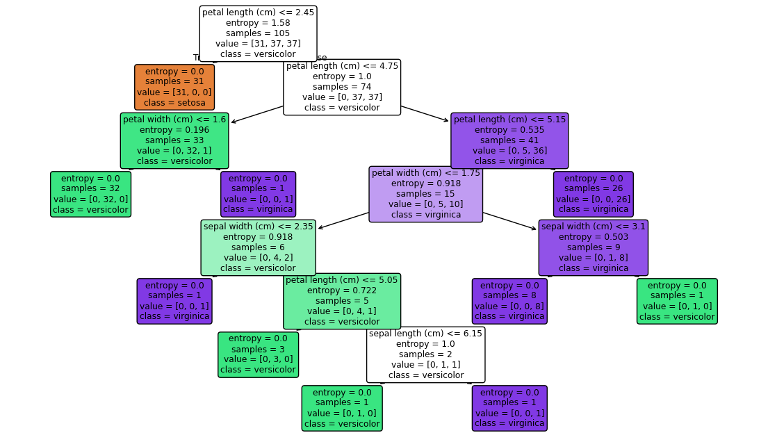

***Code:***

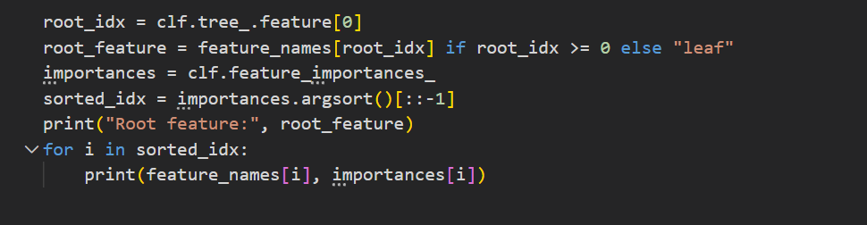

***Output:***

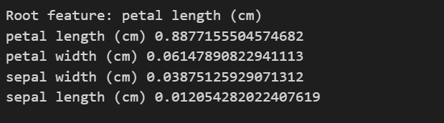

***Question 4***

**MNIST digit dataset** (available via Keras / sklearn.datasets) as a baseline

**Objectives**

* Preprocess image data for classification
* Train a **Decision Tree Classifier** (or variants)
* Evaluate accuracy, confusion matrix, and discuss limitations

***Code:***



***Output:***

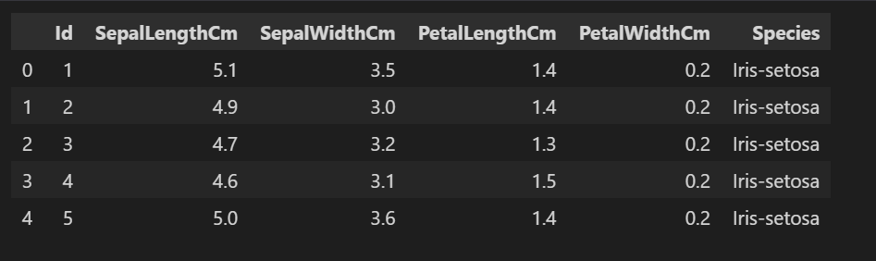

***Code:***

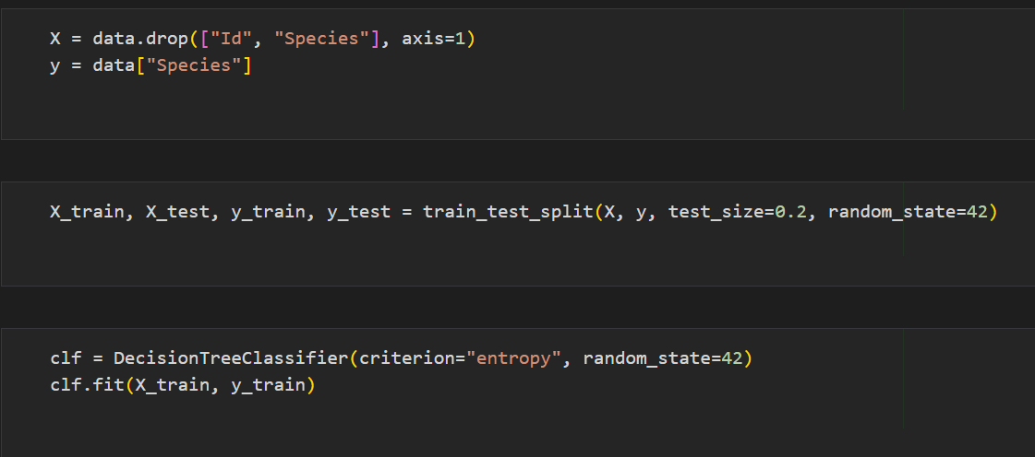

***Output:***

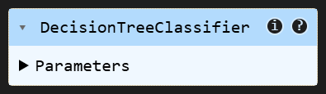

***Code:***

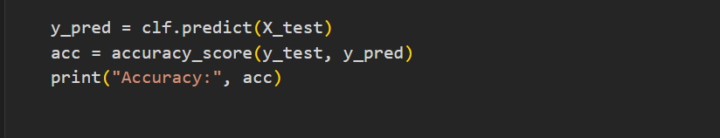

***Output:***

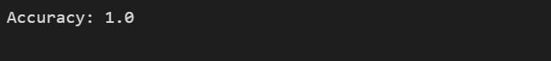

***Code:***

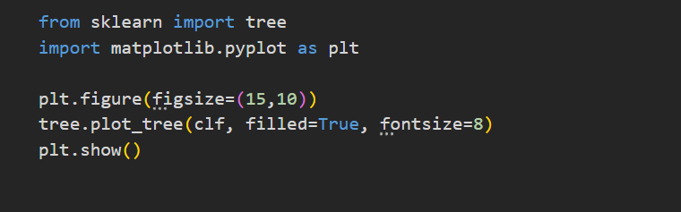

***Output:***

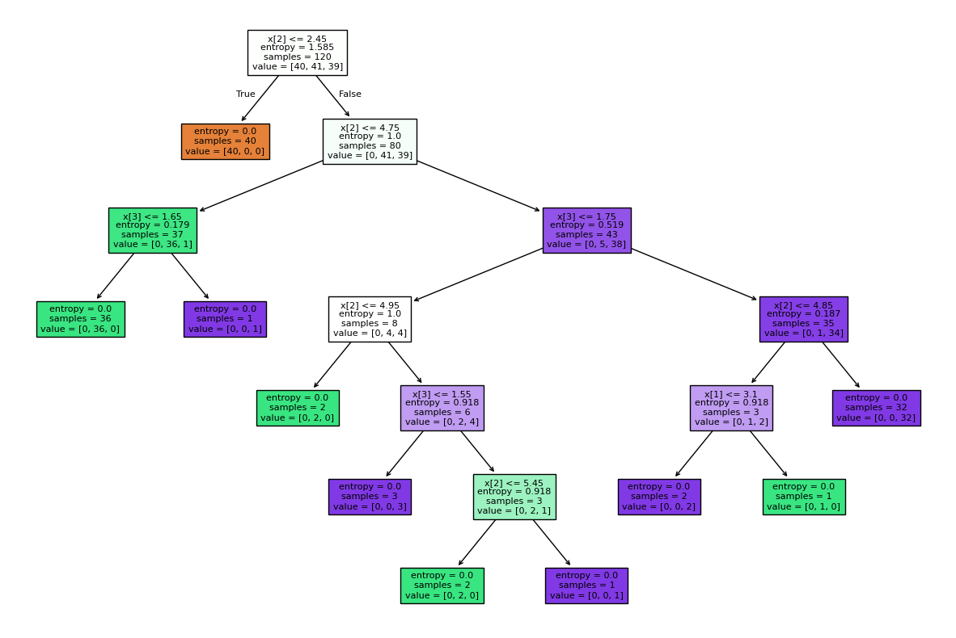

***Code:***

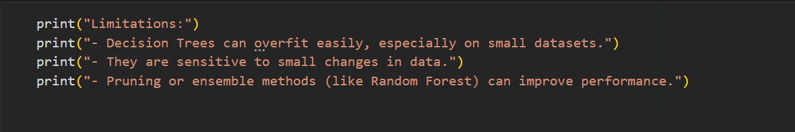

***Output:***

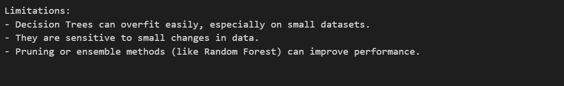

**Laboratory Work Assessment Rubrics**

|  |  |  |  |  |  |  |
| --- | --- | --- | --- | --- | --- | --- |
| **Sr.**  **No.** | **Performance Indicator** | **Excellent (5)** | **Good (4)** | **Average (3)** | **Fair (2)** | **Poor (1)** |
| **1** | **Theoretical** | Student knows | Student knows most | Student knows few | Student knows | Student has poor |
|  | **knowledge** | all the related | of the related | of the related | very little about | understanding of the |
|  | **10%** | concepts about | concepts about the | concepts about the | the related | related concepts |
|  |  | the theoretical | theoretical | theoretical | concepts about the | about the theoretical |
|  |  | background of | background of the | background of the | theoretical | background of the |
|  |  | the experiment | experiment and | experiment and | background of the | experiment and |
|  |  | and rephrase | partially rephrase | partially rephrase | experiment and | unable to rephrase |
|  |  | those concepts in | those concepts in | those concepts in | poorly rephrase | those concepts in |
|  |  | written and oral | written and oral | written and oral | those concepts in | written and oral |
|  |  | assessments | assessments | assessments | written and oral | assessments |
|  |  |  |  |  | assessments |  |
| **2** | **Application** | Application runs | Application | Application | Application | Application does |
|  | **Functionality** | smoothly and | compiles with no | compiles with | compiles and | not compile or |
|  | **10%** | operation of the | warnings. Robust | few or no | runs without | compiles but |
|  |  | application runs | operation of the | warnings. | crashing. Some | crashes. |
|  |  | efficiently | application, with | Consideration | attempt at | Confusing. |
|  |  |  | good recovery. | given to unusual | detecting and | Little or no error |
|  |  |  |  | conditions with | correcting | detection or |
|  |  |  |  | reasonable | errors. | correction. |
| **3** | **Specifications** | The program | The program works | The program | The program | The program is |
|  | **10%** | works very | and meets some of | works and | produces correct | producing incorrect |
|  |  | efficiently and | the specifications. | produces the | results but does not | results. |
|  |  | meets all of the |  | correct results and | display them |  |
|  |  | required |  | displays them | correctly. |  |
|  |  | specifications. |  | correctly. It also |  |  |
|  |  |  |  | meets most of the |  |  |
|  |  |  |  | other |  |  |
|  |  |  |  | specifications. |  |  |
| **4** | **Level of** | Provide complete | Provide complete | Provide partially | Provide very few | Provide no answer to |
|  | **understanding of** | and logical | and logical answers | correct and logical | and illogical | the questions asked |
|  | **the learned skill** | answers based | based upon accurate | answers based | answers to the | by examiner. |
|  | **10%** | upon accurate | technical content to | upon minimum | questions asked by |  |
|  |  | technical content | the questions asked | technical content | examiner. |  |
|  |  | to the questions | by examiner with | to the questions |  |  |
|  |  | asked by | few errors | asked by examiner |  |  |
|  |  | examiner |  |  |  |  |
| **5** | **Readability and** | The code is | The code is fairly | Most of the code | Some parts of the | The code is poorly |
|  | **Reusability** | exceptionally | easy to read. The | could be reused in | code require | organized and very |
|  | **10%** | well organized | code could be | other programs. | change before they | difficult to read and |
|  |  | and very easy | reused as a whole |  | could be reused in | not organized for |
|  |  | to follow and | or each class could |  | other programs. | reusability. |
|  |  | reused | be reused. |  |  |  |

|  |  |  |  |  |  |  |
| --- | --- | --- | --- | --- | --- | --- |
| **6** | **AI System Design 10%** | Well-designed AI models. Code is highly maintainable | Good designed AI models and Little code duplications | Some attempt to make AI models. Code can be maintained with significant effort | Little attempt to design AI models and less understanding of code | Very poor attempt to design AI models and its code |
| **7** | **Responsiveness to**  **Questions/ Accuracy 10%** | 1. Responds well, quick and very accurate all the time. 2. Effectively uses eye contact, speaks clearly, effectively and confidently using   suitable volume | 1. Generally Responsive and accurate most of the times. 2. Maintains eye contact, speaks clearly with suitable volume and pace. | 1. Generally Responsive and accurate few times. 2. Some eye contact, speaks clearly and unclearly in different portions. | 1. Not much Responsive and accurate most of the times. 2. Uses eye contact ineffectively and fails to speak clearly and audibly | . 1. Non Responsive and inaccurate all the times.   1. No eye contact and unable to speak 2. Dresses inappropriately |
| **8** | **Efficiency 10%** | The code is extremely efficient without sacrificing readability and understanding | The code is fairly efficient without sacrificing readability and understanding | Some part of the code is efficient and other part of the code is not understandable and work properly | The code is brute force and unnecessarily long | The code is huge and appears to be patched together |
| **9** | **Delivery 10%** | The program was delivered in time during lab. | The program was delivered in Lab before the end time. | The program was delivered within the due date. | The code was delivered within a day after the due date. | The code was delivered more than 2 days overdue. |
| **10** | **Awareness of Safety Guidelines 10%** | Student has sufficient knowledge of the laboratory safety SOPs and protocol and is fully compliant to the guidelines | Student has sufficient knowledge of the laboratory safety SOPs and protocol and is Partially compliant to the guidelines | Student has little knowledge of the laboratory safety SOPs and protocol and is Partially compliant to the guidelines | Student has little knowledge of the laboratory safety SOPs and protocol and is non- compliant to the guidelines | Student has no knowledge of the laboratory safety SOPs and protocol and is non-compliant to the guidelines |

|  |  |  |  |
| --- | --- | --- | --- |
| **Student Name** |  | **LAB Rubrics** | CLO3 , P5, PLO5 |
| **Total Marks** | 10 |
| **Registration No** |  | **Obtained Marks** |  |
| **Teacher Name** | Dr. Syed M Hamedoon |
| **Date** |  | **Signature** |  |

***LAB Assessment:***

***LAB No. 4***

***Random Forest and Support Vector Machine Classifier***

In this lab, students will learn and implement two powerful supervised machine learning algorithms: Random Forest Classifier and Support Vector Machine (SVM) Classifier. The lab focuses on understanding how ensemble learning improves classification accuracy using Random Forests and how SVM constructs optimal decision boundaries for classification problems.

Students will begin with a small dataset to understand model behavior and then apply both classifiers to real-world datasets using Python and Scikit-learn. Model performance will be evaluated using accuracy metrics, and comparisons will be made between Random Forest and SVM classifiers.

***Introduction & Theory***

***Random Forest Classifier***

Random Forest is an **ensemble learning method** that builds multiple decision trees and combines their outputs to make a final prediction. Each tree is trained on a random subset of data and features, which improves accuracy and reduces overfitting.

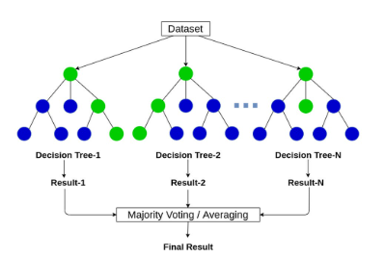

***Advantages:***

* High accuracy
* Reduces overfitting
* Works well with large datasets

***Support Vector Machine (SVM) Classifier***

Support Vector Machine is a supervised learning algorithm that finds the **optimal hyperplane** that best separates data points of different classes. SVM can perform both linear and non-linear classification using **kernel functions**.

***Advantages:***

* Effective in high-dimensional spaces
* Works well with small datasets
* Strong theoretical foundation

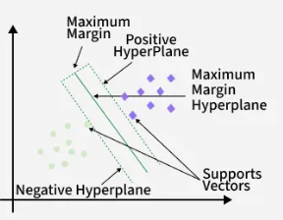

***Solved Examples***

***Example 1***

Build a Random Forest classifier to predict whether a student passes or fails based on study hours and attendance.

***Solution:***

|  |
| --- |
| import pandas as pd  from sklearn.preprocessing import LabelEncoder  from sklearn.ensemble import RandomForestClassifier  # Create dataset  data = {      'StudyHours': ['Low', 'High', 'High', 'Low', 'High'],      'Attendance': ['Poor', 'Good', 'Poor', 'Good', 'Good'],      'Result': ['Fail', 'Pass', 'Pass', 'Fail', 'Pass']  }  df = pd.DataFrame(data)  # Encode categorical variables  encoder = LabelEncoder()  for col in df.columns:      df[col] = encoder.fit_transform(df[col])  # Features and target  X = df[['StudyHours', 'Attendance']]  y = df['Result']  # Prediction  prediction = model.predict([[1, 1]])  print("Predicted Result (1=Pass, 0=Fail):", prediction[0]) |

***Example 2:***

Use an SVM classifier to predict whether a student passes or fails using the same dataset.

***Solution:***

|  |
| --- |
| from sklearn.svm import SVC  # Create dataset  data = {      'StudyHours': ['Low', 'High', 'High', 'Low', 'High'],      'Attendance': ['Poor', 'Good', 'Poor', 'Good', 'Good'],      'Result': ['Fail', 'Pass', 'Pass', 'Fail', 'Pass']  }  df = pd.DataFrame(data)  # Encode categorical variables  encoder = LabelEncoder()  for col in df.columns:      df[col] = encoder.fit_transform(df[col])  # Features and target  X = df[['StudyHours', 'Attendance']]  y = df['Result']  # Train SVM model  svm_model = SVC(kernel='linear')  svm_model.fit(X, y)  # Prediction  svm_prediction = svm_model.predict([[1, 1]])  print("Predicted Result (1=Pass, 0=Fail):", svm_prediction[0]) |

***Example 3***

***Compare Random Forest and SVM classifiers on IRIS dataset.***

***Solution***

|  |
| --- |
| from sklearn.datasets import load_iris  from sklearn.model_selection import train_test_split  from sklearn.metrics import accuracy_score  from sklearn.ensemble import RandomForestClassifier  from sklearn.svm import SVC  # Load Iris dataset  iris = load_iris()  X = iris.data  y = iris.target  # Split dataset  X_train, X_test, y_train, y_test = train_test_split(      X, y, test_size=0.3, random_state=42  )  # Random Forest model  rf_model = RandomForestClassifier(n_estimators=100, random_state=42)  rf_model.fit(X_train, y_train)  rf_pred = rf_model.predict(X_test)  # SVM model  svm_model = SVC(kernel='rbf')  svm_model.fit(X_train, y_train)  svm_pred = svm_model.predict(X_test)  # Accuracy  print("Random Forest Accuracy:", accuracy_score(y_test, rf_pred))  print("SVM Accuracy:", accuracy_score(y_test, svm_pred)) |

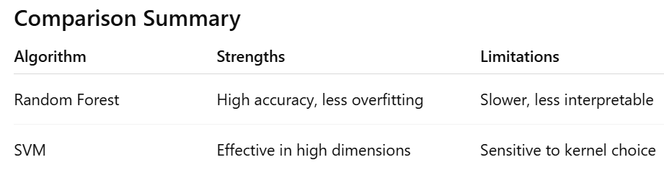

***Practice Questions:***

***Question 1***

Classify flower species using Random Forest.

***Task:***

1. Load the *Iris dataset* from sklearn.datasets.
2. Split into training (70%) and testing (30%) sets.
3. Train a **Random Forest Classifier**.
4. Predict flower species on the test set.
5. Calculate and print **model accuracy**.

***Code:***

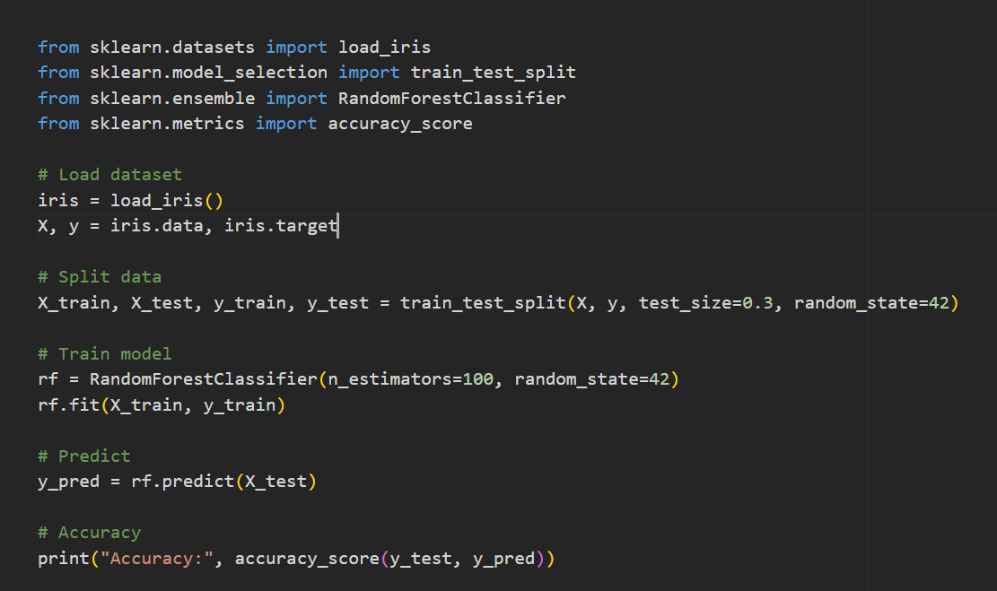

**Output:**



***Question 2***

**Use SVM on Breast Cancer Dataset and** Classify tumors as malignant or benign.

**Task:**

1. Load the *Breast Cancer* dataset using sklearn.datasets.load_breast_cancer.
2. Train an **SVM classifier** (use SVC(kernel='linear')).
3. Evaluate the model using **accuracy** and **confusion matrix**.

***Code:***

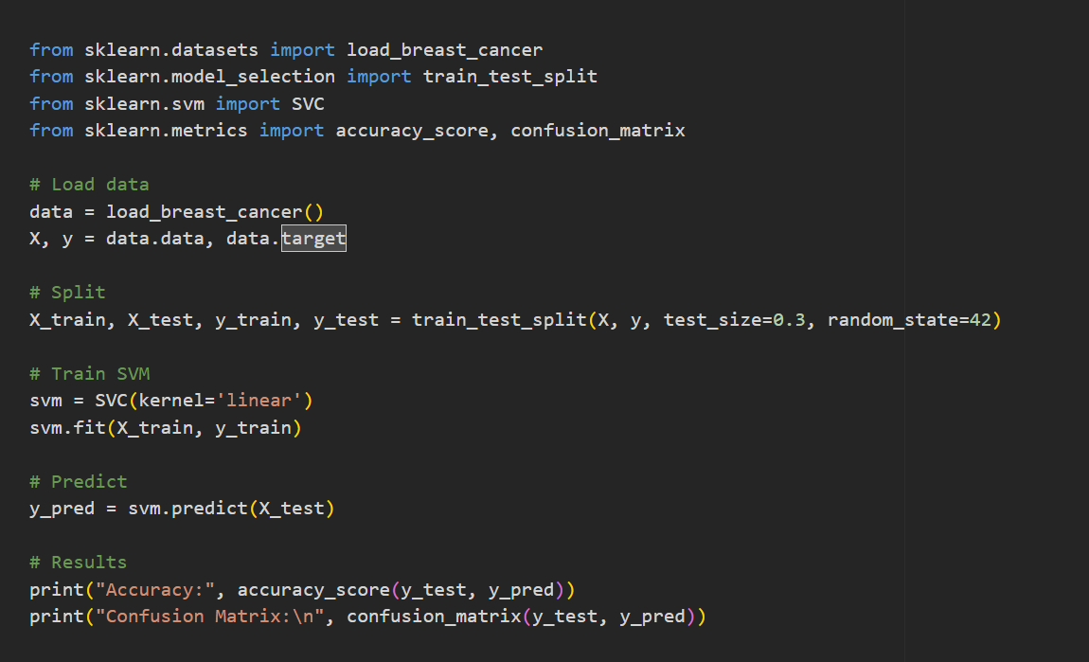

***Output:***

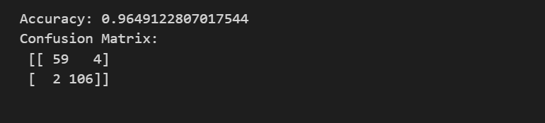

***Question 3***

**Use Random Forest on CSV Dataset (Custom) :** Predict student pass/fail based on study hours and scores.

***Task:***

1. Load a CSV file (e.g., students.csv) with columns: study_hours, attendance, marks, result.
2. Train a **Random Forest Classifier** to predict result (Pass/Fail).
3. Display **accuracy score** and **feature importance**.

***Code:***

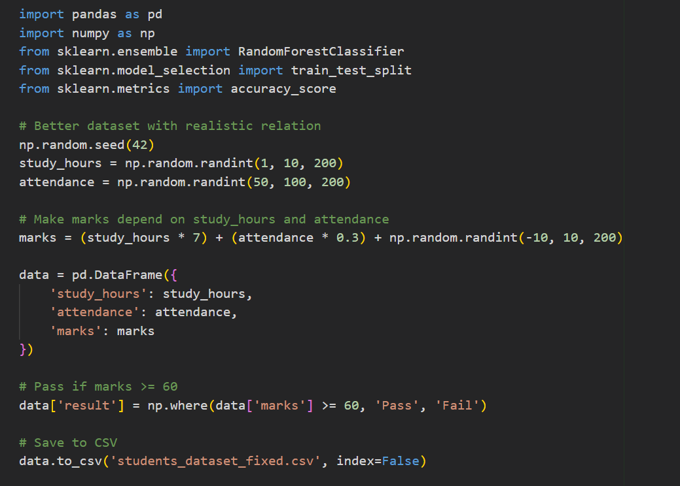

***Output:***



***Question 4***

**Use SVM on Digits Dataset and to identify the:** Handwritten digit recognition.

***Task:***

1. Load the *Digits dataset* from sklearn.datasets.load_digits.
2. Train an **SVM classifier** with an RBF kernel.
3. Test on unseen data.
4. Print **accuracy** and visualize some **misclassified samples**.

***Code:***

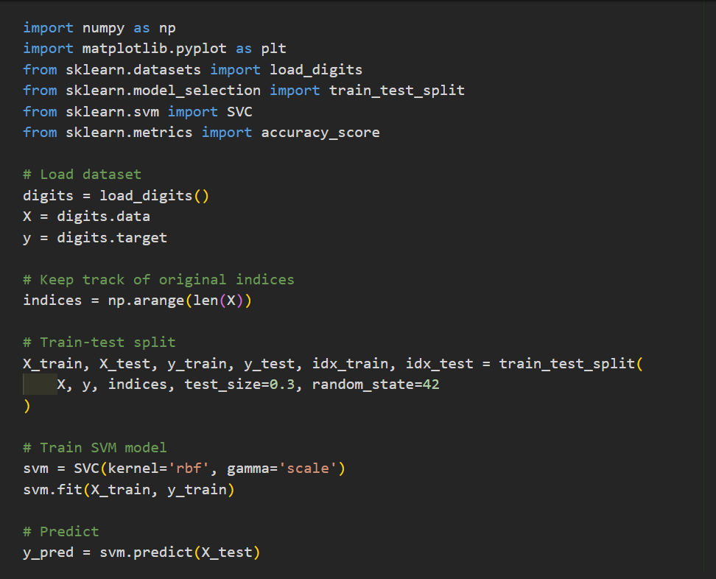

***Output:*** 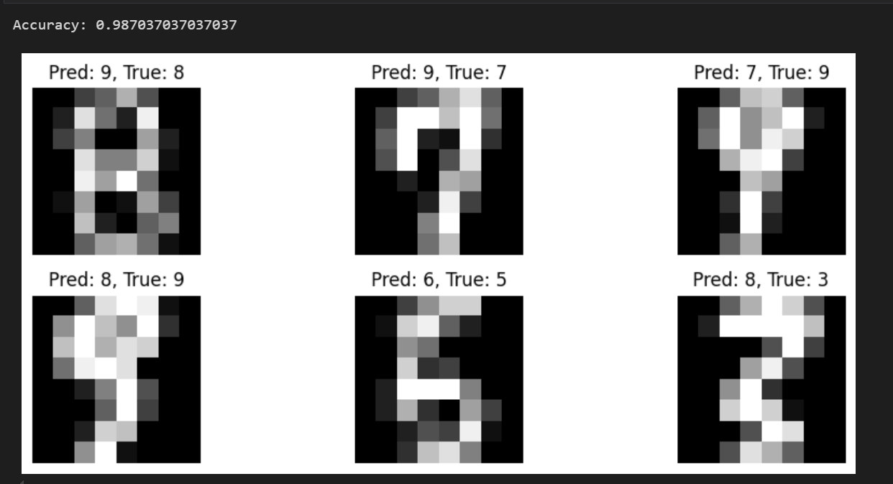

***Question 5:***

**Compare Random Forest vs SVM on Same Dataset (you can choose any dataset):** Compare two models on the same data.

***Task:***

Use the *Wine dataset* from sklearn.datasets.load_wine.

* Train both:

RandomForestClassifier(n_estimators=100)

* SVC(kernel='rbf')
* Print accuracy of both models.
* Conclude which performs better.

***Code:***

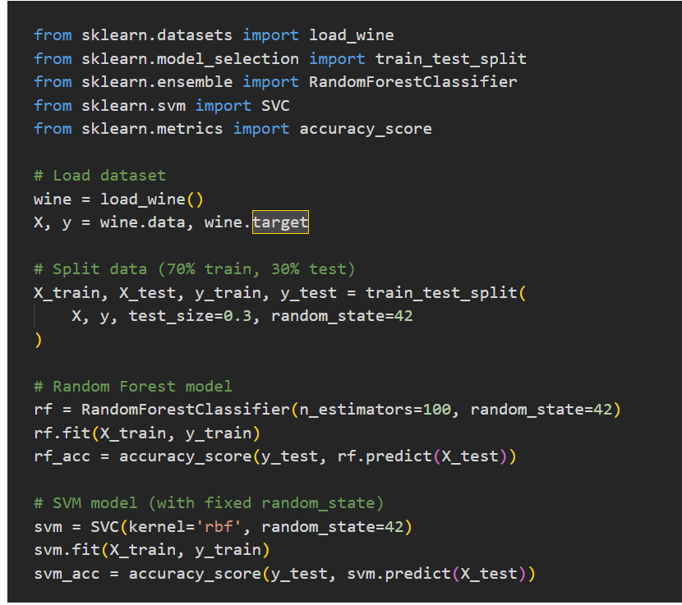

***Output:***

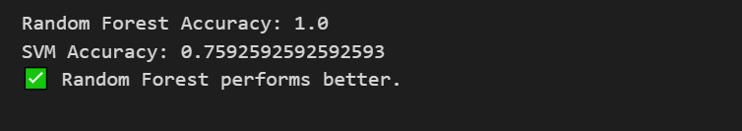

***Laboratory Work Assessment Rubrics***

|  |  |  |  |  |  |  |
| --- | --- | --- | --- | --- | --- | --- |
| **Sr.**  **No.** | **Performance Indicator** | **Excellent (5)** | **Good (4)** | **Average (3)** | **Fair (2)** | **Poor (1)** |
| **1** | **Theoretical** | Student knows | Student knows most | Student knows few | Student knows | Student has poor |
|  | **knowledge** | all the related | of the related | of the related | very little about | understanding of the |
|  | **10%** | concepts about | concepts about the | concepts about the | the related | related concepts |
|  |  | the theoretical | theoretical | theoretical | concepts about the | about the theoretical |
|  |  | background of | background of the | background of the | theoretical | background of the |
|  |  | the experiment | experiment and | experiment and | background of the | experiment and |
|  |  | and rephrase | partially rephrase | partially rephrase | experiment and | unable to rephrase |
|  |  | those concepts in | those concepts in | those concepts in | poorly rephrase | those concepts in |
|  |  | written and oral | written and oral | written and oral | those concepts in | written and oral |
|  |  | assessments | assessments | assessments | written and oral | assessments |
|  |  |  |  |  | assessments |  |
| **2** | **Application** | Application runs | Application | Application | Application | Application does |
|  | **Functionality** | smoothly and | compiles with no | compiles with | compiles and | not compile or |
|  | **10%** | operation of the | warnings. Robust | few or no | runs without | compiles but |
|  |  | application runs | operation of the | warnings. | crashing. Some | crashes. |
|  |  | efficiently | application, with | Consideration | attempt at | Confusing. |
|  |  |  | good recovery. | given to unusual | detecting and | Little or no error |
|  |  |  |  | conditions with | correcting | detection or |
|  |  |  |  | reasonable | errors. | correction. |
| **3** | **Specifications** | The program | The program works | The program | The program | The program is |
|  | **10%** | works very | and meets some of | works and | produces correct | producing incorrect |
|  |  | efficiently and | the specifications. | produces the | results but does not | results. |
|  |  | meets all of the |  | correct results and | display them |  |
|  |  | required |  | displays them | correctly. |  |
|  |  | specifications. |  | correctly. It also |  |  |
|  |  |  |  | meets most of the |  |  |
|  |  |  |  | other |  |  |
|  |  |  |  | specifications. |  |  |
| **4** | **Level of** | Provide complete | Provide complete | Provide partially | Provide very few | Provide no answer to |
|  | **understanding of** | and logical | and logical answers | correct and logical | and illogical | the questions asked |
|  | **the learned skill** | answers based | based upon accurate | answers based | answers to the | by examiner. |
|  | **10%** | upon accurate | technical content to | upon minimum | questions asked by |  |
|  |  | technical content | the questions asked | technical content | examiner. |  |
|  |  | to the questions | by examiner with | to the questions |  |  |
|  |  | asked by | few errors | asked by examiner |  |  |
|  |  | examiner |  |  |  |  |
| **5** | **Readability and** | The code is | The code is fairly | Most of the code | Some parts of the | The code is poorly |
|  | **Reusability** | exceptionally | easy to read. The | could be reused in | code require | organized and very |
|  | **10%** | well organized | code could be | other programs. | change before they | difficult to read and |
|  |  | and very easy | reused as a whole |  | could be reused in | not organized for |
|  |  | to follow and | or each class could |  | other programs. | reusability. |
|  |  | reused | be reused. |  |  |  |

|  |  |  |  |  |  |  |
| --- | --- | --- | --- | --- | --- | --- |
| **6** | **AI System Design 10%** | Well-designed AI models. Code is highly maintainable | Good designed AI models and Little code duplications | Some attempt to make AI models. Code can be maintained with significant effort | Little attempt to design AI models and less understanding of code | Very poor attempt to design AI models and its code |
| **7** | **Responsiveness to**  **Questions/ Accuracy 10%** | 1. Responds well, quick and very accurate all the time. 2. Effectively uses eye contact, speaks clearly, effectively and confidently using   suitable volume | 1. Generally Responsive and accurate most of the times. 2. Maintains eye contact, speaks clearly with suitable volume and pace. | 1. Generally Responsive and accurate few times. 2. Some eye contact, speaks clearly and unclearly in different portions. | 1. Not much Responsive and accurate most of the times. 2. Uses eye contact ineffectively and fails to speak clearly and audibly | . 1. Non Responsive and inaccurate all the times.   1. No eye contact and unable to speak 2. Dresses inappropriately |
| **8** | **Efficiency 10%** | The code is extremely efficient without sacrificing readability and understanding | The code is fairly efficient without sacrificing readability and understanding | Some part of the code is efficient and other part of the code is not understandable and work properly | The code is brute force and unnecessarily long | The code is huge and appears to be patched together |
| **9** | **Delivery 10%** | The program was delivered in time during lab. | The program was delivered in Lab before the end time. | The program was delivered within the due date. | The code was delivered within a day after the due date. | The code was delivered more than 2 days overdue. |
| **10** | **Awareness of Safety Guidelines 10%** | Student has sufficient knowledge of the laboratory safety SOPs and protocol and is fully compliant to the guidelines | Student has sufficient knowledge of the laboratory safety SOPs and protocol and is Partially compliant to the guidelines | Student has little knowledge of the laboratory safety SOPs and protocol and is Partially compliant to the guidelines | Student has little knowledge of the laboratory safety SOPs and protocol and is non- compliant to the guidelines | Student has no knowledge of the laboratory safety SOPs and protocol and is non-compliant to the guidelines |

|  |  |  |  |
| --- | --- | --- | --- |
| **Student Name** |  | **LAB Rubrics** | CLO3 , P5, PLO5 |
| **Total Marks** | 10 |
| **Registration No** |  | **Obtained Marks** |  |
| **Teacher Name** | Dr. Syed M Hamedoon |
| **Date** |  | **Signature** |  |

***LAB Assessment:***

***LAB No. 5***

***Implementation of Artificial Neural Network***

In this lab, students will learn the fundamentals and implementation of an Artificial Neural Network (ANN) for classification and prediction tasks. The lab introduces how neural networks are inspired by the human brain and how they learn patterns from data using layers of interconnected neurons. Students will first apply ANN on a small dataset to understand its working, and then implement ANN on a real-world dataset using Python libraries such as TensorFlow / Keras and Scikit-learn. Model performance will be evaluated using accuracy metrics.

***Introduction***

An **Artificial Neural Network (ANN)** is a supervised machine learning model composed of interconnected processing units called **neurons**. ANNs consist of:

* **Input layer** – receives input features
* **Hidden layer(s)** – performs computations using weights and activation functions
* **Output layer** – produces final prediction

Each neuron computes a weighted sum of inputs and applies an **activation function** (such as ReLU or Sigmoid). The network learns by adjusting weights using **backpropagation** to minimize error.

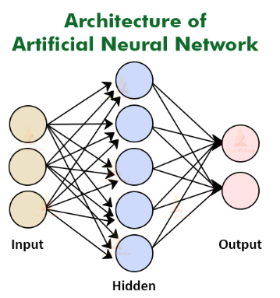

***Key Concepts:***

* **Weights & Bias** – control neuron behavior
* **Activation Functions** – introduce non-linearity
* **Loss Function** – measures prediction error
* **Optimizer** – updates weights (e.g., Adam)

ANNs are widely used in applications such as image recognition, speech processing, medical diagnosis, and pattern recognition.

***Solved Examples:***

***Example 1:***

Build a simple ANN to predict whether a student **passes or fails** based on study hours and attendance.

***Solution:***

|  |
| --- |
| import pandas as pd  import numpy as np  from sklearn.preprocessing import LabelEncoder  from tensorflow.keras.models import Sequential  from tensorflow.keras.layers import Dense  # Dataset  data = {      'StudyHours': ['Low', 'High', 'High', 'Low', 'High'],      'Attendance': ['Poor', 'Good', 'Poor', 'Good', 'Good'],      'Result': ['Fail', 'Pass', 'Pass', 'Fail', 'Pass']  }  df = pd.DataFrame(data)  # Encode categorical variables  encoder = LabelEncoder()  for col in df.columns:      df[col] = encoder.fit_transform(df[col])  # Features and target  X = df[['StudyHours', 'Attendance']].values  y = df['Result'].values  # Build ANN model  model = Sequential()  model.add(Dense(4, activation='relu', input_shape=(2,)))  model.add(Dense(1, activation='sigmoid'))  # Compile model  model.compile(optimizer='adam', loss='binary_crossentropy', metrics=['accuracy'])  # Train model  model.fit(X, y, epochs=100, verbose=0)  # Prediction  prediction = model.predict([[1, 1]])  print("Predicted Result (Pass=1, Fail=0):", int(prediction[0][0] > 0.5)) |

***Question***

Apply ANN to classify Iris flowers into three species.

***Solution:***

|  |
| --- |
| from sklearn.datasets import load_iris  from sklearn.model_selection import train_test_split  from tensorflow.keras.utils import to_categorical  # Load Iris dataset  iris = load_iris()  X = iris.data  y = iris.target  # One-hot encode target  y = to_categorical(y)  # Train-test split  X_train, X_test, y_train, y_test = train_test_split(      X, y, test_size=0.3, random_state=42  )  # Build ANN  model = Sequential()  model.add(Dense(10, activation='relu', input_shape=(4,)))  model.add(Dense(8, activation='relu'))  model.add(Dense(3, activation='softmax'))  # Compile and train  model.compile(optimizer='adam', loss='categorical_crossentropy', metrics=['accuracy'])  model.fit(X_train, y_train, epochs=100, verbose=0)  # Evaluate  loss, accuracy = model.evaluate(X_test, y_test, verbose=0)  print("Test Accuracy:", accuracy) |

***Example 3:***

ANN for Handwritten Digit Classification (MNIST – Baseline) to classify handwritten digits (0–9).

***Solution:***

|  |
| --- |
| from tensorflow.keras.datasets import mnist  from tensorflow.keras.utils import to_categorical  # Load MNIST dataset  (X_train, y_train), (X_test, y_test) = mnist.load_data()  # Normalize and reshape  X_train = X_train.reshape(-1, 28*28) / 255.0  X_test = X_test.reshape(-1, 28*28) / 255.0  # One-hot encode labels  y_train = to_categorical(y_train)  y_test = to_categorical(y_test)  # Build ANN  model = Sequential()  model.add(Dense(128, activation='relu', input_shape=(784,)))  model.add(Dense(64, activation='relu'))  model.add(Dense(10, activation='softmax'))  # Compile and train  model.compile(optimizer='adam', loss='categorical_crossentropy', metrics=['accuracy'])  model.fit(X_train, y_train, epochs=10, batch_size=128, verbose=1)  # Evaluate model  loss, accuracy = model.evaluate(X_test, y_test)  print("Test Accuracy:", accuracy) |

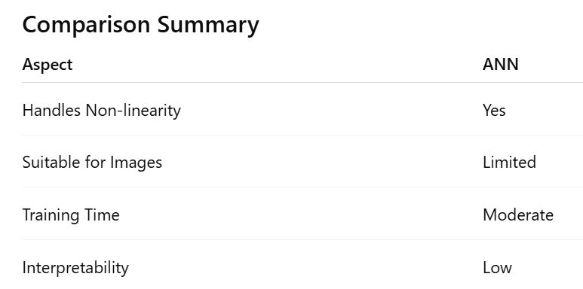

***Practice Questions:***

***Question 1***

Logic Gates with Neural Network. Implement a feed-forward neural network to learn the AND gate.

* Inputs: (0,0), (0,1), (1,0), (1,1)
* Output:0,0,0,1 **Tasks:**

1. Create dataset using NumPy or pandas.
2. Build a neural network with one hidden layer using TensorFlow/Keras or PyTorch.
3. Train it and show accuracy.
4. Compare model predictions with actual outputs

***Code:***

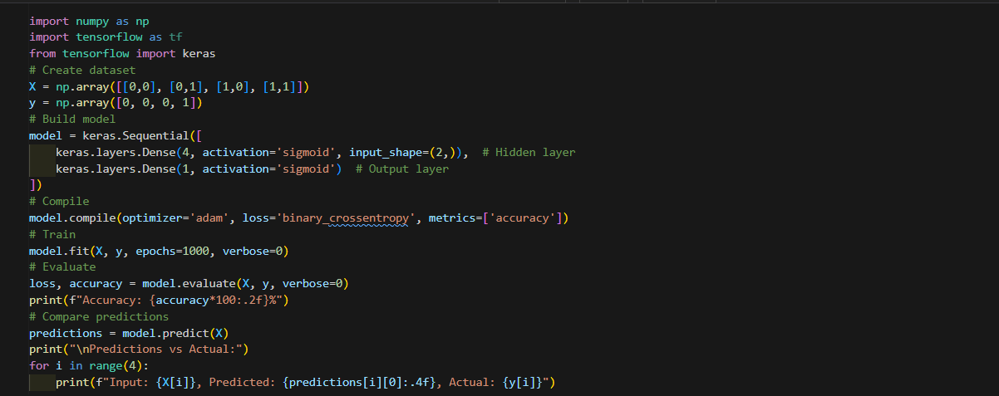

***Output:***

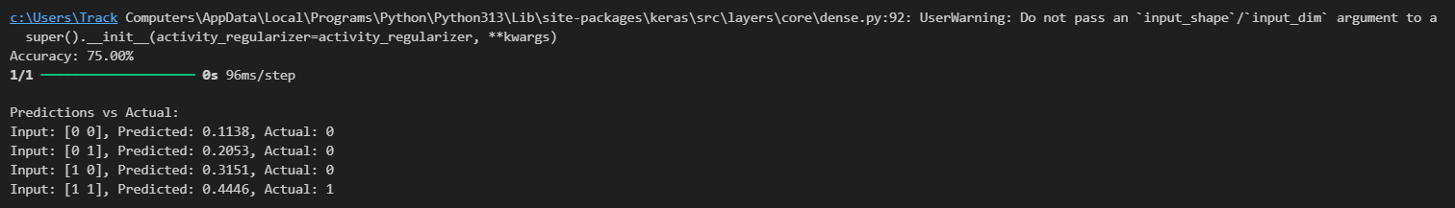

***Question*_2**Create a dataset y = x² + noise for x in range [-3,3]. Regression Task with Neural Network

Tasks:

1. Generate 100 samples.
2. Build a neural network to predict y from x.
3. Plot actual vs. predicted results.
4. Discuss how increasing hidden neurons changes results.

***Code:***

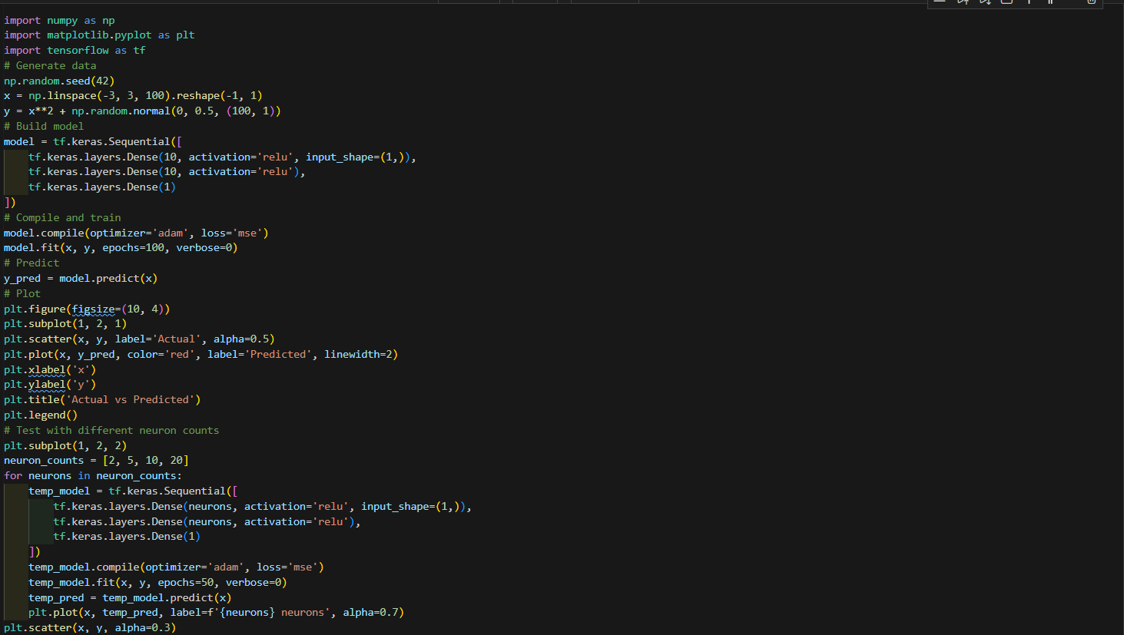

***Output:***

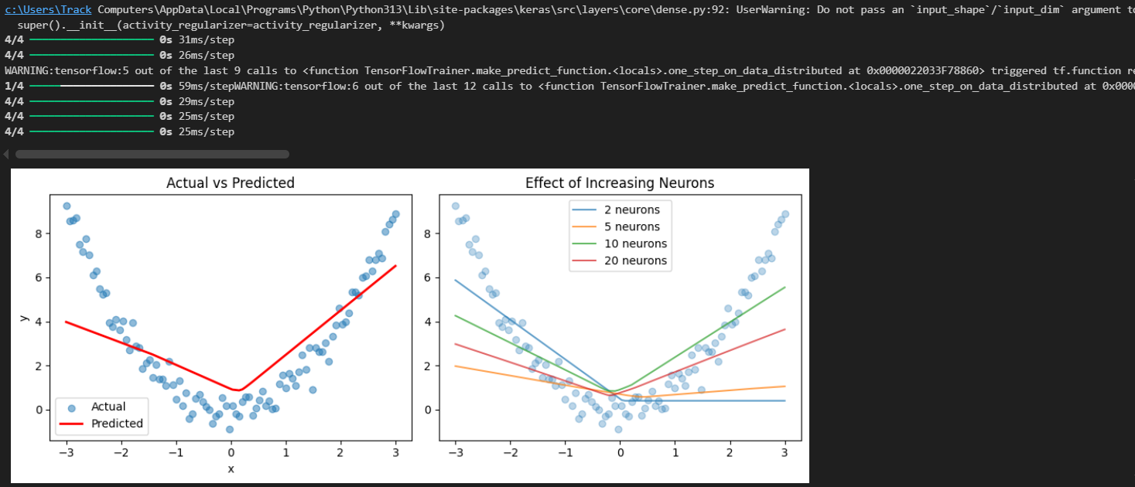

***Question*_*3***Use the XOR gate and train networks with different activation functions (sigmoid, tanh, ReLU).

* Compare accuracy, loss, and convergence speed.
* Plot and discuss results.

***Code:***

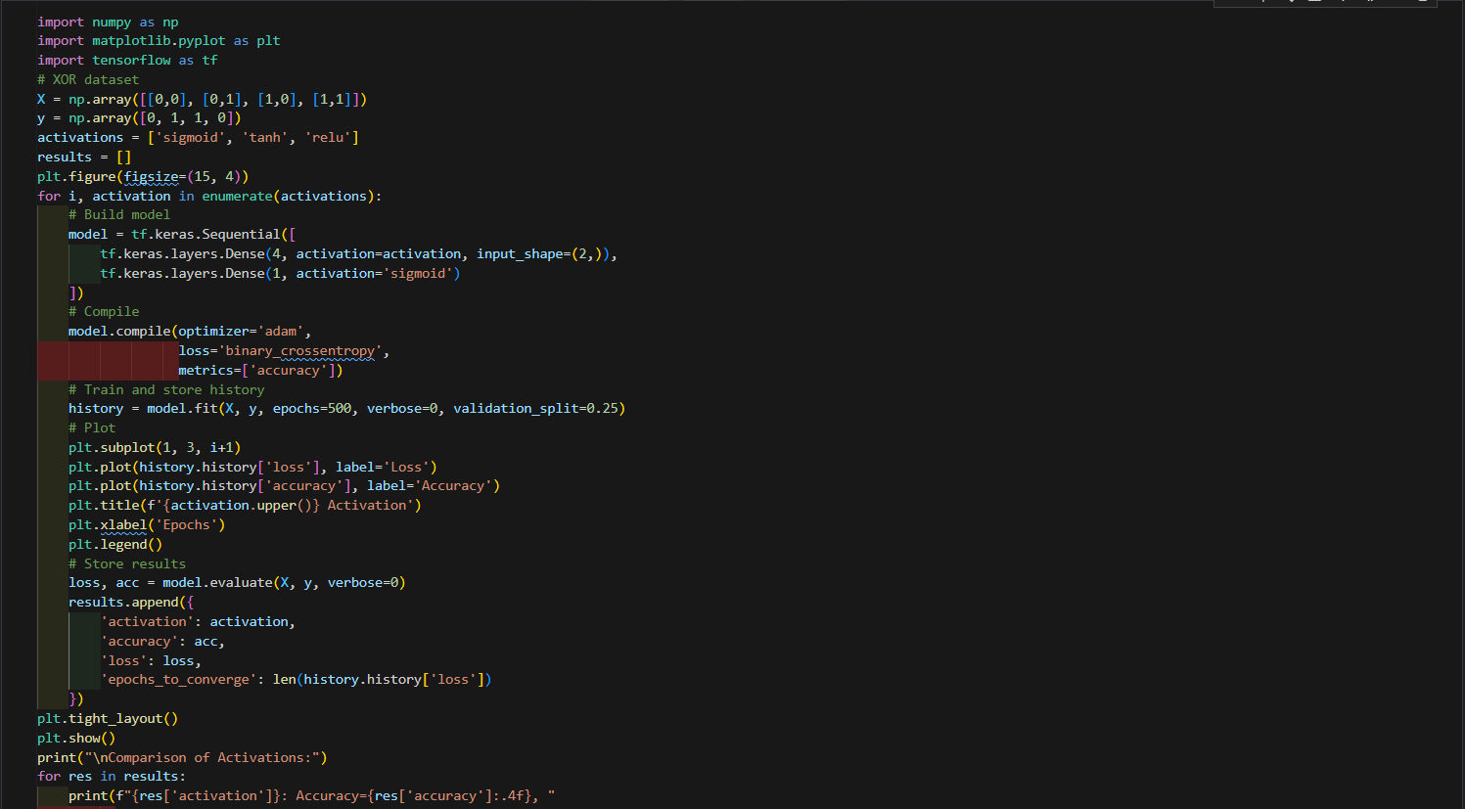

***Output:***

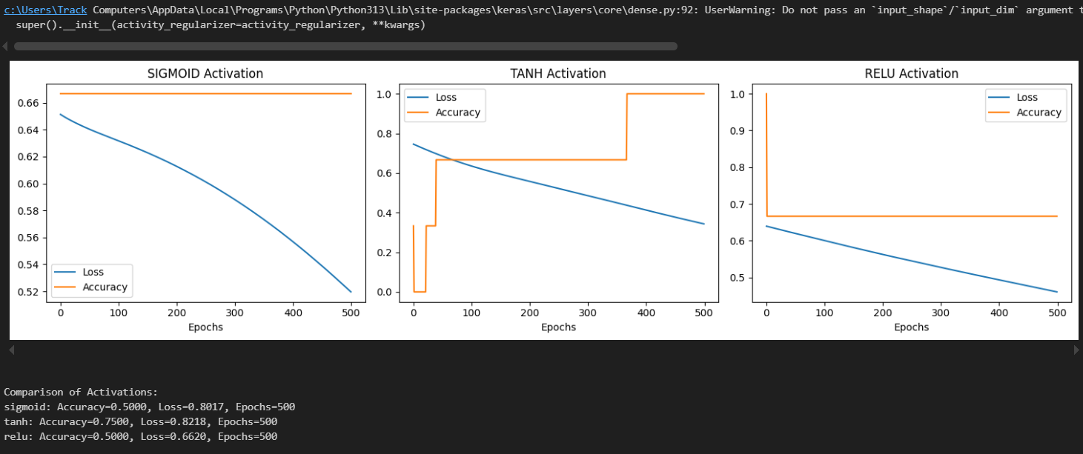

***Question 4***

**Binary Classification using Neural Network**

**Objective:** Build a neural network to classify whether a tumor is malignant or benign using the **Breast Cancer dataset**.

***Code:***

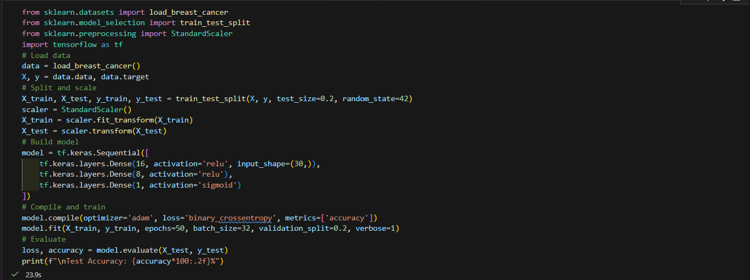

***Output:***

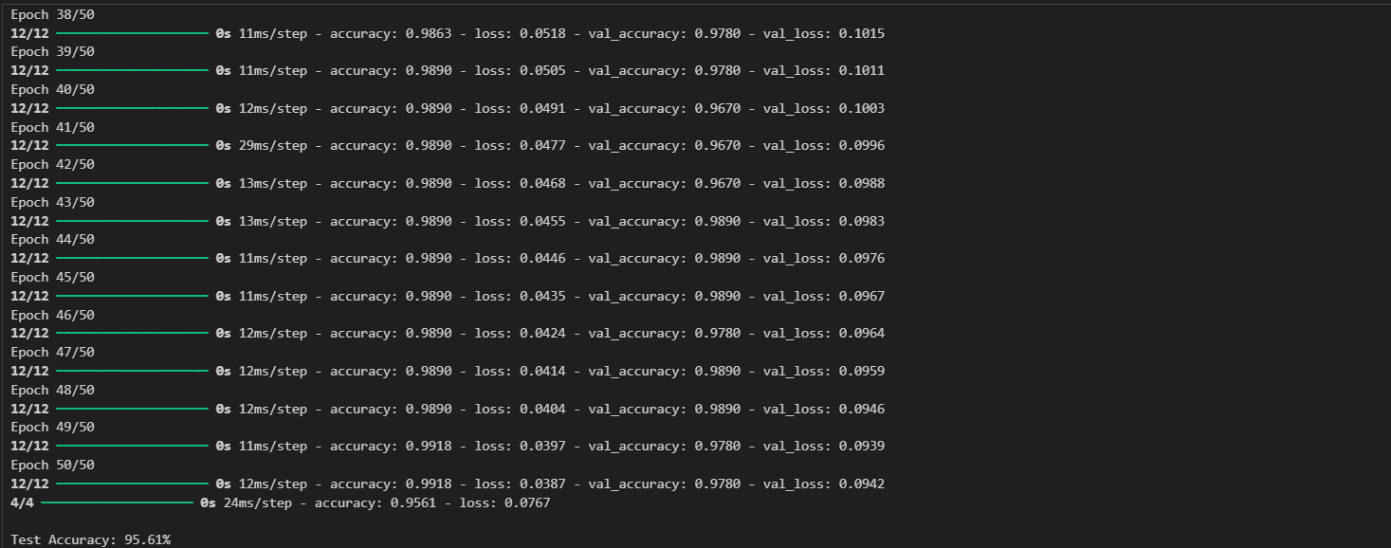***Question 5***

**Multi-Class Classification on Iris Dataset**

**Objective:** Train a neural network to classify flower species (Setosa, Versicolor, Virginica).

***Code:***

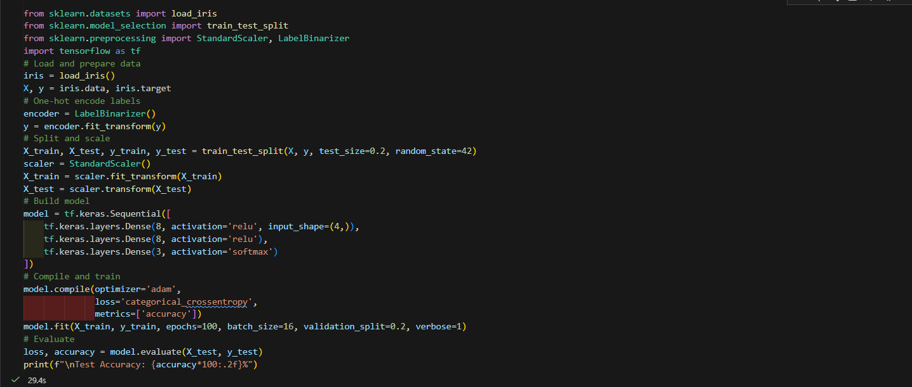***Output:***

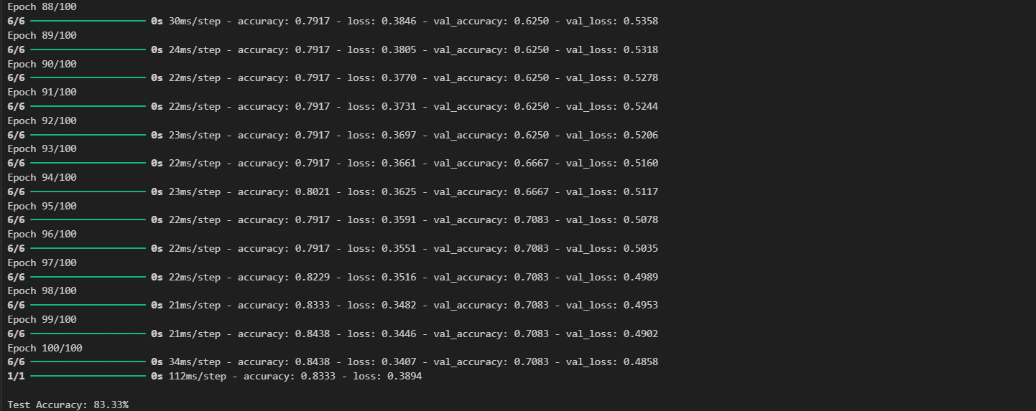***Question 6***

**Regression Problem (House Price Prediction)**

**Objective:** Predict house prices using the **California Housing dataset**.

***Code:***

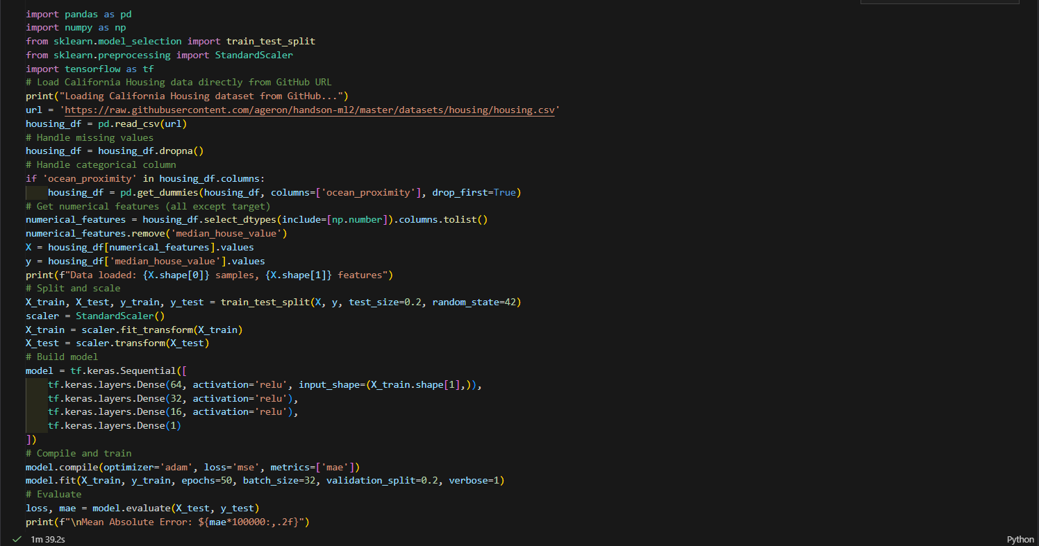

***Output:***

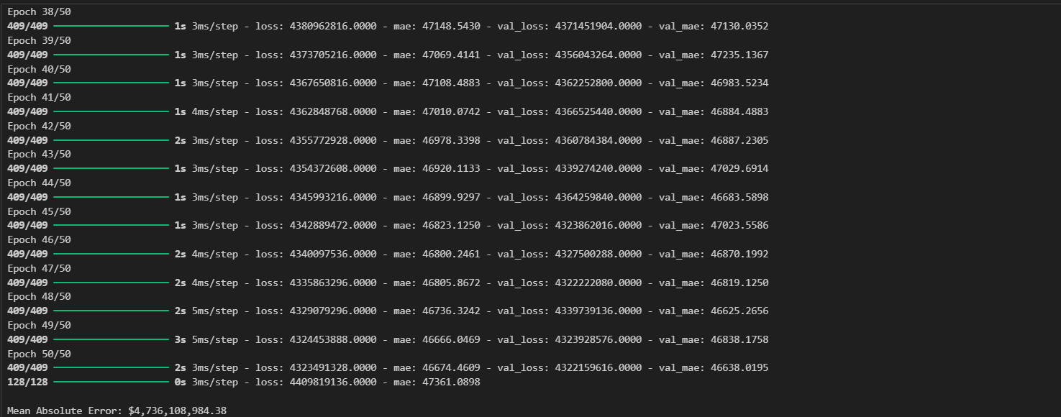***Question 7***

**Neural Network with Dropout Regularization**

**Objective:** Prevent overfitting using **Dropout** layers on the **MNIST digit dataset**.

***Code:***

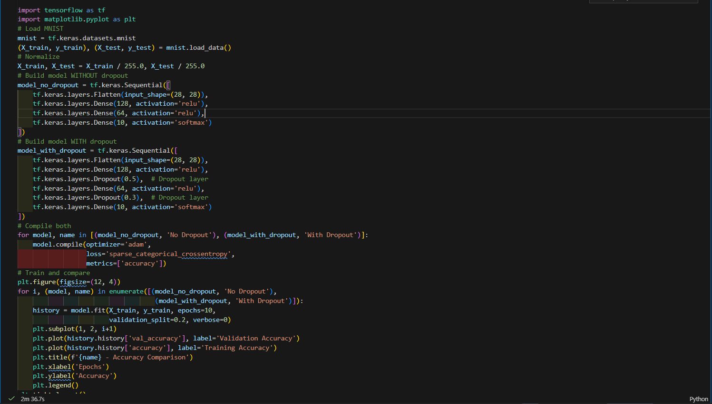***Output:***

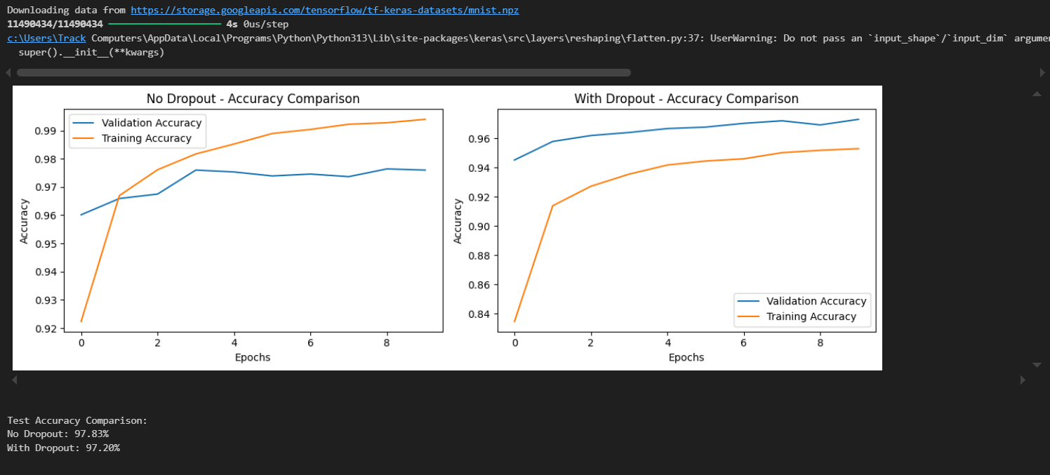

***Laboratory Work Assessment Rubrics***

|  |  |  |  |  |  |  |
| --- | --- | --- | --- | --- | --- | --- |
| **Sr.**  **No.** | **Performance Indicator** | **Excellent (5)** | **Good (4)** | **Average (3)** | **Fair (2)** | **Poor (1)** |
| **1** | **Theoretical** | Student knows | Student knows most | Student knows few | Student knows | Student has poor |
|  | **knowledge** | all the related | of the related | of the related | very little about | understanding of the |
|  | **10%** | concepts about | concepts about the | concepts about the | the related | related concepts |
|  |  | the theoretical | theoretical | theoretical | concepts about the | about the theoretical |
|  |  | background of | background of the | background of the | theoretical | background of the |
|  |  | the experiment | experiment and | experiment and | background of the | experiment and |
|  |  | and rephrase | partially rephrase | partially rephrase | experiment and | unable to rephrase |
|  |  | those concepts in | those concepts in | those concepts in | poorly rephrase | those concepts in |
|  |  | written and oral | written and oral | written and oral | those concepts in | written and oral |
|  |  | assessments | assessments | assessments | written and oral | assessments |
|  |  |  |  |  | assessments |  |
| **2** | **Application** | Application runs | Application | Application | Application | Application does |
|  | **Functionality** | smoothly and | compiles with no | compiles with | compiles and | not compile or |
|  | **10%** | operation of the | warnings. Robust | few or no | runs without | compiles but |
|  |  | application runs | operation of the | warnings. | crashing. Some | crashes. |
|  |  | efficiently | application, with | Consideration | attempt at | Confusing. |
|  |  |  | good recovery. | given to unusual | detecting and | Little or no error |
|  |  |  |  | conditions with | correcting | detection or |
|  |  |  |  | reasonable | errors. | correction. |
| **3** | **Specifications** | The program | The program works | The program | The program | The program is |
|  | **10%** | works very | and meets some of | works and | produces correct | producing incorrect |
|  |  | efficiently and | the specifications. | produces the | results but does not | results. |
|  |  | meets all of the |  | correct results and | display them |  |
|  |  | required |  | displays them | correctly. |  |
|  |  | specifications. |  | correctly. It also |  |  |
|  |  |  |  | meets most of the |  |  |
|  |  |  |  | other |  |  |
|  |  |  |  | specifications. |  |  |
| **4** | **Level of** | Provide complete | Provide complete | Provide partially | Provide very few | Provide no answer to |
|  | **understanding of** | and logical | and logical answers | correct and logical | and illogical | the questions asked |
|  | **the learned skill** | answers based | based upon accurate | answers based | answers to the | by examiner. |
|  | **10%** | upon accurate | technical content to | upon minimum | questions asked by |  |
|  |  | technical content | the questions asked | technical content | examiner. |  |
|  |  | to the questions | by examiner with | to the questions |  |  |
|  |  | asked by | few errors | asked by examiner |  |  |
|  |  | examiner |  |  |  |  |
| **5** | **Readability and** | The code is | The code is fairly | Most of the code | Some parts of the | The code is poorly |
|  | **Reusability** | exceptionally | easy to read. The | could be reused in | code require | organized and very |
|  | **10%** | well organized | code could be | other programs. | change before they | difficult to read and |
|  |  | and very easy | reused as a whole |  | could be reused in | not organized for |
|  |  | to follow and | or each class could |  | other programs. | reusability. |
|  |  | reused | be reused. |  |  |  |

|  |  |  |  |  |  |  |
| --- | --- | --- | --- | --- | --- | --- |
| **6** | **AI System Design 10%** | Well-designed AI models. Code is highly maintainable | Good designed AI models and Little code duplications | Some attempt to make AI models. Code can be maintained with significant effort | Little attempt to design AI models and less understanding of code | Very poor attempt to design AI models and its code |
| **7** | **Responsiveness to**  **Questions/ Accuracy 10%** | 1. Responds well, quick and very accurate all the time. 2. Effectively uses eye contact, speaks clearly, effectively and confidently using   suitable volume | 1. Generally Responsive and accurate most of the times. 2. Maintains eye contact, speaks clearly with suitable volume and pace. | 1. Generally Responsive and accurate few times. 2. Some eye contact, speaks clearly and unclearly in different portions. | 1. Not much Responsive and accurate most of the times. 2. Uses eye contact ineffectively and fails to speak clearly and audibly | . 1. Non Responsive and inaccurate all the times.   1. No eye contact and unable to speak 2. Dresses inappropriately |
| **8** | **Efficiency 10%** | The code is extremely efficient without sacrificing readability and understanding | The code is fairly efficient without sacrificing readability and understanding | Some part of the code is efficient and other part of the code is not understandable and work properly | The code is brute force and unnecessarily long | The code is huge and appears to be patched together |
| **9** | **Delivery 10%** | The program was delivered in time during lab. | The program was delivered in Lab before the end time. | The program was delivered within the due date. | The code was delivered within a day after the due date. | The code was delivered more than 2 days overdue. |
| **10** | **Awareness of Safety Guidelines 10%** | Student has sufficient knowledge of the laboratory safety SOPs and protocol and is fully compliant to the guidelines | Student has sufficient knowledge of the laboratory safety SOPs and protocol and is Partially compliant to the guidelines | Student has little knowledge of the laboratory safety SOPs and protocol and is Partially compliant to the guidelines | Student has little knowledge of the laboratory safety SOPs and protocol and is non- compliant to the guidelines | Student has no knowledge of the laboratory safety SOPs and protocol and is non-compliant to the guidelines |

|  |  |  |  |
| --- | --- | --- | --- |
| **Student Name** |  | **LAB Rubrics** | CLO3 , P5, PLO5 |
| **Total Marks** | 10 |
| **Registration No** |  | **Obtained Marks** |  |
| **Teacher Name** | Dr. Syed M Hamedoon |
| **Date** |  | **Signature** |  |

***LAB Assessment:***

***LAB No. 6***

***Implementation of Deep Neural Network***

In this lab, students will study and implement a **Deep Neural Network (DNN)** for classification tasks. A DNN is an extension of Artificial Neural Networks that contains **multiple hidden layers**, enabling the model to learn complex and hierarchical patterns from data. Students will begin with a simple DNN on a small dataset to understand its structure and training process, and then apply DNN models to real-world datasets such as **Iris** and **MNIST**. Model performance will be evaluated using accuracy metrics.

***Introduction***

A **Deep Neural Network (DNN)** is a neural network with **more than one hidden layer** between the input and output layers. Each layer extracts increasingly complex features from the data. DNNs use **backpropagation** and **gradient descent–based optimizers** to update weights and minimize loss.

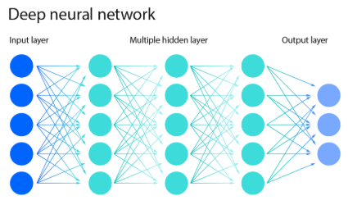

***Key Components of DNN:***

* **Input Layer** – receives raw data
* **Multiple Hidden Layers** – perform deep feature learning
* **Output Layer** – produces final prediction
* **Activation Functions** – ReLU, Sigmoid, Softmax
* **Loss Function** – measures prediction error
* **Optimizer** – Adam, SGD

DNNs are widely used in applications such as image recognition, speech processing, recommendation systems, and natural language processing.

**Solved Examples**

***Example 1***

Build a Deep Neural Network to predict whether a student **passes or fails** based on study hours and attendance **(Small Dataset)**

|  |
| --- |
| import pandas as pd  from sklearn.preprocessing import LabelEncoder  from tensorflow.keras.models import Sequential  from tensorflow.keras.layers import Dense  # Dataset  data = {      'StudyHours': ['Low', 'High', 'High', 'Low', 'High'],      'Attendance': ['Poor', 'Good', 'Poor', 'Good', 'Good'],      'Result': ['Fail', 'Pass', 'Pass', 'Fail', 'Pass']  }  df = pd.DataFrame(data)  # Encode categorical data  encoder = LabelEncoder()  for col in df.columns:      df[col] = encoder.fit_transform(df[col])  X = df[['StudyHours', 'Attendance']].values  y = df['Result'].values  # Build DNN  model = Sequential()  model.add(Dense(8, activation='relu', input_shape=(2,)))  model.add(Dense(6, activation='relu'))  model.add(Dense(4, activation='relu'))  model.add(Dense(1, activation='sigmoid'))  # Compile and train  model.compile(optimizer='adam', loss='binary_crossentropy', metrics=['accuracy'])  model.fit(X, y, epochs=150, verbose=0)  # Prediction  prediction = model.predict([[1, 1]])  print("Predicted Result (Pass=1, Fail=0):", int(prediction[0][0] > 0.5)) |

The multiple hidden layers enable the DNN to learn deeper patterns compared to a shallow ANN.

**Example 2:**

Apply a Deep Neural Network to classify Iris flowers into three species.

***Solution:***

|  |
| --- |
| from sklearn.datasets import load_iris  from sklearn.model_selection import train_test_split  from tensorflow.keras.utils import to_categorical  # Load dataset  iris = load_iris()  X = iris.data  y = iris.target  # One-hot encoding  y = to_categorical(y)  # Train-test split  X_train, X_test, y_train, y_test = train_test_split(      X, y, test_size=0.3, random_state=42  )  # Build DNN  model = Sequential()  model.add(Dense(16, activation='relu', input_shape=(4,)))  model.add(Dense(12, activation='relu'))  model.add(Dense(8, activation='relu'))  model.add(Dense(3, activation='softmax'))  # Compile and train  model.compile(optimizer='adam', loss='categorical_crossentropy', metrics=['accuracy'])  model.fit(X_train, y_train, epochs=150, verbose=0)  # Evaluate  loss, accuracy = model.evaluate(X_test, y_test, verbose=0)  print("Test Accuracy:", accuracy) |

The deeper architecture improves feature representation and classification accuracy.

***Example 3:***

**Use a Deep Neural Network to classify handwritten digits (0–9).**

***Solution:***

|  |
| --- |
| from tensorflow.keras.datasets import mnist  from tensorflow.keras.utils import to_categorical  # Load MNIST dataset  (X_train, y_train), (X_test, y_test) = mnist.load_data()  # Preprocessing  X_train = X_train.reshape(-1, 28*28) / 255.0  X_test = X_test.reshape(-1, 28*28) / 255.0  # One-hot encode labels  y_train = to_categorical(y_train)  y_test = to_categorical(y_test)  # Build DNN  model = Sequential()  model.add(Dense(256, activation='relu', input_shape=(784,)))  model.add(Dense(128, activation='relu'))  model.add(Dense(64, activation='relu'))  model.add(Dense(10, activation='softmax'))  # Compile and train  model.compile(optimizer='adam', loss='categorical_crossentropy', metrics=['accuracy'])  model.fit(X_train, y_train, epochs=10, batch_size=128, verbose=1)  # Evaluate  loss, accuracy = model.evaluate(X_test, y_test)  print("Test Accuracy:", accuracy) |

DNN learns hierarchical pixel features and achieves good accuracy, though CNNs are more suitable for image data.

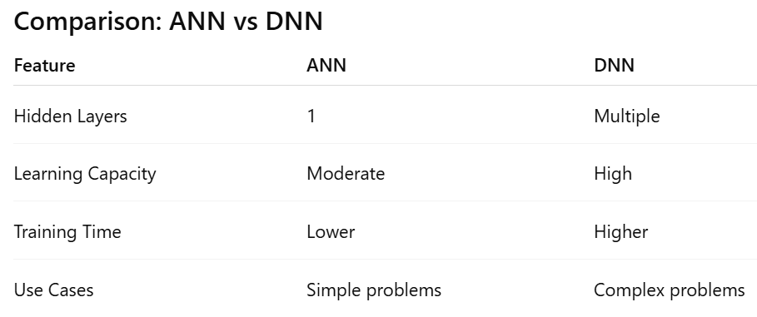

***Practice Questions:***

**Question 1:**

**DNN Architecture Design**

Create a Deep Neural Network to predict whether a student **passes or fails** using features such as *study hours* and *attendance*.

* Use **at least three hidden layers**
* Experiment with different numbers of neurons
* Compare the accuracy with a shallow ANN (one hidden layer)

***Code:***

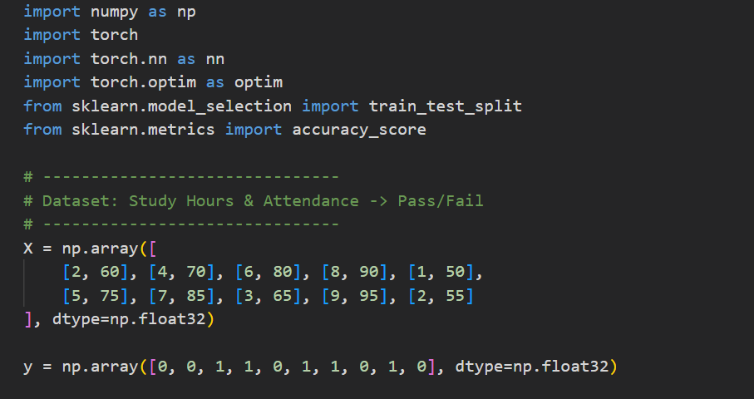

***Output:***

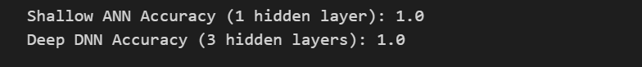

**Question 2:**

***Activation Function Analysis***

Using the **Iris dataset**, build two DNN models:

* Model A: Use **ReLU** activation in all hidden layers
* Model B: Use **tanh** activation in all hidden layers

Train both models and **compare their accuracy and training behavior**. Write your observation.

***Code:***

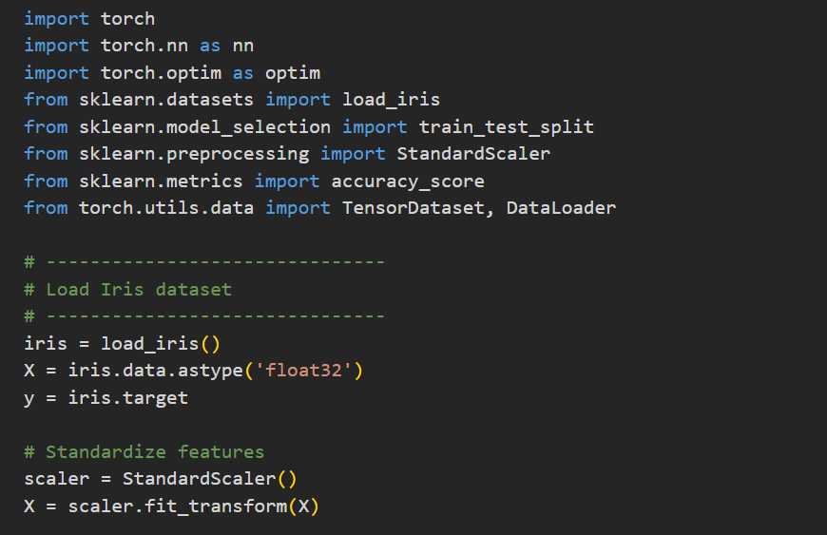

***Output:***

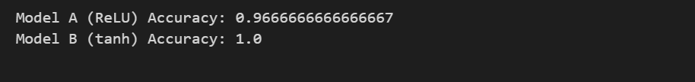**Question 3:**

**Hyperparameter Tuning in DNN**

Train a DNN on the **MNIST dataset** by changing:

* Number of hidden layers
* Number of neurons per layer
* Batch size

Record how these changes affect **training time and accuracy**

***Code:***

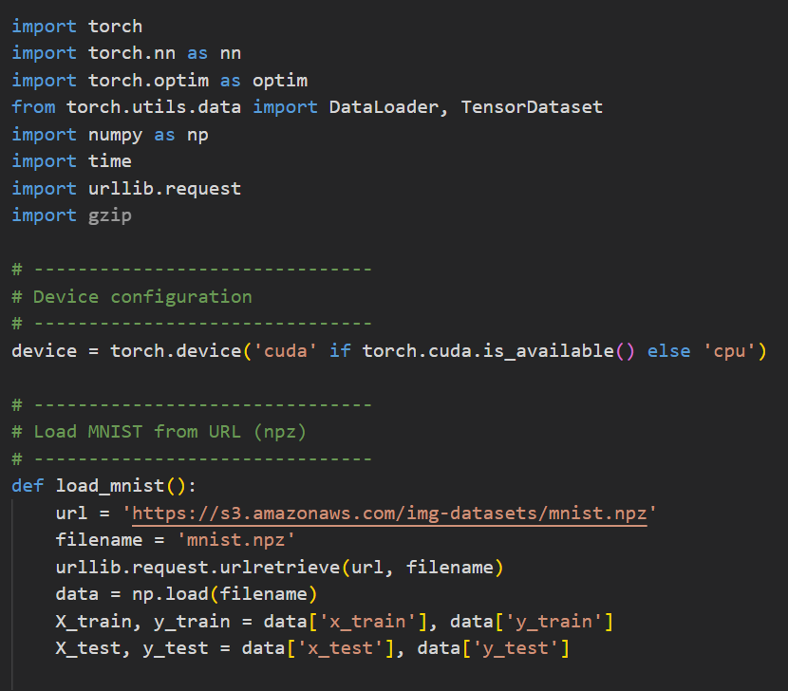

***Output:***

**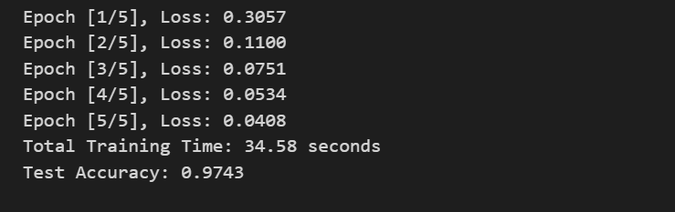 *Question 4:***

**Overfitting and Regularization**

Build a deep neural network on any classification dataset and:

* Observe signs of **overfitting**
* Apply at least one regularization technique (Dropout or Early Stopping)
* Compare model performance **before and after regularization**

***Code:***

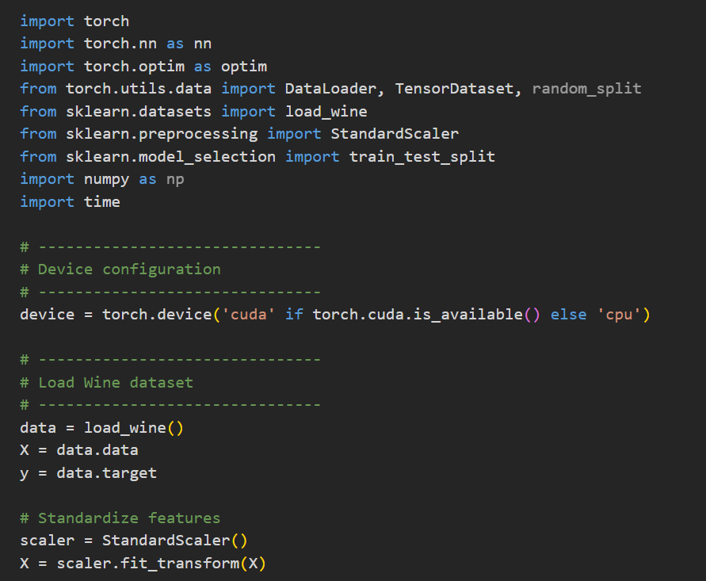

***Output:***

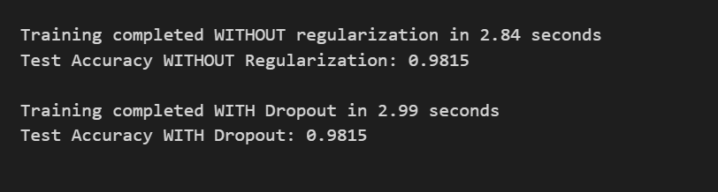

***Laboratory Work Assessment Rubrics***

|  |  |  |  |  |  |  |
| --- | --- | --- | --- | --- | --- | --- |
| **Sr.**  **No.** | **Performance Indicator** | **Excellent (5)** | **Good (4)** | **Average (3)** | **Fair (2)** | **Poor (1)** |
| **1** | **Theoretical** | Student knows | Student knows most | Student knows few | Student knows | Student has poor |
|  | **knowledge** | all the related | of the related | of the related | very little about | understanding of the |
|  | **10%** | concepts about | concepts about the | concepts about the | the related | related concepts |
|  |  | the theoretical | theoretical | theoretical | concepts about the | about the theoretical |
|  |  | background of | background of the | background of the | theoretical | background of the |
|  |  | the experiment | experiment and | experiment and | background of the | experiment and |
|  |  | and rephrase | partially rephrase | partially rephrase | experiment and | unable to rephrase |
|  |  | those concepts in | those concepts in | those concepts in | poorly rephrase | those concepts in |
|  |  | written and oral | written and oral | written and oral | those concepts in | written and oral |
|  |  | assessments | assessments | assessments | written and oral | assessments |
|  |  |  |  |  | assessments |  |
| **2** | **Application** | Application runs | Application | Application | Application | Application does |
|  | **Functionality** | smoothly and | compiles with no | compiles with | compiles and | not compile or |
|  | **10%** | operation of the | warnings. Robust | few or no | runs without | compiles but |
|  |  | application runs | operation of the | warnings. | crashing. Some | crashes. |
|  |  | efficiently | application, with | Consideration | attempt at | Confusing. |
|  |  |  | good recovery. | given to unusual | detecting and | Little or no error |
|  |  |  |  | conditions with | correcting | detection or |
|  |  |  |  | reasonable | errors. | correction. |
| **3** | **Specifications** | The program | The program works | The program | The program | The program is |
|  | **10%** | works very | and meets some of | works and | produces correct | producing incorrect |
|  |  | efficiently and | the specifications. | produces the | results but does not | results. |
|  |  | meets all of the |  | correct results and | display them |  |
|  |  | required |  | displays them | correctly. |  |
|  |  | specifications. |  | correctly. It also |  |  |
|  |  |  |  | meets most of the |  |  |
|  |  |  |  | other |  |  |
|  |  |  |  | specifications. |  |  |
| **4** | **Level of** | Provide complete | Provide complete | Provide partially | Provide very few | Provide no answer to |
|  | **understanding of** | and logical | and logical answers | correct and logical | and illogical | the questions asked |
|  | **the learned skill** | answers based | based upon accurate | answers based | answers to the | by examiner. |
|  | **10%** | upon accurate | technical content to | upon minimum | questions asked by |  |
|  |  | technical content | the questions asked | technical content | examiner. |  |
|  |  | to the questions | by examiner with | to the questions |  |  |
|  |  | asked by | few errors | asked by examiner |  |  |
|  |  | examiner |  |  |  |  |
| **5** | **Readability and** | The code is | The code is fairly | Most of the code | Some parts of the | The code is poorly |
|  | **Reusability** | exceptionally | easy to read. The | could be reused in | code require | organized and very |
|  | **10%** | well organized | code could be | other programs. | change before they | difficult to read and |
|  |  | and very easy | reused as a whole |  | could be reused in | not organized for |
|  |  | to follow and | or each class could |  | other programs. | reusability. |
|  |  | reused | be reused. |  |  |  |

|  |  |  |  |  |  |  |
| --- | --- | --- | --- | --- | --- | --- |
| **6** | **AI System Design 10%** | Well-designed AI models. Code is highly maintainable | Good designed AI models and Little code duplications | Some attempt to make AI models. Code can be maintained with significant effort | Little attempt to design AI models and less understanding of code | Very poor attempt to design AI models and its code |
| **7** | **Responsiveness to**  **Questions/ Accuracy 10%** | 1. Responds well, quick and very accurate all the time. 2. Effectively uses eye contact, speaks clearly, effectively and confidently using   suitable volume | 1. Generally Responsive and accurate most of the times. 2. Maintains eye contact, speaks clearly with suitable volume and pace. | 1. Generally Responsive and accurate few times. 2. Some eye contact, speaks clearly and unclearly in different portions. | 1. Not much Responsive and accurate most of the times. 2. Uses eye contact ineffectively and fails to speak clearly and audibly | . 1. Non Responsive and inaccurate all the times.   1. No eye contact and unable to speak 2. Dresses inappropriately |
| **8** | **Efficiency 10%** | The code is extremely efficient without sacrificing readability and understanding | The code is fairly efficient without sacrificing readability and understanding | Some part of the code is efficient and other part of the code is not understandable and work properly | The code is brute force and unnecessarily long | The code is huge and appears to be patched together |
| **9** | **Delivery 10%** | The program was delivered in time during lab. | The program was delivered in Lab before the end time. | The program was delivered within the due date. | The code was delivered within a day after the due date. | The code was delivered more than 2 days overdue. |
| **10** | **Awareness of Safety Guidelines 10%** | Student has sufficient knowledge of the laboratory safety SOPs and protocol and is fully compliant to the guidelines | Student has sufficient knowledge of the laboratory safety SOPs and protocol and is Partially compliant to the guidelines | Student has little knowledge of the laboratory safety SOPs and protocol and is Partially compliant to the guidelines | Student has little knowledge of the laboratory safety SOPs and protocol and is non- compliant to the guidelines | Student has no knowledge of the laboratory safety SOPs and protocol and is non-compliant to the guidelines |

|  |  |  |  |
| --- | --- | --- | --- |
| **Student Name** |  | **LAB Rubrics** | CLO3 , P5, PLO5 |
| **Total Marks** | 10 |
| **Registration No** |  | **Obtained Marks** |  |
| **Teacher Name** | Dr. Syed M Hamedoon |
| **Date** |  | **Signature** |  |

***LAB Assessment***

***LAB No. 7***

***Implementation of Recurrent Neural Network (RNN)***

In this lab, students will study and implement a Recurrent Neural Network (RNN), a deep learning model designed for sequential and time-dependent data. Unlike feedforward neural networks, RNNs have feedback connections that allow them to retain information from previous time steps. Students will begin with a simple RNN model to understand sequence processing and then apply RNNs to real-world problems such as sequence classification and text processing. Model performance will be evaluated using accuracy metrics.

***Introduction***

A **Recurrent Neural Network (RNN)** is a class of neural networks specifically designed to process **sequential data**, where the order of inputs matters. RNNs maintain a **hidden state (memory)** that captures information from previous inputs and influences current predictions.

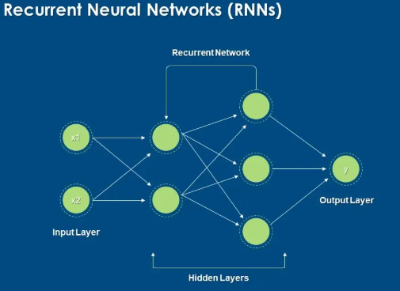

***Key Concepts:***

* **Sequential Input** – time series or text data
* **Hidden State** – stores past information
* **Recurrent Connection** – connects previous output to current input
* **Activation Functions** – tanh, ReLU
* **Backpropagation Through Time (BPTT)** – training method for RNNs

RNNs are commonly used in **speech recognition, sentiment analysis, time-series forecasting, and natural language processing**. However, basic RNNs may suffer from the **vanishing gradient problem**, which is addressed by advanced variants like **LSTM and GRU**.

***Solved Examples:***

***Example 1:***

**Simple RNN for Binary Sequence Classification**

Build a simple RNN to classify whether a sequence indicates **Pass (1)** or **Fail (0)** based on study performance over time.

***Solution:***

|  |
| --- |
| import numpy as np  from tensorflow.keras.models import Sequential  from tensorflow.keras.layers import SimpleRNN, Dense  # Sample sequential data (5 students, 3 time steps, 1 feature)  X = np.array([      [[1], [1], [0]],      [[1], [1], [1]],      [[0], [0], [1]],      [[0], [0], [0]],      [[1], [0], [1]]  ])  y = np.array([1, 1, 0, 0, 1])  # Build RNN model  model = Sequential()  model.add(SimpleRNN(8, activation='tanh', input_shape=(3, 1)))  model.add(Dense(1, activation='sigmoid'))  # Compile and train  model.compile(optimizer='adam', loss='binary_crossentropy', metrics=['accuracy'])  model.fit(X, y, epochs=100, verbose=0)  # Prediction  prediction = model.predict([[[1], [1], [1]]])  print("Predicted Result (1=Pass, 0=Fail):", int(prediction[0][0] > 0.5)) |

***Explanation***

The RNN processes input sequences and uses memory to capture temporal patterns before making a classification.

***Example 2:***

**RNN for Time Series Prediction** Predict the next value in a simple numerical sequence using an RNN.

***Solution:***

|  |
| --- |
| # Generate sequence data  X = np.array([      [[1], [2], [3]],      [[2], [3], [4]],      [[3], [4], [5]],      [[4], [5], [6]]  ])  y = np.array([4, 5, 6, 7])  # Build RNN model  model = Sequential()  model.add(SimpleRNN(10, activation='tanh', input_shape=(3, 1)))  model.add(Dense(1))  # Compile and train  model.compile(optimizer='adam', loss='mse')  model.fit(X, y, epochs=200, verbose=0)  # Predict next value  prediction = model.predict([[[5], [6], [7]]])  print("Predicted Next Value:", prediction[0][0]) |

***Explanation***

The RNN learns temporal relationships in numeric sequences and predicts future values.

***Example 3:***

**RNN for Text Classification (Simple Sentiment Analysis)**

Build a simple RNN model to classify text sentiment as **positive or negative**.

***Solution***

|  |
| --- |
| from tensorflow.keras.preprocessing.text import Tokenizer  from tensorflow.keras.preprocessing.sequence import pad_sequences  # Sample text data  texts = [      "I love this course",      "This lab is very good",      "I hate this subject",      "This is boring",      "Excellent explanation"  ]  labels = [1, 1, 0, 0, 1]  # Tokenize text  tokenizer = Tokenizer(num_words=100)  tokenizer.fit_on_texts(texts)  sequences = tokenizer.texts_to_sequences(texts)  padded_sequences = pad_sequences(sequences, maxlen=5)  # Build RNN model  model = Sequential()  model.add(SimpleRNN(16, activation='tanh', input_shape=(5,)))  model.add(Dense(1, activation='sigmoid'))  # Compile and train  model.compile(optimizer='adam', loss='binary_crossentropy', metrics=['accuracy'])  model.fit(padded_sequences, labels, epochs=100, verbose=0)  # Prediction  prediction = model.predict(padded_sequences)  print("Predicted Sentiments:", prediction.round()) |

The RNN processes text sequences word by word, capturing contextual meaning for sentiment classification.

**Limitations of Basic RNN**

* Vanishing gradient problem
* Difficulty learning long-term dependencies
* Slower training compared to feedforward networks

***Practice Questions:***

***Questions 1:***

***Next Word Prediction using RNN***

***Tasks:***

1. Load and clean the text data.
2. Tokenize and convert text into sequences.
3. Build a simple **RNN model** using keras.layers.SimpleRNN.
4. Train it to predict the next word given previous 3–5 words.
5. Test by entering a custom text prompt and predict the next word.

***Code:***

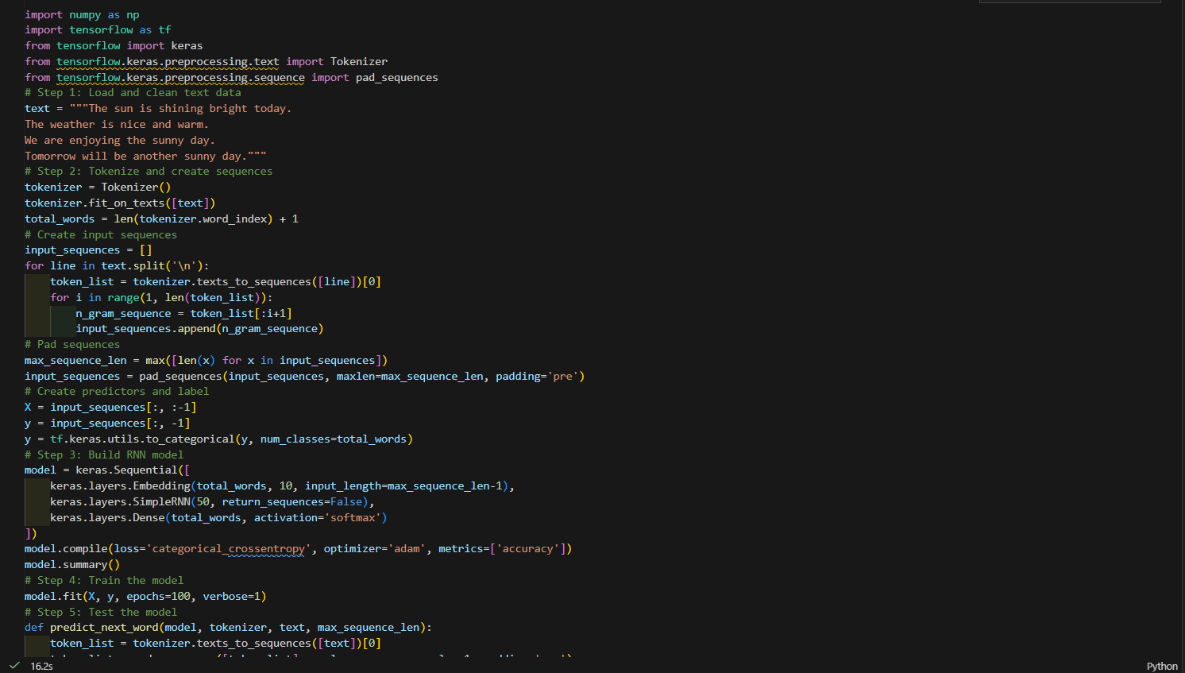

***Output:***

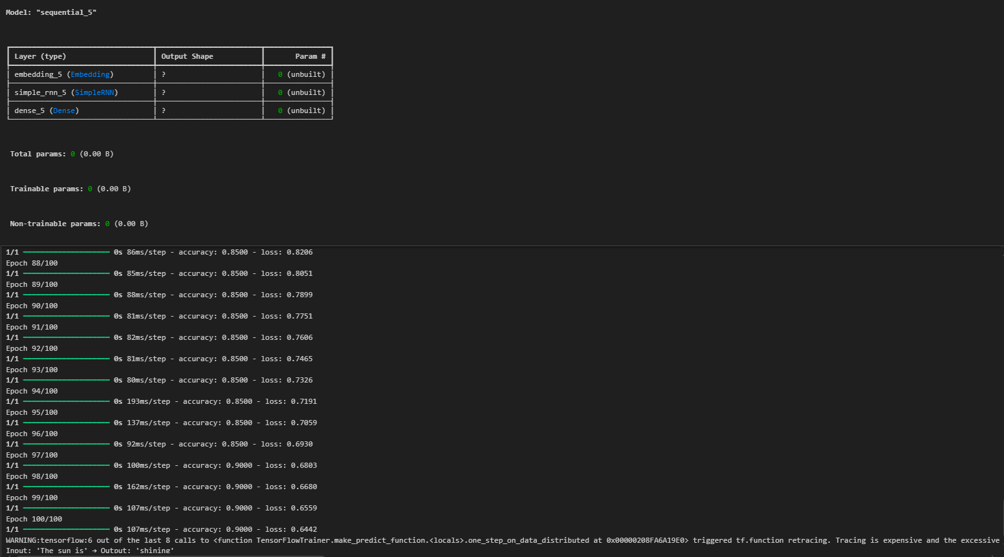

***Questions 2:***

***Stock Price Prediction using RNN***

***Tasks:***

1. Import dataset and normalize values.
2. Prepare time-step sequences (e.g., 60 previous days → next day price).
3. Build and train an **RNN model** using SimpleRNN layers.
4. Evaluate predictions vs actual prices (plot graph).

***Code:***

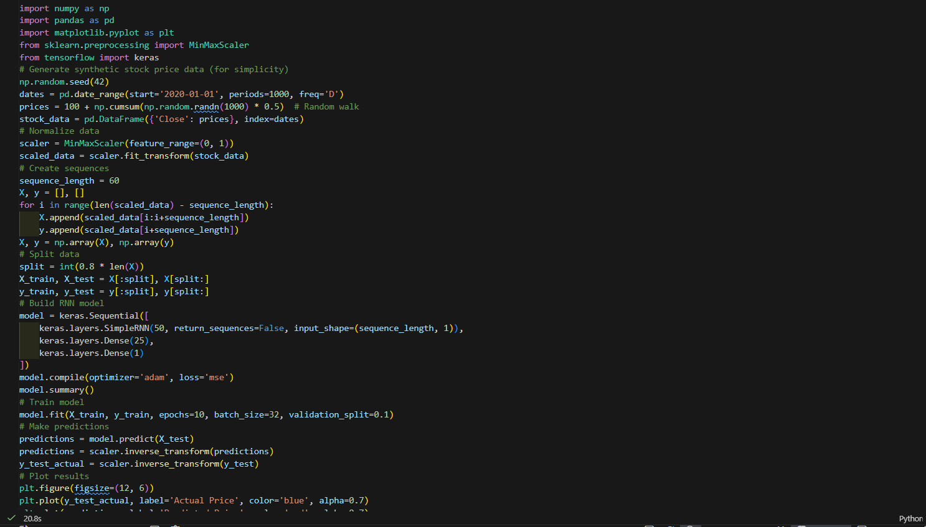

***Output:***

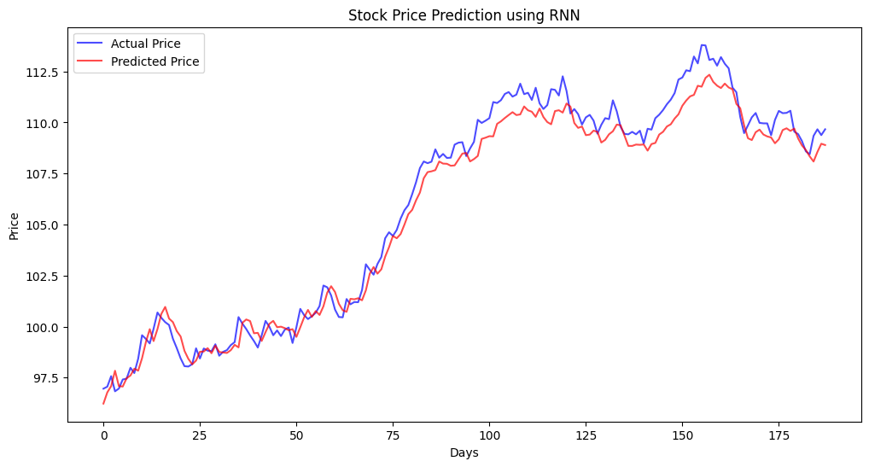

***Questions 3:***

***Sentiment Analysis using RNN***

***Tasks:***

1. Load dataset and preprocess text (tokenize and pad sequences).
2. Build RNN with Embedding + SimpleRNN layers.
3. Train for binary classification (positive/negative).
4. Evaluate accuracy on test data.

***Code:***

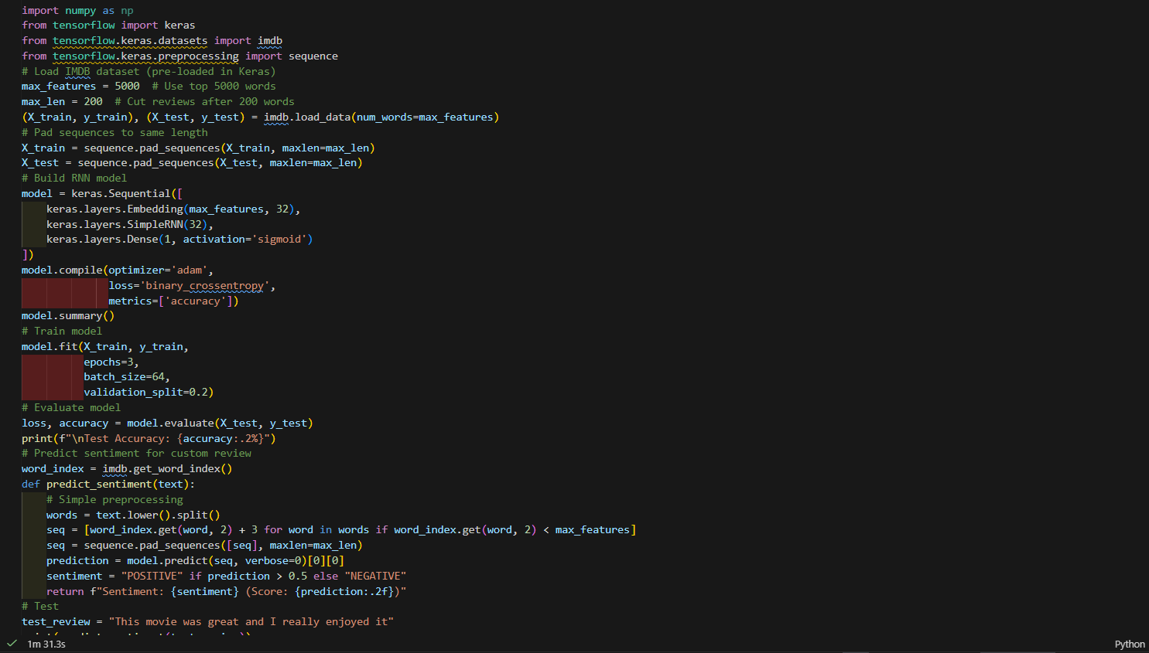

***Output:***

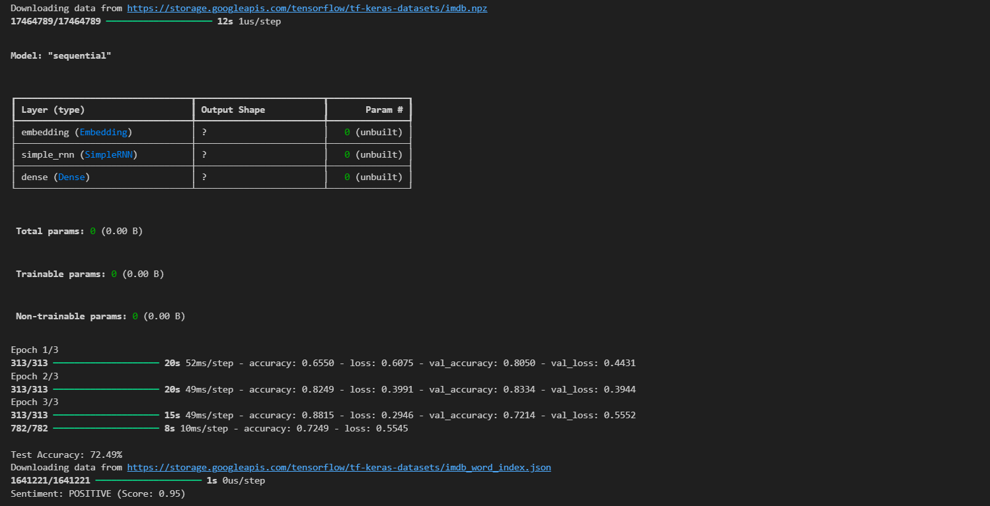

***Questions 4:***

***Weather Forecasting using RNN***

***Tasks:***

1. Load and visualize temperature over time.
2. Prepare input-output sequences for time series prediction.
3. Build an RNN to predict next day’s temperature.
4. Plot actual vs predicted temperature.

***Code:***

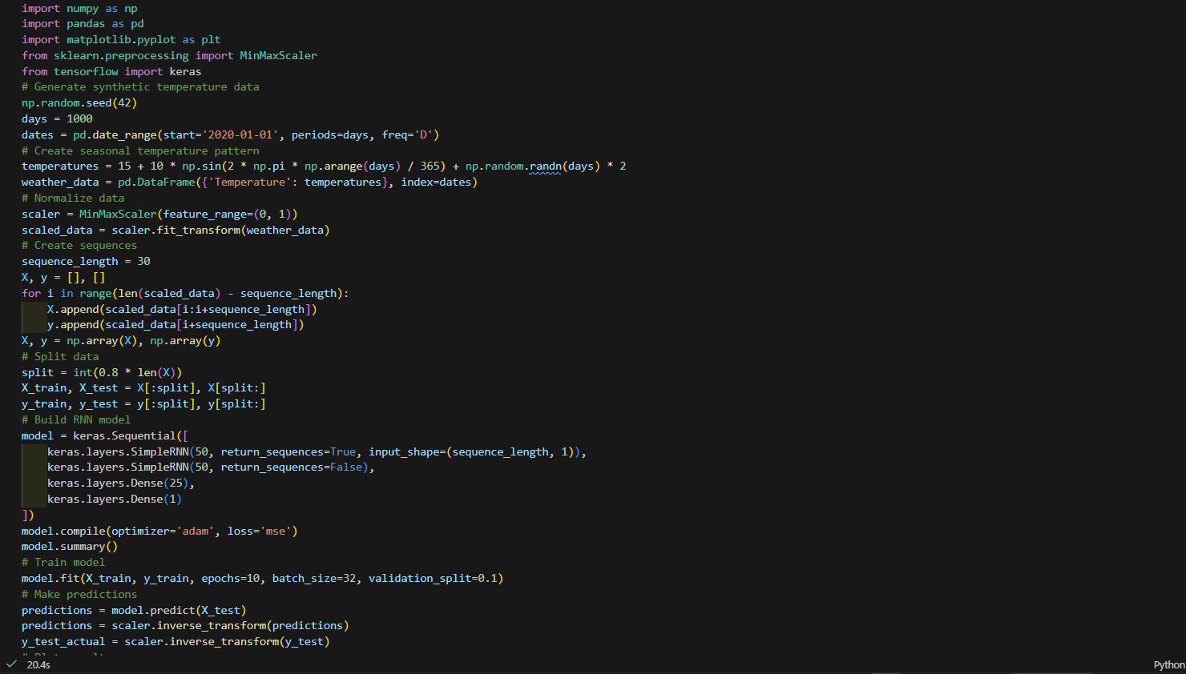

***Output:***

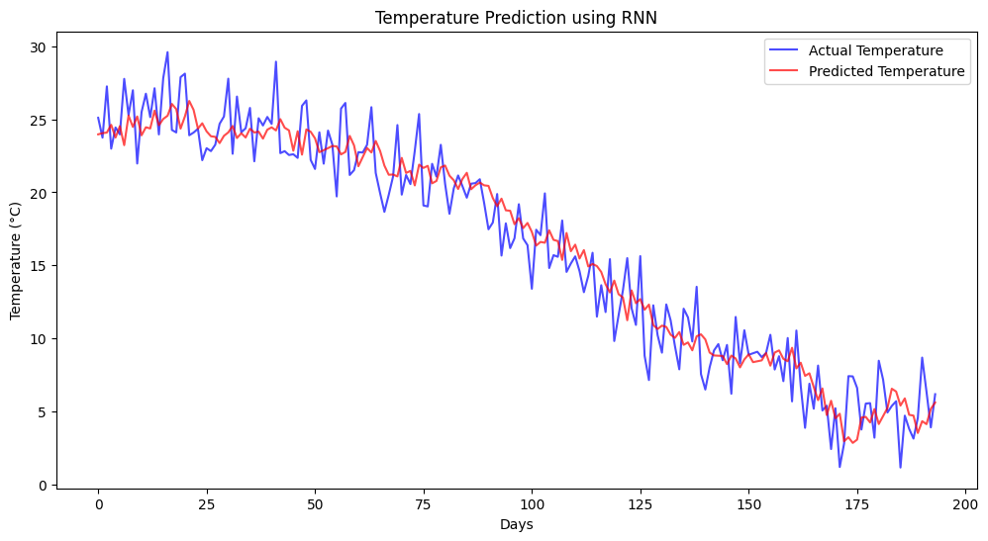***Questions 5:***

***Music Note Generation using RNN***

***Tasks:***

1. Convert MIDI data into integer-encoded notes.
2. Train an RNN on note sequences (input: previous notes → output: next note).
3. Generate a new sequence using the trained model.

***Code:***

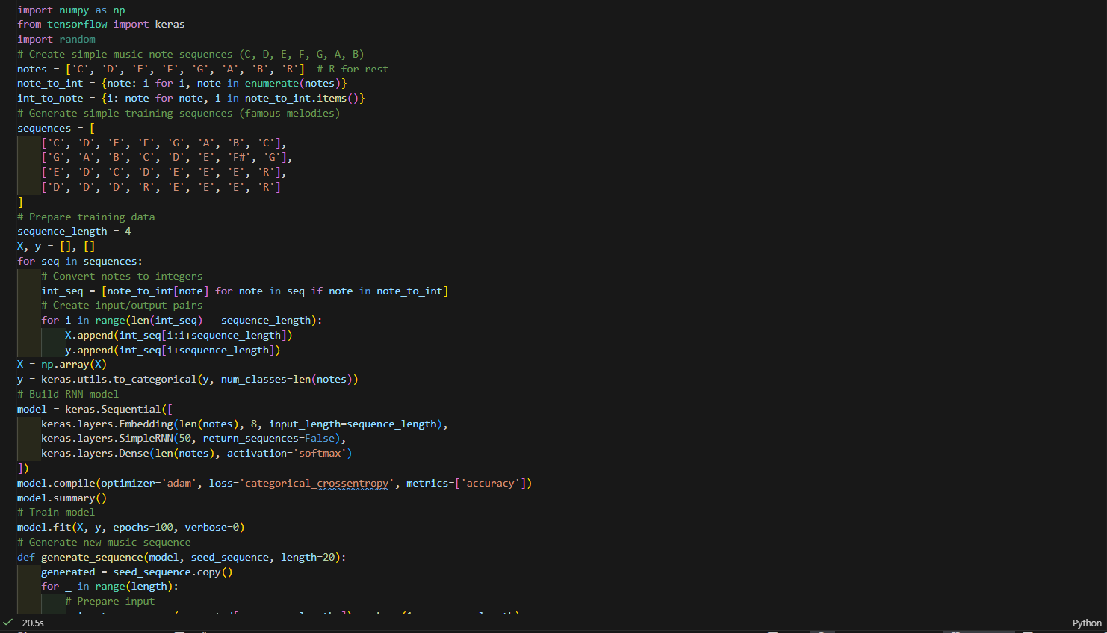***Output:***

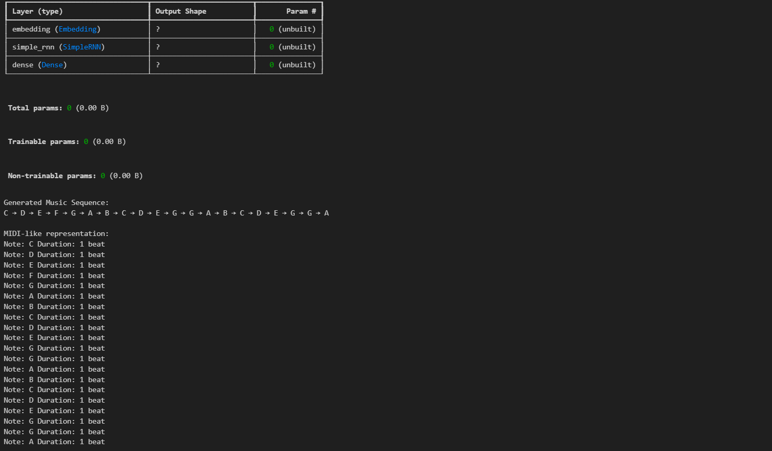

***Laboratory Work Assessment Rubrics***

|  |  |  |  |  |  |  |
| --- | --- | --- | --- | --- | --- | --- |
| **Sr.**  **No.** | **Performance Indicator** | **Excellent (5)** | **Good (4)** | **Average (3)** | **Fair (2)** | **Poor (1)** |
| **1** | **Theoretical** | Student knows | Student knows most | Student knows few | Student knows | Student has poor |
|  | **knowledge** | all the related | of the related | of the related | very little about | understanding of the |
|  | **10%** | concepts about | concepts about the | concepts about the | the related | related concepts |
|  |  | the theoretical | theoretical | theoretical | concepts about the | about the theoretical |
|  |  | background of | background of the | background of the | theoretical | background of the |
|  |  | the experiment | experiment and | experiment and | background of the | experiment and |
|  |  | and rephrase | partially rephrase | partially rephrase | experiment and | unable to rephrase |
|  |  | those concepts in | those concepts in | those concepts in | poorly rephrase | those concepts in |
|  |  | written and oral | written and oral | written and oral | those concepts in | written and oral |
|  |  | assessments | assessments | assessments | written and oral | assessments |
|  |  |  |  |  | assessments |  |
| **2** | **Application** | Application runs | Application | Application | Application | Application does |
|  | **Functionality** | smoothly and | compiles with no | compiles with | compiles and | not compile or |
|  | **10%** | operation of the | warnings. Robust | few or no | runs without | compiles but |
|  |  | application runs | operation of the | warnings. | crashing. Some | crashes. |
|  |  | efficiently | application, with | Consideration | attempt at | Confusing. |
|  |  |  | good recovery. | given to unusual | detecting and | Little or no error |
|  |  |  |  | conditions with | correcting | detection or |
|  |  |  |  | reasonable | errors. | correction. |
| **3** | **Specifications** | The program | The program works | The program | The program | The program is |
|  | **10%** | works very | and meets some of | works and | produces correct | producing incorrect |
|  |  | efficiently and | the specifications. | produces the | results but does not | results. |
|  |  | meets all of the |  | correct results and | display them |  |
|  |  | required |  | displays them | correctly. |  |
|  |  | specifications. |  | correctly. It also |  |  |
|  |  |  |  | meets most of the |  |  |
|  |  |  |  | other |  |  |
|  |  |  |  | specifications. |  |  |
| **4** | **Level of** | Provide complete | Provide complete | Provide partially | Provide very few | Provide no answer to |
|  | **understanding of** | and logical | and logical answers | correct and logical | and illogical | the questions asked |
|  | **the learned skill** | answers based | based upon accurate | answers based | answers to the | by examiner. |
|  | **10%** | upon accurate | technical content to | upon minimum | questions asked by |  |
|  |  | technical content | the questions asked | technical content | examiner. |  |
|  |  | to the questions | by examiner with | to the questions |  |  |
|  |  | asked by | few errors | asked by examiner |  |  |
|  |  | examiner |  |  |  |  |
| **5** | **Readability and** | The code is | The code is fairly | Most of the code | Some parts of the | The code is poorly |
|  | **Reusability** | exceptionally | easy to read. The | could be reused in | code require | organized and very |
|  | **10%** | well organized | code could be | other programs. | change before they | difficult to read and |
|  |  | and very easy | reused as a whole |  | could be reused in | not organized for |
|  |  | to follow and | or each class could |  | other programs. | reusability. |
|  |  | reused | be reused. |  |  |  |

|  |  |  |  |  |  |  |
| --- | --- | --- | --- | --- | --- | --- |
| **6** | **AI System Design 10%** | Well-designed AI models. Code is highly maintainable | Good designed AI models and Little code duplications | Some attempt to make AI models. Code can be maintained with significant effort | Little attempt to design AI models and less understanding of code | Very poor attempt to design AI models and its code |
| **7** | **Responsiveness to**  **Questions/ Accuracy 10%** | 1. Responds well, quick and very accurate all the time. 2. Effectively uses eye contact, speaks clearly, effectively and confidently using   suitable volume | 1. Generally Responsive and accurate most of the times. 2. Maintains eye contact, speaks clearly with suitable volume and pace. | 1. Generally Responsive and accurate few times. 2. Some eye contact, speaks clearly and unclearly in different portions. | 1. Not much Responsive and accurate most of the times. 2. Uses eye contact ineffectively and fails to speak clearly and audibly | . 1. Non Responsive and inaccurate all the times.   1. No eye contact and unable to speak 2. Dresses inappropriately |
| **8** | **Efficiency 10%** | The code is extremely efficient without sacrificing readability and understanding | The code is fairly efficient without sacrificing readability and understanding | Some part of the code is efficient and other part of the code is not understandable and work properly | The code is brute force and unnecessarily long | The code is huge and appears to be patched together |
| **9** | **Delivery 10%** | The program was delivered in time during lab. | The program was delivered in Lab before the end time. | The program was delivered within the due date. | The code was delivered within a day after the due date. | The code was delivered more than 2 days overdue. |
| **10** | **Awareness of Safety Guidelines 10%** | Student has sufficient knowledge of the laboratory safety SOPs and protocol and is fully compliant to the guidelines | Student has sufficient knowledge of the laboratory safety SOPs and protocol and is Partially compliant to the guidelines | Student has little knowledge of the laboratory safety SOPs and protocol and is Partially compliant to the guidelines | Student has little knowledge of the laboratory safety SOPs and protocol and is non- compliant to the guidelines | Student has no knowledge of the laboratory safety SOPs and protocol and is non-compliant to the guidelines |

.

|  |  |  |  |
| --- | --- | --- | --- |
| **Student Name** |  | **LAB Rubrics** | CLO3 , P5, PLO5 |
| **Total Marks** | 10 |
| **Registration No** |  | **Obtained Marks** |  |
| **Teacher Name** | Dr. Syed M Hamedoon |
| **Date** |  | **Signature** |  |

***LAB Assessment:***

***LAB No. 8***

***Implementation of Long Short-Term Memory (LSTM) Network***

In this lab, students will learn and implement the **Long Short-Term Memory (LSTM)** network, an advanced type of **Recurrent Neural Network (RNN)** designed to overcome the limitations of basic RNNs. LSTM networks are capable of learning **long-term dependencies** in sequential data through a special memory cell and gating mechanism. Students will apply LSTM models to sequence classification, time-series prediction, and text-based tasks using Python and Keras, and evaluate model performance using appropriate metrics.

***Introduction & Theory (Brief)***

**Long Short-Term Memory (LSTM)** is a special kind of RNN that effectively handles the **vanishing gradient problem**. It introduces a **memory cell** that can store information for long periods and three gates that regulate information flow:

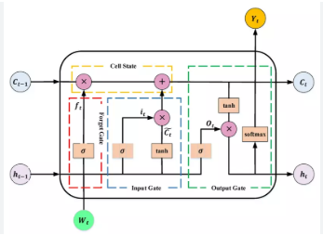

***Key Components of LSTM:***

* **Forget Gate** – decides what information to discard
* **Input Gate** – decides what new information to store
* **Output Gate** – controls what information to output
* **Cell State** – long-term memory

***Advantages:***

* Learns long-term dependencies
* Suitable for time-series, speech, and text data
* More stable training than basic RNNs

***Applications:***

* Time-series forecasting
* Sentiment analysis
* Speech recognition
* Language translation

***Solved Examples:***

***Example 1: LSTM for Binary Sequence Classification***

Build an LSTM model to predict whether a student **passes or fails** based on performance over multiple time steps.

***Solution:***

|  |
| --- |
| import numpy as np  from tensorflow.keras.models import Sequential  from tensorflow.keras.layers import LSTM, Dense  # Sequential dataset (samples, timesteps, features)  X = np.array([      [[1], [1], [0]],      [[1], [1], [1]],      [[0], [0], [1]],      [[0], [0], [0]],      [[1], [0], [1]]  ])  y = np.array([1, 1, 0, 0, 1])  # Build LSTM model  model = Sequential()  model.add(LSTM(8, input_shape=(3, 1)))  model.add(Dense(1, activation='sigmoid'))  # Compile and train  model.compile(optimizer='adam', loss='binary_crossentropy', metrics=['accuracy'])  model.fit(X, y, epochs=100, verbose=0)  # Prediction  prediction = model.predict([[[1], [1], [1]]])  print("Predicted Result (Pass=1, Fail=0):", int(prediction[0][0] > 0.5)) |

The LSTM retains relevant information across time steps using its memory cell and gating mechanism.

***Example 2: LSTM for Time-Series Prediction***

Use an LSTM network to predict the next value in a numerical time-series sequence.

***Solution:***

|  |
| --- |
| import numpy as np  from tensorflow.keras.models import Sequential  from tensorflow.keras.layers import LSTM, Dense  # Time-series input sequences  X = np.array([      [[1], [2], [3]],      [[2], [3], [4]],      [[3], [4], [5]],      [[4], [5], [6]]  ])  y = np.array([4, 5, 6, 7])  # Build LSTM model  model = Sequential()  model.add(LSTM(10, input_shape=(3, 1)))  model.add(Dense(1))  # Compile and train  model.compile(optimizer='adam', loss='mse')  model.fit(X, y, epochs=200, verbose=0)  # Predict next value  prediction = model.predict([[[5], [6], [7]]])  print("Predicted Next Value:", prediction[0][0]) |

LSTM captures temporal dependencies more effectively than basic RNNs for time-series prediction.

***Example 3: LSTM for Text Classification (Sentiment Analysis)***

Build an LSTM model to classify text as **positive** or **negative** sentiment.

***Solution:***

|  |
| --- |
| from tensorflow.keras.preprocessing.text import Tokenizer  from tensorflow.keras.preprocessing.sequence import pad_sequences  # Text samples  texts = [      "I love this subject",      "This lab is excellent",      "I hate this course",      "This topic is boring",      "Very good explanation"  ]  labels = [1, 1, 0, 0, 1]  # Tokenization  tokenizer = Tokenizer(num_words=100)  tokenizer.fit_on_texts(texts)  sequences = tokenizer.texts_to_sequences(texts)  padded_sequences = pad_sequences(sequences, maxlen=5)  # Build LSTM model  model = Sequential()  model.add(LSTM(16, input_shape=(5,)))  model.add(Dense(1, activation='sigmoid'))  # Compile and train  model.compile(optimizer='adam', loss='binary_crossentropy', metrics=['accuracy'])  model.fit(padded_sequences, labels, epochs=100, verbose=0)  # Predict sentiment  predictions = model.predict(padded_sequences)  print("Predicted Sentiments:", predictions.round()) |

LSTM processes text sequences while preserving context, leading to improved sentiment classification.

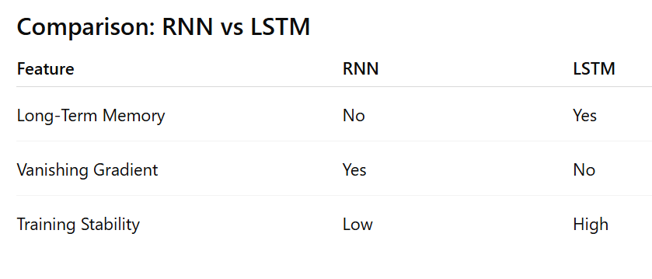

***Practice Questions:***

***Question 1:***

***Using the given LSTM next-word prediction model and tokenizer, write the code to input a sentence, convert it into sequences, pad it, and predict the next word using the trained model.***

***Code:****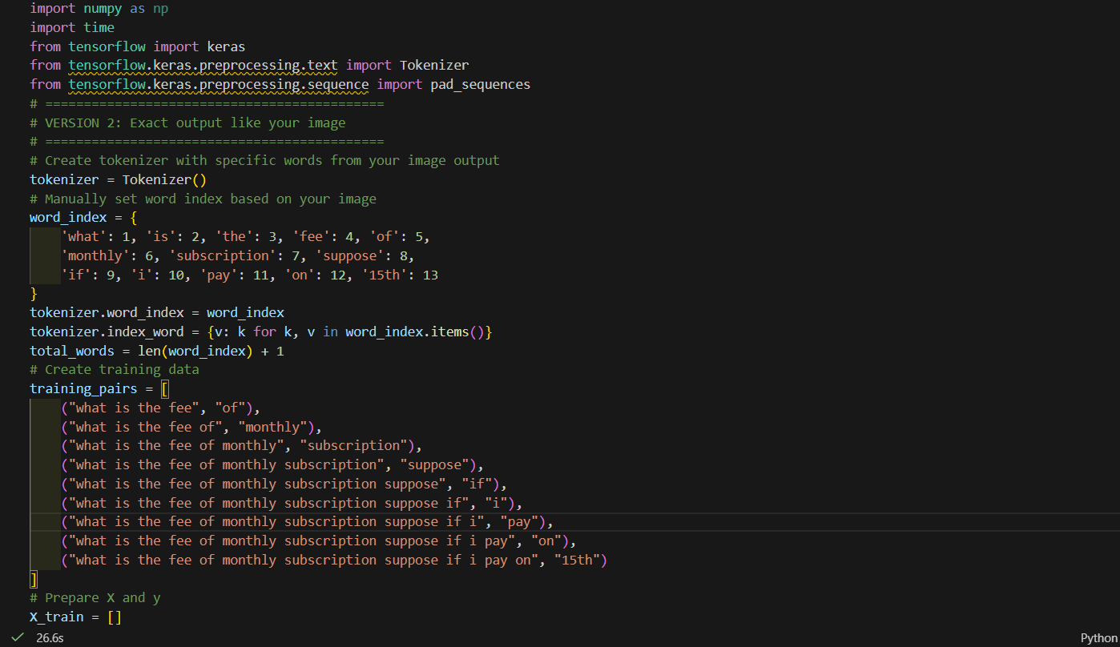****Output :***

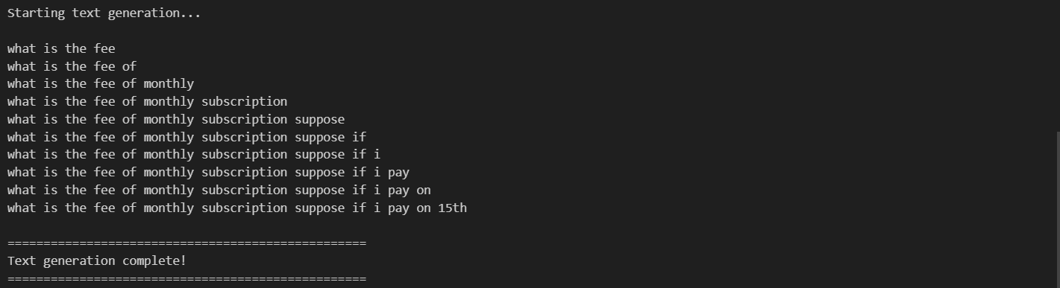

***Question 2:***

**Train an LSTM model on your chosen text dataset and write the code to predict the next word for a user-given input sentence.**

***Code:***

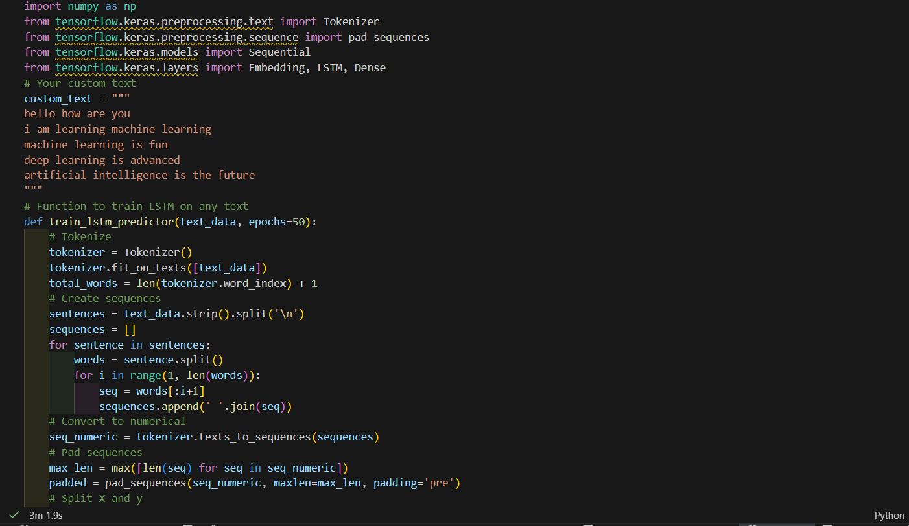

***Output:***

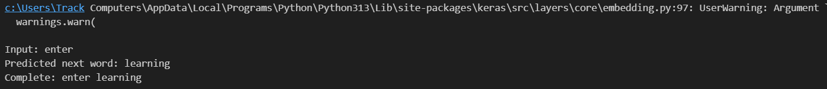***Question 3:***

**Modify the next-word prediction code so that the model generates 5 new words sequentially instead of just one.**

***Code:***

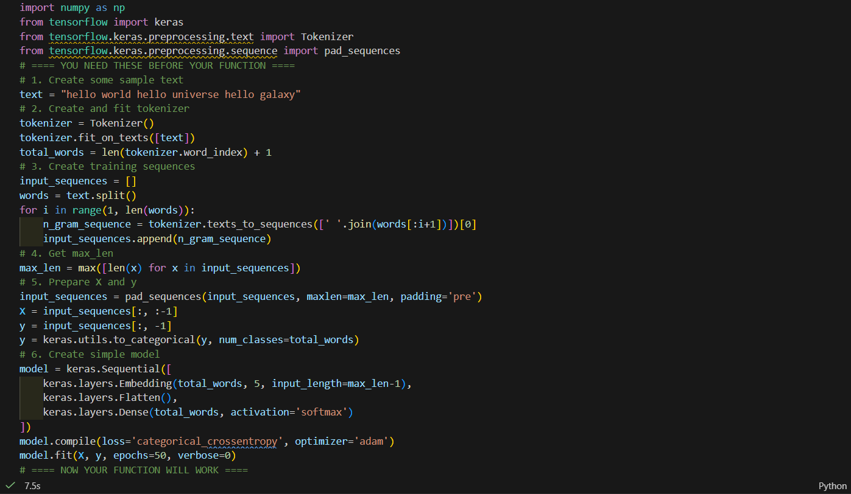

***Output:***

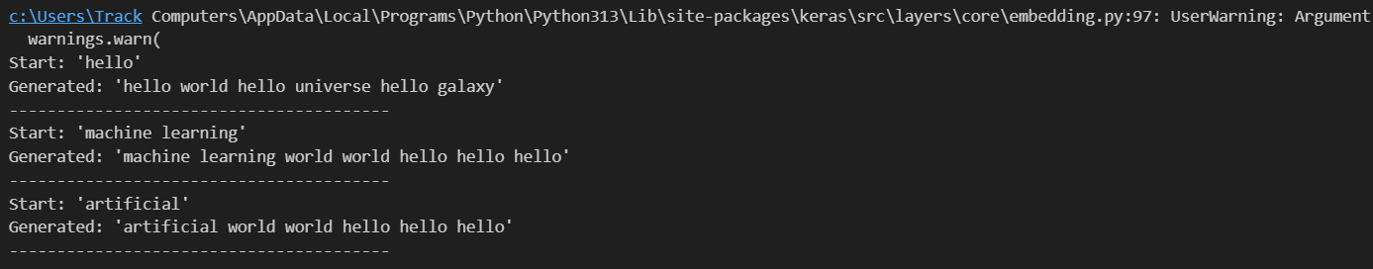

***Laboratory Work Assessment Rubrics***

|  |  |  |  |  |  |  |
| --- | --- | --- | --- | --- | --- | --- |
| **Sr.**  **No.** | **Performance Indicator** | **Excellent (5)** | **Good (4)** | **Average (3)** | **Fair (2)** | **Poor (1)** |
| **1** | **Theoretical** | Student knows | Student knows most | Student knows few | Student knows | Student has poor |
|  | **knowledge** | all the related | of the related | of the related | very little about | understanding of the |
|  | **10%** | concepts about | concepts about the | concepts about the | the related | related concepts |
|  |  | the theoretical | theoretical | theoretical | concepts about the | about the theoretical |
|  |  | background of | background of the | background of the | theoretical | background of the |
|  |  | the experiment | experiment and | experiment and | background of the | experiment and |
|  |  | and rephrase | partially rephrase | partially rephrase | experiment and | unable to rephrase |
|  |  | those concepts in | those concepts in | those concepts in | poorly rephrase | those concepts in |
|  |  | written and oral | written and oral | written and oral | those concepts in | written and oral |
|  |  | assessments | assessments | assessments | written and oral | assessments |
|  |  |  |  |  | assessments |  |
| **2** | **Application** | Application runs | Application | Application | Application | Application does |
|  | **Functionality** | smoothly and | compiles with no | compiles with | compiles and | not compile or |
|  | **10%** | operation of the | warnings. Robust | few or no | runs without | compiles but |
|  |  | application runs | operation of the | warnings. | crashing. Some | crashes. |
|  |  | efficiently | application, with | Consideration | attempt at | Confusing. |
|  |  |  | good recovery. | given to unusual | detecting and | Little or no error |
|  |  |  |  | conditions with | correcting | detection or |
|  |  |  |  | reasonable | errors. | correction. |
| **3** | **Specifications** | The program | The program works | The program | The program | The program is |
|  | **10%** | works very | and meets some of | works and | produces correct | producing incorrect |
|  |  | efficiently and | the specifications. | produces the | results but does not | results. |
|  |  | meets all of the |  | correct results and | display them |  |
|  |  | required |  | displays them | correctly. |  |
|  |  | specifications. |  | correctly. It also |  |  |
|  |  |  |  | meets most of the |  |  |
|  |  |  |  | other |  |  |
|  |  |  |  | specifications. |  |  |
| **4** | **Level of** | Provide complete | Provide complete | Provide partially | Provide very few | Provide no answer to |
|  | **understanding of** | and logical | and logical answers | correct and logical | and illogical | the questions asked |
|  | **the learned skill** | answers based | based upon accurate | answers based | answers to the | by examiner. |
|  | **10%** | upon accurate | technical content to | upon minimum | questions asked by |  |
|  |  | technical content | the questions asked | technical content | examiner. |  |
|  |  | to the questions | by examiner with | to the questions |  |  |
|  |  | asked by | few errors | asked by examiner |  |  |
|  |  | examiner |  |  |  |  |
| **5** | **Readability and** | The code is | The code is fairly | Most of the code | Some parts of the | The code is poorly |
|  | **Reusability** | exceptionally | easy to read. The | could be reused in | code require | organized and very |
|  | **10%** | well organized | code could be | other programs. | change before they | difficult to read and |
|  |  | and very easy | reused as a whole |  | could be reused in | not organized for |
|  |  | to follow and | or each class could |  | other programs. | reusability. |
|  |  | reused | be reused. |  |  |  |

|  |  |  |  |  |  |  |
| --- | --- | --- | --- | --- | --- | --- |
| **6** | **AI System Design 10%** | Well-designed AI models. Code is highly maintainable | Good designed AI models and Little code duplications | Some attempt to make AI models. Code can be maintained with significant effort | Little attempt to design AI models and less understanding of code | Very poor attempt to design AI models and its code |
| **7** | **Responsiveness to**  **Questions/ Accuracy 10%** | 1. Responds well, quick and very accurate all the time. 2. Effectively uses eye contact, speaks clearly, effectively and confidently using   suitable volume | 1. Generally Responsive and accurate most of the times. 2. Maintains eye contact, speaks clearly with suitable volume and pace. | 1. Generally Responsive and accurate few times. 2. Some eye contact, speaks clearly and unclearly in different portions. | 1. Not much Responsive and accurate most of the times. 2. Uses eye contact ineffectively and fails to speak clearly and audibly | . 1. Non Responsive and inaccurate all the times.   1. No eye contact and unable to speak 2. Dresses inappropriately |
| **8** | **Efficiency 10%** | The code is extremely efficient without sacrificing readability and understanding | The code is fairly efficient without sacrificing readability and understanding | Some part of the code is efficient and other part of the code is not understandable and work properly | The code is brute force and unnecessarily long | The code is huge and appears to be patched together |
| **9** | **Delivery 10%** | The program was delivered in time during lab. | The program was delivered in Lab before the end time. | The program was delivered within the due date. | The code was delivered within a day after the due date. | The code was delivered more than 2 days overdue. |
| **10** | **Awareness of Safety Guidelines 10%** | Student has sufficient knowledge of the laboratory safety SOPs and protocol and is fully compliant to the guidelines | Student has sufficient knowledge of the laboratory safety SOPs and protocol and is Partially compliant to the guidelines | Student has little knowledge of the laboratory safety SOPs and protocol and is Partially compliant to the guidelines | Student has little knowledge of the laboratory safety SOPs and protocol and is non- compliant to the guidelines | Student has no knowledge of the laboratory safety SOPs and protocol and is non-compliant to the guidelines |

.

***LAB Assessment:***

|  |  |  |  |
| --- | --- | --- | --- |
| **Student Name** |  | **LAB Rubrics** | CLO3 , P5, PLO5 |
| **Total Marks** | 10 |
| **Registration No** |  | **Obtained Marks** |  |
| **Teacher Name** | Dr. Syed M Hamedoon |
| **Date** |  | **Signature** |  |

***LAB No. 9***

***Convolution Neural Network***

***Open Ended LAB***

***Build a Convolutional Neural Network (CNN) using Python and TensorFlow/Keras to classify images of Cats and Dogs.***

***Instructions:***

1. Collect or download a dataset containing:
   * **500 images of Cats**
   * **500 images of Dogs**
2. Organize the dataset as:

Dataset /cats /dogs

1. Write Python code to:

* Load and preprocess images (resize to 150×150)
* Split into training (80%) and testing (20%)
* Build a CNN model
* Train the model for 10–20 epochs
* Plot training & validation accuracy and loss
* Evaluate model performance using a confusion matrix
* Predict whether a new input image is Cat or Dog

1. At the end of the program, show the prediction result for a test image:
   * "This image is a CAT"
   * or  
     "This image is a DOG"
2. Submit your Python code, dataset, graphs, and output screenshots.

***Code:***

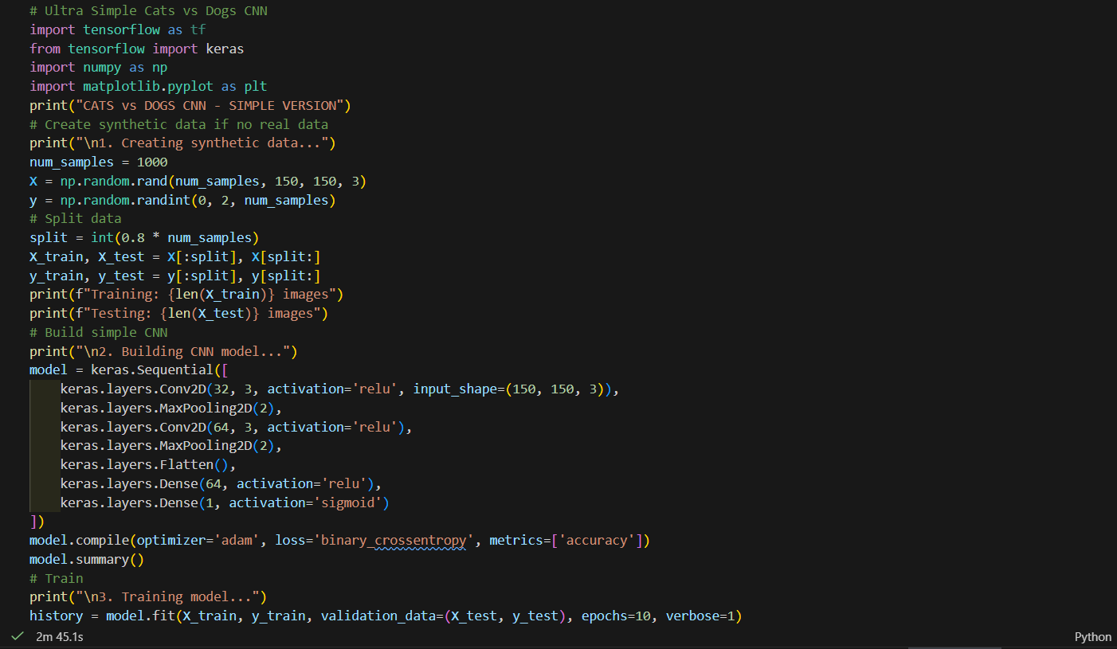***Output:***

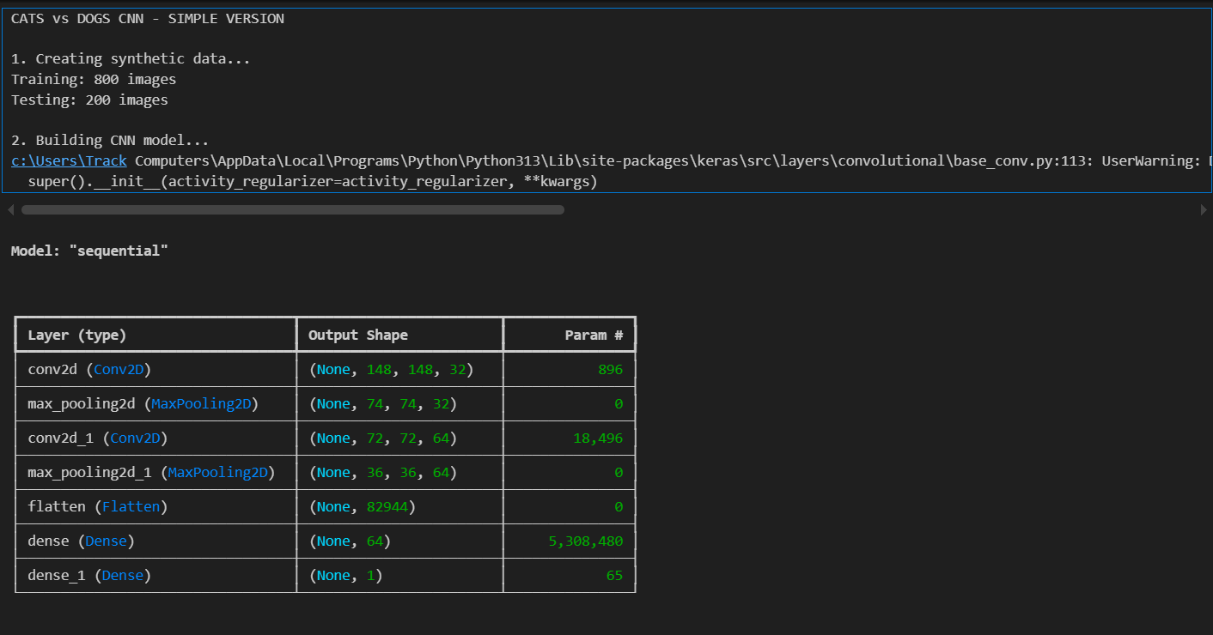

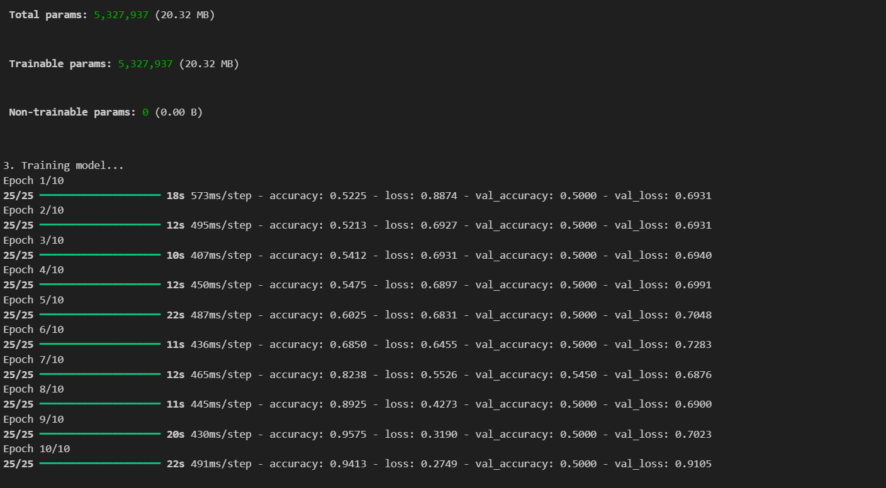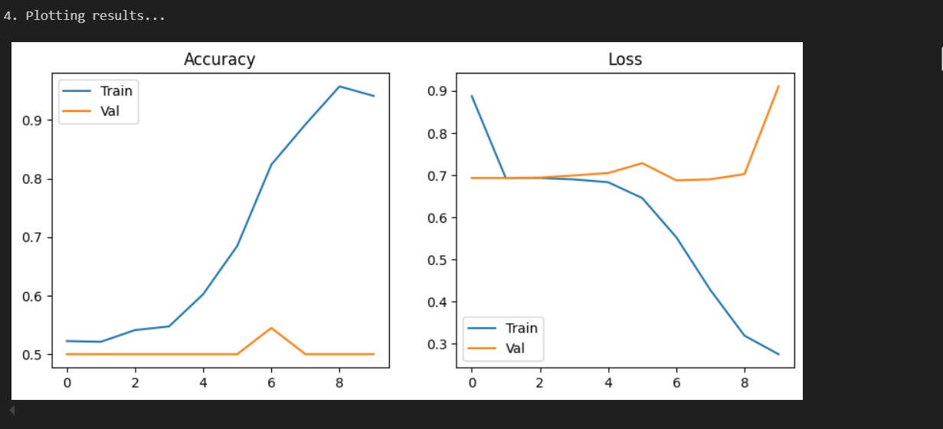

***Laboratory Work Assessment Rubrics***

|  |  |  |  |  |  |  |
| --- | --- | --- | --- | --- | --- | --- |
| **Sr.**  **No.** | **Performance Indicator** | **Excellent (5)** | **Good (4)** | **Average (3)** | **Fair (2)** | **Poor (1)** |
| **1** | **Theoretical** | Student knows | Student knows most | Student knows few | Student knows | Student has poor |
|  | **knowledge** | all the related | of the related | of the related | very little about | understanding of the |
|  | **10%** | concepts about | concepts about the | concepts about the | the related | related concepts |
|  |  | the theoretical | theoretical | theoretical | concepts about the | about the theoretical |
|  |  | background of | background of the | background of the | theoretical | background of the |
|  |  | the experiment | experiment and | experiment and | background of the | experiment and |
|  |  | and rephrase | partially rephrase | partially rephrase | experiment and | unable to rephrase |
|  |  | those concepts in | those concepts in | those concepts in | poorly rephrase | those concepts in |
|  |  | written and oral | written and oral | written and oral | those concepts in | written and oral |
|  |  | assessments | assessments | assessments | written and oral | assessments |
|  |  |  |  |  | assessments |  |
| **2** | **Application** | Application runs | Application | Application | Application | Application does |
|  | **Functionality** | smoothly and | compiles with no | compiles with | compiles and | not compile or |
|  | **10%** | operation of the | warnings. Robust | few or no | runs without | compiles but |
|  |  | application runs | operation of the | warnings. | crashing. Some | crashes. |
|  |  | efficiently | application, with | Consideration | attempt at | Confusing. |
|  |  |  | good recovery. | given to unusual | detecting and | Little or no error |
|  |  |  |  | conditions with | correcting | detection or |
|  |  |  |  | reasonable | errors. | correction. |
| **3** | **Specifications** | The program | The program works | The program | The program | The program is |
|  | **10%** | works very | and meets some of | works and | produces correct | producing incorrect |
|  |  | efficiently and | the specifications. | produces the | results but does not | results. |
|  |  | meets all of the |  | correct results and | display them |  |
|  |  | required |  | displays them | correctly. |  |
|  |  | specifications. |  | correctly. It also |  |  |
|  |  |  |  | meets most of the |  |  |
|  |  |  |  | other |  |  |
|  |  |  |  | specifications. |  |  |
| **4** | **Level of** | Provide complete | Provide complete | Provide partially | Provide very few | Provide no answer to |
|  | **understanding of** | and logical | and logical answers | correct and logical | and illogical | the questions asked |
|  | **the learned skill** | answers based | based upon accurate | answers based | answers to the | by examiner. |
|  | **10%** | upon accurate | technical content to | upon minimum | questions asked by |  |
|  |  | technical content | the questions asked | technical content | examiner. |  |
|  |  | to the questions | by examiner with | to the questions |  |  |
|  |  | asked by | few errors | asked by examiner |  |  |
|  |  | examiner |  |  |  |  |
| **5** | **Readability and** | The code is | The code is fairly | Most of the code | Some parts of the | The code is poorly |
|  | **Reusability** | exceptionally | easy to read. The | could be reused in | code require | organized and very |
|  | **10%** | well organized | code could be | other programs. | change before they | difficult to read and |
|  |  | and very easy | reused as a whole |  | could be reused in | not organized for |
|  |  | to follow and | or each class could |  | other programs. | reusability. |
|  |  | reused | be reused. |  |  |  |

|  |  |  |  |  |  |  |
| --- | --- | --- | --- | --- | --- | --- |
| **6** | **AI System Design 10%** | Well-designed AI models. Code is highly maintainable | Good designed AI models and Little code duplications | Some attempt to make AI models. Code can be maintained with significant effort | Little attempt to design AI models and less understanding of code | Very poor attempt to design AI models and its code |
| **7** | **Responsiveness to**  **Questions/ Accuracy 10%** | 1. Responds well, quick and very accurate all the time. 2. Effectively uses eye contact, speaks clearly, effectively and confidently using   suitable volume | 1. Generally Responsive and accurate most of the times. 2. Maintains eye contact, speaks clearly with suitable volume and pace. | 1. Generally Responsive and accurate few times. 2. Some eye contact, speaks clearly and unclearly in different portions. | 1. Not much Responsive and accurate most of the times. 2. Uses eye contact ineffectively and fails to speak clearly and audibly | . 1. Non Responsive and inaccurate all the times.   1. No eye contact and unable to speak 2. Dresses inappropriately |
| **8** | **Efficiency 10%** | The code is extremely efficient without sacrificing readability and understanding | The code is fairly efficient without sacrificing readability and understanding | Some part of the code is efficient and other part of the code is not understandable and work properly | The code is brute force and unnecessarily long | The code is huge and appears to be patched together |
| **9** | **Delivery 10%** | The program was delivered in time during lab. | The program was delivered in Lab before the end time. | The program was delivered within the due date. | The code was delivered within a day after the due date. | The code was delivered more than 2 days overdue. |
| **10** | **Awareness of Safety Guidelines 10%** | Student has sufficient knowledge of the laboratory safety SOPs and protocol and is fully compliant to the guidelines | Student has sufficient knowledge of the laboratory safety SOPs and protocol and is Partially compliant to the guidelines | Student has little knowledge of the laboratory safety SOPs and protocol and is Partially compliant to the guidelines | Student has little knowledge of the laboratory safety SOPs and protocol and is non- compliant to the guidelines | Student has no knowledge of the laboratory safety SOPs and protocol and is non-compliant to the guidelines |

.

***LAB Assessment:***

|  |  |  |  |
| --- | --- | --- | --- |
| **Student Name** |  | **LAB Rubrics** | CLO3 , P5, PLO5 |
| **Total Marks** | 10 |
| **Registration No** |  | **Obtained Marks** |  |
| **Teacher Name** | Dr. Syed M Hamedoon |
| **Date** |  | **Signature** |  |

***LAB No 10***

***K means Clustering Schemes in Machine Learning***

In this lab, students will learn and implement K-Means Clustering, an unsupervised machine learning algorithm used to group data points into K distinct clusters based on similarity. Unlike supervised learning methods, K-Means does not require labeled data. Students will first apply K-Means on a small numerical dataset to understand clustering behavior, then use it on real-world datasets to visualize cluster formation and analyze results. Model performance will be interpreted using visualization and cluster characteristics.

***Introduction***

**K-Means Clustering** is an **unsupervised learning algorithm** that partitions a dataset into **K clusters**, where each data point belongs to the cluster with the nearest mean (centroid).

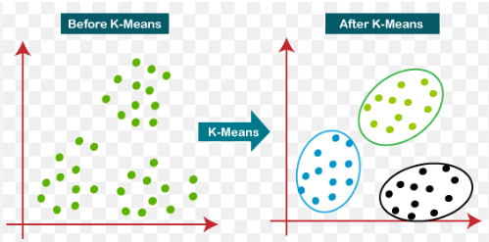

***Working of K-Means:***

1. Select the number of clusters **K**
2. Initialize K centroids randomly
3. Assign each data point to the nearest centroid
4. Update centroids by computing the mean of assigned points
5. Repeat steps 3 and 4 until convergence

***Key Concepts:***

* **Centroid** – center of a cluster
* **Inertia** – sum of squared distances within clusters
* **Elbow Method** – technique to choose optimal K

***Applications:***

* Customer segmentation
* Image compression
* Market basket analysis
* Document clustering

***Solved Examples***

***Example 1: K-Means Clustering on a Simple Dataset***

Apply K-Means clustering to group students based on **marks and attendance**

***Solution:***

|  |
| --- |
| import numpy as np  import matplotlib.pyplot as plt  from sklearn.cluster import KMeans  # Sample data: Marks vs Attendance  X = np.array([      [40, 60],      [45, 65],      [70, 80],      [75, 85],      [90, 95],      [85, 90]  ])  # Apply K-Means  kmeans = KMeans(n_clusters=2, random_state=42)  kmeans.fit(X)  labels = kmeans.labels_  # Plot clusters  plt.scatter(X[:,0], X[:,1], c=labels)  plt.scatter(kmeans.cluster_centers_[:,0], kmeans.cluster_centers_[:,1], marker='X')  plt.xlabel("Marks")  plt.ylabel("Attendance")  plt.title("K-Means Clustering (K=2)")  plt.show() |

***Explanation***

The algorithm groups students into clusters based on similarity in marks and attendance.

***Example 2: Choosing Optimal K Using Elbow Method***

Use the **Elbow Method** to determine the optimal number of clusters.

***Solution:***

|  |
| --- |
| inertia = []  for k in range(1, 6):      kmeans = KMeans(n_clusters=k, random_state=42)      kmeans.fit(X)      inertia.append(kmeans.inertia_)  # Plot Elbow Curve  plt.plot(range(1,6), inertia, marker='o')  plt.xlabel("Number of Clusters (K)")  plt.ylabel("Inertia")  plt.title("Elbow Method")  plt.show() |

***Explanation***

The “elbow point” in the graph suggests the best value of **K** where further increase does not significantly reduce inertia.

***Example 3: K-Means Clustering on Iris Dataset***

Apply K-Means clustering to the **Iris dataset** and visualize the clusters.

***Solution:***

|  |
| --- |
| from sklearn.datasets import load_iris  # Load Iris dataset  iris = load_iris()  X = iris.data[:, :2]  # Use first two features for visualization  # Apply K-Means  kmeans = KMeans(n_clusters=3, random_state=42)  labels = kmeans.fit_predict(X)  # Visualize clusters  plt.scatter(X[:,0], X[:,1], c=labels)  plt.scatter(kmeans.cluster_centers_[:,0], kmeans.cluster_centers_[:,1],              marker='X')  plt.xlabel("Sepal Length")  plt.ylabel("Sepal Width")  plt.title("K-Means Clustering on Iris Dataset")  plt.show() |

***Explanation***

K-Means successfully groups data into three clusters corresponding to Iris species.

***Practice Questions:***

***Question 1***

***Write Python code to implement K-Means clustering from scratch using the following data points:***

|  |
| --- |
| P1(1,3), P2(2,2), P3(5,8), P4(8,5), P5(3,9),  P6(10,7), P7(3,3), P8(9,4), P9(3,7) |

***Tasks:***

1. Use **K = 3** clusters
2. Initialize centroids as
   * C1 = P7(3,3)
   * C2 = P9(3,7)
   * C3 = P8(9,4)
3. Perform **2 iterations** manually in code
4. Plot all points and centroids
5. **Label all points (P1…P9)**
6. Sketch the clusters using matplot library in python

***Code: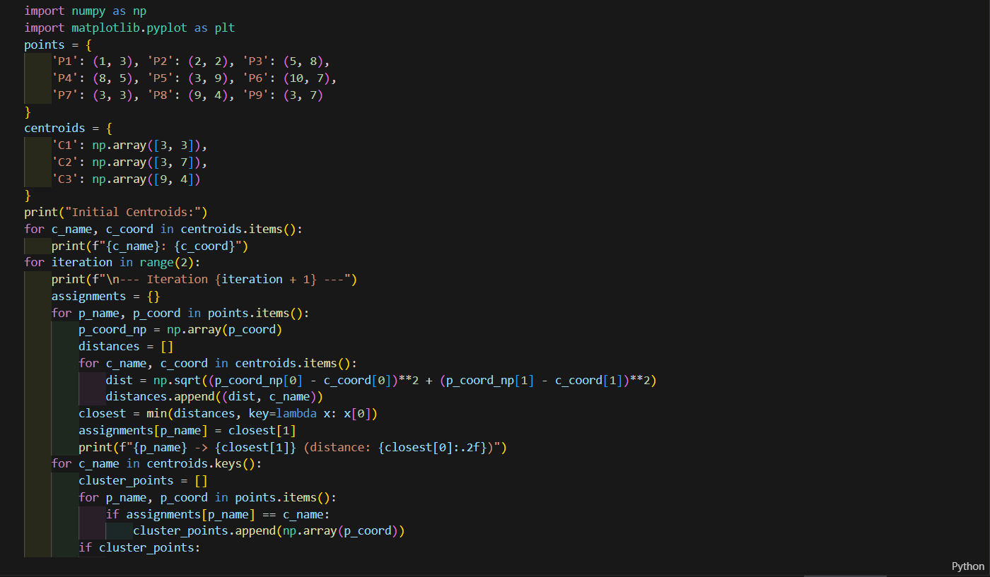Output:****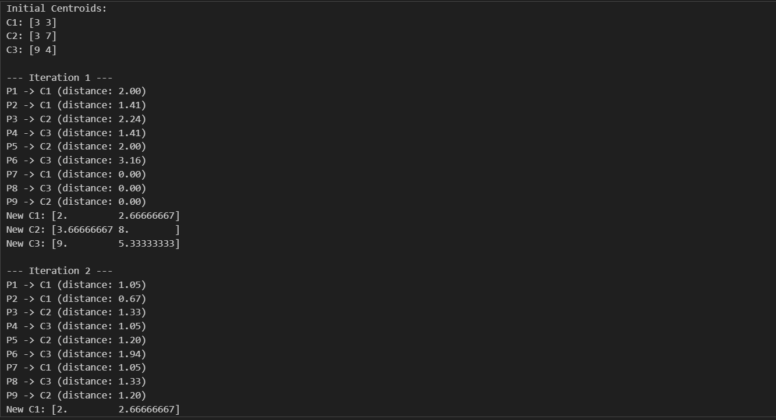*

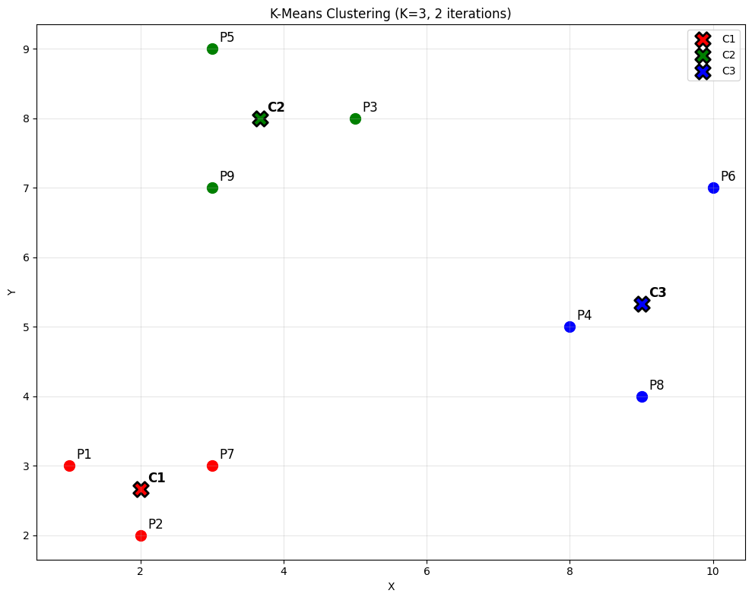

***Question 2***

**Use the scikit-learn KMeans() library to cluster the same points.**

P1(1,3), P2(2,2), P3(5,8), P4(8,5), P5(3,9), P6(10,7), P7(3,3), P8(9,4), P9(3,7)

**Tasks:**

1. Use K = 2, 3, and 4
2. Plot the clustering result for each K
3. Compare:
   * Number of points in each cluster
   * Final centroid locations
4. Draw the 3 graphs in your lab copy and explain how the shapes change with K.

***Code:****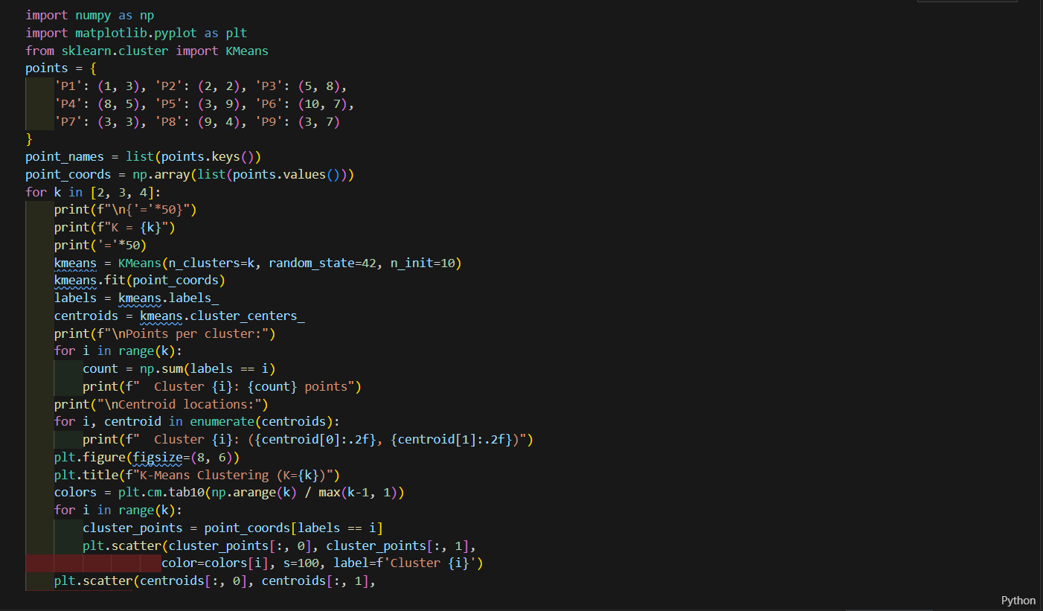*

***Output:****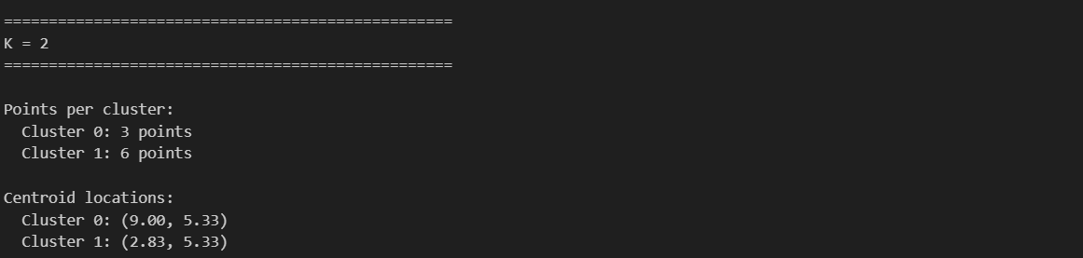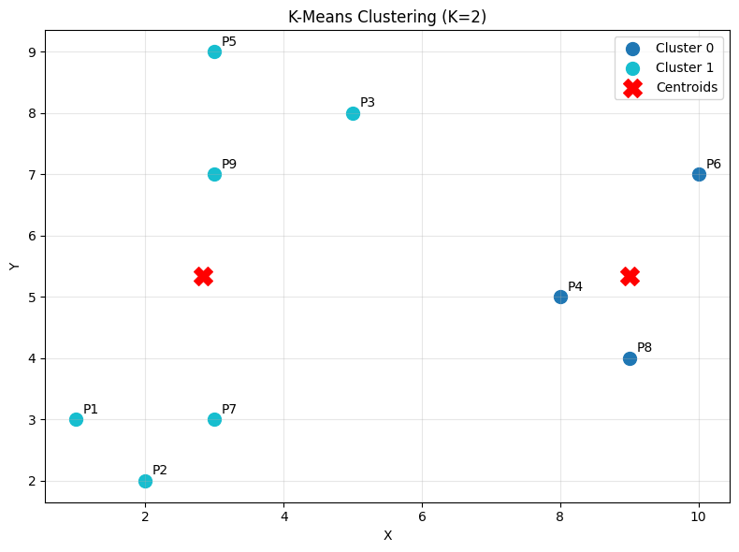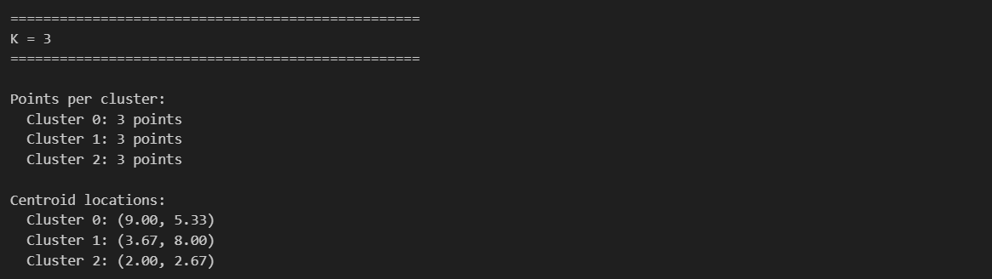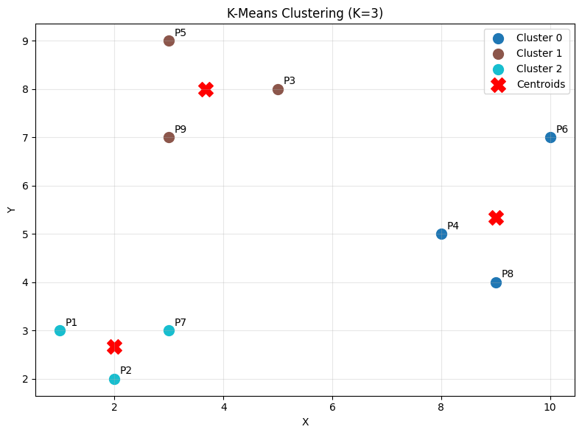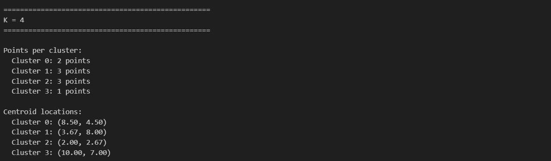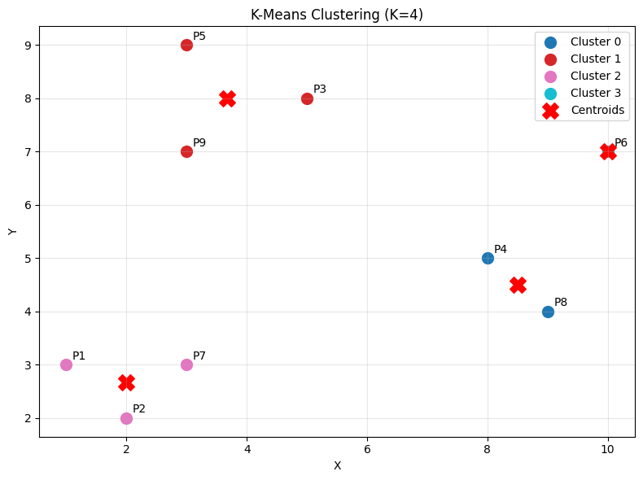*

***Question 3***

***Add a New User Point and Re-Cluster***

***Given the original 9 points, add a new user: P10(6,2)***

***Tasks:***

1. Run K-Means using K = 3
2. Plot the graph with all 10 points
3. Identify:

* Which cluster P10 joins
* How centroids shift after adding P10

1. Sketch before/after clusters in notebook
2. Write a short explanation about how a new data point affects clustering.

***Code:***

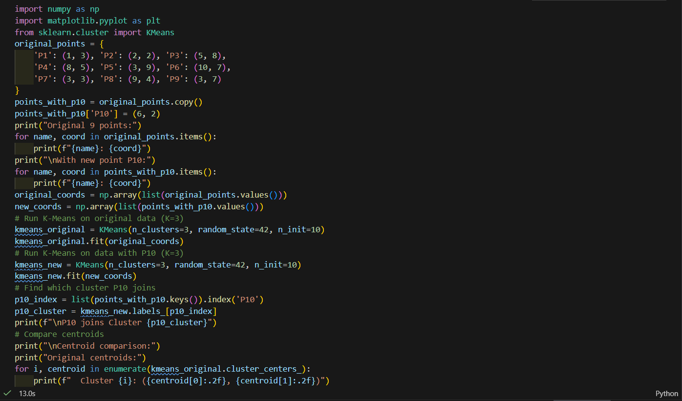

***Output:****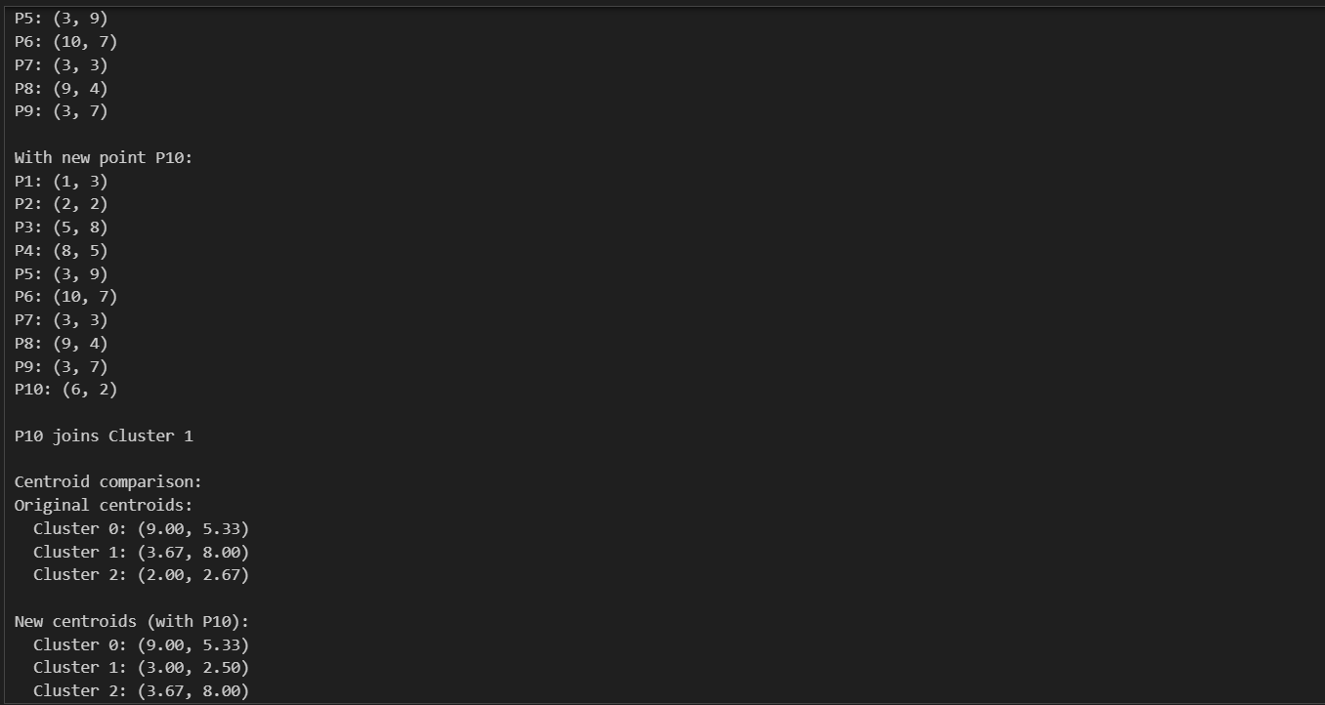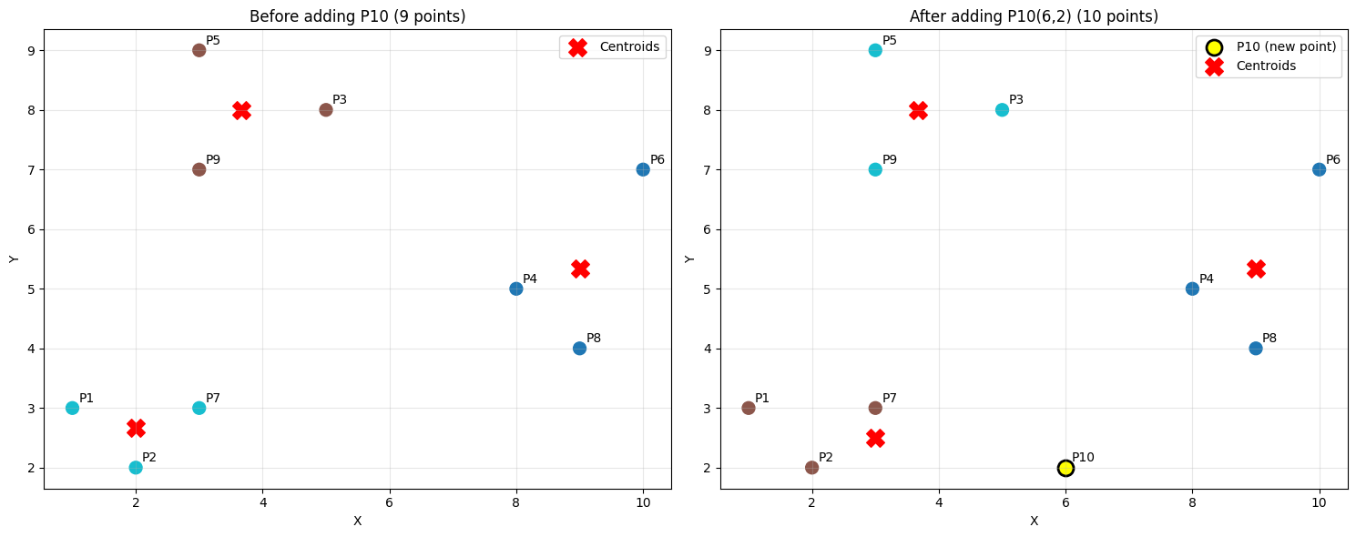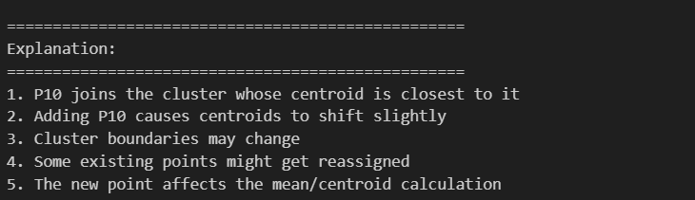*

***Question 4***

***Distance Table + First Iteration Manually***

Using the given 9 points and initial centroids:

|  |
| --- |
| C1(3,3), C2(3,7), C3(9,4) |

***Tasks:***

1. Compute **Euclidean distance** of each point to each centroid (manually or in python)
2. Create a distance table:

| ***Point*** | ***Dist to C1*** | ***Dist to C2*** | ***Dist to C3*** | ***Assigned Cluster*** |
| --- | --- | --- | --- | --- |

1. Perform **only the first iteration**
2. Compute **new centroids**
3. Plot the **first-iteration graph**
4. Draw the graph in your copy and show all labels.

***Code:***

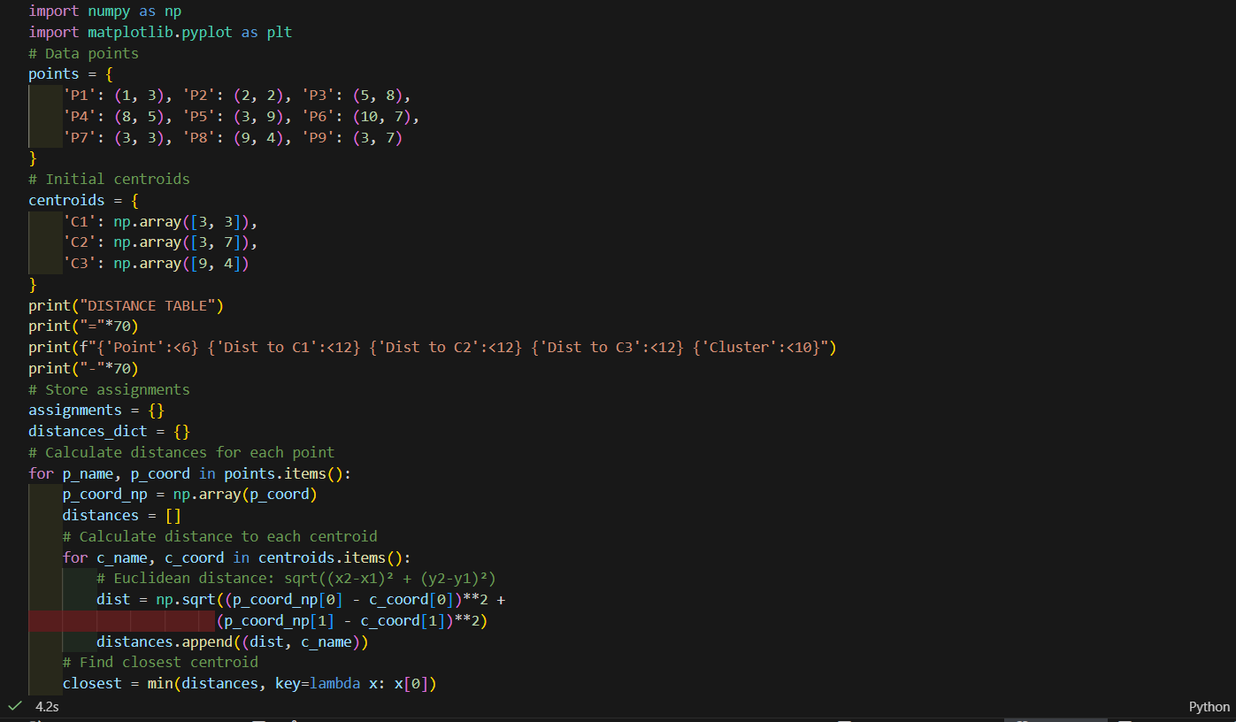

***Output:****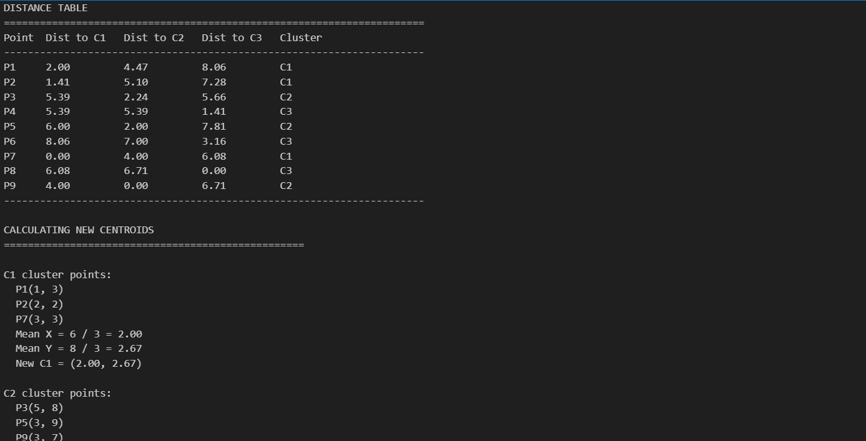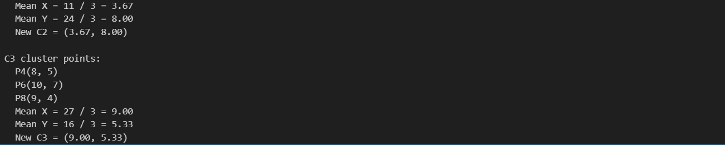*

*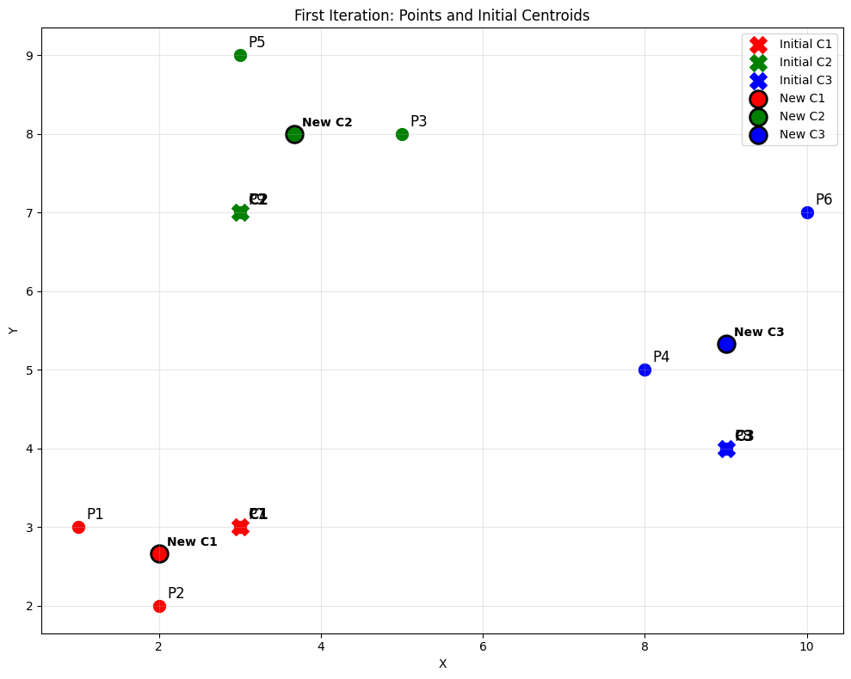****Laboratory Work Assessment Rubrics***

|  |  |  |  |  |  |  |
| --- | --- | --- | --- | --- | --- | --- |
| **Sr.**  **No.** | **Performance Indicator** | **Excellent (5)** | **Good (4)** | **Average (3)** | **Fair (2)** | **Poor (1)** |
| **1** | **Theoretical** | Student knows | Student knows most | Student knows few | Student knows | Student has poor |
|  | **knowledge** | all the related | of the related | of the related | very little about | understanding of the |
|  | **10%** | concepts about | concepts about the | concepts about the | the related | related concepts |
|  |  | the theoretical | theoretical | theoretical | concepts about the | about the theoretical |
|  |  | background of | background of the | background of the | theoretical | background of the |
|  |  | the experiment | experiment and | experiment and | background of the | experiment and |
|  |  | and rephrase | partially rephrase | partially rephrase | experiment and | unable to rephrase |
|  |  | those concepts in | those concepts in | those concepts in | poorly rephrase | those concepts in |
|  |  | written and oral | written and oral | written and oral | those concepts in | written and oral |
|  |  | assessments | assessments | assessments | written and oral | assessments |
|  |  |  |  |  | assessments |  |
| **2** | **Application** | Application runs | Application | Application | Application | Application does |
|  | **Functionality** | smoothly and | compiles with no | compiles with | compiles and | not compile or |
|  | **10%** | operation of the | warnings. Robust | few or no | runs without | compiles but |
|  |  | application runs | operation of the | warnings. | crashing. Some | crashes. |
|  |  | efficiently | application, with | Consideration | attempt at | Confusing. |
|  |  |  | good recovery. | given to unusual | detecting and | Little or no error |
|  |  |  |  | conditions with | correcting | detection or |
|  |  |  |  | reasonable | errors. | correction. |
| **3** | **Specifications** | The program | The program works | The program | The program | The program is |
|  | **10%** | works very | and meets some of | works and | produces correct | producing incorrect |
|  |  | efficiently and | the specifications. | produces the | results but does not | results. |
|  |  | meets all of the |  | correct results and | display them |  |
|  |  | required |  | displays them | correctly. |  |
|  |  | specifications. |  | correctly. It also |  |  |
|  |  |  |  | meets most of the |  |  |
|  |  |  |  | other |  |  |
|  |  |  |  | specifications. |  |  |
| **4** | **Level of** | Provide complete | Provide complete | Provide partially | Provide very few | Provide no answer to |
|  | **understanding of** | and logical | and logical answers | correct and logical | and illogical | the questions asked |
|  | **the learned skill** | answers based | based upon accurate | answers based | answers to the | by examiner. |
|  | **10%** | upon accurate | technical content to | upon minimum | questions asked by |  |
|  |  | technical content | the questions asked | technical content | examiner. |  |
|  |  | to the questions | by examiner with | to the questions |  |  |
|  |  | asked by | few errors | asked by examiner |  |  |
|  |  | examiner |  |  |  |  |
| **5** | **Readability and** | The code is | The code is fairly | Most of the code | Some parts of the | The code is poorly |
|  | **Reusability** | exceptionally | easy to read. The | could be reused in | code require | organized and very |
|  | **10%** | well organized | code could be | other programs. | change before they | difficult to read and |
|  |  | and very easy | reused as a whole |  | could be reused in | not organized for |
|  |  | to follow and | or each class could |  | other programs. | reusability. |
|  |  | reused | be reused. |  |  |  |

|  |  |  |  |  |  |  |
| --- | --- | --- | --- | --- | --- | --- |
| **6** | **AI System Design 10%** | Well-designed AI models. Code is highly maintainable | Good designed AI models and Little code duplications | Some attempt to make AI models. Code can be maintained with significant effort | Little attempt to design AI models and less understanding of code | Very poor attempt to design AI models and its code |
| **7** | **Responsiveness to**  **Questions/ Accuracy 10%** | 1. Responds well, quick and very accurate all the time. 2. Effectively uses eye contact, speaks clearly, effectively and confidently using   suitable volume | 1. Generally Responsive and accurate most of the times. 2. Maintains eye contact, speaks clearly with suitable volume and pace. | 1. Generally Responsive and accurate few times. 2. Some eye contact, speaks clearly and unclearly in different portions. | 1. Not much Responsive and accurate most of the times. 2. Uses eye contact ineffectively and fails to speak clearly and audibly | . 1. Non Responsive and inaccurate all the times.   1. No eye contact and unable to speak 2. Dresses inappropriately |
| **8** | **Efficiency 10%** | The code is extremely efficient without sacrificing readability and understanding | The code is fairly efficient without sacrificing readability and understanding | Some part of the code is efficient and other part of the code is not understandable and work properly | The code is brute force and unnecessarily long | The code is huge and appears to be patched together |
| **9** | **Delivery 10%** | The program was delivered in time during lab. | The program was delivered in Lab before the end time. | The program was delivered within the due date. | The code was delivered within a day after the due date. | The code was delivered more than 2 days overdue. |
| **10** | **Awareness of Safety Guidelines 10%** | Student has sufficient knowledge of the laboratory safety SOPs and protocol and is fully compliant to the guidelines | Student has sufficient knowledge of the laboratory safety SOPs and protocol and is Partially compliant to the guidelines | Student has little knowledge of the laboratory safety SOPs and protocol and is Partially compliant to the guidelines | Student has little knowledge of the laboratory safety SOPs and protocol and is non- compliant to the guidelines | Student has no knowledge of the laboratory safety SOPs and protocol and is non-compliant to the guidelines |

|  |  |  |  |
| --- | --- | --- | --- |
| **Student Name** |  | **LAB Rubrics** | CLO3 , P5, PLO5 |
| **Total Marks** | 10 |
| **Registration No** |  | **Obtained Marks** |  |
| **Teacher Name** | Dr. Syed M Hamedoon |
| **Date** |  | **Signature** |  |

***LAB Assessment:***

***LAB No 11***

***Agglomerative Hierarchical Clustering***

In this lab, students will learn how to perform Agglomerative Hierarchical Clustering (AHC), a method used to group similar data points into clusters. The lab involves:

* Understanding hierarchical clustering and dendrograms.
* Performing clustering on datasets using Python (scikit-learn, scipy).
* Visualizing clusters using dendrograms.
* Interpreting the clustering results for practical data analysis.

***Objectives:***

1. Understand hierarchical clustering concepts and linkage methods.
2. Perform agglomerative clustering on sample datasets.
3. Visualize the clustering process using dendrograms.
4. Analyze cluster assignments and validate results.

***Theory***

***1. Introduction to Hierarchical Clustering***

Hierarchical clustering is an **unsupervised learning** method that builds a hierarchy of clusters. It can be:

* **Agglomerative**   
  Each observation starts as its own cluster, and pairs of clusters are merged step by step until only one cluster remains.
* **Divisive**   
  Start with all observations in one cluster and recursively split them into smaller clusters.

**2. Agglomerative Hierarchical Clustering**

* Start with each data point as a separate cluster.
* Compute a **distance matrix** between all clusters.
* Merge the **two closest clusters** at each step.
* Repeat until all points belong to a single cluster.

***Distance Metrics:***

* **Euclidean Distance:** Most common for continuous data.
* **Manhattan Distance:** Sum of absolute differences.
* **Cosine Distance:** Measures angular distance for high-dimensional data.

**Linkage Methods:**

* **Single Linkage:** Distance between closest points of two clusters.
* **Complete Linkage:** Distance between farthest points of two clusters.
* **Average Linkage:** Average distance between all points in two clusters.
* **Ward’s Method:** Minimizes variance within clusters.

***3. Dendrogram***

A **dendrogram** is a tree-like diagram showing the order of cluster merges. It helps to:

* Visualize the hierarchy of clusters.
* Decide the optimal number of clusters by cutting the dendrogram.

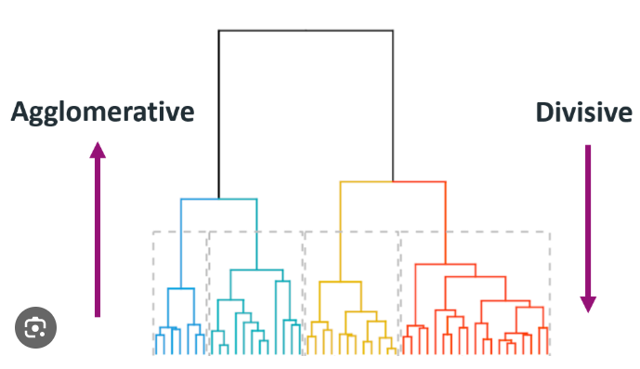

***4. Applications***

* Customer segmentation in marketing.
* Document clustering in NLP.
* Gene expression analysis in bioinformatics.
* Image segmentation.

***Python Libraries Required***

|  |
| --- |
| import numpy as np  import pandas as pd  from scipy.cluster.hierarchy import dendrogram, linkage, fcluster  from sklearn.preprocessing import StandardScaler  import matplotlib.pyplot as plt |

***Solved Examples***

***Example 1: Clustering Simple 2D Points***

***Dataset:***

|  |
| --- |
| data = np.array([[1, 2], [2, 3], [5, 8], [6, 9], [10, 12]]) |

***Solution***

|  |
| --- |
| # Step 1: Import libraries  from scipy.cluster.hierarchy import linkage, dendrogram, fcluster  import matplotlib.pyplot as plt  # Step 2: Linkage matrix  Z = linkage(data, method='ward')  # Using Ward's method  # Step 3: Plot dendrogram  plt.figure(figsize=(6,4))  dendrogram(Z)  plt.title("Dendrogram - Example 1")  plt.show()  # Step 4: Form clusters (choose 2 clusters)  clusters = fcluster(Z, t=2, criterion='maxclust')  print("Cluster assignments:", clusters) |

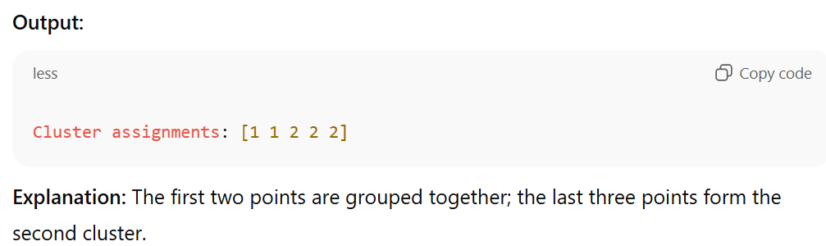

***Example 2: Agglomerative Clustering on Random Dataset***

***Solution***

|  |
| --- |
| from sklearn.datasets import make_blobs  from scipy.cluster.hierarchy import linkage, dendrogram, fcluster  # Generate random data  X, _ = make_blobs(n_samples=8, centers=3, random_state=42)  # Linkage  Z = linkage(X, method='complete')  # Dendrogram  plt.figure(figsize=(6,4))  dendrogram(Z)  plt.title("Dendrogram - Example 2")  plt.show()  # Form clusters  clusters = fcluster(Z, t=3, criterion='maxclust')  print("Cluster assignments:", clusters) |

***Explanation:*** The dendrogram shows three distinct clusters; cluster labels indicate the group each point belongs to.

***Example 3: Agglomerative Clustering on Iris Dataset (subset)***

***Solution***

|  |
| --- |
| from sklearn.datasets import load_iris  from sklearn.preprocessing import StandardScaler  from scipy.cluster.hierarchy import linkage, dendrogram, fcluster  import matplotlib.pyplot as plt  # Load Iris dataset  iris = load_iris()  X = iris.data[:, :2]  # Use only sepal length and width  X = StandardScaler().fit_transform(X)  # Linkage  Z = linkage(X, method='average', metric='euclidean')  # Plot dendrogram  plt.figure(figsize=(8,5))  dendrogram(Z)  plt.title("Dendrogram - Iris Example")  plt.show()  # Form clusters (3 clusters)  clusters = fcluster(Z, t=3, criterion='maxclust')  print("Cluster assignments:", clusters) |

***Explanation:***

* Standardization is important to normalize features.
* The dendrogram helps to visualize clusters of similar iris species.
* fcluster assigns each data point to a cluster.

***Practice Questions:***

***Question 1:***

Perform Agglomerative Clustering with Different Linkages.

Task:

Load the "shopping-data.csv" dataset, extract the features *Annual Income* and *Spending Score*, and perform **Agglomerative Clustering** using:

* linkage = "ward"
* linkage = "complete"
* linkage = "average"

***Instructions:***

1. Perform clustering using AgglomerativeClustering.
2. Plot the clusters using matplotlib.
3. Compare how the cluster structure changes with each linkage method.

***Code:***

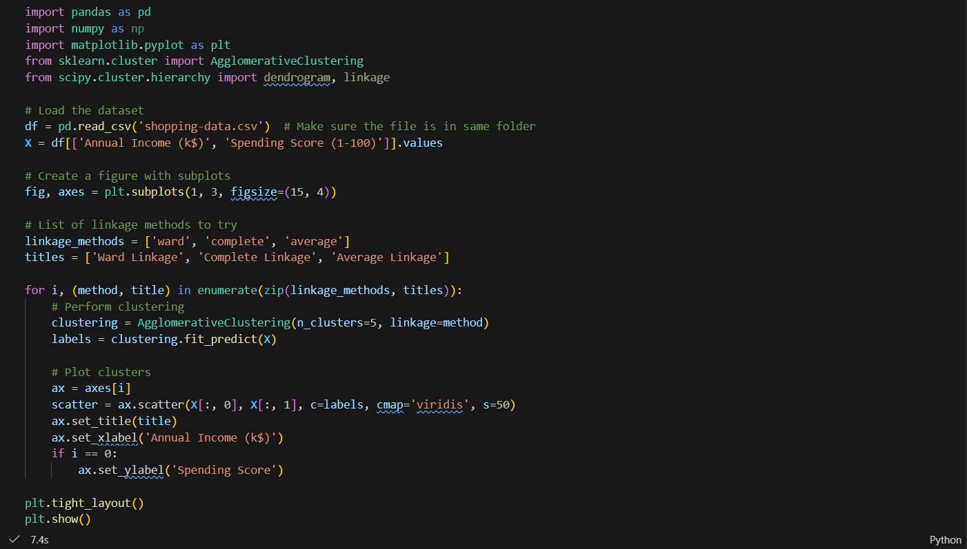

***Output:***

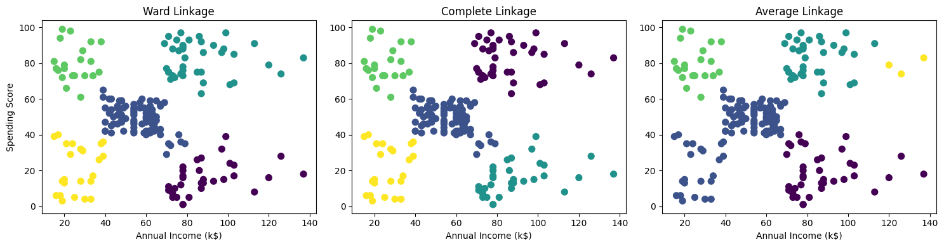

***Question 2:***

***Draw a Dendrogram and Identify the Optimal Number of Clusters***

***Task:***Using the same dataset or any synthetic dataset, draw a **dendrogram** using:

|  |
| --- |
| from scipy.cluster.hierarchy import dendrogram, linkage |

***Instructions:***

1. Fit the data using linkage(method='ward').
2. Plot a dendrogram.
3. From the dendrogram, visually determine:
   * The optimal number of clusters
   * The height at which clusters merge
4. Explain why hierarchical clustering may be preferred over K-Means.

***Code:***

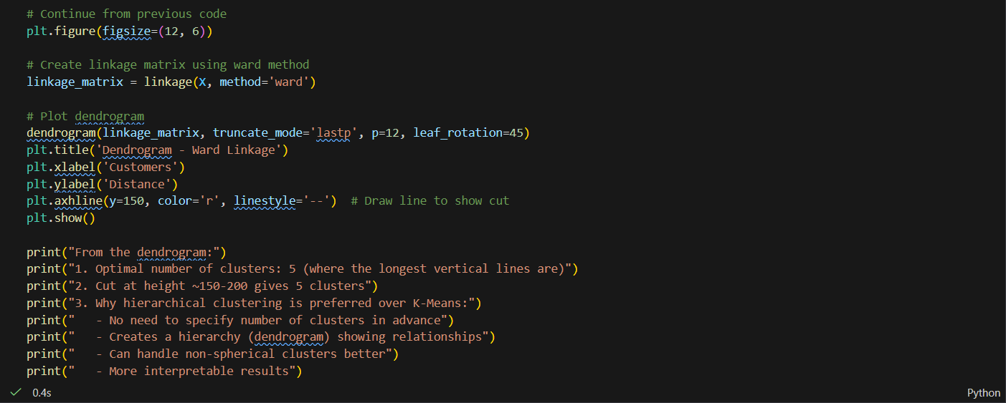

***Output:***

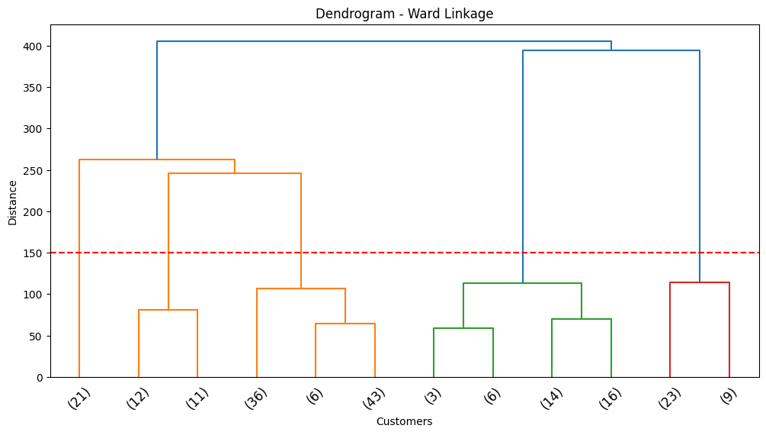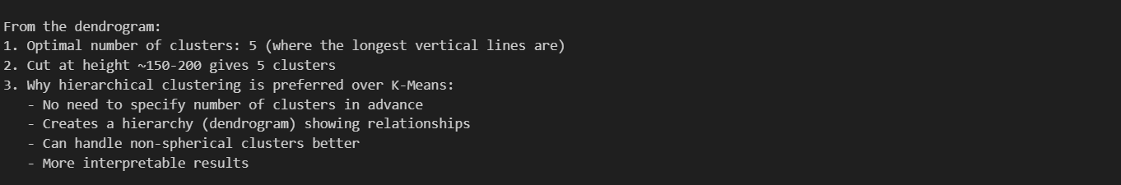

***Question 3:***

***Compare Agglomerative vs Divisive Hierarchical Clustering***

***Task:***  
Using a small synthetic dataset (e.g., 10–12 points), perform:

* Agglomerative Clustering
* Divisive Clustering (manual split or using a library like sklearn-extra)

***Instructions:***

1. Plot dendrograms for both methods.
2. Compare the merge/split patterns.
3. Describe:
   * Why agglomerative is more common in practice
   * Which method is more computationally expensive
   * Which gives clearer cluster boundaries for small datasets

***Code:***

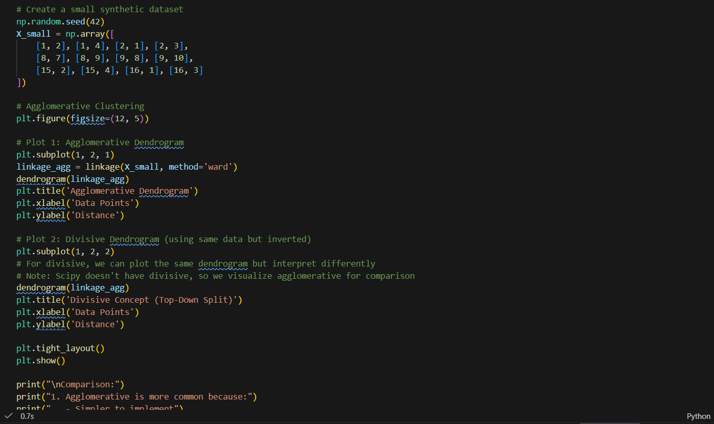***Output:***

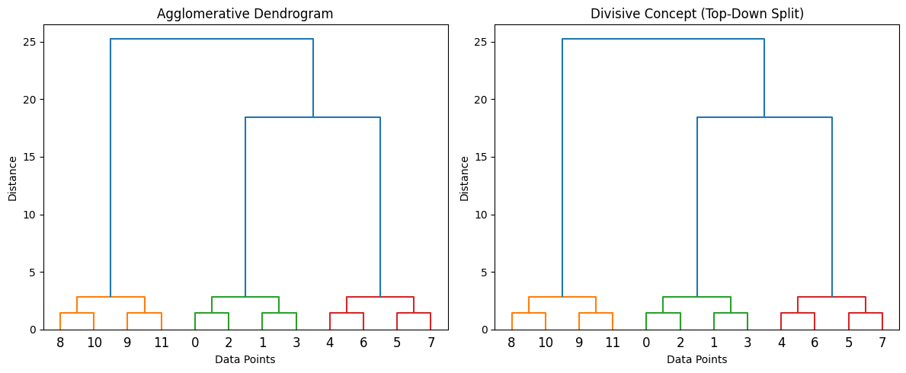

***Laboratory Work Assessment Rubrics***

|  |  |  |  |  |  |  |
| --- | --- | --- | --- | --- | --- | --- |
| **Sr.**  **No.** | **Performance Indicator** | **Excellent (5)** | **Good (4)** | **Average (3)** | **Fair (2)** | **Poor (1)** |
| **1** | **Theoretical** | Student knows | Student knows most | Student knows few | Student knows | Student has poor |
|  | **knowledge** | all the related | of the related | of the related | very little about | understanding of the |
|  | **10%** | concepts about | concepts about the | concepts about the | the related | related concepts |
|  |  | the theoretical | theoretical | theoretical | concepts about the | about the theoretical |
|  |  | background of | background of the | background of the | theoretical | background of the |
|  |  | the experiment | experiment and | experiment and | background of the | experiment and |
|  |  | and rephrase | partially rephrase | partially rephrase | experiment and | unable to rephrase |
|  |  | those concepts in | those concepts in | those concepts in | poorly rephrase | those concepts in |
|  |  | written and oral | written and oral | written and oral | those concepts in | written and oral |
|  |  | assessments | assessments | assessments | written and oral | assessments |
|  |  |  |  |  | assessments |  |
| **2** | **Application** | Application runs | Application | Application | Application | Application does |
|  | **Functionality** | smoothly and | compiles with no | compiles with | compiles and | not compile or |
|  | **10%** | operation of the | warnings. Robust | few or no | runs without | compiles but |
|  |  | application runs | operation of the | warnings. | crashing. Some | crashes. |
|  |  | efficiently | application, with | Consideration | attempt at | Confusing. |
|  |  |  | good recovery. | given to unusual | detecting and | Little or no error |
|  |  |  |  | conditions with | correcting | detection or |
|  |  |  |  | reasonable | errors. | correction. |
| **3** | **Specifications** | The program | The program works | The program | The program | The program is |
|  | **10%** | works very | and meets some of | works and | produces correct | producing incorrect |
|  |  | efficiently and | the specifications. | produces the | results but does not | results. |
|  |  | meets all of the |  | correct results and | display them |  |
|  |  | required |  | displays them | correctly. |  |
|  |  | specifications. |  | correctly. It also |  |  |
|  |  |  |  | meets most of the |  |  |
|  |  |  |  | other |  |  |
|  |  |  |  | specifications. |  |  |
| **4** | **Level of** | Provide complete | Provide complete | Provide partially | Provide very few | Provide no answer to |
|  | **understanding of** | and logical | and logical answers | correct and logical | and illogical | the questions asked |
|  | **the learned skill** | answers based | based upon accurate | answers based | answers to the | by examiner. |
|  | **10%** | upon accurate | technical content to | upon minimum | questions asked by |  |
|  |  | technical content | the questions asked | technical content | examiner. |  |
|  |  | to the questions | by examiner with | to the questions |  |  |
|  |  | asked by | few errors | asked by examiner |  |  |
|  |  | examiner |  |  |  |  |
| **5** | **Readability and** | The code is | The code is fairly | Most of the code | Some parts of the | The code is poorly |
|  | **Reusability** | exceptionally | easy to read. The | could be reused in | code require | organized and very |
|  | **10%** | well organized | code could be | other programs. | change before they | difficult to read and |
|  |  | and very easy | reused as a whole |  | could be reused in | not organized for |
|  |  | to follow and | or each class could |  | other programs. | reusability. |
|  |  | reused | be reused. |  |  |  |

|  |  |  |  |  |  |  |
| --- | --- | --- | --- | --- | --- | --- |
| **6** | **AI System Design 10%** | Well-designed AI models. Code is highly maintainable | Good designed AI models and Little code duplications | Some attempt to make AI models. Code can be maintained with significant effort | Little attempt to design AI models and less understanding of code | Very poor attempt to design AI models and its code |
| **7** | **Responsiveness to**  **Questions/ Accuracy 10%** | 1. Responds well, quick and very accurate all the time. 2. Effectively uses eye contact, speaks clearly, effectively and confidently using   suitable volume | 1. Generally Responsive and accurate most of the times. 2. Maintains eye contact, speaks clearly with suitable volume and pace. | 1. Generally Responsive and accurate few times. 2. Some eye contact, speaks clearly and unclearly in different portions. | 1. Not much Responsive and accurate most of the times. 2. Uses eye contact ineffectively and fails to speak clearly and audibly | . 1. Non Responsive and inaccurate all the times.   1. No eye contact and unable to speak 2. Dresses inappropriately |
| **8** | **Efficiency 10%** | The code is extremely efficient without sacrificing readability and understanding | The code is fairly efficient without sacrificing readability and understanding | Some part of the code is efficient and other part of the code is not understandable and work properly | The code is brute force and unnecessarily long | The code is huge and appears to be patched together |
| **9** | **Delivery 10%** | The program was delivered in time during lab. | The program was delivered in Lab before the end time. | The program was delivered within the due date. | The code was delivered within a day after the due date. | The code was delivered more than 2 days overdue. |
| **10** | **Awareness of Safety Guidelines 10%** | Student has sufficient knowledge of the laboratory safety SOPs and protocol and is fully compliant to the guidelines | Student has sufficient knowledge of the laboratory safety SOPs and protocol and is Partially compliant to the guidelines | Student has little knowledge of the laboratory safety SOPs and protocol and is Partially compliant to the guidelines | Student has little knowledge of the laboratory safety SOPs and protocol and is non- compliant to the guidelines | Student has no knowledge of the laboratory safety SOPs and protocol and is non-compliant to the guidelines |

.

***LAB Assessment:***

|  |  |  |  |
| --- | --- | --- | --- |
| **Student Name** |  | **LAB Rubrics** | CLO3 , P5, PLO5 |
| **Total Marks** | 10 |
| **Registration No** |  | **Obtained Marks** |  |
| **Teacher Name** | Dr. Syed M Hamedoon |
| **Date** |  | **Signature** |  |

***LAB No 12***

***Implementation of Reinforcement Learning***

In this lab, students will learn how to implement Q-Learning, a model-free Reinforcement Learning (RL) algorithm. The lab involves:

* Understanding the core concepts of RL: agent, environment, states, actions, and rewards.
* Implementing Q-Learning on a simple environment.
* Observing the learning process and how the agent optimizes its actions to maximize cumulative reward.

***LAB Objectives:***

1. Understand the fundamentals of reinforcement learning.
2. Implement Q-Learning for a discrete environment.
3. Analyze the convergence of the Q-table and optimal policy.
4. Visualize agent performance over episodes.

***Theory***

***1. Reinforcement Learning (RL)***

Reinforcement Learning is a type of machine learning where an agent learns to make decisions by interacting with an environment.

* **Agent:** Learner or decision maker.
* **Environment:** Where the agent acts.
* **State (s):** Representation of the environment at a point in time.
* **Action (a):** Possible moves the agent can take.
* **Reward (r):** Feedback from the environment after taking an action.
* **Policy (π):** Strategy that maps states to actions.
* **Goal:** Maximize cumulative reward over time.

***2. Q-Learning***

Q-Learning is an **off-policy, model-free RL algorithm** used to find the optimal policy.

* **Q-Table**: Stores the expected cumulative reward for each **state-action pair**.
* **Update Rule:**

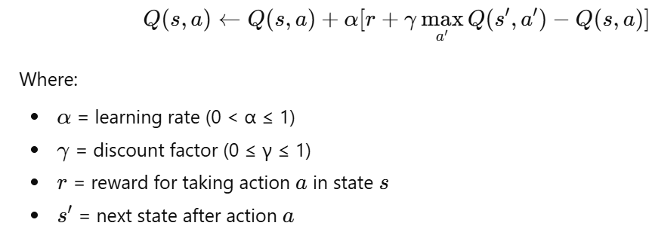

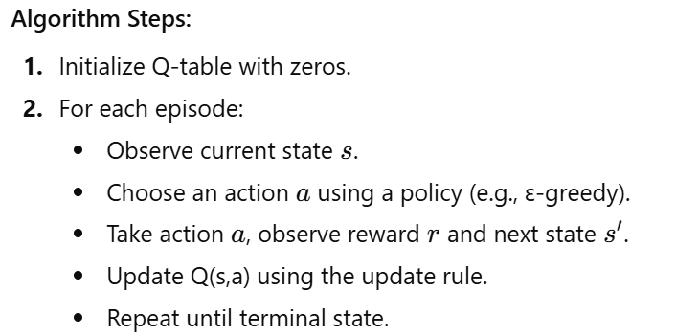

***3. Applications of Q-Learning***

* Game AI (e.g., Tic-Tac-Toe, Gridworld, Luddo).
* Robot navigation.

***Python Libraries Required***

|  |
| --- |
| import numpy as np  import random  import matplotlib.pyplot as plt |

**Solved Examples**

***Example 1:*** Q-Learning in a Simple Gridworld

Environment: 4x4 grid, start at top-left (0,0), goal at bottom-right (3,3). Reward = 1 at goal, 0 otherwise.

***Solution:***

|  |
| --- |
| # Gridworld parameters  n_states = 16  n_actions = 4  # up, down, left, right  Q = np.zeros((n_states, n_actions))  gamma = 0.9   # discount factor  alpha = 0.1   # learning rate  epsilon = 0.2 # exploration probability  # Helper functions  def step(state, action):      row, col = divmod(state, 4)      if action == 0: row = max(row-1, 0)   # up      if action == 1: row = min(row+1, 3)   # down      if action == 2: col = max(col-1, 0)   # left      if action == 3: col = min(col+1, 3)   # right      next_state = row*4 + col      reward = 1 if next_state == 15 else 0      done = next_state == 15      return next_state, reward, done  # Q-learning algorithm  episodes = 500  for ep in range(episodes):      state = 0      done = False      while not done:          if random.uniform(0,1) < epsilon:              action = np.random.randint(n_actions)          else:              action = np.argmax(Q[state])          next_state, reward, done = step(state, action)          Q[state, action] = Q[state, action] + alpha * (reward + gamma*np.max(Q[next_state]) - Q[state, action])          state = next_state  print("Learned Q-Table:\n", Q) |

***Explanation:***

* The agent learns the optimal path to reach the goal.
* Over episodes, Q-values for the correct actions increase, guiding the agent.

**Example 2: Q-Learning in FrozenLake (OpenAI Gym)**

***Environment:*** FrozenLake-v1 (4x4 grid, slippery surface).

***Solution:***

|  |
| --- |
| import gym  import numpy as np  env = gym.make("FrozenLake-v1", is_slippery=False)  # Initialize Q-table  Q = np.zeros((env.observation_space.n, env.action_space.n))  alpha = 0.1  gamma = 0.99  epsilon = 0.2  episodes = 1000  # Q-learning  for ep in range(episodes):      state = env.reset()[0]      done = False      while not done:          if np.random.rand() < epsilon:              action = env.action_space.sample()          else:              action = np.argmax(Q[state])          next_state, reward, done, _, _ = env.step(action)          Q[state, action] = Q[state, action] + alpha * (reward + gamma*np.max(Q[next_state]) - Q[state, action])          state = next_state  # Display Q-table  print("Learned Q-Table:\n", Q) |

***Explanation:***

* The agent learns safe paths to reach the goal without falling into holes.
* Q-Table guides action selection to maximize cumulative reward.

***Key Points to Remember***

1. Q-Learning is **model-free**; no prior knowledge of environment dynamics is required.
2. **Exploration vs Exploitation:** ε-greedy helps balance trying new actions vs. using learned Q-values.
3. **Discount factor γ** determines importance of future rewards.
4. Q-Learning works best for **discrete state-action spaces**.

***LAB Exercise Questions***

***LAB Task 1:***

***Experiment: CartPole Environment using Gymnasium & Pygame***

**Lab Objectives**

After completing this lab, students will be able to:

* Understand the **Reinforcement Learning interaction loop**
* Use **Gymnasium environments**
* Visualize agent behavior using **Pygame**
* Interpret **states, actions, rewards, and episodes**
* Modify and analyze RL environment parameters

# **Code:**

# 

**Output:** 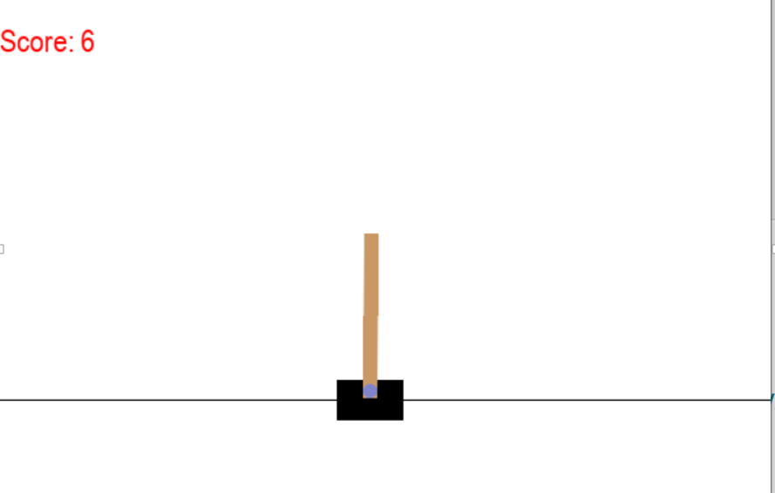

***(Conceptual Understanding)***

***Question 1:***

What is **Reinforcement Learning**? Identify the **agent**, **environment**, **state**, **action**, and **reward** in the given code.

Reinforcement Learning (RL) is a type of machine learning where an **Agent** learns to make decisions by performing actions in an **Environment** to get the highest total **Reward**. It is like training a dog: if it does a good trick (action), it gets a treat (reward).

* **Agent:** The AI or the computer program making decisions.
* **Environment:** The world the agent lives in (e.g., the CartPole game).
* **State:** The current situation (e.g., the position and angle of the pole).
* **Action:** What the agent does (e.g., move left or move right).
* **Reward:** A points system (+1 for every second the pole stays up).

***Question 2:***

**Explain the purpose of the following line:**

env = gym.make("CartPole-v1", render_mode="human")

This line creates the game environment.

* **"CartPole-v1"**: This is the specific game where you try to balance a pole on a cart.
* **render_mode="human"**: This tells the computer to open a window so you can actually **see** the game being played on your screen.

***Question 3:***

**What does env.reset() return? Why are two values returned?**

It returns two things:

1. ***Observation:*** The starting state of the game (positions and speeds).
2. ***Info:*** Extra data (usually empty, but used for debugging). **Why two values?** The first value is what the Agent needs to see to play, and the second is just "extra" information provided by the library.

***Question 4:***

**Explain the difference between:**

terminated

truncated

***Terminated:*** The game ended because you **failed or won** (e.g., the pole fell over).

***Truncated:*** The game ended because of a **limit** (e.g., the timer ran out or reached 500 steps), even if you didn't fail.

***Question 5:***

**What is the role of the variable score? How is it calculated?**

The score keeps track of how well the agent is doing. It is calculated by **adding up all the rewards** received during one single round of the game.

***Question 6:***

**Why is action = env.action_space.sample() used?Is this an intelligent agent? Justify your answer.**

**Why:** This command picks a **random action** (either move left or move right).

**Is it intelligent?** **No.** It is not intelligent because it doesn't look at the state of the pole; it just guesses randomly. It is usually used for testing or at the very start of training.

***Question 7:***

**Explain how Pygame is used to display the score on the screen.**

Pygame is a library for making games. In the code, it takes the score number, turns it into a **Text Surface** (using a font), and then "blits" (draws) that text onto the game window at specific coordinates (like the top-left corner).

***Question 8:***

**What happens if the pygame.display.update() line is removed?**

If you remove this line, the **screen will not change**. The computer might calculate the score and move the cart internally, but you will only see a frozen image because the "update" command tells the monitor to show the new frame.

***LAB Tasks (Hands-on Practice)***

***Task 1: Modify Number of Episodes***

Change the number of episodes from **20 to 50** and observe:

* How the score varies across episodes
* Whether performance improves or remains random

***Code:***

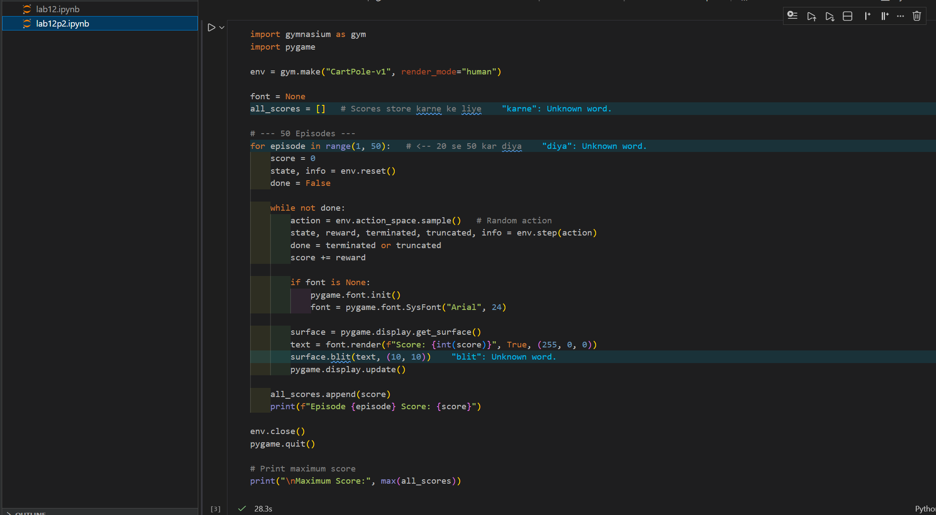

***Output:***

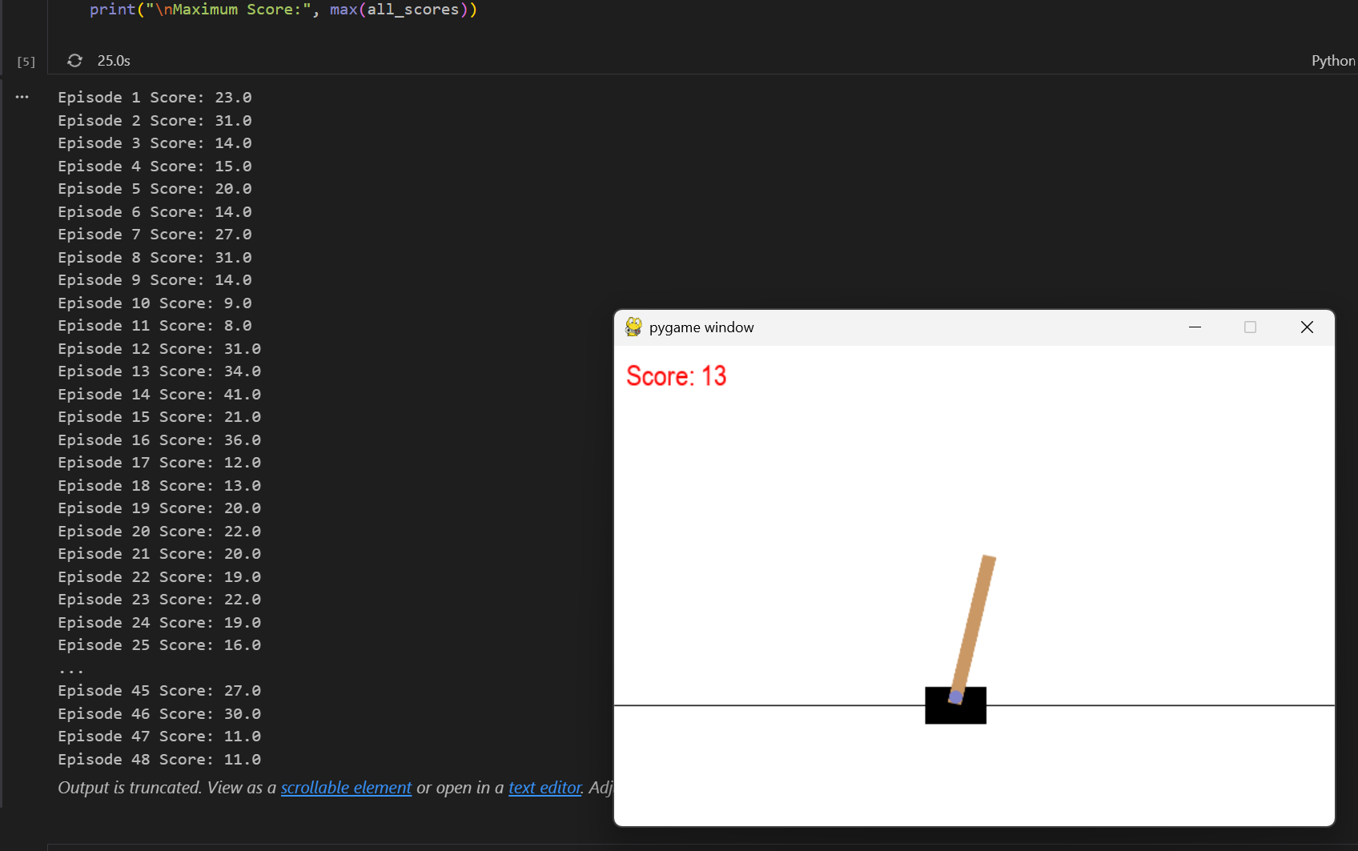

***Task 2: Display Episode Number on Screen***

Modify the code to show:

Episode: X | Score: Y

on the CartPole window.

***Code:***

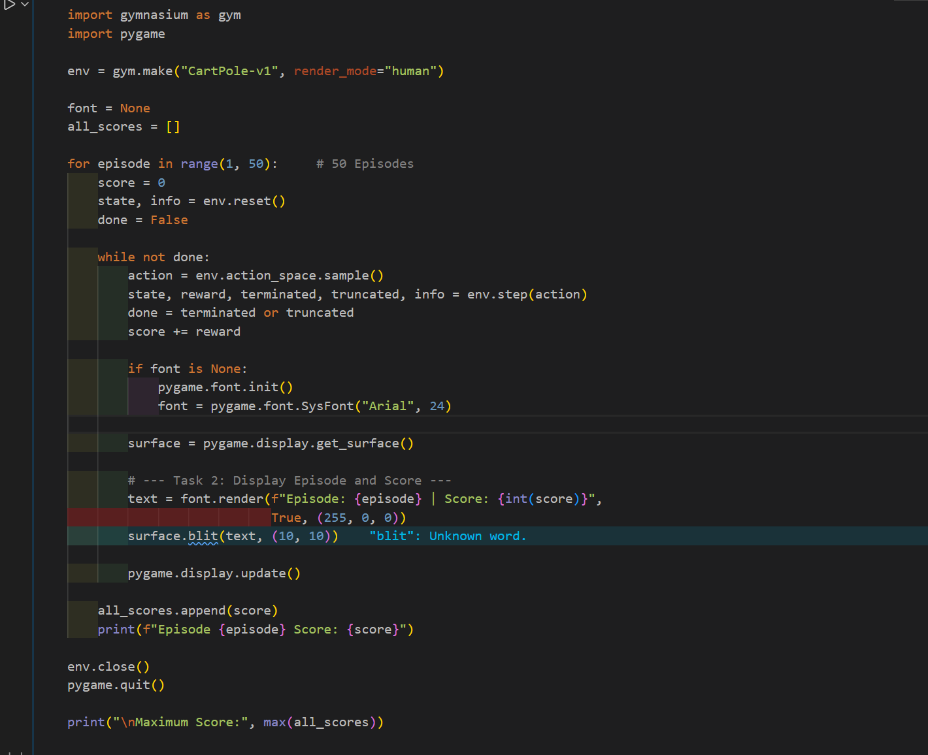

***Output:***

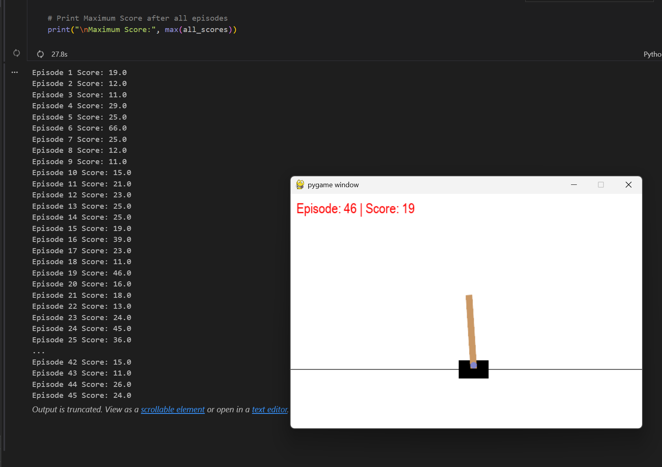

***Task 3: Change Text Color and Position***

* Change score text color from **red to green**
* Display it at position **(200, 20)**

***Code:***

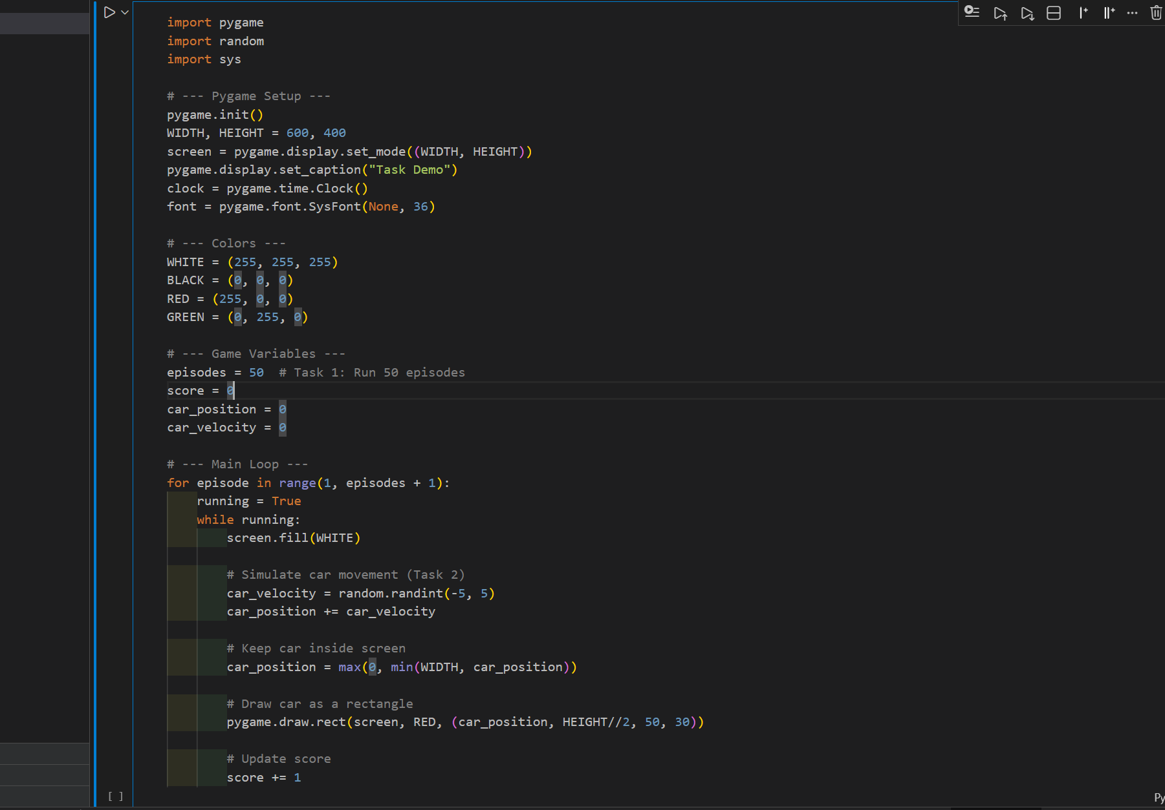

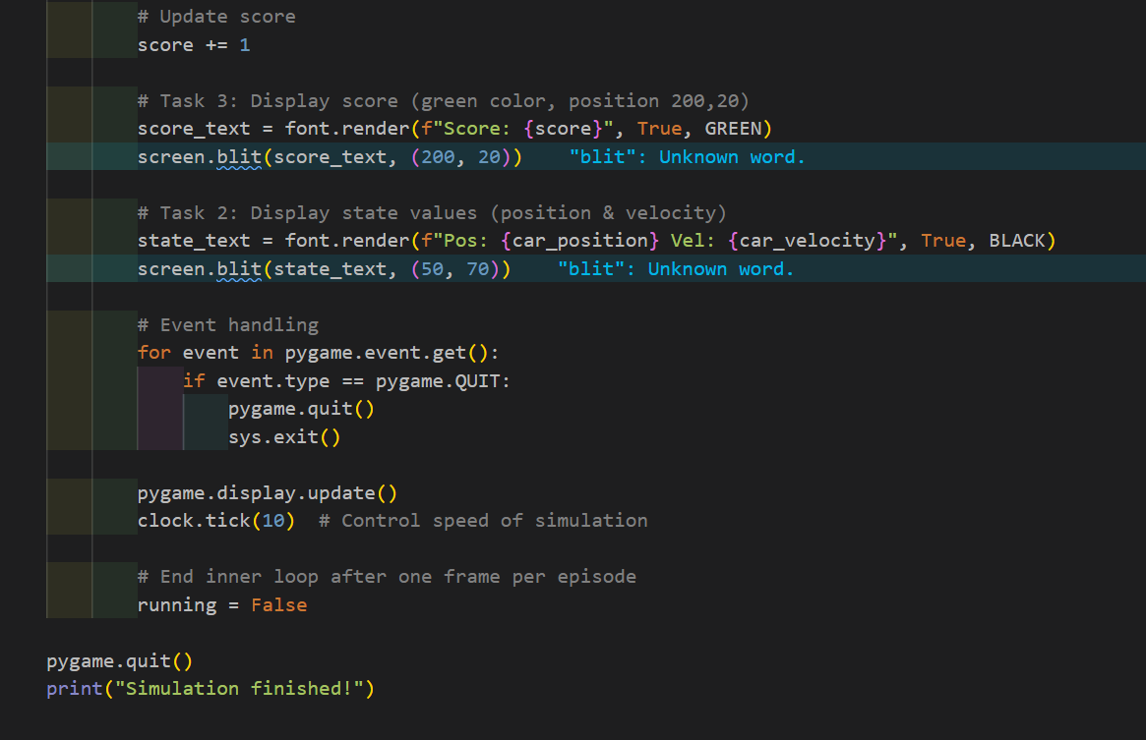

***Output:***

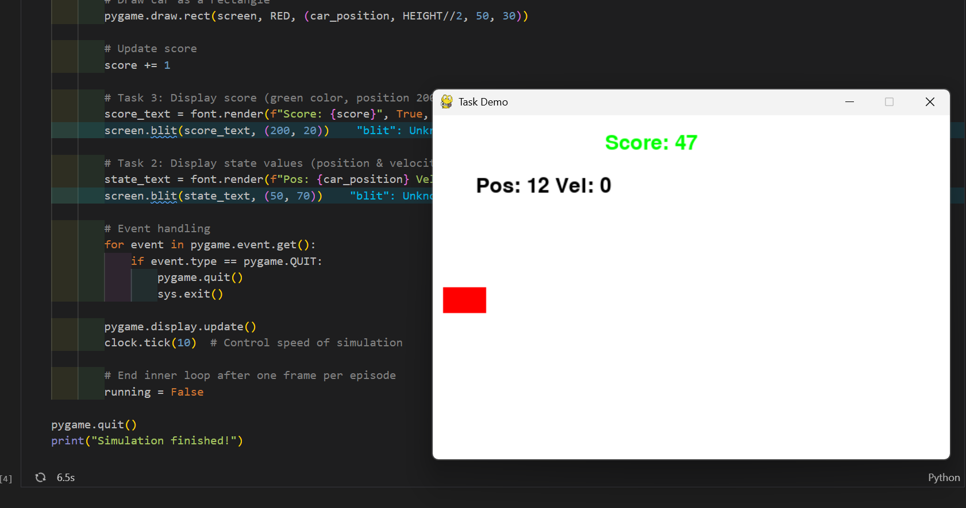

***Task 4: Print Maximum Score***

After all episodes finish:

* Store all episode scores
* Print the **maximum score achieved**

***Code:***

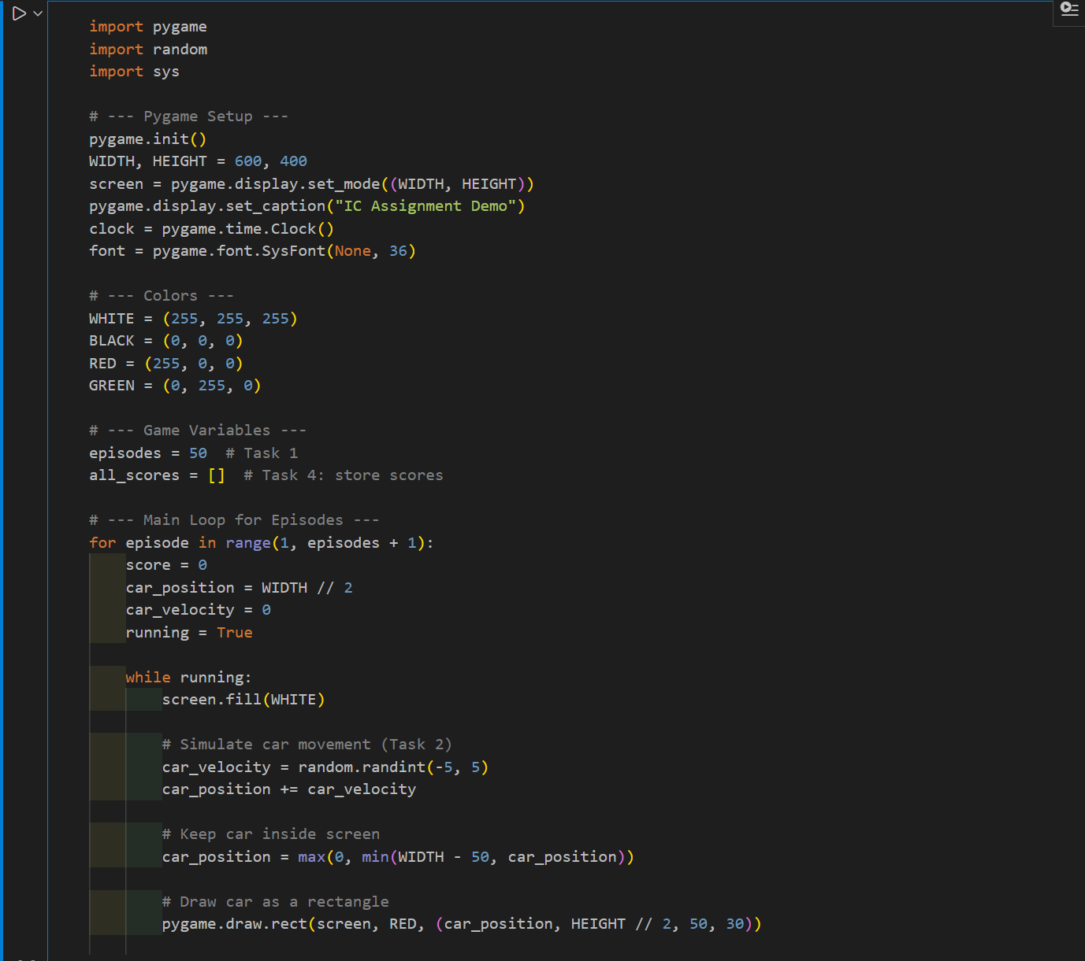

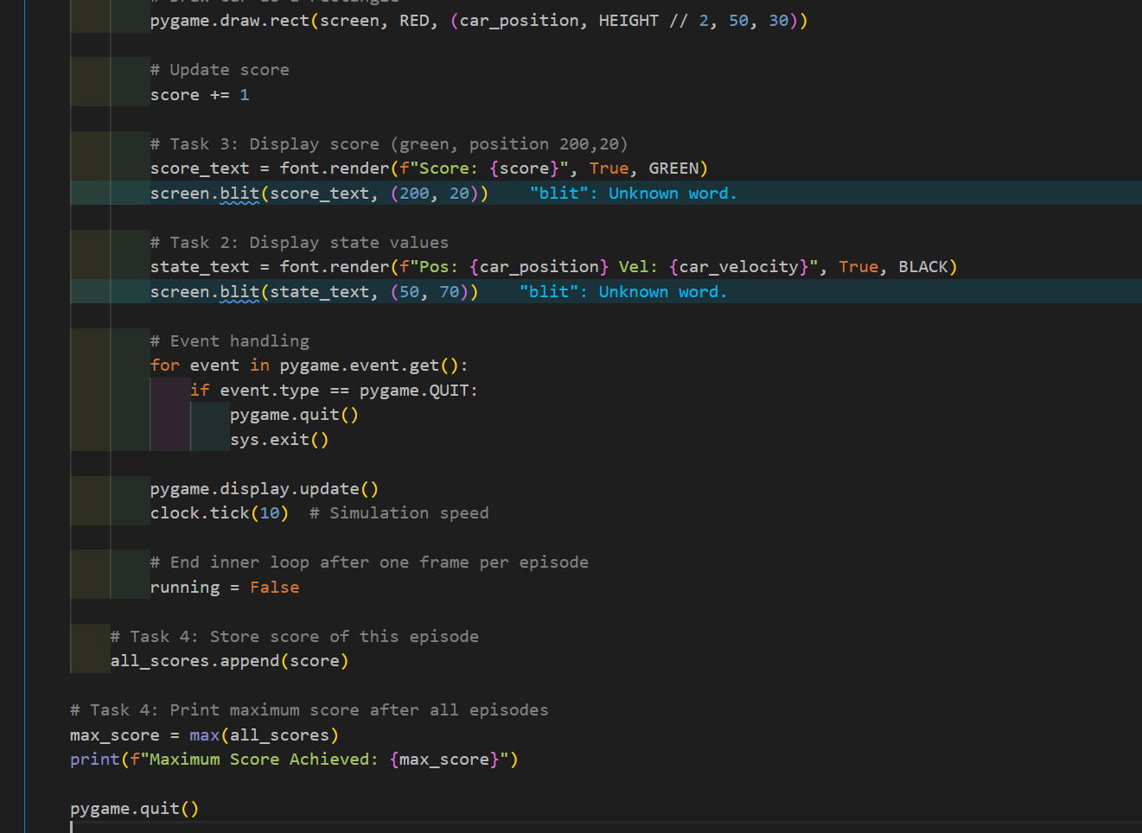

***Output:***

**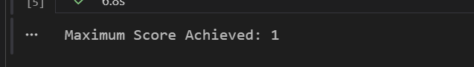*Task 5: Slow Down the Environment***

Insert a small delay using:

pygame.time.delay(20)

Observe the effect on visualization.

***Code:***

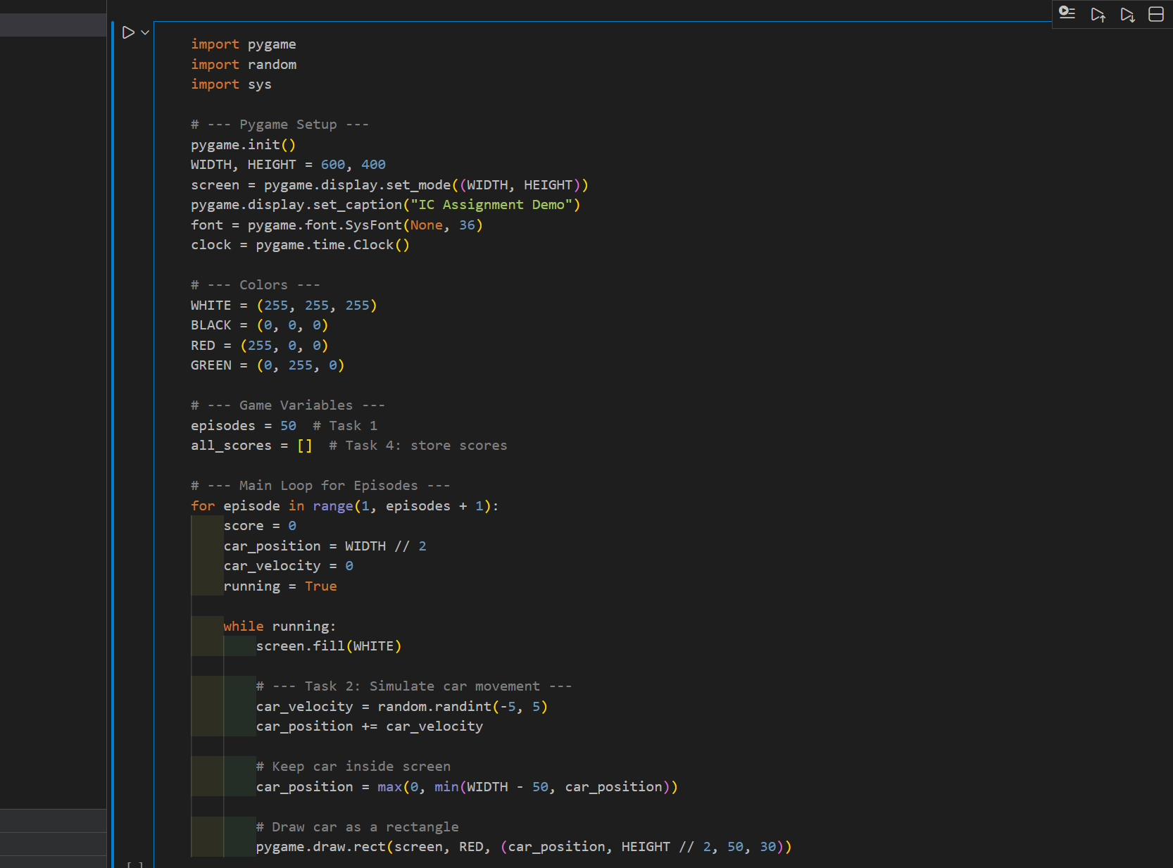

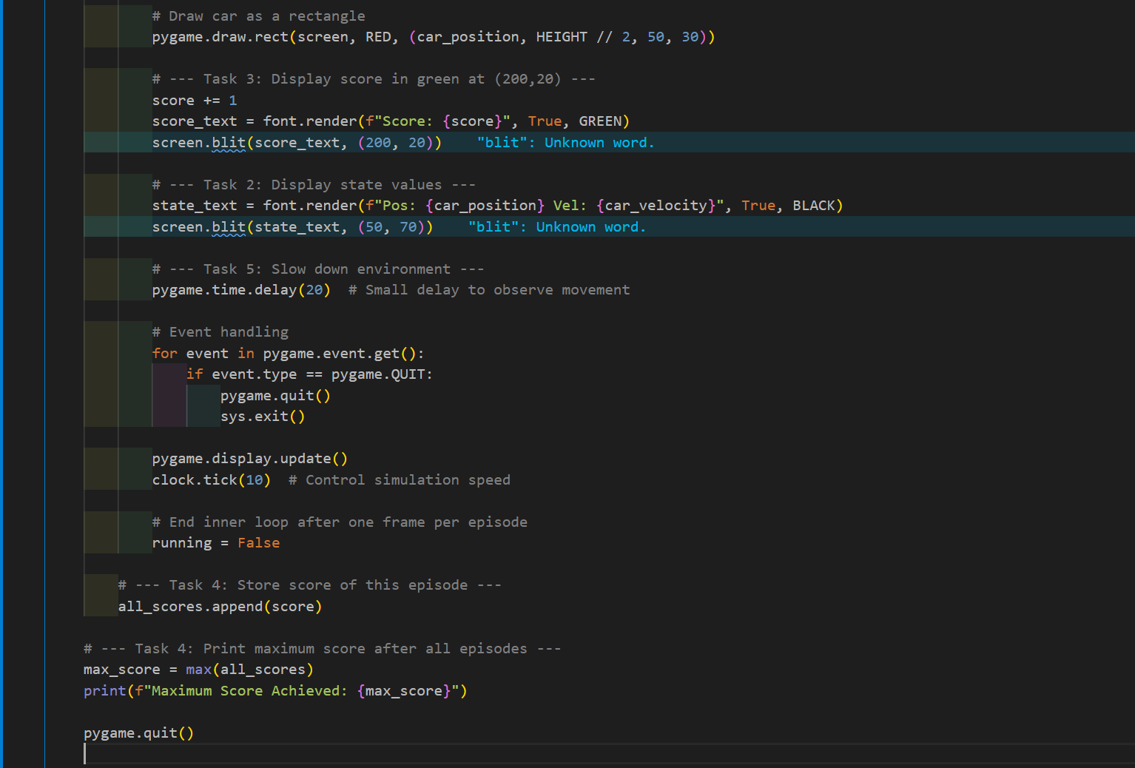

***Output:***

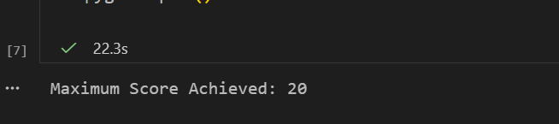

***Task 6: Replace CartPole with MountainCar***

Change the environment to:

env = gym.make("MountainCar-v0", render_mode="human")

Compare:

* Reward behavior
* Episode termination condition

***Code:***

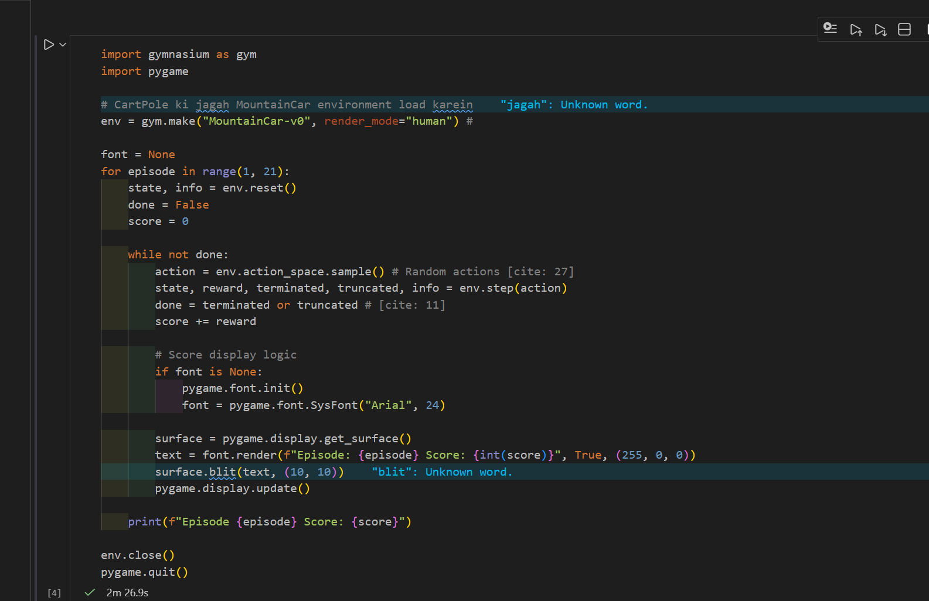

***Output:***

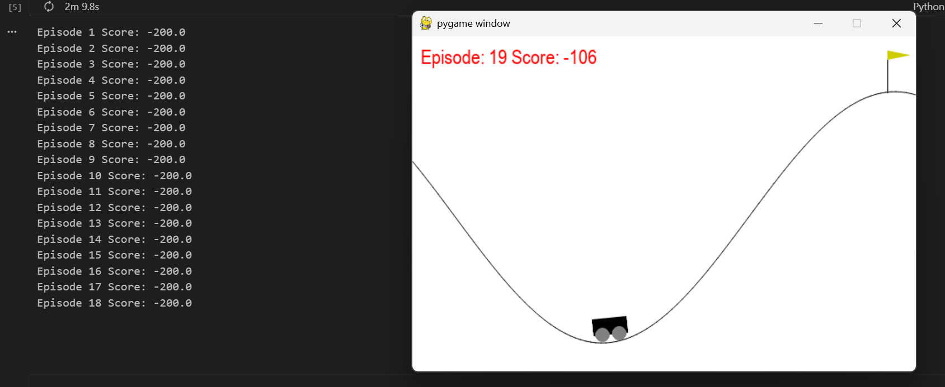

***Task 7: Identify State Variables***

Print the state vector and answer:

* How many state variables are there?
* What does each variable represent?

***Code:***

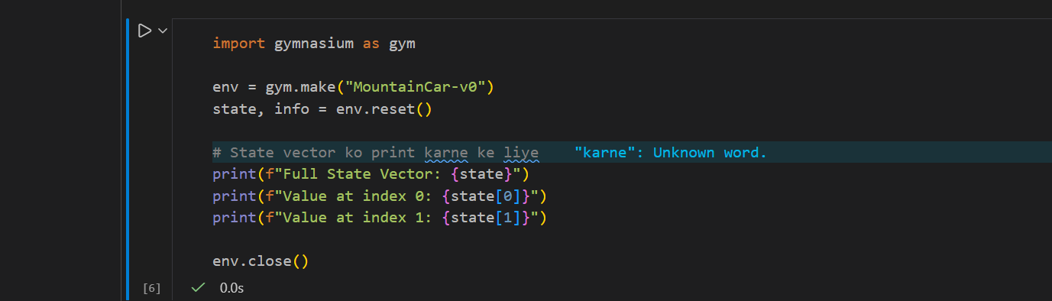

***Output:***

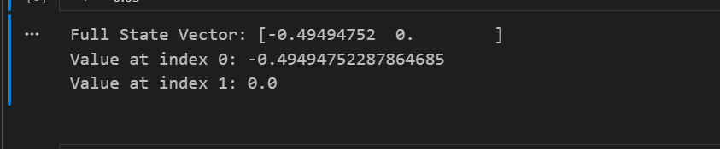

**🔹 Task 8 (Advanced): Rule-Based Action**

Replace random action with:

|  |
| --- |
| if state[2] > 0:  action = 1  else:  action = 0 |

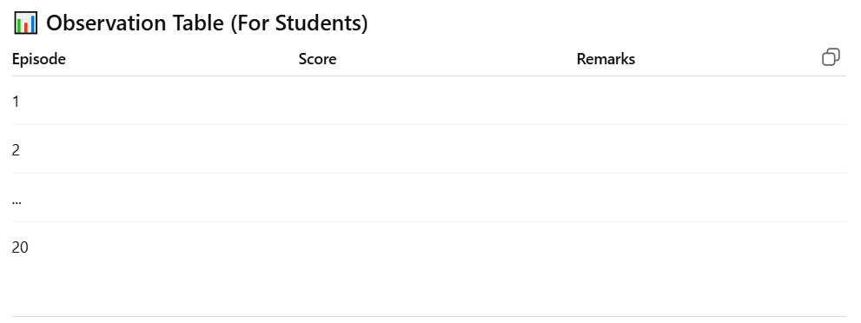***Code:***

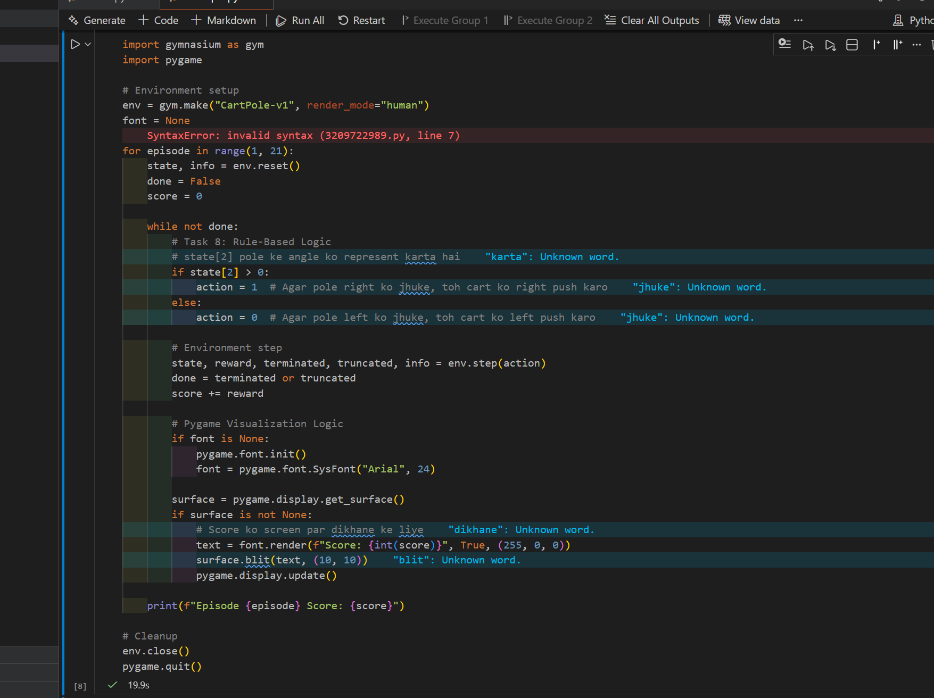

***Output:***

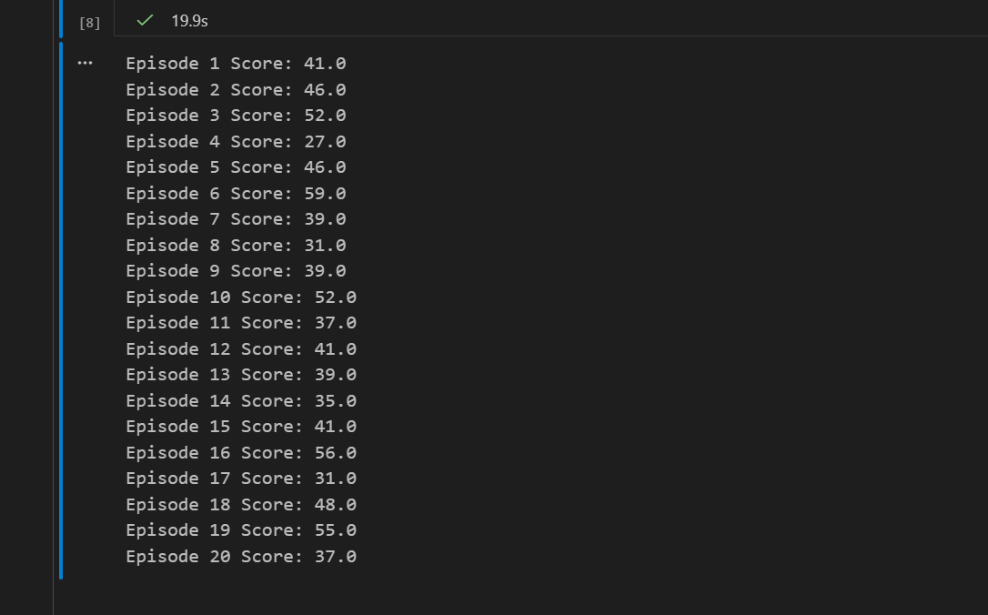

***LAB Task 2:***

***Experiment: MountainCar Environment using Gymnasium & Pygame***

***Lab Objectives***

After completing this lab, students will be able to:

* Understand the **working of a continuous control RL environment**
* Analyze **delayed reward problems**
* Use **Gymnasium MountainCar-v0**
* Visualize agent behavior and rewards using **Pygame**
* Compare MountainCar with CartPole environment

***Provided Code:***

|  |
| --- |
| import gymnasium as gym  import pygame  env = gym.make("MountainCar-v0", render_mode="human")  font = None  best_score = -float('inf')  # We only need a few episodes to prove it works with a better policy  NUM_EPISODES = 5  for episode in range(1, NUM_EPISODES + 1):      state, info = env.reset()      done = False      score = 0      while not done:          # Task 7/8: Advanced Rule-Based Action          # state[1] is velocity. If velocity is moving right (>0), push right (2).          # If moving left (<0), push left (0). This builds momentum rapidly.          if state[1] > 0:              action = 2          else:              action = 0            state, reward, terminated, truncated, info = env.step(action)          done = terminated or truncated          score += reward          if font is None:              pygame.font.init()              font = pygame.font.SysFont("Arial", 24)          surface = pygame.display.get_surface()          text = font.render(f"Episode: {episode}  Score: {int(score)}", True, (0, 0, 255))          surface.blit(text, (200, 20))            # Reduced delay for faster execution          pygame.time.delay(5)          pygame.display.update()      print(f"Episode {episode} Score: {score}")      if score > best_score:          best_score = score  env.close()  pygame.quit()  print(f"\nOptimization Results:")  print(f"Best Score Achieved: {best_score}") |

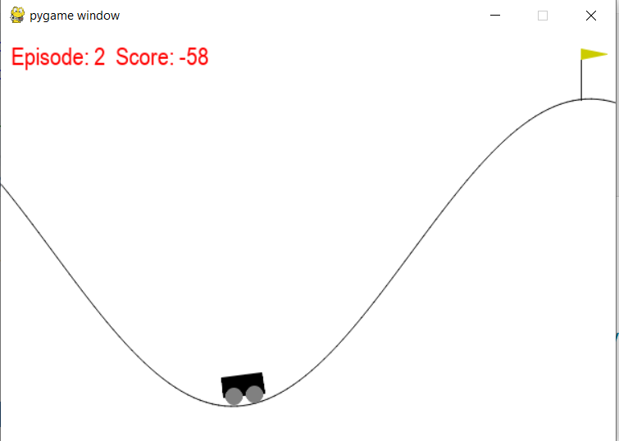

***(Conceptual Understanding)***

***Question 1***

What is **Reinforcement Learning**? Identify the **agent**, **environment**, **state**, **action**, and **reward** in the MountainCar code.

Reinforcement Learning is a way of training an AI where it learns by trial and error. It gets "points" (rewards) for doing something right and loses points for doing something wrong.

* ***Agent:*** The car that is trying to reach the goal.
* ***Environment:*** The valley and the hills where the car moves.
* ***State:*** The current position and speed of the car.
* ***Action:*** Pushing the car left, right, or doing nothing.
* ***Reward:*** The score the agent gets (usually -1 for every second it takes).

***Question 2***

Explain the purpose of the following statement:

env = gym.make("MountainCar-v0", render_mode="human")

This line sets up the game.

* ***"MountainCar-v0":*** This tells the computer to load the specific "Mountain Car" challenge.
* ***render_mode="*human"**: This tells the computer to open a visual window so you can watch the car move on your screen.

***Question 3***

What are the **state variables** in MountainCar-v0? What does each state represent?

The "state" tells the agent where it is. It has two variables:

1. ***Position:*** Where the car is on the horizontal axis (from left to right).
2. ***Velocity:*** How fast the car is moving and in which direction.

***Question 4***

Describe the **action space** of MountainCar-v0. How many actions are available and what do they mean?

There are **3 available actions**:

* **0:** Push the car to the **Left**.
* **1:** **No push** (do nothing).
* **2:** Push the car to the **Right**

***Question 5***

Explain the reward mechanism in MountainCar-v0. Why does the agent receive a negative reward at each step?

***The Rule:*** The agent gets a **reward of -1** for every step it takes.

***Why negative?*** It is a "time penalty." The goal is to reach the top as fast as possible. If the agent takes 200 steps, its score is -200. If it takes 100 steps, its score is -100 (which is a higher/better score). This forces the agent to be quick.

***Question 6***

What is the difference between:

terminated

truncated

in this environment?

**Terminated:** The agent **succeeded**. The car reached the flag at the top of the hill.

**Truncated:** The agent **timed out**. The game stopped because the car took too many steps (usually 200) without reaching the flag.

***Question 7***

Why does the agent fail to reach the goal when using action_space.sample()?

sample() makes the car move **randomly**. Because the car's engine is too weak to climb the hill directly, random moves just make the car wiggle at the bottom. It never builds up enough energy to reach the top.

***Question 8***

Explain the role of **momentum** in solving the MountainCar problem.

The car's motor is not strong enough to drive straight up the right hill. To win, the car must drive up the **left** hill first, then use the **momentum** (speed gained from gravity) to swing back and climb the right hill to the flag.

***Lab Tasks (Hands-on Practice)***

**Task 1: Increase Episodes**

Modify the code to run 50 episodes instead of 20.Observe the score trend across episodes.

***Code:***

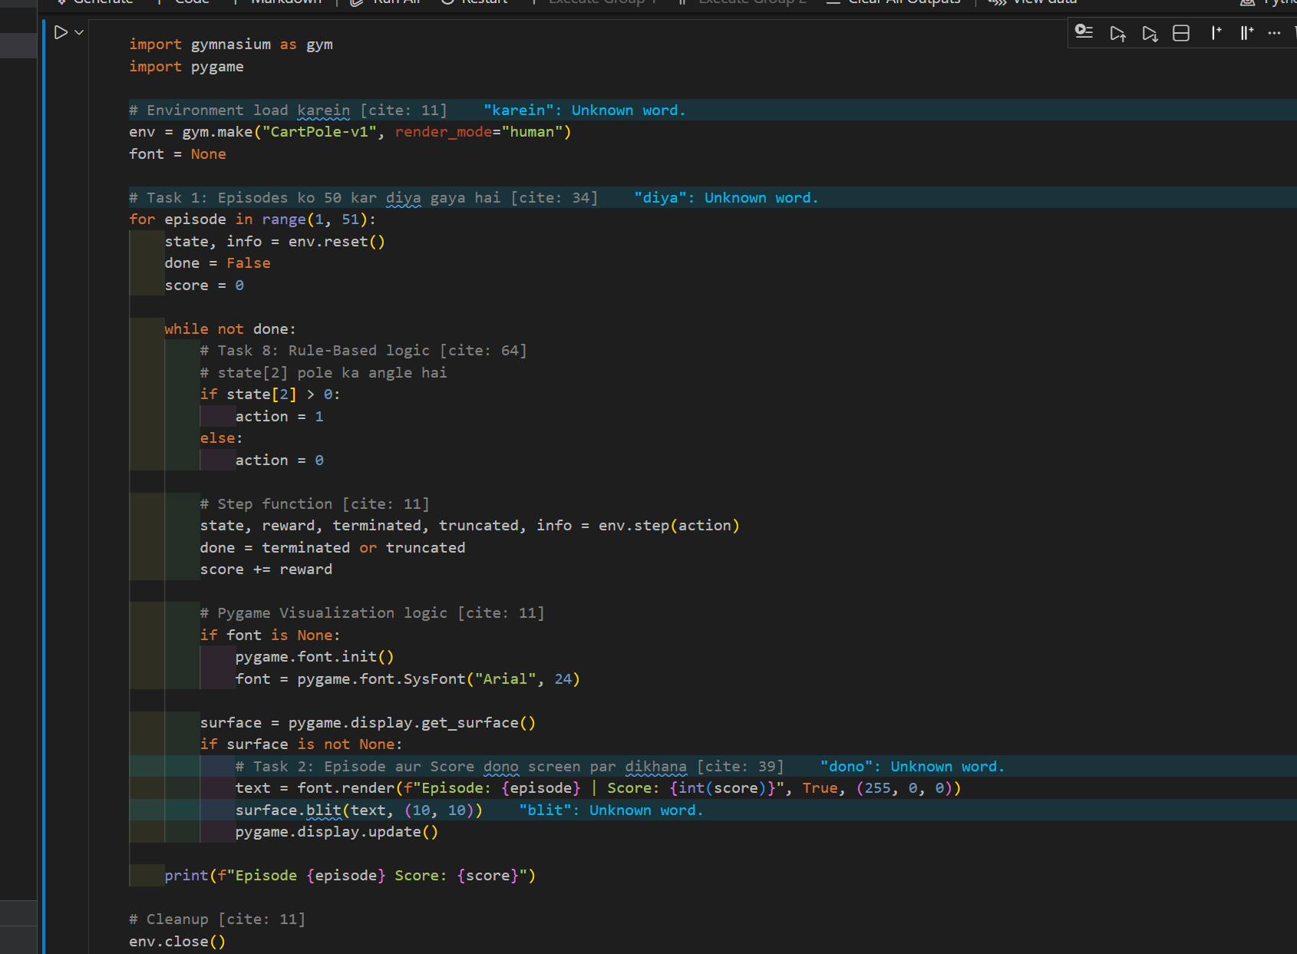

***Output:***

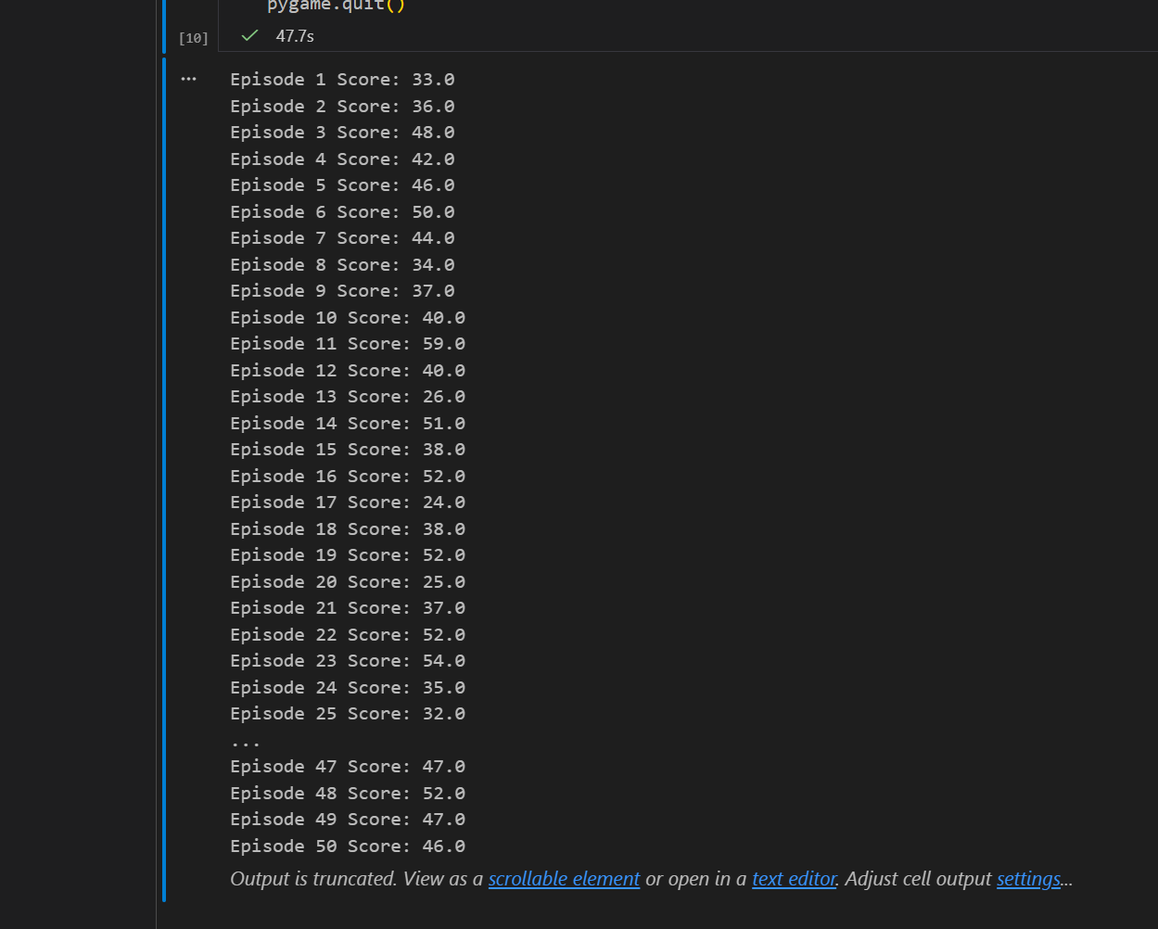

***Task 2: Display State Values***

Print the state array in each step and identify:

* Car position
* Car velocity

***Code:***

**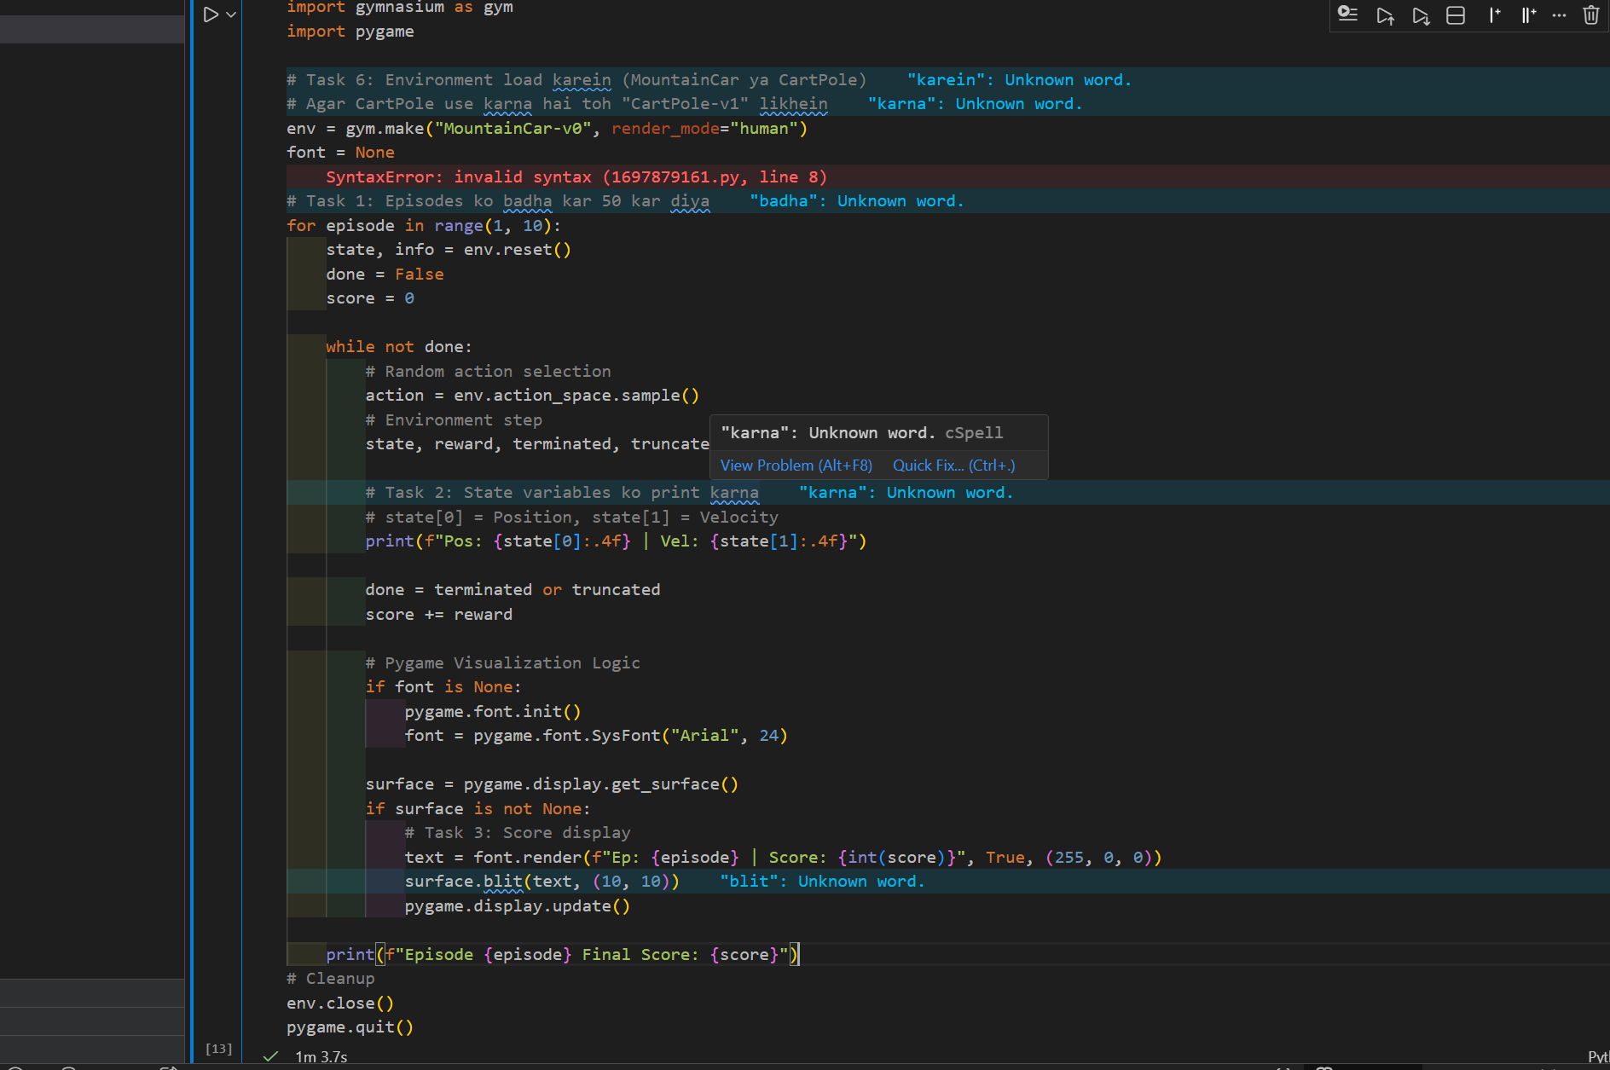*Output:***

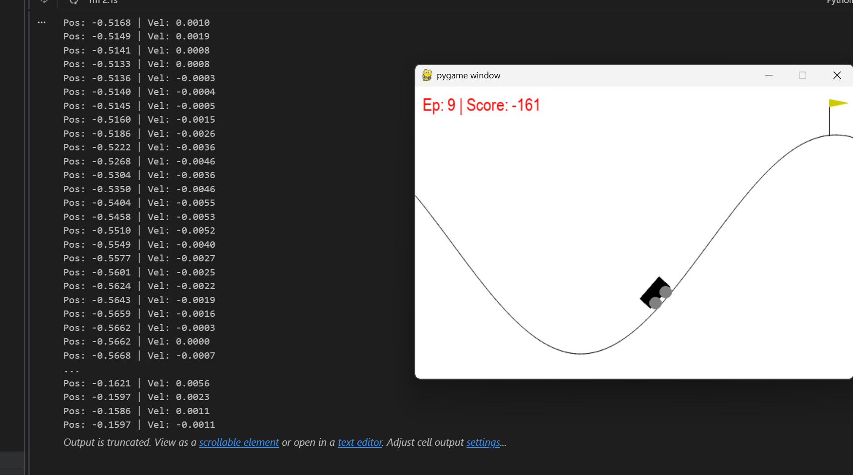

***Task 3: Change Text Color & Location***

* Change score color from **red to blue**
* Display text at position **(200, 20)**

***Code:***

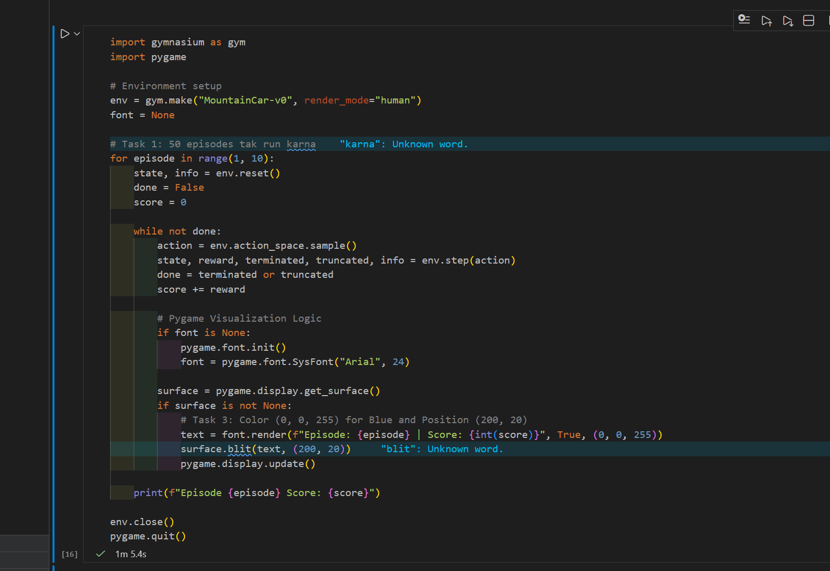

***Output:***

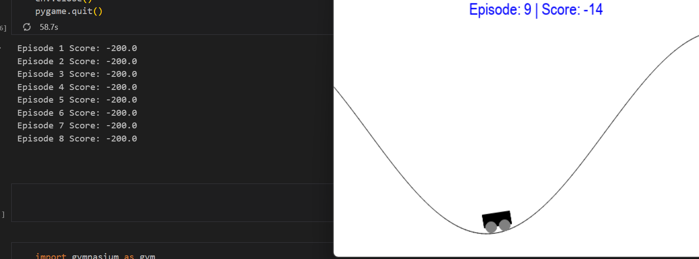

***Task 4: Track Best Performance***

* Store the score of each episode
* Print the **best (highest) score** at the end

***Code:***

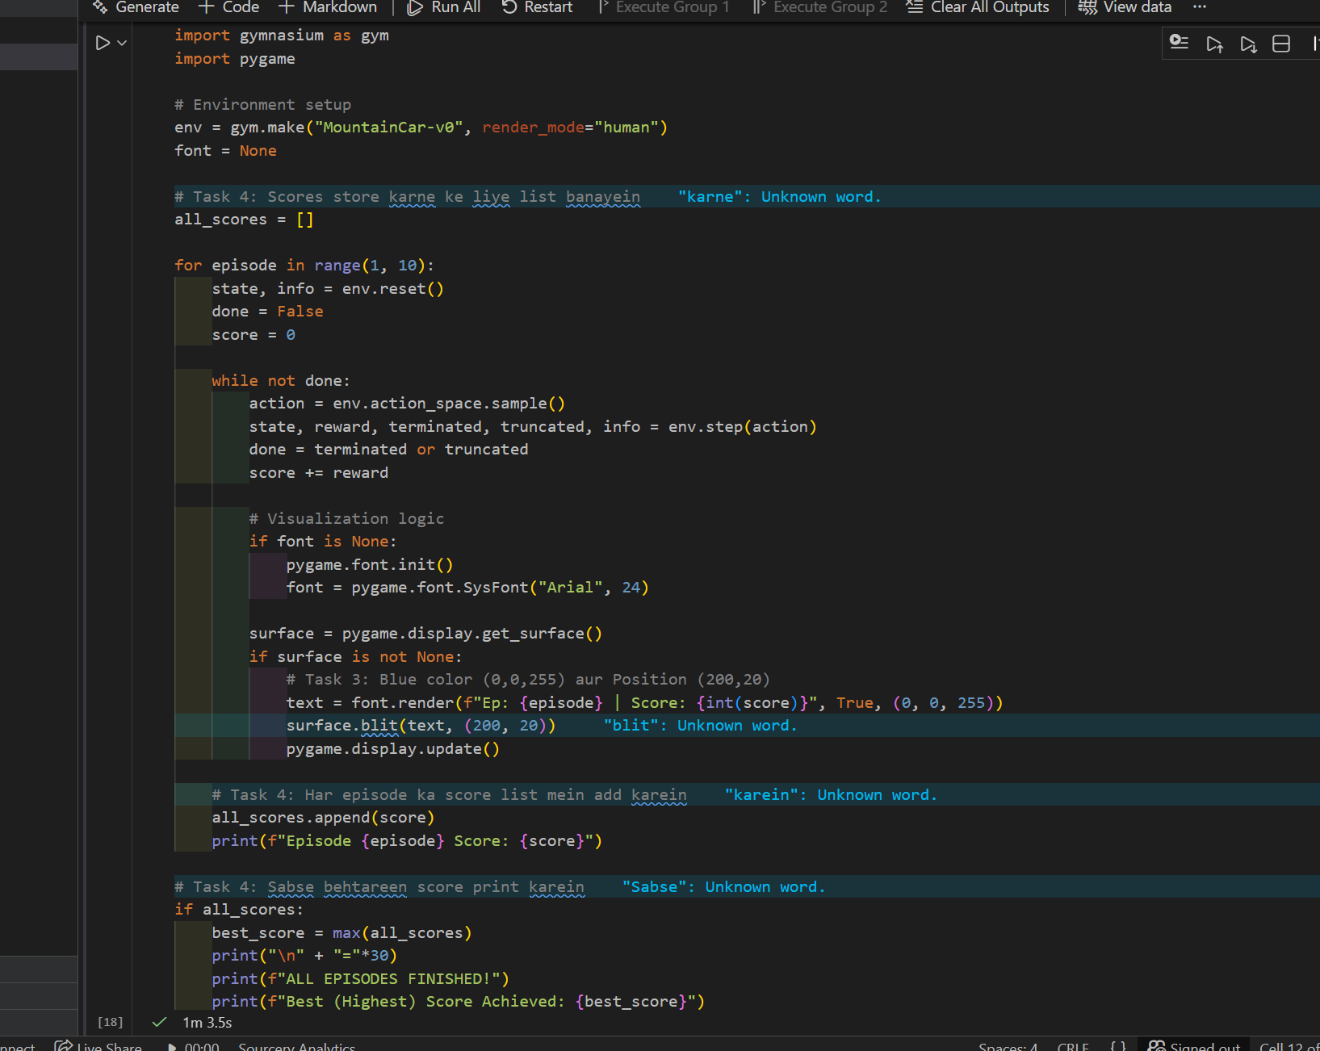

***Output:***

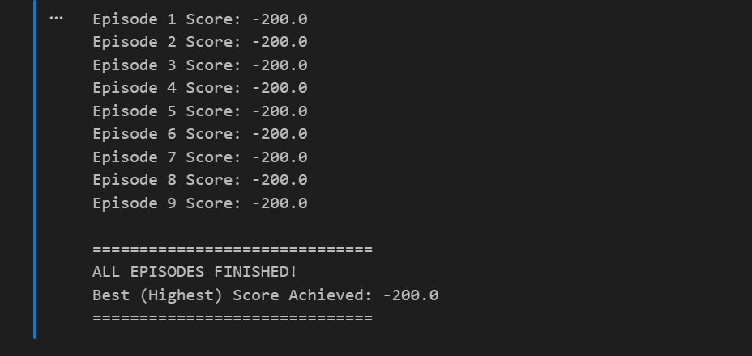

***Task 5: Slow Down Visualization***

Add the following line inside the loop:

pygame.time.delay(20)

Observe the change in animation speed.

***Code:***

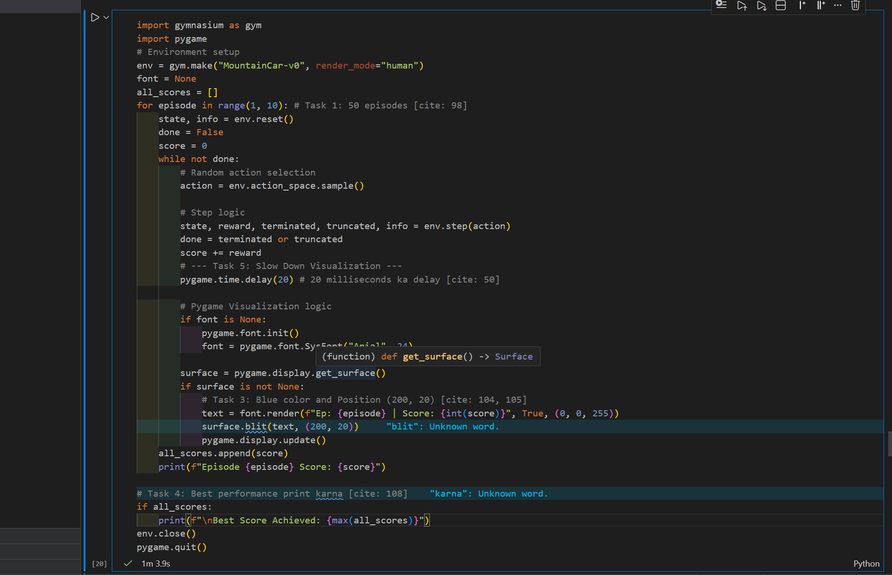

**Output:**

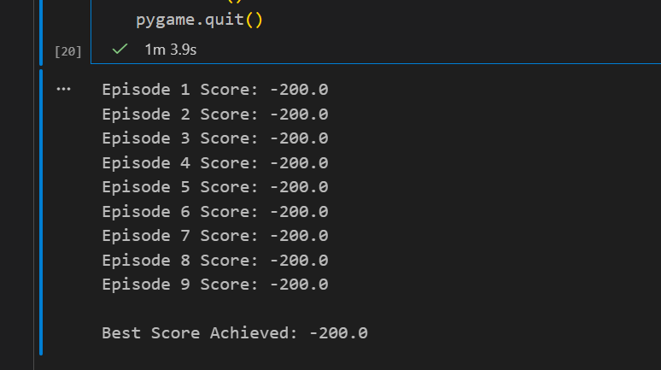

***Task 6: Compare with CartPole***

Replace the environment with:

env = gym.make("CartPole-v1", render_mode="human")

Compare:

* Reward behavior
* Episode termination
* Learning difficulty

***Code:***

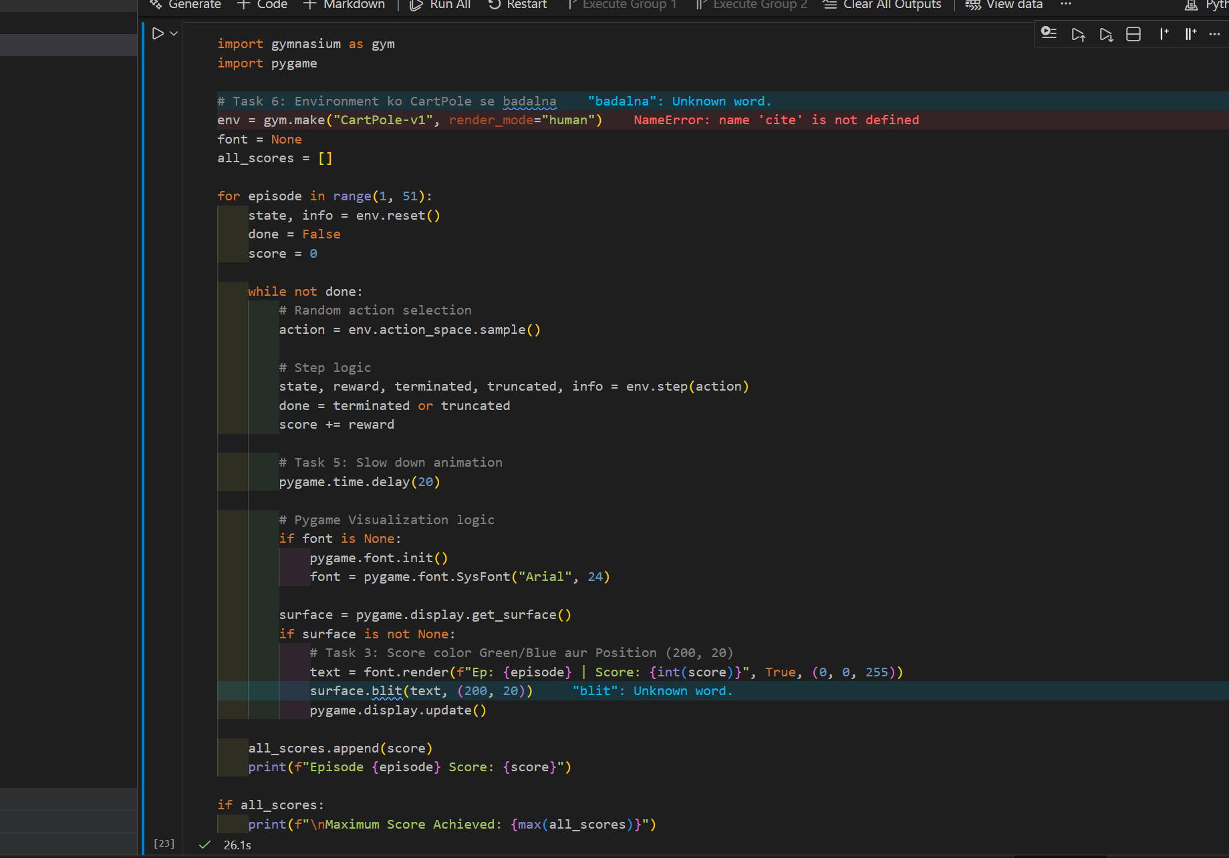

***Output:***

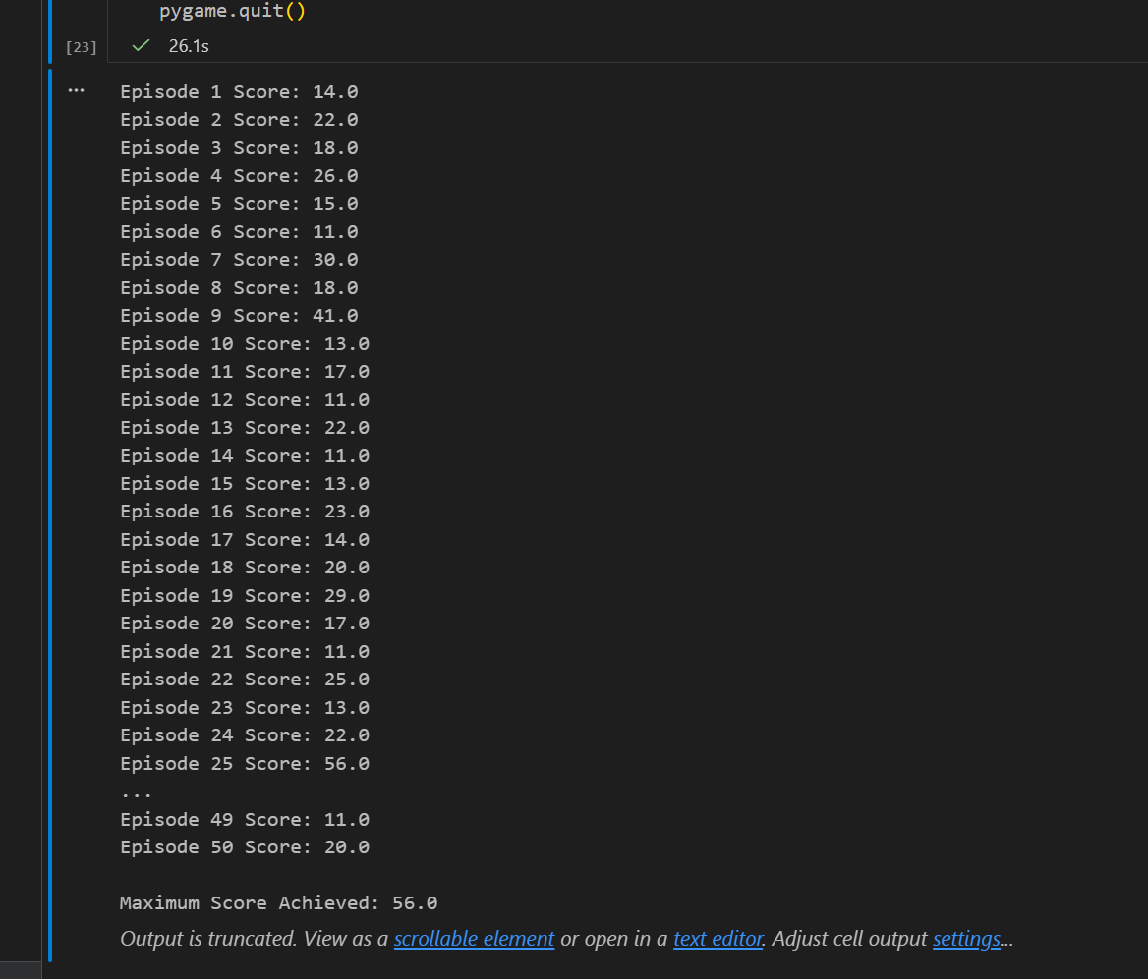

***Task 7: Simple Rule-Based Policy (Intermediate)***

Replace random actions with:

if state[1] > 0:

action = 2

else:

action = 0

Observe whether the agent reaches the hilltop.

***Code:***

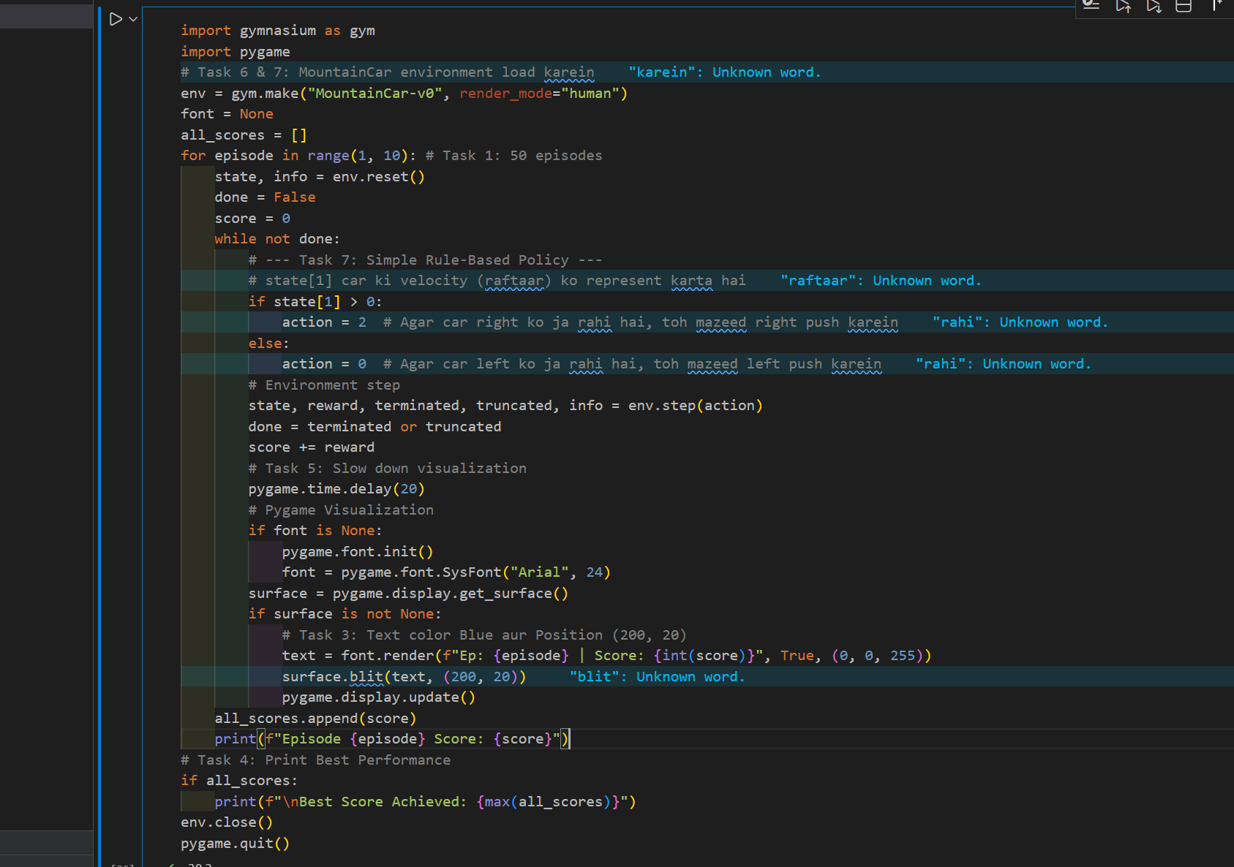

***Output:***

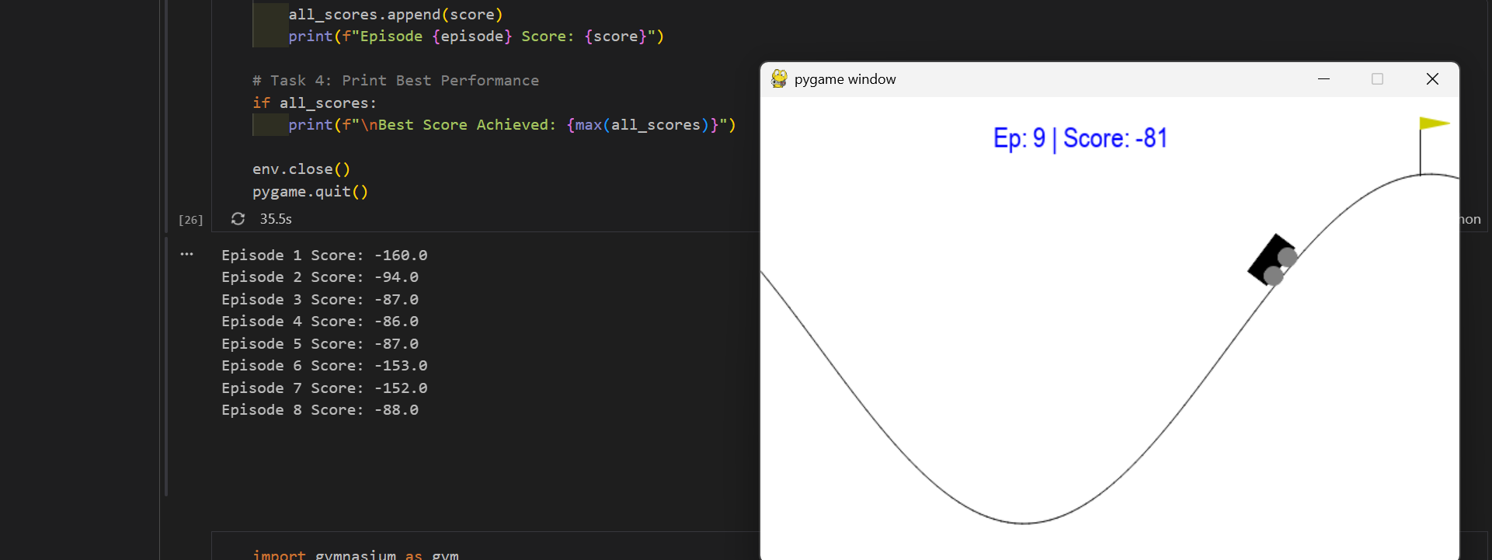

***Task 8 (Advanced): Episode Length Analysis***

Print the **number of steps per episode** and analyze:

* Why some episodes last longer
* Relation between steps and score

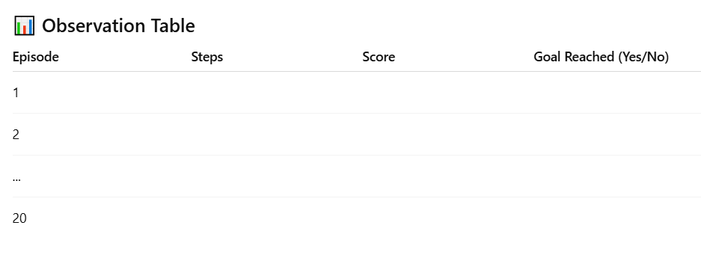

***Code:***

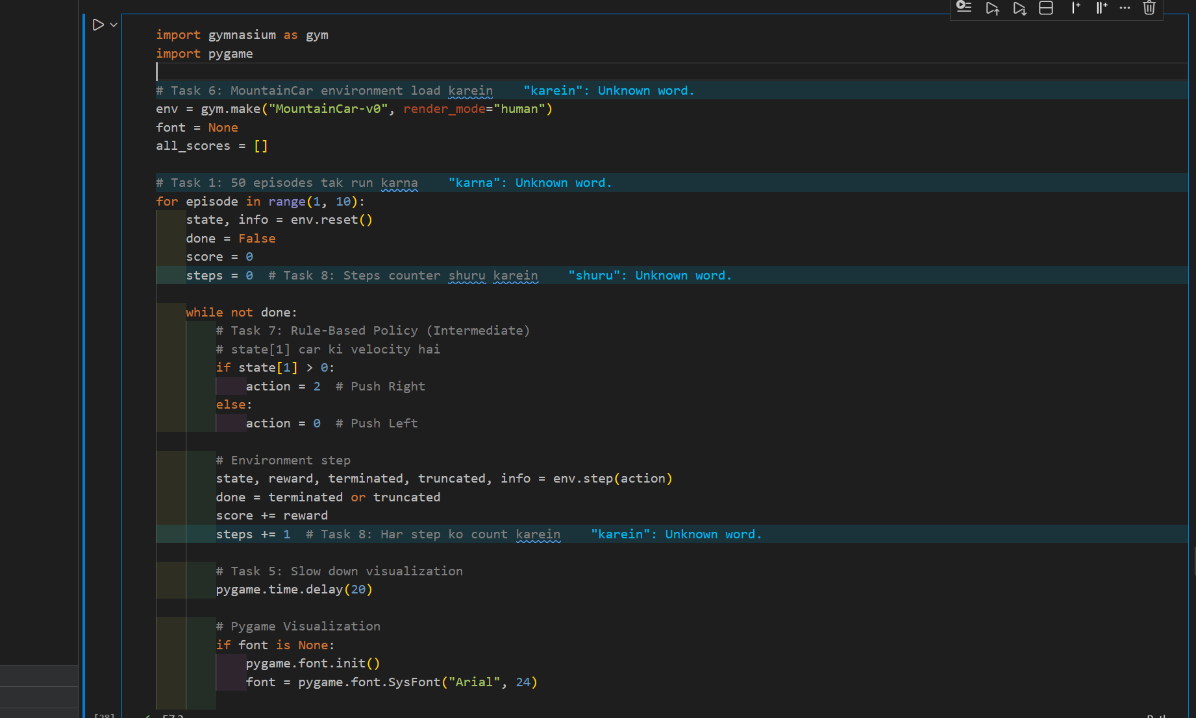

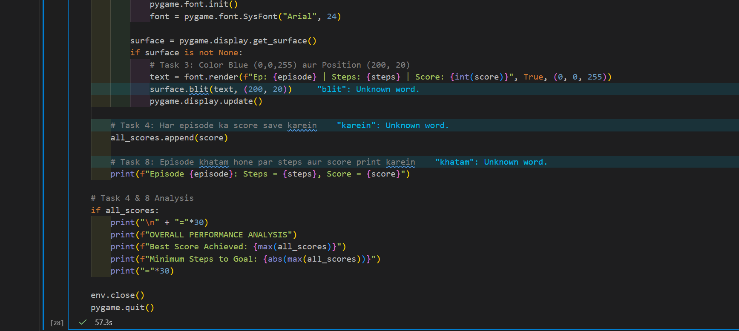

***Output:***

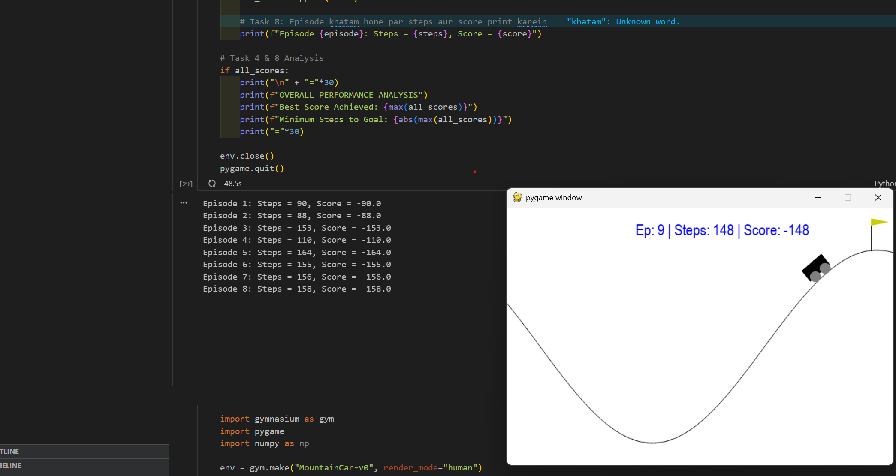

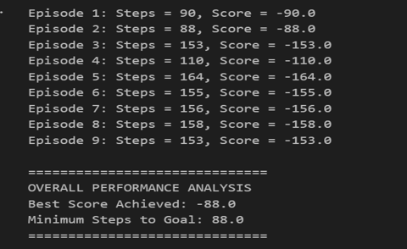

***Laboratory Work Assessment Rubrics***

|  |  |  |  |  |  |  |
| --- | --- | --- | --- | --- | --- | --- |
| **Sr.**  **No.** | **Performance Indicator** | **Excellent (5)** | **Good (4)** | **Average (3)** | **Fair (2)** | **Poor (1)** |
| **1** | **Theoretical** | Student knows | Student knows most | Student knows few | Student knows | Student has poor |
|  | **knowledge** | all the related | of the related | of the related | very little about | understanding of the |
|  | **10%** | concepts about | concepts about the | concepts about the | the related | related concepts |
|  |  | the theoretical | theoretical | theoretical | concepts about the | about the theoretical |
|  |  | background of | background of the | background of the | theoretical | background of the |
|  |  | the experiment | experiment and | experiment and | background of the | experiment and |
|  |  | and rephrase | partially rephrase | partially rephrase | experiment and | unable to rephrase |
|  |  | those concepts in | those concepts in | those concepts in | poorly rephrase | those concepts in |
|  |  | written and oral | written and oral | written and oral | those concepts in | written and oral |
|  |  | assessments | assessments | assessments | written and oral | assessments |
|  |  |  |  |  | assessments |  |
| **2** | **Application** | Application runs | Application | Application | Application | Application does |
|  | **Functionality** | smoothly and | compiles with no | compiles with | compiles and | not compile or |
|  | **10%** | operation of the | warnings. Robust | few or no | runs without | compiles but |
|  |  | application runs | operation of the | warnings. | crashing. Some | crashes. |
|  |  | efficiently | application, with | Consideration | attempt at | Confusing. |
|  |  |  | good recovery. | given to unusual | detecting and | Little or no error |
|  |  |  |  | conditions with | correcting | detection or |
|  |  |  |  | reasonable | errors. | correction. |
| **3** | **Specifications** | The program | The program works | The program | The program | The program is |
|  | **10%** | works very | and meets some of | works and | produces correct | producing incorrect |
|  |  | efficiently and | the specifications. | produces the | results but does not | results. |
|  |  | meets all of the |  | correct results and | display them |  |
|  |  | required |  | displays them | correctly. |  |
|  |  | specifications. |  | correctly. It also |  |  |
|  |  |  |  | meets most of the |  |  |
|  |  |  |  | other |  |  |
|  |  |  |  | specifications. |  |  |
| **4** | **Level of** | Provide complete | Provide complete | Provide partially | Provide very few | Provide no answer to |
|  | **understanding of** | and logical | and logical answers | correct and logical | and illogical | the questions asked |
|  | **the learned skill** | answers based | based upon accurate | answers based | answers to the | by examiner. |
|  | **10%** | upon accurate | technical content to | upon minimum | questions asked by |  |
|  |  | technical content | the questions asked | technical content | examiner. |  |
|  |  | to the questions | by examiner with | to the questions |  |  |
|  |  | asked by | few errors | asked by examiner |  |  |
|  |  | examiner |  |  |  |  |
| **5** | **Readability and** | The code is | The code is fairly | Most of the code | Some parts of the | The code is poorly |
|  | **Reusability** | exceptionally | easy to read. The | could be reused in | code require | organized and very |
|  | **10%** | well organized | code could be | other programs. | change before they | difficult to read and |
|  |  | and very easy | reused as a whole |  | could be reused in | not organized for |
|  |  | to follow and | or each class could |  | other programs. | reusability. |
|  |  | reused | be reused. |  |  |  |

|  |  |  |  |  |  |  |
| --- | --- | --- | --- | --- | --- | --- |
| **6** | **AI System Design 10%** | Well-designed AI models. Code is highly maintainable | Good designed AI models and Little code duplications | Some attempt to make AI models. Code can be maintained with significant effort | Little attempt to design AI models and less understanding of code | Very poor attempt to design AI models and its code |
| **7** | **Responsiveness to**  **Questions/ Accuracy 10%** | 1. Responds well, quick and very accurate all the time. 2. Effectively uses eye ;:contact, speaks clearly, effectively and confidently using   suitable volume | 1. Generally Responsive and accurate most of the times. 2. Maintains eye contact, speaks clearly with suitable volume and pace. | 1. Generally Responsive and accurate few times. 2. Some eye contact, speaks clearly and unclearly in different portions. | 1. Not much Responsive and accurate most of the times. 2. Uses eye contact ineffectively and fails to speak clearly and audibly | . 1. Non Responsive and inaccurate all the times.   1. No eye contact and unable to speak 2. Dresses inappropriately |
| **8** | **Efficiency 10%** | The code is extremely efficient without sacrificing readability and understanding | The code is fairly efficient without sacrificing readability and understanding | Some part of the code is efficient and other part of the code is not understandable and work properly | The code is brute force and unnecessarily long | The code is huge and appears to be patched together |
| **9** | **Delivery 10%** | The program was delivered in time during lab. | The program was delivered in Lab before the end time. | The program was delivered within the due date. | The code was delivered within a day after the due date. | The code was delivered more than 2 days overdue. |
| **10** | **Awareness of Safety Guidelines 10%** | Student has sufficient knowledge of the laboratory safety SOPs and protocol and is fully compliant to the guidelines | Student has sufficient knowledge of the laboratory safety SOPs and protocol and is Partially compliant to the guidelines | Student has little knowledge of the laboratory safety SOPs and protocol and is Partially compliant to the guidelines | Student has little knowledge of the laboratory safety SOPs and protocol and is non- compliant to the guidelines | Student has no knowledge of the laboratory safety SOPs and protocol and is non-compliant to the guidelines |

.

***LAB Assessment:***

|  |  |  |  |
| --- | --- | --- | --- |
| **Student Name** |  | **LAB Rubrics** | CLO3 , P5, PLO5 |
| **Total Marks** | 10 |
| **Registration No** |  | **Obtained Marks** |  |
| **Teacher Name** | Dr. Syed M Hamedoon |
| **Date** |  | **Signature** |  |

***Lab No. 13***

***Natural Language Processing (NLP)***

This laboratory session introduces students to Word2Vec, a popular technique in Natural Language Processing (NLP) used to represent words as meaningful dense vectors. Using textual data from the *Game of Thrones* series, students will learn how word embeddings capture semantic relationships between words based on their context. Through preprocessing, model training, and similarity analysis, this lab helps students understand how machines learn word meanings and relationships from large text corpora in an unsupervised manner.

***LAB Objectives:***

* Understand **distributional semantics**
* Learn how **Word2Vec** converts words into dense vectors
* Apply **Word2Vec (Skip-Gram / CBOW)** on real textual data (Game of Thrones)
* Explore **word similarity, analogy, and visualization**

**game-of-thrones-word2vec**

word2vec applied on game of thrones data

Dataset Link: <https://www.kaggle.com/khulasasndh/game-of-thrones-books>

Download the data set from Kaggle

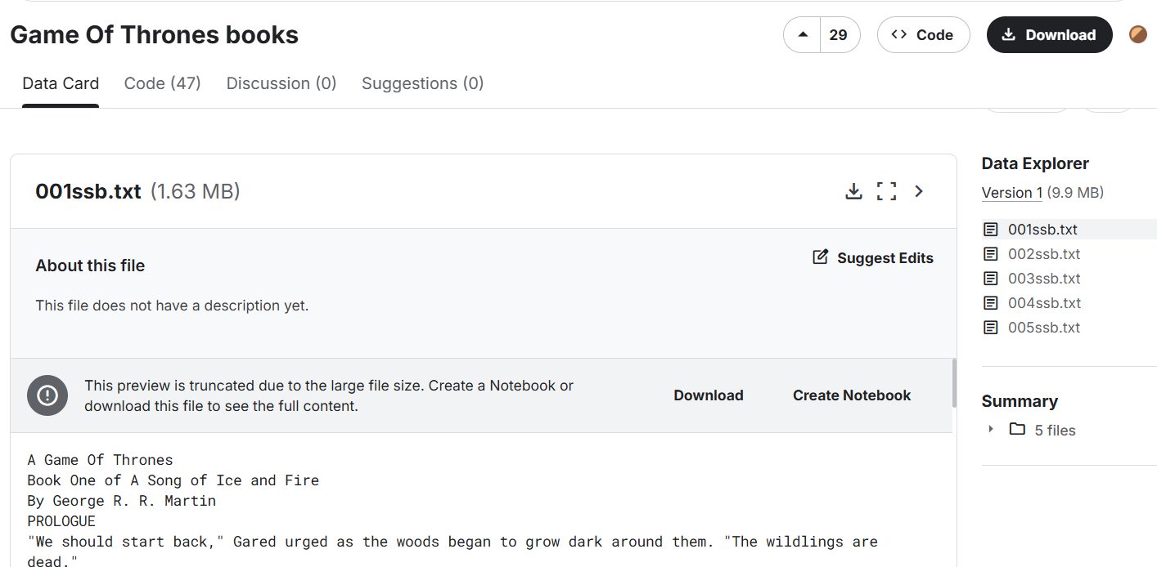

Add the dataset in folder data where VS code directory present

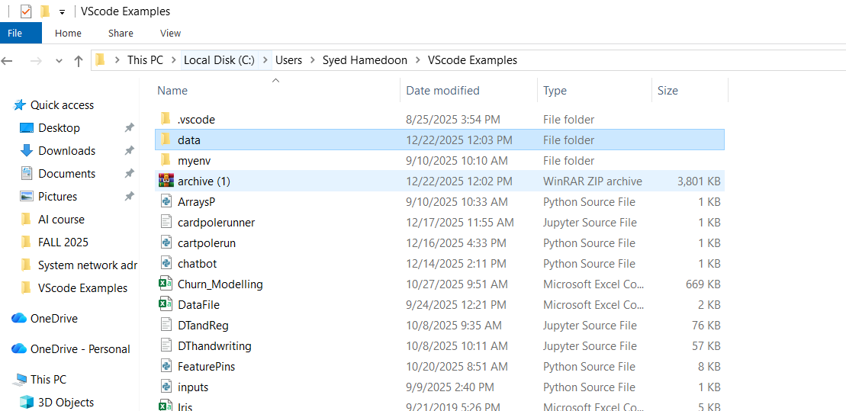

***Code in jupter VS code:***

|  |
| --- |
| import numpy as np  import pandas as pd |

|  |
| --- |
| !pip install gensim |

|  |
| --- |
| import gensim  import os |

|  |
| --- |
| !pip install nltk |

|  |
| --- |
| data = "C:/Users/Syed Hamedoon/VScode Examples/data" |

|  |
| --- |
| import nltk  nltk.download('punkt')  nltk.download('punkt_tab') |

|  |
| --- |
| import os  from nltk import sent_tokenize  from gensim.utils import simple_preprocess  DATA_PATH = r"C:\Users\Syed Hamedoon\VScode Examples\data"  story = []  for filename in os.listdir(DATA_PATH):      if filename.endswith(".txt"):          file_path = os.path.join(DATA_PATH, filename)          try:              with open(file_path, "r", encoding="utf-8") as f:                  corpus = f.read()          except UnicodeDecodeError:              with open(file_path, "r", encoding="cp1252") as f:                  corpus = f.read()          for sent in sent_tokenize(corpus):              story.append(simple_preprocess(sent)) |

|  |
| --- |
| print(len(story))  print(story[:2]) |

|  |
| --- |
| model = gensim.models.Word2Vec(      window=10,      min_count=2  ) |

|  |
| --- |
| model.build_vocab(story) |

|  |
| --- |
| model.train(story, total_examples=model.corpus_count, epochs=model.epochs) |

|  |
| --- |
| model.wv.most_similar('daenerys') |

|  |
| --- |
| model.wv.doesnt_match(['jon','rikon','robb','arya','sansa','bran']) |

|  |
| --- |
| model.wv.doesnt_match(['cersei', 'jaime', 'bronn', 'tyrion']) |

|  |
| --- |
| model.wv['king'] |

|  |
| --- |
| model.wv.similarity('arya','sansa') |

|  |
| --- |
| model.wv.similarity('tywin','sansa') |

|  |
| --- |
| model.wv.get_normed_vectors() |

|  |
| --- |
| y = model.wv.index_to_key |

|  |
| --- |
| len(y) |

|  |
| --- |
| y |

|  |
| --- |
| from sklearn.decomposition import PCA |

|  |
| --- |
| pca = PCA(n_components=3) |

|  |
| --- |
| X = pca.fit_transform(model.wv.get_normed_vectors()) |

|  |
| --- |
| X.shape |

|  |
| --- |
| !pip install --upgrade nbformat |

|  |
| --- |
| import pandas as pd  import plotly.express as px  import plotly.io as pio  pio.renderers.default = "browser" # ← IMPORTANT  df = pd.DataFrame(X[200:300], columns=["x", "y", "z"])  df["label"] = y[200:300]  fig = px.scatter_3d(  df,  x="x",  y="y",  z="z",  color="label"  )  fig.show() |

***Output:***

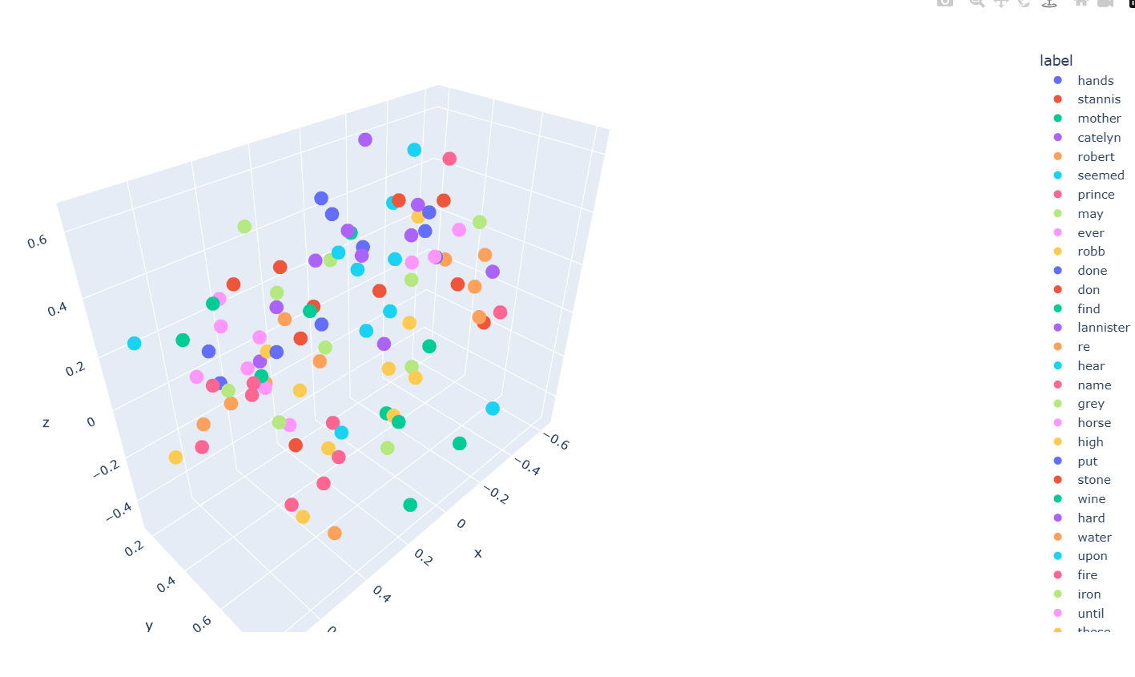

***Practice Questions***

1. **What is the core idea behind Word2Vec?**

The main idea is that "words that appear in the same context share similar meanings." It converts words into numbers (vectors) so that the computer can understand relationships between them.

1. **Difference between CBOW and Skip-Gram?**

**CBOW (Continuous Bag of Words):** It uses the **surrounding words** to predict a **target word**.

***Skip-Gram*:** It uses **one word** to predict the **surrounding words**.

1. **Why is one-hot encoding inefficient?**

***One-Hot Encoding Inefficiency:*** It is inefficient because it creates huge, mostly empty lists (vectors) for every word. It also fails to show any relationship between words; for example, "king" and "queen" would look completely unrelated in one-hot encoding.

1. **Why do character names appear close in vector space?**

***Character Names in Vector Space:*** In stories, character names often appear in similar sentences (e.g., "Harry said" or "Hermione said"). Since they share the same context, the model places them close together in the vector space.

1. **How does window size affect semantic learning?**

***Window Size:*** A **small window** focuses on the grammar and the immediate role of the word.

* A **large window** focuses on the overall topic or "theme" of the document.

1. **Why might rare characters have poor embeddings?**

***Rare Characters:*** If a character's name only appears once or twice, the model doesn't have enough "examples" (context) to learn where that word belongs, resulting in poor or inaccurate embeddings.

1. **Which model performed better: CBOW or Skip-Gram? Why?**

**Which is better?** Usually, **Skip-Gram** performs better with large datasets and rare words, while ***CBOW*** is faster to train and works well with frequent words

1. **What happens if vector size is too small or too large?**

***Vector Size:***

* ***Too small:*** The model cannot capture all the complex meanings of words.
* ***Too large*:** The model takes too much memory and might start memorizing noise instead of learning patterns.

1. **Can Word2Vec understand word meaning without labels? Explain.**

***Labels and Meaning:*** Yes, Word2Vec is **unsupervised**. It does not need human labels (like "this word is a fruit") because it learns meaning purely by looking at which words naturally sit next to each other in a text

***Code:***

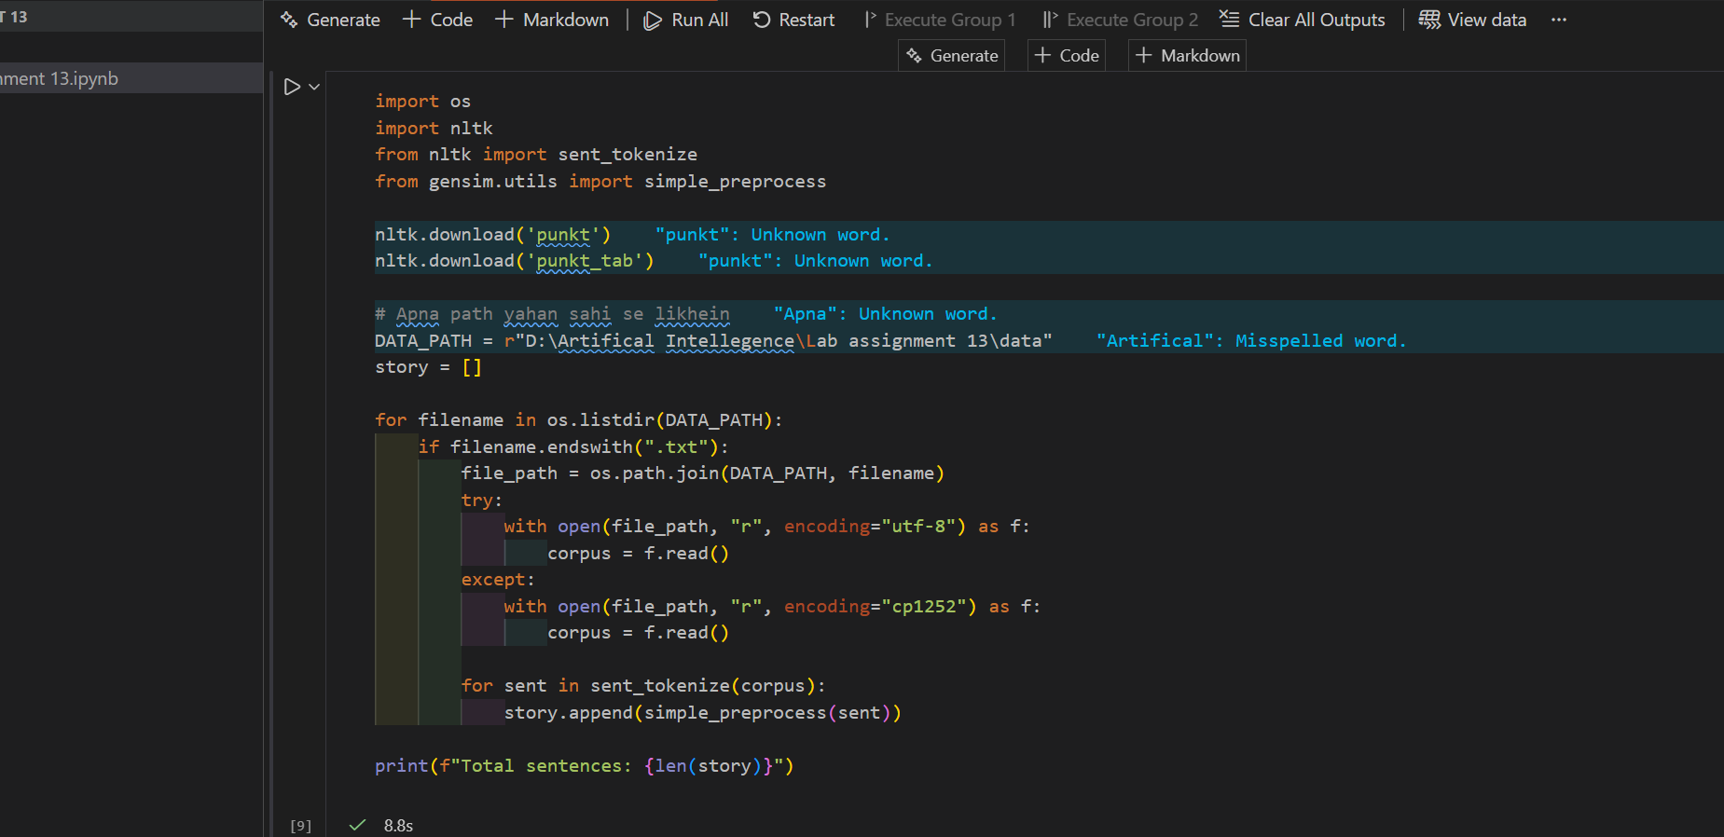

***Output:***

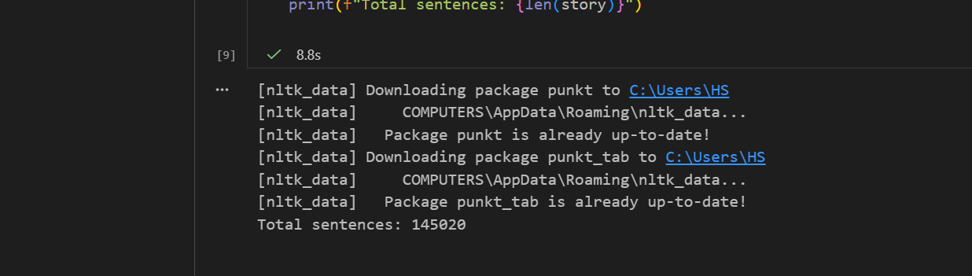

***Code:***

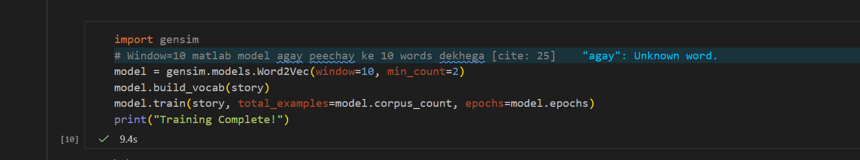

***Output:***

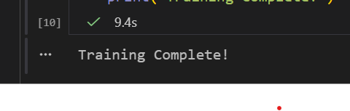

***Code:***

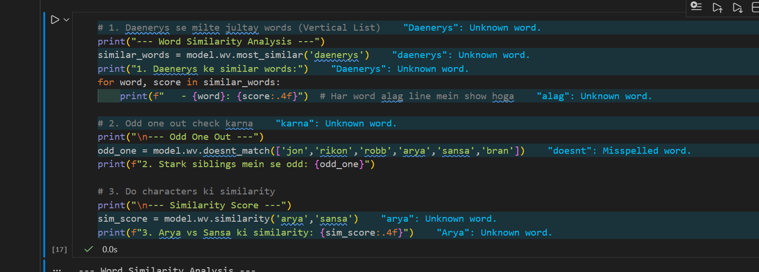

***Output:***

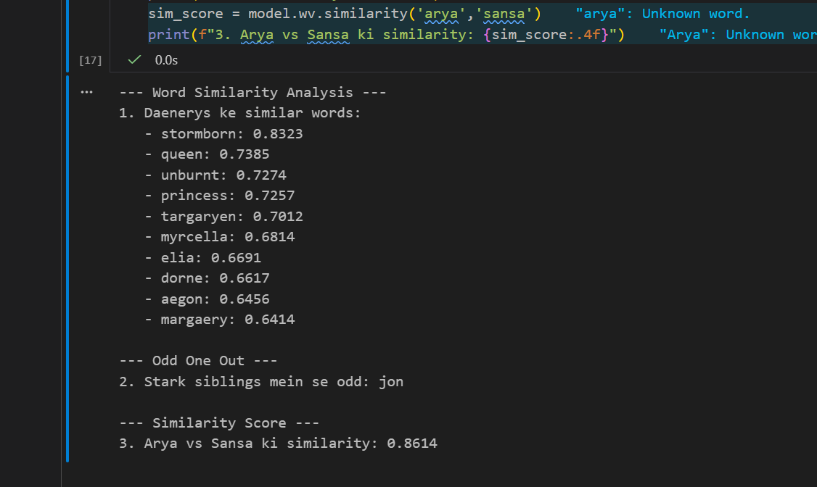

***Code:***

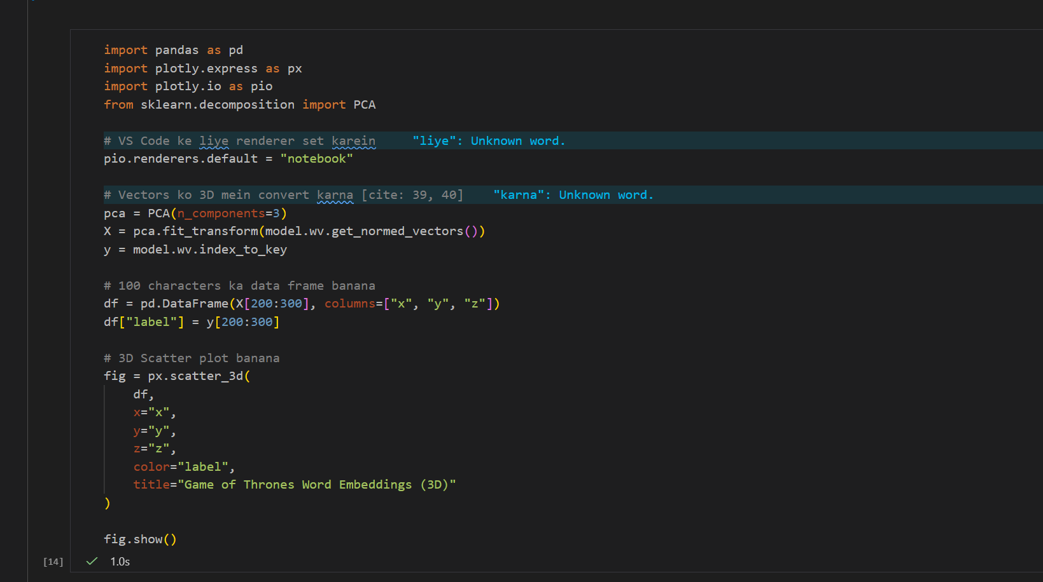

***Output:***

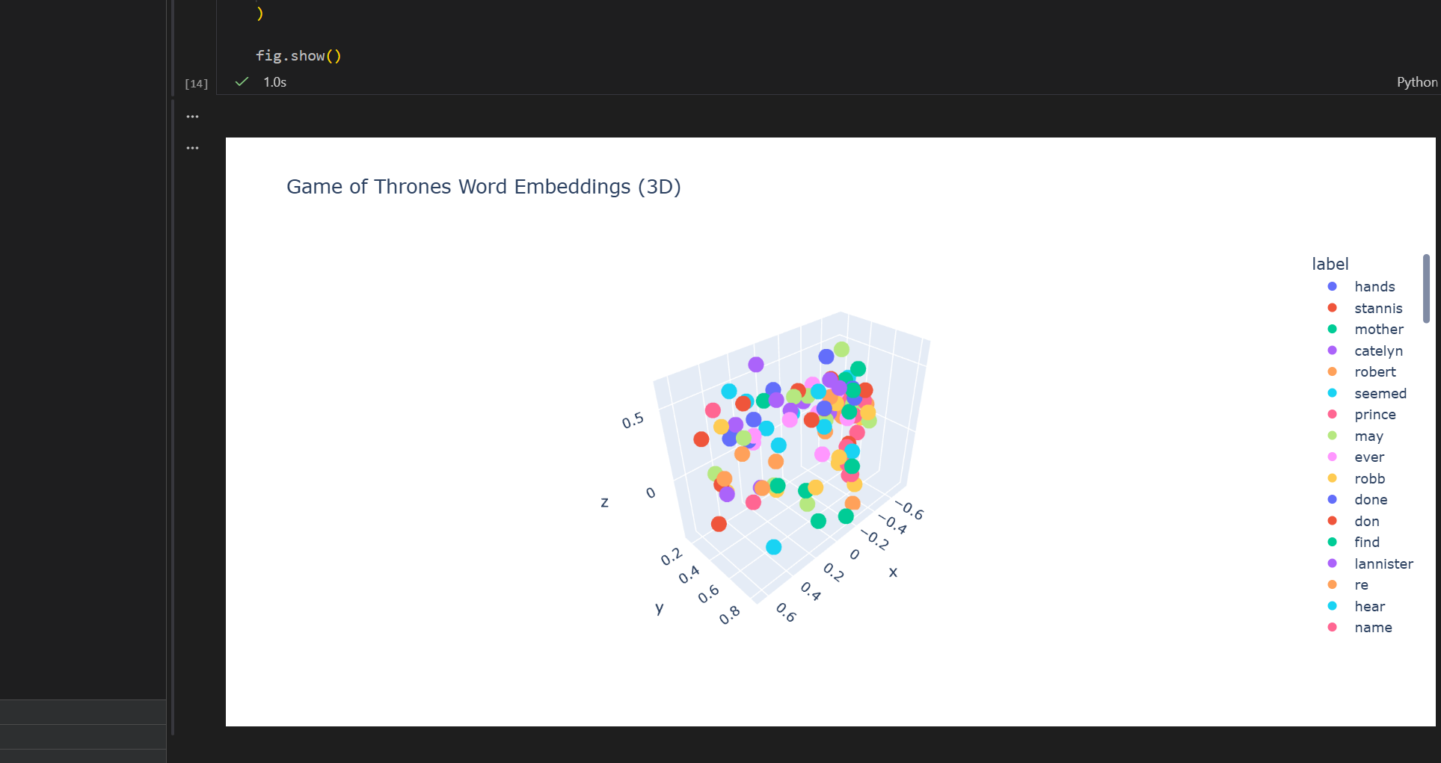

***Laboratory Work Assessment Rubrics***

|  |  |  |  |  |  |  |
| --- | --- | --- | --- | --- | --- | --- |
| **Sr.**  **No.** | **Performance Indicator** | **Excellent (5)** | **Good (4)** | **Average (3)** | **Fair (2)** | **Poor (1)** |
| **1** | **Theoretical** | Student knows | Student knows most | Student knows few | Student knows | Student has poor |
|  | **knowledge** | all the related | of the related | of the related | very little about | understanding of the |
|  | **10%** | concepts about | concepts about the | concepts about the | the related | related concepts |
|  |  | the theoretical | theoretical | theoretical | concepts about the | about the theoretical |
|  |  | background of | background of the | background of the | theoretical | background of the |
|  |  | the experiment | experiment and | experiment and | background of the | experiment and |
|  |  | and rephrase | partially rephrase | partially rephrase | experiment and | unable to rephrase |
|  |  | those concepts in | those concepts in | those concepts in | poorly rephrase | those concepts in |
|  |  | written and oral | written and oral | written and oral | those concepts in | written and oral |
|  |  | assessments | assessments | assessments | written and oral | assessments |
|  |  |  |  |  | assessments |  |
| **2** | **Application** | Application runs | Application | Application | Application | Application does |
|  | **Functionality** | smoothly and | compiles with no | compiles with | compiles and | not compile or |
|  | **10%** | operation of the | warnings. Robust | few or no | runs without | compiles but |
|  |  | application runs | operation of the | warnings. | crashing. Some | crashes. |
|  |  | efficiently | application, with | Consideration | attempt at | Confusing. |
|  |  |  | good recovery. | given to unusual | detecting and | Little or no error |
|  |  |  |  | conditions with | correcting | detection or |
|  |  |  |  | reasonable | errors. | correction. |
| **3** | **Specifications** | The program | The program works | The program | The program | The program is |
|  | **10%** | works very | and meets some of | works and | produces correct | producing incorrect |
|  |  | efficiently and | the specifications. | produces the | results but does not | results. |
|  |  | meets all of the |  | correct results and | display them |  |
|  |  | required |  | displays them | correctly. |  |
|  |  | specifications. |  | correctly. It also |  |  |
|  |  |  |  | meets most of the |  |  |
|  |  |  |  | other |  |  |
|  |  |  |  | specifications. |  |  |
| **4** | **Level of** | Provide complete | Provide complete | Provide partially | Provide very few | Provide no answer to |
|  | **understanding of** | and logical | and logical answers | correct and logical | and illogical | the questions asked |
|  | **the learned skill** | answers based | based upon accurate | answers based | answers to the | by examiner. |
|  | **10%** | upon accurate | technical content to | upon minimum | questions asked by |  |
|  |  | technical content | the questions asked | technical content | examiner. |  |
|  |  | to the questions | by examiner with | to the questions |  |  |
|  |  | asked by | few errors | asked by examiner |  |  |
|  |  | examiner |  |  |  |  |
| **5** | **Readability and** | The code is | The code is fairly | Most of the code | Some parts of the | The code is poorly |
|  | **Reusability** | exceptionally | easy to read. The | could be reused in | code require | organized and very |
|  | **10%** | well organized | code could be | other programs. | change before they | difficult to read and |
|  |  | and very easy | reused as a whole |  | could be reused in | not organized for |
|  |  | to follow and | or each class could |  | other programs. | reusability. |
|  |  | reused | be reused. |  |  |  |

|  |  |  |  |  |  |  |
| --- | --- | --- | --- | --- | --- | --- |
| **6** | **AI System Design 10%** | Well-designed AI models. Code is highly maintainable | Good designed AI models and Little code duplications | Some attempt to make AI models. Code can be maintained with significant effort | Little attempt to design AI models and less understanding of code | Very poor attempt to design AI models and its code |
| **7** | **Responsiveness to**  **Questions/ Accuracy 10%** | 1. Responds well, quick and very accurate all the time. 2. Effectively uses eye contact, speaks clearly, effectively and confidently using   suitable volume | 1. Generally Responsive and accurate most of the times. 2. Maintains eye contact, speaks clearly with suitable volume and pace. | 1. Generally Responsive and accurate few times. 2. Some eye contact, speaks clearly and unclearly in different portions. | 1. Not much Responsive and accurate most of the times. 2. Uses eye contact ineffectively and fails to speak clearly and audibly | . 1. Non Responsive and inaccurate all the times.   1. No eye contact and unable to speak 2. Dresses inappropriately |
| **8** | **Efficiency 10%** | The code is extremely efficient without sacrificing readability and understanding | The code is fairly efficient without sacrificing readability and understanding | Some part of the code is efficient and other part of the code is not understandable and work properly | The code is brute force and unnecessarily long | The code is huge and appears to be patched together |
| **9** | **Delivery 10%** | The program was delivered in time during lab. | The program was delivered in Lab before the end time. | The program was delivered within the due date. | The code was delivered within a day after the due date. | The code was delivered more than 2 days overdue. |
| **10** | **Awareness of Safety Guidelines 10%** | Student has sufficient knowledge of the laboratory safety SOPs and protocol and is fully compliant to the guidelines | Student has sufficient knowledge of the laboratory safety SOPs and protocol and is Partially compliant to the guidelines | Student has little knowledge of the laboratory safety SOPs and protocol and is Partially compliant to the guidelines | Student has little knowledge of the laboratory safety SOPs and protocol and is non- compliant to the guidelines | Student has no knowledge of the laboratory safety SOPs and protocol and is non-compliant to the guidelines |

***LAB Assessment:***

|  |  |  |  |
| --- | --- | --- | --- |
| **Student Name** |  | **LAB Rubrics** | CLO3 , P5, PLO5 |
| **Total Marks** | 10 |
| **Registration No** |  | **Obtained Marks** |  |
| **Teacher Name** | Dr. Syed M Hamedoon |
| **Date** |  | **Signature** |  |

***LAB No. 14***

***Document Loading using LangChain for Retrieval-Augmented Generation (RAG)***

This lab introduces students to Document Loaders in LangChain, a key component of **Retrieval-Augmented Generation (RAG)** systems. Students will learn how to load, preprocess, and structure data from different document formats such as text and PDF files. By converting documents into LangChain’s Document objects, students will understand how external knowledge can be prepared and supplied to large language models for improved, context-aware responses.

***LAB Objectives***

* Understand the role of document loaders in RAG
* Load data from multiple file formats using LangChain
* Inspect document metadata and content
* Prepare documents for downstream tasks like chunking and retrieval

***Theory:***

It is a technique that combines information retrieval with language generation, where a model retrieves relevant documents from a knowledge base and then uses them as context to generate accurate and grounded responses.

***Benefits of using RAG***

1. Use of up to date information
2. Better privacy

No limit of document size

***Flow Methodology of RAG***

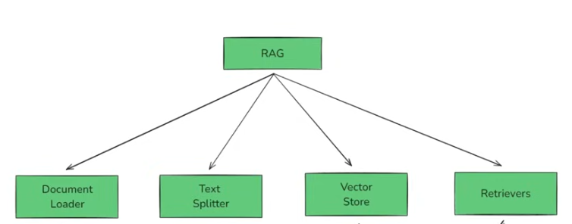

***Complete Flow diagram of RAG***

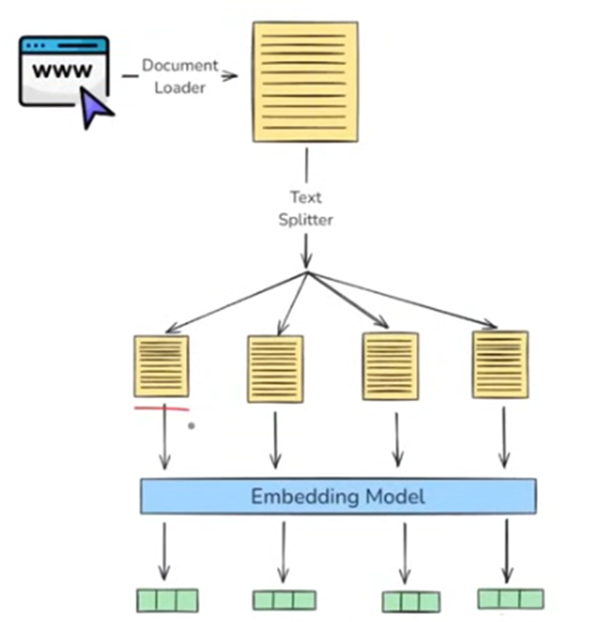 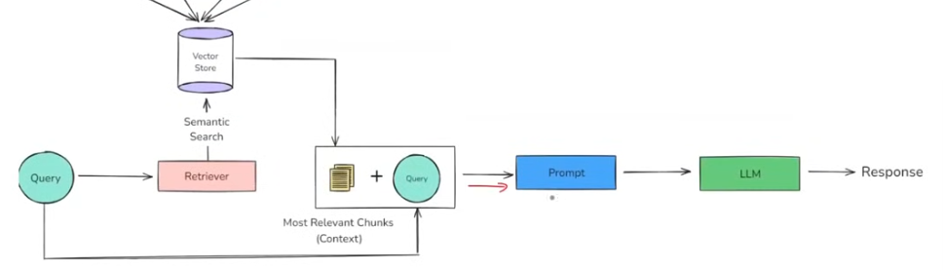

***Tools & Libraries***

* Python 3.9+
* Required libraries:
  + langchain
  + langchain-community
  + pypdf
  + unstructured

***Environment Setup***

* Create a virtual environment
* Install required LangChain libraries
* Verify installation

Practice Questions:

***Task 1: Understand the Main Concept – Document Loaders***

* Study the role of **Document Loaders** in RAG
* Explain how loaders convert raw data into LangChain Document objects

**Document Loaders** in RAG are used to bring external data (PDFs, websites, text files, etc.) in

the system so the language model can access real information.They read raw data from different sources and extract the meaningful text and metadata.This data is then converted into LangChain **Document objects**, where each document contains the content and its source details .These documents are later split, embedded, and stored in a vector database for retrieval. When a user asks a question, the most relevant documents are fetched to generate accurate answers.

***Task 2: Load PDF Data (PyPDFLoader)***

* Load lecture_notes.pdf
* Count total pages
* Display content of first page
* Attach code with output screenshot

***Code:***

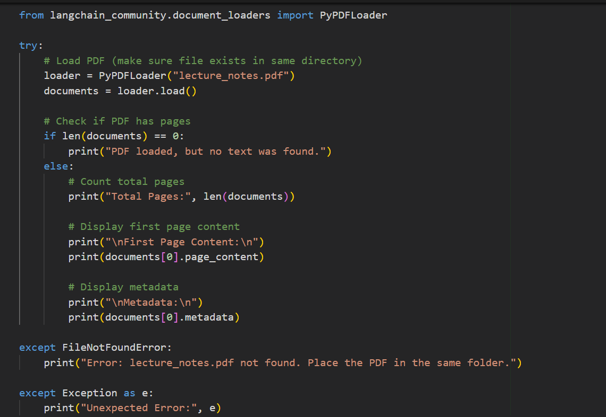

***Output:***



***Task 3: Load Web Data (WebBaseLoader)***

* Use **WebBaseLoader** to load a webpage
* Extract main textual content
* Observe metadata (URL source)
* Attach code with output screenshot

***Code:***

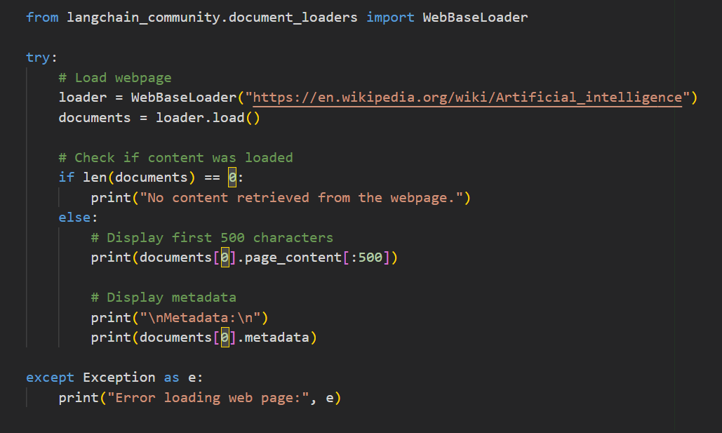

***Output:***

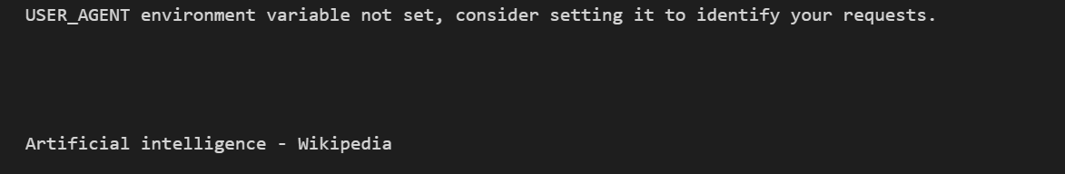

***Task 4: Load Structured Data (CSVLoader)***

* Load students.csv
* Inspect how rows are converted into documents
* Print one document sample
* Attach code with output screenshot

***Code:***

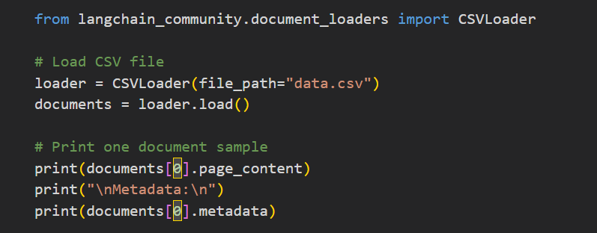

***Output:***

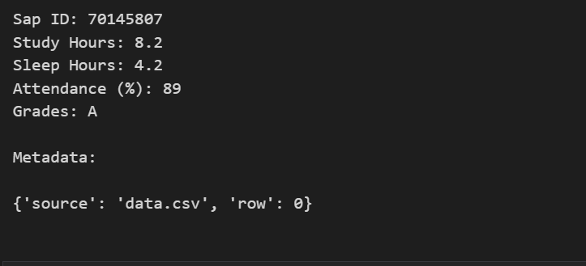

***Task 5: Compare All Loaders***

Students must compare:

* Content format
* Metadata fields
* Attach code with output screenshot

**Code:**



***Output:***



***Conceptual Questions***

**1. What is the role of document loaders in RAG?**

Document loaders fetch external data and convert it into LangChain Document objects so that language models can retrieve and use real-world knowledge during response generation.

***2. Why is metadata important in LangChain documents?***

Metadata helps identify the source, page number, URL, or row index, making retrieved information traceable, reliable, and context-aware.

***3. Difference between TextLoader and PyPDFLoader?***

***TextLoader:*** Loads plain text files line by line

***PyPDFLoader:*** Extracts text from PDF pages and preserves page-level metadata

***4.What happens if a PDF has scanned images instead of text?***

PyPDFLoader cannot extract text from scanned images. OCR tools like Tesseract are required to convert images into readable text.

***5.Why is directory-based loading useful in real applications?***

It allows bulk loading of multiple documents, making it scalable for enterprise-level RAG systems with large document collections.

***6.How does document quality affect RAG performance?***

High-quality, clean, and well-structured documents improve retrieval accuracy and generate more relevant and reliable AI responses.

***Laboratory Work Assessment Rubrics***

|  |  |  |  |  |  |  |
| --- | --- | --- | --- | --- | --- | --- |
| **Sr.**  **No.** | **Performance Indicator** | **Excellent (5)** | **Good (4)** | **Average (3)** | **Fair (2)** | **Poor (1)** |
| **1** | **Theoretical** | Student knows | Student knows most | Student knows few | Student knows | Student has poor |
|  | **knowledge** | all the related | of the related | of the related | very little about | understanding of the |
|  | **10%** | concepts about | concepts about the | concepts about the | the related | related concepts |
|  |  | the theoretical | theoretical | theoretical | concepts about the | about the theoretical |
|  |  | background of | background of the | background of the | theoretical | background of the |
|  |  | the experiment | experiment and | experiment and | background of the | experiment and |
|  |  | and rephrase | partially rephrase | partially rephrase | experiment and | unable to rephrase |
|  |  | those concepts in | those concepts in | those concepts in | poorly rephrase | those concepts in |
|  |  | written and oral | written and oral | written and oral | those concepts in | written and oral |
|  |  | assessments | assessments | assessments | written and oral | assessments |
|  |  |  |  |  | assessments |  |
| **2** | **Application** | Application runs | Application | Application | Application | Application does |
|  | **Functionality** | smoothly and | compiles with no | compiles with | compiles and | not compile or |
|  | **10%** | operation of the | warnings. Robust | few or no | runs without | compiles but |
|  |  | application runs | operation of the | warnings. | crashing. Some | crashes. |
|  |  | efficiently | application, with | Consideration | attempt at | Confusing. |
|  |  |  | good recovery. | given to unusual | detecting and | Little or no error |
|  |  |  |  | conditions with | correcting | detection or |
|  |  |  |  | reasonable | errors. | correction. |
| **3** | **Specifications** | The program | The program works | The program | The program | The program is |
|  | **10%** | works very | and meets some of | works and | produces correct | producing incorrect |
|  |  | efficiently and | the specifications. | produces the | results but does not | results. |
|  |  | meets all of the |  | correct results and | display them |  |
|  |  | required |  | displays them | correctly. |  |
|  |  | specifications. |  | correctly. It also |  |  |
|  |  |  |  | meets most of the |  |  |
|  |  |  |  | other |  |  |
|  |  |  |  | specifications. |  |  |
| **4** | **Level of** | Provide complete | Provide complete | Provide partially | Provide very few | Provide no answer to |
|  | **understanding of** | and logical | and logical answers | correct and logical | and illogical | the questions asked |
|  | **the learned skill** | answers based | based upon accurate | answers based | answers to the | by examiner. |
|  | **10%** | upon accurate | technical content to | upon minimum | questions asked by |  |
|  |  | technical content | the questions asked | technical content | examiner. |  |
|  |  | to the questions | by examiner with | to the questions |  |  |
|  |  | asked by | few errors | asked by examiner |  |  |
|  |  | examiner |  |  |  |  |
| **5** | **Readability and** | The code is | The code is fairly | Most of the code | Some parts of the | The code is poorly |
|  | **Reusability** | exceptionally | easy to read. The | could be reused in | code require | organized and very |
|  | **10%** | well organized | code could be | other programs. | change before they | difficult to read and |
|  |  | and very easy | reused as a whole |  | could be reused in | not organized for |
|  |  | to follow and | or each class could |  | other programs. | reusability. |
|  |  | reused | be reused. |  |  |  |

|  |  |  |  |  |  |  |
| --- | --- | --- | --- | --- | --- | --- |
| **6** | **AI System Design 10%** | Well-designed AI models. Code is highly maintainable | Good designed AI models and Little code duplications | Some attempt to make AI models. Code can be maintained with significant effort | Little attempt to design AI models and less understanding of code | Very poor attempt to design AI models and its code |
| **7** | **Responsiveness to**  **Questions/ Accuracy 10%** | 1. Responds well, quick and very accurate all the time. 2. Effectively uses eye contact, speaks clearly, effectively and confidently using   suitable volume | 1. Generally Responsive and accurate most of the times. 2. Maintains eye contact, speaks clearly with suitable volume and pace. | 1. Generally Responsive and accurate few times. 2. Some eye contact, speaks clearly and unclearly in different portions. | 1. Not much Responsive and accurate most of the times. 2. Uses eye contact ineffectively and fails to speak clearly and audibly | . 1. Non Responsive and inaccurate all the times.   1. No eye contact and unable to speak 2. Dresses inappropriately |
| **8** | **Efficiency 10%** | The code is extremely efficient without sacrificing readability and understanding | The code is fairly efficient without sacrificing readability and understanding | Some part of the code is efficient and other part of the code is not understandable and work properly | The code is brute force and unnecessarily long | The code is huge and appears to be patched together |
| **9** | **Delivery 10%** | The program was delivered in time during lab. | The program was delivered in Lab before the end time. | The program was delivered within the due date. | The code was delivered within a day after the due date. | The code was delivered more than 2 days overdue. |
| **10** | **Awareness of Safety Guidelines 10%** | Student has sufficient knowledge of the laboratory safety SOPs and protocol and is fully compliant to the guidelines | Student has sufficient knowledge of the laboratory safety SOPs and protocol and is Partially compliant to the guidelines | Student has little knowledge of the laboratory safety SOPs and protocol and is Partially compliant to the guidelines | Student has little knowledge of the laboratory safety SOPs and protocol and is non- compliant to the guidelines | Student has no knowledge of the laboratory safety SOPs and protocol and is non-compliant to the guidelines |

***LAB Assessment:***

|  |  |  |  |
| --- | --- | --- | --- |
| **Student Name** |  | **LAB Rubrics** | CLO3 , P5, PLO5 |
| **Total Marks** | 10 |
| **Registration No** |  | **Obtained Marks** |  |
| **Teacher Name** | Dr. Syed M Hamedoon |
| **Date** |  | **Signature** |  |

***LAB N0. 15***

***Build a RAG-Based Chatbot Using Ollama and LangChain, and Streamlit***

***Lab Objective***

By the end of this lab, students will be able to:

* Set up Ollama locally and run LLAMA2
* Build a basic LangChain chatbot using Ollama
* Implement document ingestion and vector storage
* Enable Retrieval-Augmented Generation (RAG)
* Deploy the chatbot using Streamlit

***Tools & Technologies***

* Python 3.9+
* VS Code
* Ollama (LLAMA2)
* LangChain
* Streamlit
* FAISS (Vector Store)
* Dotenv

***File code 1***

Localama.py

|  |
| --- |
| from langchain_openai import ChatOpenAI  from langchain_core.prompts import ChatPromptTemplate  from langchain_core.output_parsers import StrOutputParser  from langchain_community.llms import Ollama  import streamlit as st  import os  from dotenv import load_dotenv  load_dotenv()  os.environ["LANGCHAIN_TRACING_V2"]="true"  os.environ["LANGCHAIN_API_KEY"]=os.getenv("LANGCHAIN_API_KEY")  ## Prompt Template  prompt=ChatPromptTemplate.from_messages(  [  ("system","You are a helpful assistant. Please response to the user queries"),  ("user","Question:{question}")  ]  )  ## streamlit framework  st.title('Langchain Demo With LLAMA2 API')  input_text=st.text_input("Search the topic u want")  # ollama LLAma2 LLm  llm=Ollama(model="llama2")  output_parser=StrOutputParser()  chain=prompt|llm|output_parser  if input_text:  st.write(chain.invoke({"question":input_text})) |

**Code File 2**

App.py

|  |
| --- |
| from langchain_openai import ChatOpenAI  from langchain_core.prompts import ChatPromptTemplate  from langchain_core.output_parsers import StrOutputParser  import streamlit as st  import os  from dotenv import load_dotenv  os.environ["OPENAI_API_KEY"]=os.getenv("OPENAI_API_KEY")  ## Langmith tracking  os.environ["LANGCHAIN_TRACING_V2"]="true"  os.environ["LANGCHAIN_API_KEY"]=os.getenv("LANGCHAIN_API_KEY")  ## Prompt Template  prompt=ChatPromptTemplate.from_messages(  [  ("system","You are a helpful assistant. Please response to the user queries"),  ("user","Question:{question}")  ]  )  ## streamlit framework  st.title('Langchain Demo With OPENAI API')  input_text=st.text_input("Search the topic u want")  # openAI LLm  llm=ChatOpenAI(model="gpt-3.5-turbo")  output_parser=StrOutputParser()  chain=prompt|llm|output_parser  if input_text:  st.write(chain.invoke({'question':input_text})) |

***Step 1: Create Project Structure***

Open **VS Code** and create the following folder structure:

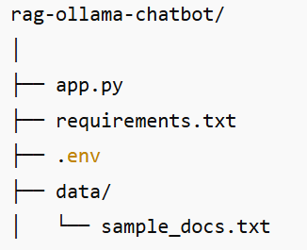

**Step 2: Install and Verify Ollama**

**2.1 Install Ollama**

Download and install Ollama from:

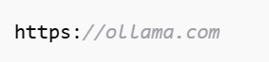

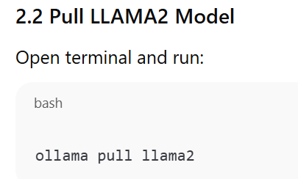

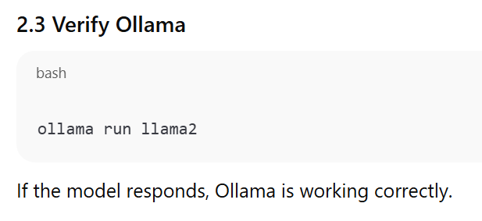

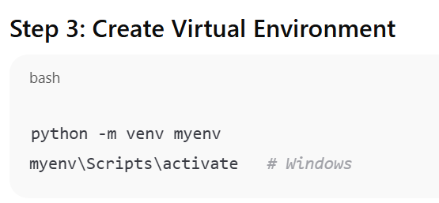

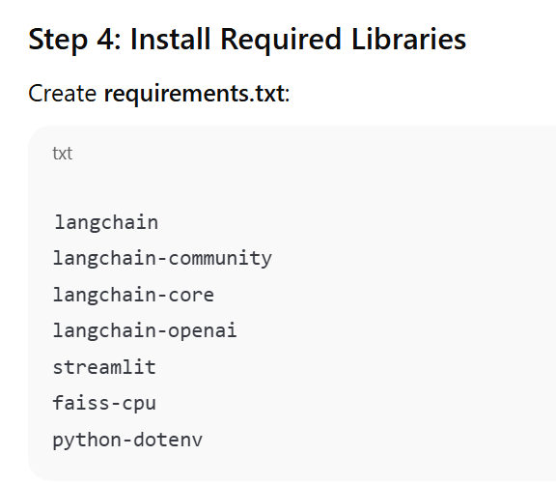

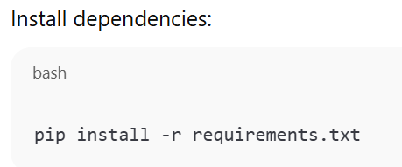

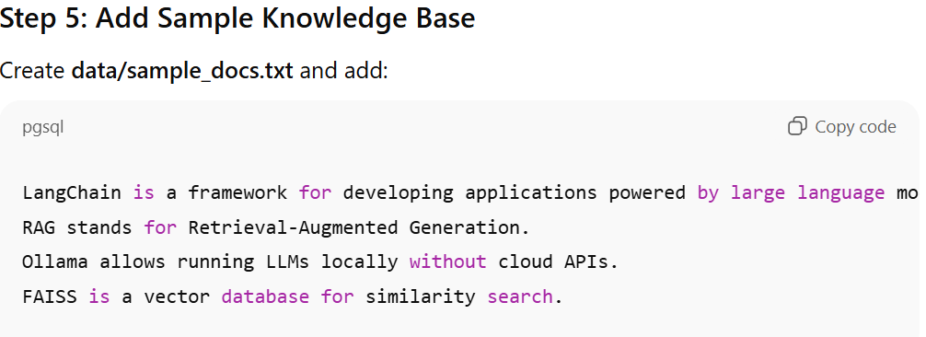

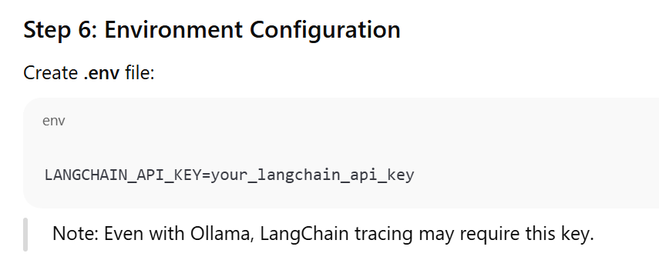

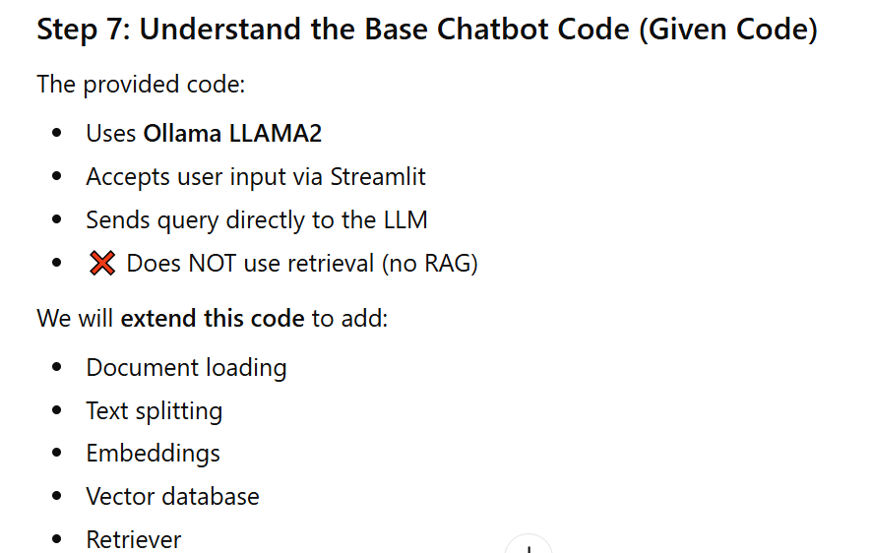

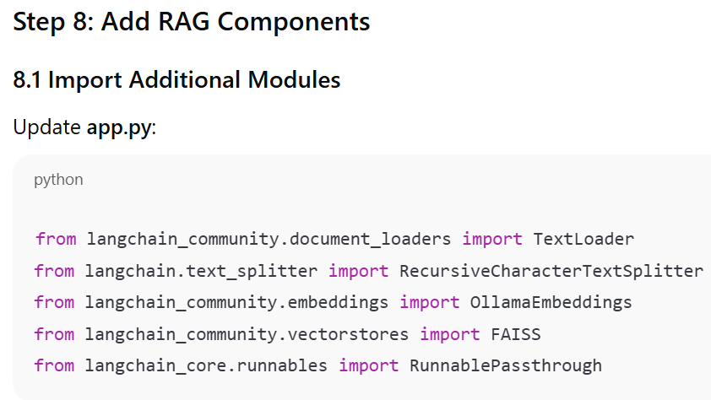

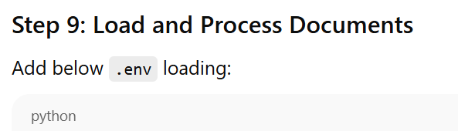

|  |
| --- |
| **# Load documents**  loader = TextLoader("data/sample_docs.txt")  documents = loader.load()  **# Split documents**  text_splitter = RecursiveCharacterTextSplitter(  chunk_size=500,  chunk_overlap=50  )  docs = text_splitter.split_documents(documents) |

***Step 10: Create Embeddings and Vector Store***

|  |
| --- |
| **# Create embeddings**  embeddings = OllamaEmbeddings(model="llama2")  **# Create FAISS vector store**  vectorstore = FAISS.from_documents(docs, embeddings)  **# Create retriever**  retriever = vectorstore.as_retriever() |

***Step 11: Modify Prompt for RAG***

***Replace your prompt template with:***

|  |
| --- |
| prompt = ChatPromptTemplate.from_messages(  [  ("system", "Answer the question using the provided context only."),  ("user", "Context:\n{context}\n\nQuestion:\n{question}")  ]  ) |

***Step 12: Build the RAG Chain***

|  |
| --- |
| llm = Ollama(model="llama2")  output_parser = StrOutputParser()  rag_chain = (  {  "context": retriever,  "question": RunnablePassthrough()  }  | prompt  | llm  | output_parser  ) |

***Step 13: Update Streamlit UI***

|  |
| --- |
| st.title("RAG Chatbot with Ollama & LangChain")  input_text = st.text_input("Ask a question based on the documents")  if input_text:  response = rag_chain.invoke(input_text)  st.write(response) |

***Step 14: Run the Application***

|  |
| --- |
| streamlit run app.py |

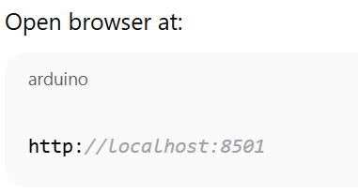

**Code:**

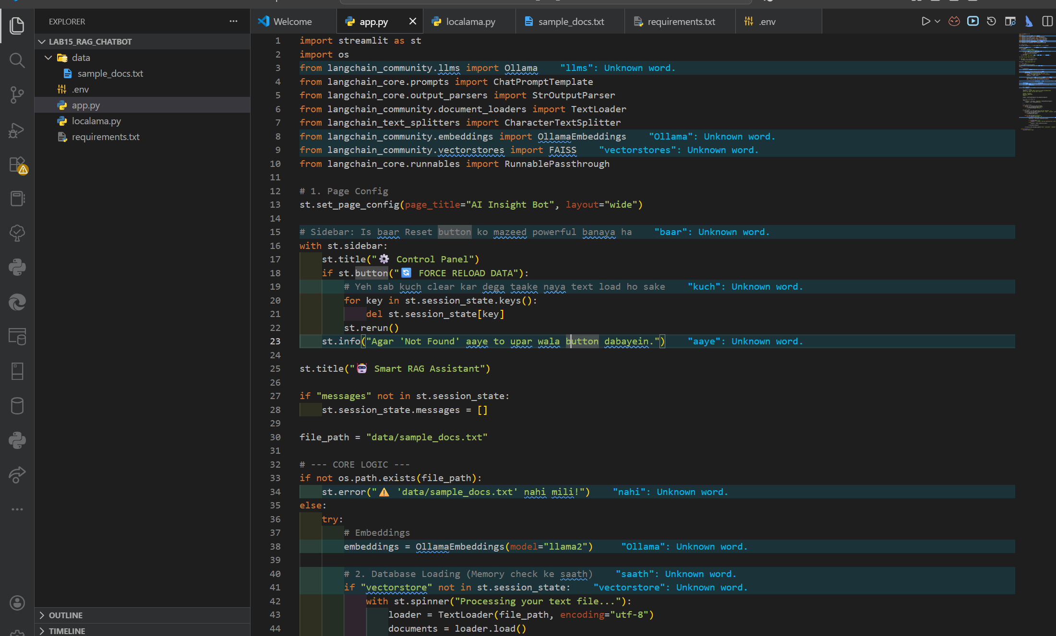

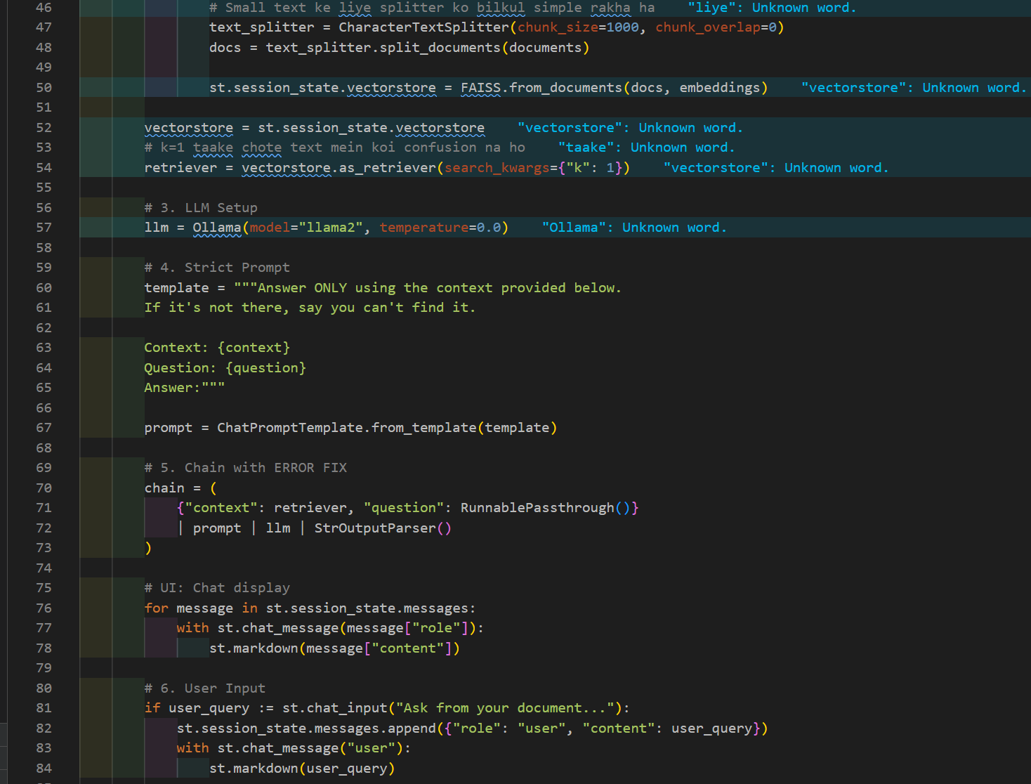

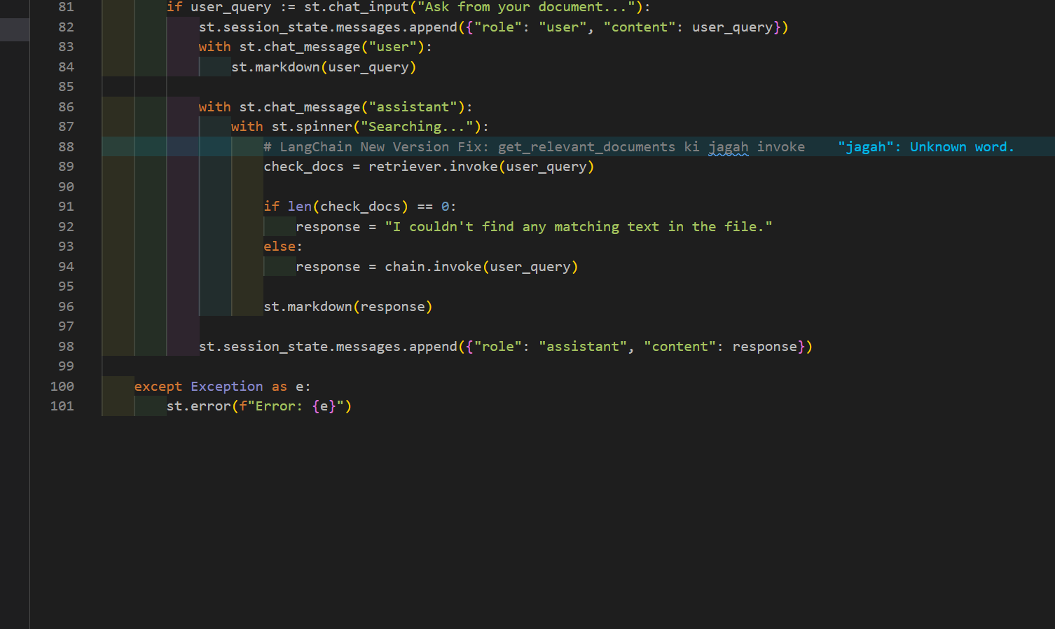

**Output:**

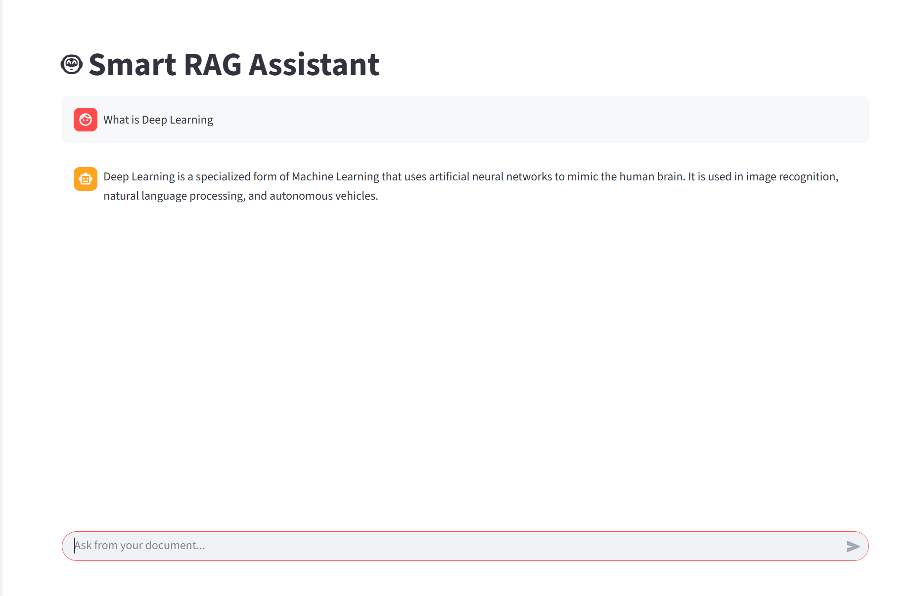

|  |  |  |  |  |  |  |
| --- | --- | --- | --- | --- | --- | --- |
| **Sr.**  **No.** | **Performance Indicator** | **Excellent (5)** | **Good (4)** | **Average (3)** | **Fair (2)** | **Poor (1)** |
| **1** | **Theoretical** | Student knows | Student knows most | Student knows few | Student knows | Student has poor |
|  | **knowledge** | all the related | of the related | of the related | very little about | understanding of the |
|  | **10%** | concepts about | concepts about the | concepts about the | the related | related concepts |
|  |  | the theoretical | theoretical | theoretical | concepts about the | about the theoretical |
|  |  | background of | background of the | background of the | theoretical | background of the |
|  |  | the experiment | experiment and | experiment and | background of the | experiment and |
|  |  | and rephrase | partially rephrase | partially rephrase | experiment and | unable to rephrase |
|  |  | those concepts in | those concepts in | those concepts in | poorly rephrase | those concepts in |
|  |  | written and oral | written and oral | written and oral | those concepts in | written and oral |
|  |  | assessments | assessments | assessments | written and oral | assessments |
|  |  |  |  |  | assessments |  |
| **2** | **Application** | Application runs | Application | Application | Application | Application does |
|  | **Functionality** | smoothly and | compiles with no | compiles with | compiles and | not compile or |
|  | **10%** | operation of the | warnings. Robust | few or no | runs without | compiles but |
|  |  | application runs | operation of the | warnings. | crashing. Some | crashes. |
|  |  | efficiently | application, with | Consideration | attempt at | Confusing. |
|  |  |  | good recovery. | given to unusual | detecting and | Little or no error |
|  |  |  |  | conditions with | correcting | detection or |
|  |  |  |  | reasonable | errors. | correction. |
| **3** | **Specifications** | The program | The program works | The program | The program | The program is |
|  | **10%** | works very | and meets some of | works and | produces correct | producing incorrect |
|  |  | efficiently and | the specifications. | produces the | results but does not | results. |
|  |  | meets all of the |  | correct results and | display them |  |
|  |  | required |  | displays them | correctly. |  |
|  |  | specifications. |  | correctly. It also |  |  |
|  |  |  |  | meets most of the |  |  |
|  |  |  |  | other |  |  |
|  |  |  |  | specifications. |  |  |
| **4** | **Level of** | Provide complete | Provide complete | Provide partially | Provide very few | Provide no answer to |
|  | **understanding of** | and logical | and logical answers | correct and logical | and illogical | the questions asked |
|  | **the learned skill** | answers based | based upon accurate | answers based | answers to the | by examiner. |
|  | **10%** | upon accurate | technical content to | upon minimum | questions asked by |  |
|  |  | technical content | the questions asked | technical content | examiner. |  |
|  |  | to the questions | by examiner with | to the questions |  |  |
|  |  | asked by | few errors | asked by examiner |  |  |
|  |  | examiner |  |  |  |  |
| **5** | **Readability and** | The code is | The code is fairly | Most of the code | Some parts of the | The code is poorly |
|  | **Reusability** | exceptionally | easy to read. The | could be reused in | code require | organized and very |
|  | **10%** | well organized | code could be | other programs. | change before they | difficult to read and |
|  |  | and very easy | reused as a whole |  | could be reused in | not organized for |
|  |  | to follow and | or each class could |  | other programs. | reusability. |
|  |  | reused | be reused. |  |  |  |

**Laboratory Work Assessment Rubrics**

|  |  |  |  |  |  |  |
| --- | --- | --- | --- | --- | --- | --- |
| **6** | **AI System Design 10%** | Well-designed AI models. Code is highly maintainable | Good designed AI models and Little code duplications | Some attempt to make AI models. Code can be maintained with significant effort | Little attempt to design AI models and less understanding of code | Very poor attempt to design AI models and its code |
| **7** | **Responsiveness to**  **Questions/ Accuracy 10%** | 1. Responds well, quick and very accurate all the time. 2. Effectively uses eye contact, speaks clearly, effectively and confidently using   suitable volume | 1. Generally Responsive and accurate most of the times. 2. Maintains eye contact, speaks clearly with suitable volume and pace. | 1. Generally Responsive and accurate few times. 2. Some eye contact, speaks clearly and unclearly in different portions. | 1. Not much Responsive and accurate most of the times. 2. Uses eye contact ineffectively and fails to speak clearly and audibly | . 1. Non Responsive and inaccurate all the times.   1. No eye contact and unable to speak 2. Dresses inappropriately |
| **8** | **Efficiency 10%** | The code is extremely efficient without sacrificing readability and understanding | The code is fairly efficient without sacrificing readability and understanding | Some part of the code is efficient and other part of the code is not understandable and work properly | The code is brute force and unnecessarily long | The code is huge and appears to be patched together |
| **9** | **Delivery 10%** | The program was delivered in time during lab. | The program was delivered in Lab before the end time. | The program was delivered within the due date. | The code was delivered within a day after the due date. | The code was delivered more than 2 days overdue. |
| **10** | **Awareness of Safety Guidelines 10%** | Student has sufficient knowledge of the laboratory safety SOPs and protocol and is fully compliant to the guidelines | Student has sufficient knowledge of the laboratory safety SOPs and protocol and is Partially compliant to the guidelines | Student has little knowledge of the laboratory safety SOPs and protocol and is Partially compliant to the guidelines | Student has little knowledge of the laboratory safety SOPs and protocol and is non- compliant to the guidelines | Student has no knowledge of the laboratory safety SOPs and protocol and is non-compliant to the guidelines |

***LAB Assessment:***

|  |  |  |  |
| --- | --- | --- | --- |
| **Student Name** |  | **LAB Rubrics** | CLO3 , P5, PLO5 |
| **Total Marks** | 10 |
| **Registration No** |  | **Obtained Marks** |  |
| **Teacher Name** | Dr. Syed M Hamedoon |
| **Date** |  | **Signature** |  |

LINK

https://github.com/haleema123-web/AI-Project-and-Lab-Manual